Table of Contents

UNITED STATES

SECURITIES AND EXCHANGE COMMISSION

Washington, D.C. 20549

FORM 10-K

- ANNUAL REPORT PURSUANT TO SECTION 13 OR 15(d) OF THE SECURITIES EXCHANGE ACT OF 1934

For the fiscal year ended September 30, 2015

- TRANSITION REPORT PURSUANT TO SECTION 13 OR 15(d) OF THE SECURITIES EXCHANGE ACT OF 1934

For the transition period from to

Commission File Number 001-32833

TransDigm Group Incorporated

(Exact name of registrant as specified in its charter)

Delaware

(State or other jurisdiction of incorporation or organization)

41-2101738

(I.R.S. Employer Identification No.)

1301 East 9th Street, Suite 3000, Cleveland, Ohio |  | 44114
(Address of principal executive offices) |  | (Zip Code)
(216) 706-2960
 | (Registrants’ telephone number, including area code)
 | Securities registered pursuant to Section 12(b) of the Act:
Common Stock |  | New York Stock Exchange
(Title) |  | (Name of exchange on which registered)
 | Securities registered pursuant to Section 12(g) of the Act:
 | None
Indicate by check mark if the registrant is a well-known seasoned issuer, as defined in Rule 405 of the Securities Act. |  |  |  | Yes x | No | ☐
Indicate by check mark if the registrant is not required to file reports pursuant to Section 13 or Section 15(d) of the Act. |  |  |  | Yes | ☐ | No x

Indicate by check mark whether the registrant: (1) has filed all reports required to be filed by Section 13 or 15(d) of the Securities Exchange Act of

1934 during the preceding 12 months (or for such shorter period that the registrant was required to file such reports) and (2) has been subject to such filing requirements for the past 90 days. Yes x No ☐

Indicate by check mark whether the registrant has submitted electronically and posted on its corporate website, if any, every Interactive Data File required to be submitted and posted pursuant to Rule 405 of Regulation S-T during the preceding 12 months (or for such shorter period that the registrant was required to submit and post such files). Yes x No ☐

Indicate by check mark if disclosure of delinquent filers pursuant to Item 405 of Regulation S-K is not contained herein, and will not be contained, to the best of registrant’s knowledge, in definitive proxy or information statements incorporated by reference in Part III of this Form 10-K or any amendment to this Form 10-K. x

Indicate by check mark whether the registrant is a large accelerated filer, an accelerated filer, a non-accelerated filer, or smaller reporting company. See the definitions of “large accelerated filer,” “accelerated filer” and “smaller reporting company” in Rule 12b-2 of the Exchange Act.

Large accelerated filer x

Accelerated filer

☐

Non-accelerated filer

☐

Smaller reporting company

☐

Indicate by check mark whether the registrant is a shell company (as defined in Rule 12b-2 of the Exchange Act).

Yes

☐

No x

The aggregate market value of the voting and non-voting common stock held by non-affiliates of the registrant as of March 27, 2015, based upon the last sale price of such voting and non-voting common stock on that date, was $10,927,295,559.

The number of shares outstanding of TransDigm Group Incorporated’s common stock, par value $.01 per share, was 53,687,448 as of November 3,

2015.

Documents incorporated by reference: The registrant incorporates by reference in Part III hereof portions of its definitive Proxy Statement for its 2016 Annual Meeting of Stockholders.

Table of Contents

 |  |  |  |  |  |  |  |  |  |  |  |  |  |  | TABLE OF CONTENTS
 |  |  |  |  |  |  |  |  |  |  |  |  |  |  |  |  |  |  |  |  |  |  |  |  |  |  | Page
PART I
 | ITEM 1 |  |  |  | BUSINESS |  |  |  |  |  |  |  |  |  |  |  |  |  |  |  |  |  |  |  |  |  | 1
 | ITEM 1A |  |  |  | RISK FACTORS |  |  |  |  |  |  |  |  |  |  |  |  |  |  |  |  |  |  |  |  |  | 5
 | ITEM 1B |  |  |  | UNRESOLVED STAFF COMMENTS |  |  |  |  |  |  |  |  |  |  |  |  |  |  |  |  |  |  |  |  |  | 13
 | ITEM 2 |  |  |  | PROPERTIES |  |  |  |  |  |  |  |  |  |  |  |  |  |  |  |  |  |  |  |  |  | 13
 | ITEM 3 |  |  |  | LEGAL PROCEEDINGS |  |  |  |  |  |  |  |  |  |  |  |  |  |  |  |  |  |  |  |  |  | 14
PART II
 | ITEM 5 |  |  |  | MARKET FOR REGISTRANT’S COMMON EQUITY, RELATED STOCKHOLDER MATTERS AND
 |  |  |  |  | ISSUER PURCHASES OF EQUITY SECURITIES |  |  |  |  |  |  |  |  |  |  |  |  |  |  |  |  |  |  |  |  |  | 15
 | ITEM 6 |  |  |  | SELECTED FINANCIAL DATA |  |  |  |  |  |  |  |  |  |  |  |  |  |  |  |  |  |  |  |  |  | 17
 | ITEM 7 |  |  |  | MANAGEMENT’S DISCUSSION AND ANALYSIS OF FINANCIAL CONDITION AND RESULTS OF
 |  |  |  |  | OPERATIONS |  |  |  |  |  |  |  |  |  |  |  |  |  |  |  |  |  |  |  |  |  | 25
 | ITEM 7A |  |  |  | QUANTITATIVE AND QUALITATIVE DISCLOSURES ABOUT MARKET RISK |  |  |  |  |  |  |  |  |  |  |  |  |  |  |  |  |  |  |  |  |  | 43
 | ITEM 8 |  |  |  | FINANCIAL STATEMENTS AND SUPPLEMENTARY DATA |  |  |  |  |  |  |  |  |  |  |  |  |  |  |  |  |  |  |  |  |  | 43
 | ITEM 9 |  |  |  | CHANGES IN AND DISAGREEMENTS WITH ACCOUNTANTS ON ACCOUNTING AND FINANCIAL
 |  |  |  |  | DISCLOSURE |  |  |  |  |  |  |  |  |  |  |  |  |  |  |  |  |  |  |  |  |  | 43
 | ITEM 9A |  |  |  | CONTROLS AND PROCEDURES |  |  |  |  |  |  |  |  |  |  |  |  |  |  |  |  |  |  |  |  |  | 44
 | ITEM 9B |  |  |  | OTHER INFORMATION |  |  |  |  |  |  |  |  |  |  |  |  |  |  |  |  |  |  |  |  |  | 46
PART III
 | ITEM 10 |  |  |  | DIRECTORS, EXECUTIVE OFFICERS AND CORPORATE GOVERNANCE |  |  |  |  |  |  |  |  |  |  |  |  |  |  |  |  |  |  |  |  |  | 46
 | ITEM 11 |  |  |  | EXECUTIVE COMPENSATION |  |  |  |  |  |  |  |  |  |  |  |  |  |  |  |  |  |  |  |  |  | 47
 | ITEM 12 |  |  |  | SECURITY OWNERSHIP OF CERTAIN BENEFICIAL OWNERS AND MANAGEMENT AND
 |  |  |  |  | RELATED STOCKHOLDER MATTERS |  |  |  |  |  |  |  |  |  |  |  |  |  |  |  |  |  |  |  |  |  | 47
 | ITEM 13 |  |  |  | CERTAIN RELATIONSHIPS AND RELATED TRANSACTIONS, AND DIRECTOR INDEPENDENCE |  |  |  |  |  |  |  |  |  |  |  |  |  |  |  |  |  |  |  |  |  | 48
 | ITEM 14 |  |  |  | PRINCIPAL ACCOUNTING FEES AND SERVICES |  |  |  |  |  |  |  |  |  |  |  |  |  |  |  |  |  |  |  |  |  | 48
PART IV
 | ITEM 15 |  |  |  | EXHIBITS AND FINANCIAL STATEMENT SCHEDULES |  |  |  |  |  |  |  |  |  |  |  |  |  |  |  |  |  |  |  |  |  | 49
 |  |  |  |  | FINANCIAL STATEMENTS AND SUPPLEMENTARY DATA |  |  |  |  |  |  |  |  |  |  |  |  |  |  |  |  |  |  |  |  |  | 68

Table of Contents

Special Note Regarding Forward-Looking Statements

This report on Form 10-K contains forward-looking statements within the meaning of Section 21E of the Securities Exchange Act of 1934, as amended (the “Exchange Act”), and 27A of the Securities Act of 1933, as amended. Discussions containing such forward-looking statements may be found in Items 1,1A, 2, 3, 5 and 7 hereof and elsewhere within this Report generally. In addition, when used in this Report, the words “believe,” “may,” “will,” “should,” “expect,” “intend,” “plan,” “predict,” “anticipate,” “estimate” or “continue” and other words and terms of similar meaning are intended to identify forward-looking statements. Although the Company (as defined below) believes that its plans, intentions and expectations reflected in or suggested by such forward-looking statements are reasonable, such forward-looking statements are subject to a number of risks and uncertainties that could cause actual results to differ materially from the forward-looking statements made in this Report. The more important of such risks and uncertainties are set forth under the caption “Risk Factors” and elsewhere in this Report. Many such factors are outside the control of the Company. Consequently, such forward-looking statements should be regarded solely as our current plans, estimates and beliefs. We do not undertake, and specifically decline, any obligation, to publicly release the results of any revisions to these forward-looking statements that may be made to reflect any future events or circumstances after the date of such statements or to reflect the occurrence of anticipated or unanticipated events. All forward-looking statements attributable to the Company or persons acting on its behalf are expressly qualified in their entirety by these cautionary statements.

Important factors that could cause actual results to differ materially from the forward-looking statements made in this Annual Report on Form 10-K include but are not limited to: the sensitivity of our business to the number of flight hours that our customers’ planes spend aloft and our customers’ profitability, both of which are affected by general economic conditions; future terrorist attacks; cyber-security threats and natural disasters; our reliance on certain customers; the U.S. defense budget and risks associated with being a government supplier; failure to maintain government or industry approvals; failure to complete or successfully integrate acquisitions; our substantial indebtedness; potential environmental liabilities; increases in raw material costs, taxes and labor costs that cannot be recovered in product pricing; risks and costs associated with our international sales and operations; and other factors.

In this report, the term “TD Group” refers to TransDigm Group Incorporated, which holds all of the outstanding capital stock of TransDigm Inc. The terms “Company,” “TransDigm,” “we,” “us,” “our” and similar terms refer to TD Group, together with TransDigm Inc. and its direct and indirect subsidiaries. References to “fiscal year” mean the year ending or ended September 30. For example, “fiscal year 2015” or “fiscal 2015” means the period from October 1, 2014 to September 30, 2015.

PART I

ITEM 1. BUSINESS

The Company

TransDigm Inc. was formed in 1993 in connection with a leveraged buyout transaction. TD Group was formed in 2003 to facilitate a leveraged buyout of TransDigm Inc. The Company was owned by private equity funds until its initial public offering in 2006. TD Group’s common stock is publicly traded on the New York Stock Exchange, or NYSE, under the ticker symbol “TDG.”

We believe we are a leading global designer, producer and supplier of highly engineered aircraft components for use on nearly all commercial and military aircraft in service today. Our business is well diversified due to the broad range of products we offer to our customers. We estimate that about 90% of our net sales for fiscal year 2015 were generated by proprietary products. In addition, for fiscal year 2015, we estimate that we generated about 80% of our net sales from products for which we are the sole source provider.

Most of our products generate significant aftermarket revenue. Once our parts are designed into and sold on a new aircraft, we generate net sales from aftermarket consumption over the life of that aircraft, which is generally estimated to be approximately 25 to 30 years. A typical platform can be produced for 20 to 30 years, giving us an estimated product life cycle in excess of 50 years. We estimate that approximately 54% of our net sales in fiscal year 2015 were generated from aftermarket sales, the vast majority of which come from the commercial and military aftermarkets. These aftermarket revenues have historically produced a higher gross margin and been more stable than sales to original equipment manufacturers, or OEMs.

Products

We primarily design, produce and supply highly-engineered proprietary aerospace components (and certain systems/subsystems) with significant aftermarket content. We seek to develop highly customized products to solve specific needs for aircraft operators and manufacturers. We attempt to differentiate ourselves based on engineering, service and manufacturing capabilities. We typically choose not to compete for non-proprietary “build to print” business because it frequently offers lower

1

Table of Contents

margins than proprietary products. We believe that our products have strong brand names within the industry and that we have a reputation for high quality, reliability and customer support.

Our business is well diversified due to the broad range of products that we offer to our customers. Some of our more significant product offerings, substantially all of which are ultimately provided to end-users in the aerospace industry, include mechanical/electro-mechanical actuators and controls, ignition systems and engine technology, specialized pumps and valves, power conditioning devices, specialized AC/DC electric motors and generators, NiCad batteries and chargers, engineered latching and locking devices, rods and locking devices, engineered connectors and elastomers, cockpit security components and systems, specialized cockpit displays, aircraft audio systems, specialized lavatory components, seat belts and safety restraints, engineered interior surfaces and related components, lighting and control technology, military personnel parachutes and cargo loading, handling and delivery systems.

Segments

The Company’s businesses are organized and managed in three reporting segments: Power & Control, Airframe and Non-aviation.

The Power & Control segment includes operations that primarily develop, produce and market systems and components that predominately provide power to or control power of the aircraft utilizing electronic, fluid, power and mechanical motion control technologies. Major product offerings include mechanical/electro-mechanical actuators and controls, ignition systems and engine technology, specialized pumps and valves, power conditioning devices, specialized AC/DC electric motors and generators and cargo loading and handling systems. Primary customers of this segment are engine and power system and subsystem suppliers, airlines, third party maintenance suppliers, military buying agencies and repair depots. Products are sold in the original equipment and aftermarket market channels.

The Airframe segment includes operations that primarily develop, produce and market systems and components that are used in non-power airframe applications utilizing airframe and cabin structure technologies. Major product offerings include engineered latching and locking devices, rods and locking devices, engineered connectors and elastomers, cockpit security components and systems, aircraft audio systems, specialized lavatory components, seat belts and safety restraints, engineered interior surfaces and related components, lighting and control technology, military personnel parachutes and cargo delivery systems. Primary customers of this segment are airframe manufacturers and cabin system suppliers and subsystem suppliers, airlines, third party maintenance suppliers, military buying agencies and repair depots. Products are sold in the original equipment and aftermarket market channels.

The Non-aviation segment includes operations that primarily develop, produce and market products for non-aviation markets. Major product offerings include seat belts and safety restraints for ground transportation applications, mechanical/electro-mechanical actuators and controls for space applications, and refueling systems for heavy equipment used in mining, construction and other industries. Primary customers of this segment are off-road vehicle suppliers and subsystem suppliers, child restraint system suppliers, satellite and space system suppliers and manufacturers of heavy equipment used in mining, construction and other industries.

For financial information about our segments, see Note 16, “Segments” to our Consolidated Financial Statements.

Sales and Marketing

Consistent with our overall strategy, our sales and marketing organization is structured to continually develop technical solutions that meet customer needs. In particular, we attempt to focus on products and programs that will lead to high-margin, repeatable sales in the aftermarket.

We have structured our sales efforts along our major product offerings, assigning a business unit manager to certain products. Each business unit manager is expected to grow the sales and profitability of the products for which he or she is responsible and to achieve the targeted annual level of bookings, sales, new business and profitability for such products. The business unit managers are assisted by account managers and sales engineers who are responsible for covering major OEM and aftermarket accounts. Account managers and sales engineers are expected to be familiar with the personnel, organization and needs of specific customers to achieve total bookings and new business goals at each account and, together with the product managers, to determine when additional resources are required at customer locations. Most of our sales personnel are evaluated, in part, on their bookings and their ability to identify and obtain new business opportunities.

Though typically performed by employees, the account manager function may be performed by independent representatives depending on the specific customer, product and geographic location. We also use a number of distributors to provide logistical support as well as primary customer contact with certain smaller accounts. Our major distributors are Aviall, Inc. (a subsidiary of The Boeing Company) and Satair A/S (a subsidiary of Airbus S.A.S.).

2

Table of Contents

Manufacturing and Engineering

We maintain 52 principal manufacturing facilities. Most of our manufacturing facilities are comprised of manufacturing, distribution and engineering functions, and most facilities have certain administrative functions, including management, sales and finance. We continually strive to improve productivity and reduce costs, including rationalization of operations, developing improved control systems that allow for accurate product profit and loss accounting, investing in equipment, tooling, information systems and implementing broad-based employee training programs. Management believes that our manufacturing systems and equipment contribute to our ability to compete by permitting us to meet the rigorous tolerances and cost sensitive price structure of aircraft component customers.

We attempt to differentiate ourselves from our competitors by producing uniquely engineered products with high quality and timely delivery. Our engineering costs are recorded in Cost of Sales and in Selling and Administrative Expenses in our Consolidated Statements of Income. Total engineering expense represents approximately 6% of our operating units’ aggregate costs, or approximately 4% of our consolidated net sales. Our proprietary products, and particularly our new product initiatives, are designed by our engineers and are intended to serve the needs of the aircraft component industry. These proprietary designs must withstand the extraordinary conditions and stresses that will be endured by products during use and meet the rigorous demands of our customers’ tolerance and quality requirements.

We use sophisticated equipment and procedures to comply with quality requirements, specifications and Federal Aviation Administration (“FAA”) and OEM requirements. We perform a variety of testing procedures, including testing under different temperature, humidity and altitude levels, shock and vibration testing and X-ray fluorescent measurement. These procedures, together with other customer approved techniques for document, process and quality control, are used throughout our manufacturing facilities.

Customers

Our customers include: (1) distributors of aerospace components; (2) worldwide commercial airlines, including national and regional airlines; (3) large commercial transport and regional and business aircraft OEMs; (4) various armed forces of the United States and friendly foreign governments; (5) defense OEMs; (6) system suppliers; and (7) various other industrial customers. For the year ended September 30, 2015, The Boeing Company (which includes Aviall, Inc., a distributor of commercial aftermarket parts to airlines throughout the world) accounted for approximately 12% of our net sales and Airbus S.A.S. accounted for approximately 11% of our net sales. Our top ten customers for fiscal year 2015 accounted for approximately 46% of our net sales. Products supplied to many of our customers are used on multiple platforms.

Active commercial production programs include the Boeing 737, 747, 767, 777 and 787, the Airbus A319/20/21, A330/A340, A350 and A380, the Bombardier CRJ’s, Challenger and Learjets, the Embraer RJ’s, the Cessna Citation family, the Raytheon Premier and Hawker and most Gulfstream airframes. Military platforms include aircraft such as the Boeing C-17, F-15, F-18 and V-22, the Airbus A400M, the Lockheed Martin C-130J, F-16 and F-35 Joint Strikefighter, the Northrop Grumman E-2C Hawkeye, the Sikorsky UH-60 helicopter, CH-47 Chinook and AH-64 Apache helicopters, the General Atomics Predator Drone and the Raytheon Patriot Missile. TransDigm has been awarded numerous contracts for the development of engineered products for production on the Airbus A320 NEO, the Boeing 737 MAX, the Sikorsky S-97, JMR helicopter and Boeing P-8 Poseidon.

The demand for our aftermarket parts and services depends on, among other things, the breadth of our installed OEM base, revenue passenger miles (“RPMs”), the size and age of the worldwide aircraft fleet and, to a lesser extent, airline profitability. We believe that we are also a leading supplier of components used on U.S. designed military aircraft, including components that are used on a variety of fighter aircraft, military freighters and military helicopters.

Competition

The niche markets within the aerospace industry that we serve are relatively fragmented and we face several competitors for many of the products and services we provide. Due to the global nature of the commercial aircraft industry, competition in these categories comes from both U.S. and foreign companies. Competitors in our product offerings range in size from divisions of large public corporations to small privately-held entities, with only one or two components in their entire product portfolios.

We compete on the basis of engineering, manufacturing and marketing high quality products, which we believe meet or exceed the performance and maintenance requirements of our customers, consistent and timely delivery, and superior customer service and support. The industry’s stringent regulatory, certification and technical requirements, and the investments necessary in the development and certification of products, create barriers to entry for potential new competitors. As long as customers receive products that meet or exceed expectations and performance standards, we believe that they will have a reduced incentive to certify another supplier because of the cost and time of the technical design and testing certification process. In addition, we believe that the availability, dependability and safety of our products are reasons for our customers to continue long-term supplier relationships.

3

Table of Contents

Government Contracts

Companies engaged in supplying defense-related equipment and services to U.S. Government agencies are subject to business risks specific to the defense industry. These risks include the ability of the U.S. Government to unilaterally: (1) suspend us from receiving new contracts pending resolution of alleged violations of procurement laws or regulations; (2) terminate existing contracts; (3) reduce the value of existing contracts; (4) audit our contract-related costs and fees, including allocated indirect costs; and (5) control and potentially prohibit the export of our products.

Governmental Regulation

The commercial aircraft component industry is highly regulated by the FAA in the United States and by the Joint Aviation Authorities in Europe and other agencies throughout the world, while the military aircraft component industry is governed by military quality specifications. We, and the components we manufacture, are required to be certified by one or more of these entities or agencies, and, in many cases, by individual OEMs, in order to engineer and service parts and components used in specific aircraft models.

We must also satisfy the requirements of our customers, including OEMs and airlines that are subject to FAA regulations, and provide these customers with products and services that comply with the government regulations applicable to commercial flight operations. In addition, the FAA requires that various maintenance routines be performed on aircraft components. We believe that we currently satisfy or exceed these maintenance standards in our repair and overhaul services. We also maintain several FAA approved repair stations.

In addition, our businesses are subject to many other laws and requirements typically applicable to manufacturers and exporters. Without limiting the foregoing, sales of many of our products that will be used on aircraft owned by foreign entities are subject to compliance with export control laws and the manufacture of our products and the operations of our businesses, including the disposal of hazardous wastes, are subject to compliance with applicable environmental laws.

Raw Materials

We require the use of various raw materials in our manufacturing processes. We also purchase a variety of manufactured component parts from various suppliers. At times, we concentrate our orders among a few suppliers in order to strengthen our supplier relationships. Most of our raw materials and component parts are generally available from multiple suppliers at competitive prices.

Intellectual Property

We have various trade secrets, proprietary information, trademarks, trade names, patents, copyrights and other intellectual property rights, which we believe, in the aggregate but not individually, are important to our business.

Backlog

As of September 30, 2015, the Company estimated its sales order backlog at $1,428 million compared to an estimated sales order backlog of $1,195 million as of September 30, 2014. The increase in estimated sales order backlog of approximately $233 million is primarily due to acquisitions. The majority of the purchase orders outstanding as of September 30, 2015 are scheduled for delivery within the next twelve months. Purchase orders may be subject to cancellation or deferral by the customer prior to shipment. The level of unfilled purchase orders at any given date during the year will be materially affected by the timing of the Company’s receipt of purchase orders and the speed with which those orders are filled. Accordingly, the Company’s backlog as of September 30, 2015 may not necessarily represent the actual amount of shipments or sales for any future period.

Foreign Operations

Although we manufacture a significant portion of our products in the United States, we manufacture some products in Belgium, China, Germany, Hungary, Malaysia, Mexico, Norway, Sri Lanka, Sweden, and the United Kingdom. Although the majority of sales of our products are made to customers (including distributors) located in the United States, our products are ultimately sold to and used by customers (including airlines and other end users of aircraft) throughout the world. A number of risks inherent in international operations could have a material adverse effect on our results of operations, including currency fluctuations, difficulties in staffing and managing multi-national operations, general economic and political uncertainties and potential for social unrest in countries in which we operate, limitations on our ability to enforce legal rights and remedies, restrictions on the repatriation of funds, change in trade policies, tariff regulation, difficulties in obtaining export and import licenses and the risk of government financed competition.

Our direct sales to foreign customers were approximately $881.1 million, $735.9 million and $572.0 million for fiscal years 2015, 2014 and 2013, respectively. Sales to foreign customers are subject to numerous additional risks, including foreign currency fluctuations, the impact of foreign government regulations, political uncertainties and differences in business practices. There can be no assurance that foreign governments will not adopt regulations or take other action that would have a

4

Table of Contents

direct or indirect adverse impact on the business or market opportunities of the Company within such governments’ countries. Furthermore, there can be no assurance that the political, cultural and economic climate outside the United States will be favorable to our operations and growth strategy.

Environmental Matters

Our operations and facilities are subject to a number of federal, state, local and foreign environmental laws and regulations that govern, among other things, discharges of pollutants into the air and water, the generation, handling, storage and disposal of hazardous materials and wastes, the remediation of contamination and the health and safety of our employees. Environmental laws and regulations may require that the Company investigate and remediate the effects of the release or disposal of materials at sites associated with past and present operations. Certain facilities and third-party sites utilized by the Company have been identified as potentially responsible parties under the federal Superfund laws and comparable state laws. The Company is currently involved in the investigation and remediation of a number of sites under applicable laws.

Estimates of the Company’s environmental liabilities are based on current facts, laws, regulations and technology. These estimates take into consideration the Company’s prior experience and professional judgment of the Company’s environmental advisors. Estimates of the Company’s environmental liabilities are further subject to uncertainties regarding the nature and extent of site contamination, the range of remediation alternatives available, evolving remediation standards, imprecise engineering evaluations and cost estimates, the extent of corrective actions that may be required and the number and financial condition of other potentially responsible parties, as well as the extent of their responsibility for the remediation.

Accordingly, as investigation and remediation proceed, it is likely that adjustments in the Company’s accruals will be necessary to reflect new information. The amounts of any such adjustments could have a material adverse effect on the Company’s results of operations or cash flows in a given period. Based on currently available information, however, the Company does not believe that future environmental costs in excess of those accrued with respect to sites for which the Company has been identified as a potentially responsible party are likely to have a material adverse effect on the Company’s financial condition.

Environmental liabilities are recorded when the liability is probable and the costs are reasonably estimable, which generally is not later than at completion of a feasibility study or when the Company has recommended a remedy or has committed to an appropriate plan of action. The liabilities are reviewed periodically and, as investigation and remediation proceed, adjustments are made as necessary. Liabilities for losses from environmental remediation obligations do not consider the effects of inflation and anticipated expenditures are not discounted to their present value. The liabilities are not reduced by possible recoveries from insurance carriers or other third parties, but do reflect anticipated allocations among potentially responsible parties at federal Superfund sites or similar state-managed sites, third party indemnity obligations, and an assessment of the likelihood that such parties will fulfill their obligations at such sites.

Employees

As of September 30, 2015, we had approximately 8,200 full-time, part-time and temporary employees. Approximately 8% of our full-time and part-time employees were represented by labor unions. Collective bargaining agreements between us and these labor unions expire at various dates ranging from April 2016 to May 2018. We consider our relationship with our employees generally to be satisfactory.

Legal Proceedings

We are from time to time subject to, and are presently involved in, litigation or other legal proceedings arising in the ordinary course of business. Based upon information currently known to us, we believe the outcome of such proceedings will not have, individually or in the aggregate, a material adverse effect on our business, our financial condition or results of operations.

Available Information

TD Group’s Annual Report on Form 10-K, Quarterly Reports on Form 10-Q and Current Reports on Form 8-K, including any amendments, will be made available free of charge on the Company’s website, www.transdigm.com, as soon as reasonably practicable, following the filing of the reports with the Securities and Exchange Commission.

ITEM 1A. RISK FACTORS

Set forth below are important risks and uncertainties that could negatively affect our business and financial condition and could cause our actual results to differ materially from those expressed in forward-looking statements contained in this report.

5

Table of Contents

Our business is sensitive to the number of flight hours that our customers’ planes spend aloft, the size and age of the worldwide aircraft fleet and our customers’ profitability. These items are, in turn, affected by general economic and geopolitical and other worldwide conditions.

Our business is directly affected by, among other factors, changes in revenue passenger miles (RPMs), the size and age of the worldwide aircraft fleet and, to a lesser extent, changes in the profitability of the commercial airline industry. RPMs and airline profitability have historically been correlated with the general economic environment, although national and international events also play a key role. For example, in the recent past, the airline industry has been severely affected by the downturn in the global economy, higher fuel prices, the increased security concerns among airline customers following the events of September 11, 2001, the Severe Acute Respiratory Syndrome, or SARS, epidemic and the conflicts in Afghanistan and Iraq, and could be impacted by future geopolitical or other worldwide conditions, such as war, terrorist acts, or a worldwide infectious disease outbreak. In addition, global market and economic conditions have been challenging with continued turbulence in the U.S. and international markets and economies and have prolonged declines in business and consumer spending. As a result of the substantial reduction in airline traffic resulting from these events, the airline industry incurred large losses and financial difficulties. Some carriers have also parked or retired a portion of their fleets and have reduced workforces and flights. During periods of reduced airline profitability, some airlines may delay purchases of spare parts, preferring instead to deplete existing inventories. If demand for new aircraft and spare parts decreases, there would be a decrease in demand for certain of our products.

Our sales to manufacturers of aircraft are cyclical, and a downturn in sales to these manufacturers may adversely affect us.

Our sales to manufacturers of large commercial aircraft, such as The Boeing Company, Airbus S.A.S, and related OEM suppliers, as well as manufacturers of business jets (which accounted for approximately 24% of our net sales in fiscal year 2015) have historically experienced periodic downturns. In the past, these sales have been affected by airline profitability, which is impacted by, among other things, fuel and labor costs, price competition, downturns in the global economy and national and international events, such as the events of September 11, 2001. In addition, sales of our products to manufacturers of business jets are impacted by, among other things, downturns in the global economy. Downturns adversely affect our net sales, gross margin and net income.

We rely heavily on certain customers for much of our sales.

Our two largest customers for fiscal year 2015 were The Boeing Company (which includes Aviall, Inc., a distributor of commercial aftermarket parts to airlines throughout the world) and Airbus S.A.S. The Boeing Company accounted for approximately 12% of our net sales and Airbus S.A.S. accounted for approximately 11% of our net sales in fiscal year 2015. Our top ten customers for fiscal year 2015 accounted for approximately 46% of our net sales. A material reduction in purchasing by one of our larger customers for any reason, including but not limited to economic downturn, decreased production, strike or resourcing, could have a material adverse effect on our net sales, gross margin and net income.

We generally do not have guaranteed future sales of our products. Further, when we enter into fixed price contracts with some of our customers, we take the risk for cost overruns.

As is customary in our business, we do not generally have long-term contracts with most of our aftermarket customers and, therefore, do not have guaranteed future sales. Although we have long-term contracts with many of our OEM customers, many of those customers may terminate the contracts on short notice and, in most cases, our customers have not committed to buy any minimum quantity of our products. In addition, in certain cases, we must anticipate the future volume of orders based upon the historic purchasing patterns of customers and upon our discussions with customers as to their anticipated future requirements, and this anticipated future volume of orders may not materialize.

We also have entered into multi-year, fixed-price contracts with some of our customers, pursuant to which we have agreed to perform the work for a fixed price and, accordingly, realize all the benefit or detriment resulting from any decreases or increases in the costs of making these products. Sometimes we accept a fixed-price contract for a product that we have not yet produced, and this increases the risk of cost overruns or delays in the completion of the design and manufacturing of the product. Most of our contracts do not permit us to recover increases in raw material prices, taxes or labor costs.

U.S. military spending is dependent upon the U.S. defense budget.

The military and defense market is significantly dependent upon government budget trends, particularly the U.S. Department of Defense (the “DOD”) budget. In addition to normal business risks, our supply of products to the United States Government is subject to unique risks largely beyond our control. DOD budgets could be negatively impacted by several factors, including, but not limited to, a change in defense spending policy by the current presidential administration, the U.S. Government’s budget deficits, spending priorities, the cost of sustaining the U.S. military presence in the Middle East and possible political pressure to reduce U.S. Government military spending, each of which could cause the DOD budget to remain

6

Table of Contents

unchanged or to decline. A significant decline in U.S. military expenditures could result in a reduction in the amount of our products sold to the various agencies and buying organizations of the U.S. Government.

We intend to pursue acquisitions. Our business may be adversely affected if we cannot consummate acquisitions on satisfactory terms, or if we cannot effectively integrate acquired operations.

A significant portion of our growth has occurred through acquisitions. Any future growth through acquisitions will be partially dependent upon the continued availability of suitable acquisition candidates at favorable prices and upon advantageous terms and conditions. We intend to pursue acquisitions that we believe will present opportunities consistent with our overall business strategy. However, we may not be able to find suitable acquisition candidates to purchase or may be unable to acquire desired businesses or assets on economically acceptable terms. In addition, we may not be able to raise the capital necessary to fund future acquisitions. Because we may actively pursue a number of opportunities simultaneously, we may encounter unforeseen expenses, complications and delays, including regulatory complications or difficulties in employing sufficient staff and maintaining operational and management oversight.

We regularly engage in discussions with respect to potential acquisition and investment opportunities. If we consummate an acquisition, our capitalization and results of operations may change significantly. Future acquisitions could result in margin dilution and further likely result in the incurrence of additional debt and contingent liabilities and an increase in interest and amortization expenses or periodic impairment charges related to goodwill and other intangible assets as well as significant charges relating to integration costs.

Acquisitions involve risks that the businesses acquired will not perform in accordance with expectations and that business judgments concerning the value, strengths and weaknesses of businesses acquired will prove incorrect. In addition, we may not be able to successfully integrate any business we acquire into our existing business. The successful integration of new businesses depends on our ability to manage these new businesses and cut excess costs. The successful integration of future acquisitions may also require substantial attention from our senior management and the management of the acquired business, which could decrease the time that they have to service, attract customers and develop new products and services or attend to other acquisition opportunities.

We are subject to certain unique business risks as a result of supplying equipment and services to the U.S. Government.

Companies engaged in supplying defense-related equipment and services to U.S. Government agencies are subject to business risks specific to the defense industry. These risks include the ability of the U.S. Government to unilaterally:

- suspend us from receiving new contracts pending resolution of alleged violations of procurement laws or regulations;

- terminate existing contracts;

- reduce the value of existing contracts; and

- audit our contract-related costs and fees, including allocated indirect costs.

Most of our U.S. Government contracts can be terminated by the U.S. Government for its convenience without significant notice. Termination for convenience provisions provide only for our recovery of costs incurred or committed, settlement expenses and profit on the work completed prior to termination.

On contracts for which the price is based on cost, the U.S. Government may review our costs and performance, as well as our accounting and general business practices. Based on the results of such audits, the U.S. Government may adjust our contract-related costs and fees, including allocated indirect costs. In addition, under U.S. Government purchasing regulations, some of our costs, including most financing costs, amortization of intangible assets, portions of research and development costs, and certain marketing expenses may not be subject to reimbursement.

Furthermore, even where the price is not based on cost, the U.S. Government may seek to review our costs to determine whether our pricing is “fair and reasonable.” Our subsidiaries are periodically subject to a pricing review. Such a review could be costly and time consuming for our management and could distract from our ability to effectively manage the business. As a result of such a review, we could be subject to providing a refund to the U.S. Government or we could be asked to enter into an arrangement whereby our prices would be based on cost or the DOD could seek to pursue alternative sources of supply for our parts. Any of those occurrences could lead to a reduction in our revenue from, or the profitability of certain of our supply arrangements with, certain agencies and buying organizations of the U.S. Government.

Moreover, U.S. Government purchasing regulations contain a number of additional operation requirements, which do not apply to entities not engaged in government contracting. Failure to comply with such government contracting requirements could result in civil and criminal penalties that could have a material adverse effect on the Company's results of operations.

7

Table of Contents

Our business may be adversely affected if we would lose our government or industry approvals or if more stringent government regulations are enacted or if industry oversight is increased.

The aerospace industry is highly regulated in the United States and in other countries. In order to sell our components, we and the components we manufacture must be certified by the FAA, the DOD and similar agencies in foreign countries and by individual manufacturers. If new and more stringent government regulations are adopted or if industry oversight increases, we might incur significant expenses to comply with any new regulations or heightened industry oversight. In addition, if material authorizations or approvals were revoked or suspended, our business would be adversely affected.

In addition to the aviation approvals, we are at times required to obtain approval from U.S. Government agencies to export our products. Failure to obtain approval to export or determination by the U.S. Government that we failed to receive required approvals or licenses could eliminate or restrict our ability to sell our products outside the United States, and the penalties that could be imposed by the U.S. Government for failure to comply with these laws could be significant.

Our substantial indebtedness could adversely affect our financial health and could harm our ability to react to changes to our business and prevent us from fulfilling our obligations under our indebtedness.

We have a significant amount of indebtedness. As of September 30, 2015, our total indebtedness was approximately $8,427.3 million, which was approximately 114.1% of our total book capitalization because of our prior year dividends being funded with indebtedness and the addition of approximately $954 million in total debt in fiscal 2015.

In addition, we may be able to incur substantial additional indebtedness in the future. For example, as of September 30, 2015, we had approximately $534 million of unused commitments under our revolving loan facility and $50 million of unused capacity under our trade receivable securitization facility (the “Securitization Facility”) (with the availability of the capacity under the Securitization Facility being dependent on the amount of our trade receivables outstanding). Although our senior secured credit facility and the indentures (the “Indentures”) governing the 5.50% Senior Subordinated Notes issued in October 2012 (the “2020 Notes”), the 7.50% Senior Subordinated Notes issued in July 2013 (the “2021 Notes”), the 6.00% Senior Subordinated Notes issued in June 2014 (the “2022 Notes), the 6.50% Senior Subordinated Notes issued June 2014 (the “2024 Notes”) and the 6.50% Senior Subordinated Notes issued May 2015 ((the “2025 Notes”) and together with the 2020 Notes, the 2021 Notes, the 2022 Notes, the 2024 Notes, the “Notes”) contain restrictions on the incurrence of additional indebtedness, these restrictions are subject to a number of significant qualifications and exceptions, and the indebtedness incurred in compliance with these qualifications and exceptions could be substantial. If we incur additional debt, the risks associated with our substantial leverage would increase.

Our substantial debt could also have other important consequences to investors. For example, it could:

- increase our vulnerability to general economic downturns and adverse competitive and industry conditions;

- increase the risk we are subjected to downgrade or put on a negative watch by the ratings agencies;

- require us to dedicate a substantial portion of our cash flow from operations to payments on our indebtedness, thereby reducing the availability of our cash flow to fund working capital, capital expenditures, research and development efforts and other general corporate purposes;

- limit our flexibility in planning for, or reacting to, changes in our business and the industry in which we operate;

- place us at a competitive disadvantage compared to competitors that have less debt; and

- limit, along with the financial and other restrictive covenants contained in the documents governing our indebtedness, among other things, our ability to borrow additional funds, make investments and incur liens.

In addition, all of our debt under the senior secured credit facility, which includes $4,377 million in term loans and a revolving loan facility of

$550 million, bears interest at floating rates. Accordingly, if interest rates increase, our debt service expense will also increase. In order to reduce the floating interest rate risk, as of September 30, 2015, six interest rate cap agreements beginning on September 30, 2015 were in place to offset the variable interest rates based on an aggregate notional amount of $750 million of debt under the senior secured credit facility. Also, three forward starting interest rate swap agreements were in place that fix the interest on an aggregate notional amount of $1,000 million of debt under the senior secured credit facility. In addition, we entered into five forward starting interest rate swap agreements that fix the interest beginning March 31, 2016 on an aggregate notional amount of $750 million of debt under the senior secured credit facility.

Our substantial level of indebtedness increases the possibility that we may be unable to generate cash sufficient to pay, when due, the principal of, interest on or other amounts due in respect of our indebtedness, including the Notes. We cannot assure you that our business will generate sufficient cash flow from operations or that future borrowings will be available to us under the senior secured credit facility or otherwise in amounts sufficient to enable us to service our indebtedness. If we cannot service our debt, we will have to take actions such as reducing or delaying capital investments, selling assets, restructuring or refinancing our debt or seeking additional equity capital.

8

Table of Contents

To service our indebtedness, we will require a significant amount of cash. Our ability to generate cash depends on many factors beyond our control and any failure to meet our debt service obligations could harm our business, financial condition and results of operations.

Our ability to make payments on and to refinance our indebtedness, including the Notes, amounts borrowed under the senior secured credit facility, amounts due under our Securitization Facility, and to fund our operations, will depend on our ability to generate cash in the future, which, to a certain extent, is subject to general economic, financial, competitive, legislative, regulatory and other factors that are beyond our control.

We cannot assure you that our business will generate sufficient cash flow from operations, that currently anticipated cost savings and operating improvements will be realized on schedule, or at all, or that future borrowings will be available to us under the senior secured credit facility or otherwise in amounts sufficient to enable us to service our indebtedness, including the amounts borrowed under the senior secured credit facility, amounts borrowed under our Securitization Facility and the Notes, or to fund our other liquidity needs. If we cannot service our debt, we will have to take actions such as reducing or delaying capital investments, selling assets, restructuring or refinancing our debt or seeking additional equity capital. We cannot assure you that any of these remedies could, if necessary, be effected on commercially reasonable terms, or at all. Our ability to restructure or refinance our debt will depend on the condition of the capital markets and our financial condition at such time. Any refinancing of our debt could be at higher interest rates and may require us to comply with more onerous covenants, which could further restrict our business operations. The terms of existing or future debt instruments, the Securitization Facility, the Indentures and the senior secured credit facility may restrict us from adopting any of these alternatives. In addition, any failure to make payments of interest and principal on our outstanding indebtedness on a timely basis would likely result in a reduction of our credit rating, which could harm our ability to incur additional indebtedness on acceptable terms and would otherwise adversely affect the Notes.

The terms of the senior secured credit facility and Indentures may restrict our current and future operations, particularly our ability to respond to changes or to take certain actions.

Our senior secured credit facility and the Indentures contain a number of restrictive covenants that impose significant operating and financial restrictions on TD Group, TransDigm Inc. and its subsidiaries (in the case of the senior secured credit facility) and TransDigm Inc. and its subsidiaries (in the case of the Indentures) and may limit their ability to engage in acts that may be in our long-term best interests. The senior secured credit facility and Indentures include covenants restricting, among other things, the ability of TD Group, TransDigm Inc. and its subsidiaries (in the case of the senior secured credit facility) and TransDigm Inc. and its subsidiaries (in the case of the Indentures) to:

- incur or guarantee additional indebtedness or issue preferred stock;

- pay distributions on, redeem or repurchase our capital stock or redeem or repurchase our subordinated debt;

- make investments;

- sell assets;

- enter into agreements that restrict distributions or other payments from our restricted subsidiaries to us;

- incur or allow to exist liens;

- consolidate, merge or transfer all or substantially all of our assets;

- engage in transactions with affiliates;

- create unrestricted subsidiaries; and

- engage in certain business activities.

A breach of any of these covenants could result in a default under the senior secured credit facility or the Indentures. If any such default occurs, the lenders under the senior secured credit facility and the holders of the Notes may elect to declare all outstanding borrowings, together with accrued interest and other amounts payable thereunder, to be immediately due and payable. The lenders under the senior secured credit facility also have the right in these circumstances to terminate any commitments they have to provide further borrowings. In addition, following an event of default under the senior secured credit facility, the lenders under that facility will have the right to proceed against the collateral granted to them to secure the debt, which includes our available cash, and they will also have the right to prevent us from making debt service payments on the Notes. If the debt under the senior secured credit facility or the Notes were to be accelerated, we cannot assure you that our assets would be sufficient to repay in full our debt.

9

Table of Contents

We could incur substantial costs as a result of violations of or liabilities under environmental laws and regulations.

Our operations and facilities are subject to a number of federal, state, local and foreign environmental laws and regulations that govern, among other things, discharges of pollutants into the air and water, the generation, handling, storage and disposal of hazardous materials and wastes, the remediation of contamination and the health and safety of our employees. Environmental laws and regulations may require that the Company investigate and remediate the effects of the release or disposal of materials at sites associated with past and present operations. Certain facilities and third-party sites utilized by subsidiaries of the Company have been identified as potentially responsible parties under the federal Superfund laws and comparable state laws. The Company is currently involved in the investigation and remediation of a number of sites under applicable laws.

Estimates of the Company’s environmental liabilities are based on current facts, laws, regulations and technology. These estimates take into consideration the Company’s prior experience and professional judgment of the Company’s environmental advisors. Estimates of the Company’s environmental liabilities are further subject to uncertainties regarding the nature and extent of site contamination, the range of remediation alternatives available, evolving remediation standards, imprecise engineering evaluations and cost estimates, the extent of corrective actions that may be required and the number and financial condition of other potentially responsible parties, as well as the extent of their responsibility for the remediation.

Accordingly, as investigation and remediation proceed, it is likely that adjustments in the Company’s accruals will be necessary to reflect new information. The amounts of any such adjustments could have a material adverse effect on the Company’s results of operations or cash flows in a given period. Based on currently available information, however, the Company does not believe that future environmental costs in excess of those accrued with respect to sites for which the Company has been identified as a potentially responsible party are likely to have a material adverse effect on the Company’s financial condition.

Environmental liabilities are recorded when the liability is probable and the costs are reasonably estimable, which generally is not later than at completion of a feasibility study or when the Company has recommended a remedy or has committed to an appropriate plan of action. The liabilities are reviewed periodically and, as investigation and remediation proceed, adjustments are made as necessary. Liabilities for losses from environmental remediation obligations do not consider the effects of inflation and anticipated expenditures are not discounted to their present value. The liabilities are not reduced by possible recoveries from insurance carriers or other third parties, but do reflect anticipated allocations among potentially responsible parties at federal Superfund sites or similar state-managed sites, third party indemnity obligations, and an assessment of the likelihood that such parties will fulfill their obligations at such sites.

We are dependent on our highly trained employees and any work stoppage or difficulty hiring similar employees could adversely affect our business.

Because our products are complicated and highly engineered, we depend on an educated and trained workforce. There is substantial competition for skilled personnel in the aircraft component industry, and we could be adversely affected by a shortage of skilled employees. We may not be able to fill new positions or vacancies created by expansion or turnover or attract and retain qualified personnel.

As of September 30, 2015, we had approximately 8,200 full-time, part-time and temporary employees. Approximately 8% of our full-time and part-time employees were represented by labor unions. Collective bargaining agreements between us and these labor unions expire at various dates ranging from April 2016 to May 2018. We consider our relationship with our employees generally to be satisfactory. Although we believe that our relations with our employees are satisfactory, we cannot assure you that we will be able to negotiate a satisfactory renewal of these collective bargaining agreements or that our employee relations will remain stable. Because we maintain a relatively small inventory of finished goods, any work stoppage could materially and adversely affect our ability to provide products to our customers.

Our business is dependent on the availability of certain components and raw materials from suppliers.

Our business is affected by the price and availability of the raw materials and component parts that we use to manufacture our components. Our business, therefore, could be adversely impacted by factors affecting our suppliers (such as the destruction of our suppliers’ facilities or their distribution infrastructure, a work stoppage or strike by our suppliers’ employees or the failure of our suppliers to provide materials of the requisite quality), or by increased costs of such raw materials or components if we were unable to pass along such price increases to our customers. Because we maintain a relatively small inventory of raw materials and component parts, our business could be adversely affected if we were unable to obtain these raw materials and components from our suppliers in the quantities we require or on favorable terms. Although we believe in most cases that we could identify alternative suppliers, or alternative raw materials or component parts, the lengthy and expensive FAA and OEM certification processes associated with aerospace products could prevent efficient replacement of a supplier, raw material or component part.

10

Table of Contents

Our facilities are located near known earthquake fault zones and hurricane paths, and the occurrence of a natural disaster could cause damage to our facilities and equipment, which could require us to curtail or cease operations.

A number of our manufacturing facilities are located in the greater Los Angeles area, an area known for earthquakes, and are thus vulnerable to damage. In addition, a number of our manufacturing facilities are located along the Eastern seaboard area susceptible to hurricanes. We are also vulnerable to damage from other types of disasters, including power loss, fire, explosions, floods, communications failures, terrorist attacks and similar events. Disruptions could also occur due to cyber-attacks, computer or equipment malfunction (accidental or intentional), operator error or process failures. Any disruption of our ability to operate our business could result in a material decrease in our revenues or significant additional costs to replace, repair or insure our assets, which could have a material adverse impact on our financial condition and results of operations.

Operations and sales outside of the United States may be subject to additional risks.

A number of risks inherent in international operations could have a material adverse effect on our results of operations, including currency fluctuations, difficulties in staffing and managing multi-national operations, general economic and political uncertainties and potential for social unrest in countries in which we operate, limitations on our ability to enforce legal rights and remedies, restrictions on the repatriation of funds, change in trade policies, tariff regulation, difficulties in obtaining export and import licenses and the risk of government financed competition. Furthermore, the Company is subject to laws and regulations, such as the Foreign Corrupt Practices Act or similar local anti-bribery laws, which generally prohibit companies and their employees, agents and contractors from making improper payments to governmental officials for the purpose of obtaining or retaining business. Failure to comply with these laws could subject the Company to civil and criminal penalties that could materially adversely affect the Company’s results of operations.

We face significant competition.

We operate in a highly competitive global industry and compete against a number of companies. Competitors in our product lines are both U.S. and foreign companies and range in size from divisions of large public corporations to small privately held entities. We believe that our ability to compete depends on high product performance, consistent high quality, short lead-time and timely delivery, competitive pricing, superior customer service and support and continued certification under customer quality requirements and assurance programs. We may have to adjust the prices of some of our products to stay competitive.

We could be adversely affected if one of our components causes an aircraft to crash.

Our operations expose us to potential liabilities for personal injury or death as a result of the failure of an aircraft component that we have designed, manufactured or serviced. While we maintain liability insurance to protect us from future product liability claims, in the event of product liability claims our insurers may attempt to deny coverage or any coverage we have may not be adequate. We also may not be able to maintain insurance coverage in the future at an acceptable cost. Any liability not covered by insurance or for which third party indemnification is not available could result in significant liability to us.

In addition, a crash caused by one of our components could damage our reputation for quality products. We believe our customers consider safety and reliability as key criteria in selecting a provider of aircraft components. If a crash were to be caused by one of our components, or if we were to otherwise fail to maintain a satisfactory record of safety and reliability, our ability to retain and attract customers may be materially adversely affected.

We could incur substantial costs as a result of data protection concerns.

The interpretation and application of data protection laws in the U.S., Europe and elsewhere are uncertain and evolving. It is possible that these laws may be interpreted and applied in a manner that is inconsistent with our data practices. Compliance could cause us to incur substantial costs or require us to change our business practices in a manner adverse to our business.

In addition, despite our efforts to protect confidential information, our facilities and systems may be vulnerable to data loss, including cyber-attacks. This could lead to negative publicity, legal claims, theft, modification or destruction of proprietary or key information, damage to or inaccessibility of critical systems, manufacture of defective products, production downtimes, operational disruptions and other significant costs, which could adversely affect our reputation, financial condition and results of operations.

We have recorded a significant amount of intangible assets, which may never generate the returns we expect.

Mergers and acquisitions have resulted in significant increases in identifiable intangible assets and goodwill. Identifiable intangible assets, which primarily include trademarks, trade names, trade secrets, and technology, were approximately $1,539.9 million at September 30, 2015, representing approximately 18.3% of our total assets. Goodwill recognized in accounting for the mergers and acquisitions was approximately $4,686.2 million at September 30, 2015, representing approximately 55.6% of our total assets. We may never realize the full value of our identifiable intangible assets and goodwill, and to the extent we were to

11

Table of Contents

determine that our identifiable intangible assets or our goodwill were impaired within the meaning of applicable accounting standards, we would be required to write-off the amount of any impairment.

Our stock price may be volatile, and your investment in our common stock could suffer a decline in value.

There has been significant volatility in the market price and trading volume of equity securities, which is unrelated to the financial performance of the companies issuing the securities. These broad market fluctuations may negatively affect the market price of our common stock. You may not be able to sell your shares at or above the purchase price due to fluctuations in the market price of our common stock caused by changes in our operating performance or prospects, including possible changes due to the cyclical nature of the aerospace industry and other factors such as fluctuations in OEM and aftermarket ordering, which could cause short-term swings in profit margins, or unrelated to our operating performance, including market conditions affecting the stock market generally or the stocks of aerospace companies more specifically.

Future sales of our common stock in the public market could lower our share price.

We may sell additional shares of common stock into the public markets or issue convertible debt securities to raise capital in the future. The market price of our common stock could decline as a result of sales of a large number of shares of our common stock in the public markets or the perception that these sales could occur. These sales, or the possibility that these sales may occur, also might make it more difficult for us to sell equity securities to raise capital at a time and price that we deem appropriate.

Our corporate documents and Delaware law contain certain provisions that could discourage, delay or prevent a change in control of our company.

Provisions in our amended and restated certificate of incorporation and bylaws may discourage, delay or prevent a merger or acquisition involving us that our stockholders may consider favorable. For example, our amended and restated certificate of incorporation authorizes our Board of Directors to issue up to 149,600,000 shares of “blank check” preferred stock. Without stockholder approval, the Board of Directors has the authority to attach special rights, including voting and dividend rights, to this preferred stock. With these rights, holders of preferred stock could make it more difficult for a third party to acquire us. Our amended and restated certificate of incorporation also provides that the affirmative vote of the holders of at least 75% of the voting power of our issued and outstanding capital stock, voting together as a single class, is required for the alteration, amendment or repeal of certain provisions of our amended and restated certificate of incorporation and certain provisions of our amended and restated bylaws, including the provisions relating to our stockholders’ ability to call special meetings, notice provisions for stockholder business to be conducted at an annual meeting, requests for stockholder lists and corporate records, nomination and removal of directors, and filling of vacancies on our Board of Directors.

We are also subject to the anti-takeover provisions of Section 203 of the Delaware General Corporation Law. Under these provisions, if anyone becomes an “interested stockholder,” we may not enter into a “business combination” with that person for three years without special approval, which could discourage a third party from making a takeover offer and could delay or prevent a change of control. For purposes of Section 203, “interested stockholder” means, generally, someone owning 15% or more of our outstanding voting stock or an affiliate of ours that owned 15% or more of our outstanding voting stock during the past three years, subject to certain exceptions as described in Section 203.

We do not pay regular quarterly or annual cash dividends on our stock.

On October 15, 2012, July 3, 2013 and June 4, 2014 the Company’s board of directors authorized and declared special cash dividends of $12.85, $22.00 and $25.00, respectively, on each outstanding share of common stock and cash dividend equivalent payments to holders of options under its stock option plans.

Notwithstanding the special cash dividends paid in October 2012, July 2013 and June 2014, we do not anticipate declaring or paying regular quarterly or annual cash dividends on our common stock or any other equity security in the foreseeable future. The amounts that may be available to us to pay future special cash dividends are restricted under our debt and other agreements. Any payment of special cash dividends on our common stock in the future will be at the discretion of our Board of Directors and will depend on our results of operations, earnings, capital requirements, financial condition, future prospects, contractual restrictions and other factors deemed relevant by our Board of Directors. Therefore, you should not rely on regular quarterly or annual dividend income from shares of our common stock and you should not rely on special dividends with any regularity or at all.

12

Table of Contents

ITEM 1B. UNRESOLVED STAFF COMMENTS

None.

ITEM 2. PROPERTIES

TransDigm’s owned properties as of September 30, 2015 are as follows:

Location | Business Segment | Square
Location | Business Segment | Footage
Miesbach, Germany | Power & Control | 242,000
Liberty, SC | Power & Control | 219,000
Waco, TX | Power & Control | 218,800
Bridport, United Kingdom | Airframe | 193,200
Ingolstadt, Germany | Airframe | 191,900
Kent, OH | Airframe | 185,000
Yakima, WA | Airframe | 142,000
Phoenix, AZ | Airframe | 138,700
Paks, Hungary | Airframe | 137,800
Los Angeles, CA | Power & Control | 131,000
Westbury, NY | Power & Control | 112,300
Pinellas Park, FL | Airframe | 110,000
Llangeinor, United Kingdom | Airframe | 110,000
Letchworth, United Kingdom | Airframe | 88,200
Placentia, CA | Airframe | 86,600
Addison, IL | Power & Control | 83,300
Painesville, OH | Power & Control | 63,900
Clearwater, FL | Power & Control | 61,000
South Euclid, OH | Power & Control | 60,000
Wichita, KS | Power & Control | 57,000
Earlysville, VA | Power & Control | 53,000
Branford, CT | Airframe | 52,000
Avenel, NJ | Power & Control | 48,500
Herstal, Belgium | Airframe | 45,700
Rancho Cucamonga, CA | Power & Control | 45,000
Valencia, CA | Airframe | 38,000
Pennsauken, NJ | Airframe | 38,000
Rancho Cucamonga, CA | Airframe | 32,700
Melaka, Malaysia | Power & Control | 24,800
Deerfield Beach, FL | Non-aviation | 20,000

The Liberty, Waco, Kent, Yakima, Phoenix, Los Angeles, Placentia, Addison, Painesville, South Euclid, Wichita, Avenel and Deerfield Beach properties and the two Rancho Cucamonga properties are subject to mortgage liens under our senior secured credit facility. The Pinellas Park property is currently under contract to sell. The Earlysville property is currently vacant.

TransDigm’s leased properties as of September 30, 2015 are as follows:

Location | Business Segment | Square
Location | Business Segment | Footage
Holmestrand, Norway | Airframe | 149,000
Santa Ana, CA | Airframe | 144,300
Dayton, NV | Airframe | 144,000
Everett, WA | Airframe | 121,000
Whippany, NJ | Power & Control | 114,300
Nittambuwa, Sri Lanka | Airframe | 113,000
Goldsboro, NC | Power & Control | 101,000

13

Table of Contents

Location | Business Segment | Square
Location | Business Segment | Footage
Fullerton, CA | Airframe | 100,000
Anaheim, CA | Airframe | 99,900
Collegeville, PA | Airframe | 90,000
Miesbach, Germany | Power & Control | 81,000
Kunshan, China | Non-aviation | 75,300
Camarillo, CA | Power & Control | 70,000
Matamoros, Mexico | Power & Control | 60,500
Elkhart, IN | Non-aviation | 51,500
Tempe, AZ | Power & Control | 40,200
Chongqing, China | Airframe | 37,700
Northridge, CA | Power & Control | 35,000
Erie, PA | Airframe | 30,500
London, United Kingdom | Airframe | 27,400
Nogales, Mexico | Airframe | 27,000
Kunshan, China | Airframe | 25,600
Bridgend, United Kingdom | Airframe | 24,800
Memphis, TN | Power & Control | 20,800
Pennsauken, NJ | Airframe | 20,500
Cleveland, OH | Corporate office | 20,100
Lund, Sweden | Power & Control | 17,600
Lake Elsinore, CA | Airframe | 16,100
Cleveland, OH | Power & Control | 13,100
Simi Valley, CA | Airframe | 10,000
Rancho Cucamonga, CA | Power & Control | 8,900
Placentia, CA | Airframe | 8,400
Eloy, AZ | Airframe | 8,100
Brize Norton, United Kingdom | Airframe | 7,200
Westbury, NY | Power & Control | 6,800
Singapore | Power & Control | 6,500
Toulouse, France | Airframe | 5,400
Pasadena, CA | Corporate office | 5,300

TransDigm also leases certain of its other non-material facilities. Management believes that our machinery, plants and offices are in satisfactory operating condition and that it will have sufficient capacity to meet foreseeable future needs without incurring significant additional capital expenditures.

ITEM 3. LEGAL PROCEEDINGS

During the ordinary course of business, TransDigm is from time to time threatened with, or may become a party to, legal actions and other proceedings related to its businesses, products or operations. While TransDigm is currently involved in some legal proceedings, management believes the results of these proceedings will not have a material effect on its financial condition, results of operations, or cash flows.

14

Table of Contents

PART II

ITEM 5. MARKET FOR REGISTRANT’S COMMON EQUITY, RELATED STOCKHOLDER MATTERS AND ISSUER PURCHASES OF EQUITY SECURITIES

Market Information

Our common stock is traded on the New York Stock Exchange, or NYSE, under the ticker symbol “TDG.” The following chart sets forth, for the periods indicated, the high and low sales prices of the common stock on the NYSE.

Quarterly Stock Prices

 | High |  |  |  | Low
Fiscal 2014
For Quarter ended December 28, 2013 | $ | 162.95 |  | $ | 136.86
For Quarter ended March 29, 2014 |  | 187.64 |  |  | 158.87
For Quarter ended June 28, 2014 |  | 198.29 |  |  | 162.20
For Quarter ended September 30, 2014 |  | 191.15 |  |  | 164.74
Fiscal 2015
For Quarter ended December 27, 2014 | $ | 201.04 |  | $ | 166.61
For Quarter ended March 28, 2015 |  | 226.21 |  |  | 194.30
For Quarter ended June 27, 2015 |  | 232.18 |  |  | 211.33
For Quarter ended September 30, 2015 |  | 244.90 |  |  | 208.35

Holders

On November 3, 2015, there were 44 stockholders of record of our common stock. We estimate that there were approximately 50,215 beneficial stockholders as of November 3, 2015, which includes an estimated amount of stockholders who have their shares held in their accounts by banks and brokers.

Dividends

In June 2014, TD Group’s Board of Directors declared a special cash dividend of $25.00 on each outstanding share of common stock. No dividends were declared in fiscal 2015.

We do not anticipate declaring or paying regular quarterly or annual cash dividends on our common stock in the near future. Any payment of special cash dividends on our common stock in the future will be at the discretion of our Board of Directors and will depend upon our results of operations, earnings, capital requirements, financial condition, future prospects, contractual restrictions under our debt documents, the availability of surplus under Delaware law and other factors deemed relevant by our Board of Directors. TD Group is a holding company and conducts all of its operations through direct and indirect subsidiaries. Unless TD Group receives dividends, distributions, advances, transfers of funds or other payments from our subsidiaries, TD Group will be unable to pay any dividends on our common stock in the future. The ability of any subsidiaries to take any of the foregoing actions is limited by the terms of our debt documents and may be limited by future debt or other agreements that we may enter into.

Performance Graph

Set forth below is a line graph comparing the cumulative total return of a hypothetical investment in the shares of common stock of TD Group with the cumulative total return of a hypothetical investment in each of the S&P Midcap 400 Index and the S&P MidCap 400 S&P Aerospace & Defense Index based on the respective market prices of each such investment on the dates shown below, assuming an initial investment of $100 on September 30, 2010.

The following performance graph and related information shall not be deemed “soliciting material” nor to be “filed” with the SEC, nor shall such information be incorporated by reference into any future filings under the Securities Act of 1933 or the Securities Exchange Act of 1934, each as amended, except to the extent we specifically incorporate it by reference into such filing.

15

Table of Contents

COMPARISON OF 5 YEAR CUMULATIVE TOTAL RETURN*

Among TransDigm Group Inc., the S&P Midcap 400 Index,

and S&P MidCap 400 S&P Aerospace & Defense Index
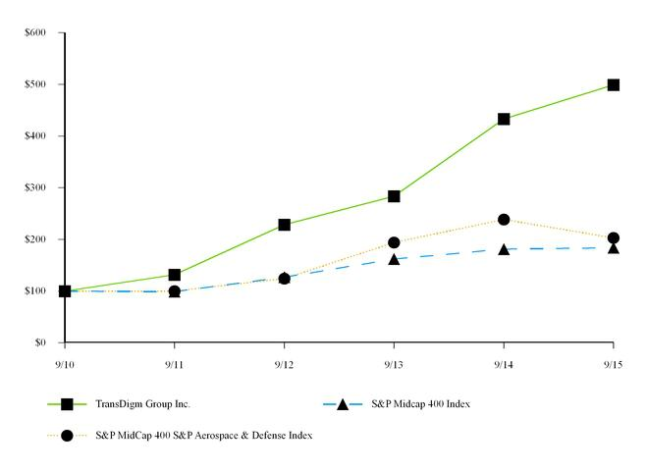

*$100 invested on 9/30/10 in stock or index, including reinvestment of dividends.

Fiscal year ending September 30.

Copyright 2015 S&P, a division of The McGraw-Hill Companies Inc. All rights reserved.

 | 9/10 |  | 9/11 |  | 9/12 |  | 9/13 |  | 9/14 |  | 9/15
TransDigm Group Inc. | 100.00 |  | 131.62 |  | 228.64 |  | 283.53 |  | 432.98 |  | 498.94
S&P Midcap 400 Index | 100.00 |  | 98.72 |  | 126.90 |  | 162.02 |  | 181.17 |  | 183.70
S&P MidCap 400 S&P Aerospace & Defense Index | 100.00 |  | 100.07 |  | 124.06 |  | 194.01 |  | 238.41 |  | 202.94

Purchases of Equity Securities by the Issuer or Affiliated Purchaser

On October 22, 2014, the Board of Directors authorized a stock repurchase program replacing our previous repurchase program permitting us to repurchase a portion of our shares outstanding not to exceed $300 million in the aggregate. No repurchases were made under the program during the year ended September 30, 2015. During the year ended September 30, 2014, the Company repurchased 909,700 shares of its common stock at a gross cost of approximately $159.9 million at a weighted-average price per share of $175.68 per share. These repurchases were made under the previous program, which permitted us to repurchase a portion of our outstanding shares not to exceed $200 million in the aggregate.

16

Table of Contents

Equity Compensation Plan Information

 |  |  | Number of Securities to Be |  |  |  |  | Number of Securities
 |  |  |  |  |  | Weighted-Average Exercise |  | Remaining Available for Future
 |  |  | Issued upon Exercise of |  |  |  |  | Issuance Under Equity
 |  |  | Outstanding Options, Warrants |  | Price of Outstanding Options, |  |  | Compensation Plans (excluding
Plan category |  |  | and Rights |  |  | Warrants and Rights |  | securities reflected in column (a))
 |  |  | (a) |  |  | (b) |  | (c)
Equity compensation plans approved by security holders⁽¹⁾ |  |  | 5,384,045 |  | $ | 110.48 |  | 5,687,944

- Includes information related to the 2003 stock option plan, the 2006 stock incentive plan and the 2014 stock option plan, each as described below.

2003 Stock Option Plan

In connection with the acquisition of the Company by Warburg Pincus in 2003, TD Group adopted a stock option plan for the benefit of our employees. The stock option plan has been amended and restated on several occasions, most recently effective as of July 18, 2008 and we refer to such stock option plan as it is currently in effect as the 2003 stock option plan. As of September 30, 2015, there were options to purchase 118,502 shares of TD Group common stock outstanding. There are no shares available for issuance under options not yet granted as the stock option plan has expired and no further grants will be made from the plan.

2006 Stock Incentive Plan

Prior to the consummation of its initial public offering, TD Group adopted a new stock incentive plan, which was amended most recently on March 3, 2011. The plan is designed to assist us in attracting, retaining, motivating and rewarding key employees, directors or consultants, and promoting the creation of long-term value for stockholders of TD Group by closely aligning the interests of these individuals with those of our stockholders. The 2006 stock incentive plan permits TD Group to award our key employees, directors or consultants stock options, restricted stock and other stock-based incentives. The total number of shares of TD Group common stock reserved for issuance or delivery under the 2006 stock incentive plan is 8,119,668, subject to adjustment in the event of any stock dividend or split, reorganization, recapitalization, merger, share exchange or any other similar corporate transaction or event. As of September 30, 2015, there were 25,962 shares of common stock issued and outstanding under the 2006 stock incentive plan that had been issued to directors. As of September 30, 2015, there were 17,700 restricted stock units issued and outstanding under the 2006 stock incentive plan. In addition, options to purchase 7,388,062 shares had been issued thereunder, of which 5,265,543 were outstanding. As of September 30, 2015, there were 687,944 shares available for issuance under awards not yet granted. The stock incentive plan will expire on March 14, 2016 and no further shares will be granted under the plan thereafter.

2014 Stock Option Plan

In July 2014, the Board of Directors of TD Group adopted a new stock option plan, which was subsequently approved by stockholders on October 2,

2014. The plan is designed to assist us in attracting, retaining, motivating and rewarding key employees, directors or consultants, and promoting the creation of long-term value for stockholders of TD Group by closely aligning the interests of these individuals with those of our stockholders. The 2014 stock option plan permits TD Group to award our key employees, directors or consultants stock options. The total number of shares of TD Group common stock reserved for issuance or delivery under the 2014 stock option plan is 5,000,000, subject to adjustment in the event of any stock dividend or split, reorganization, recapitalization, merger, share exchange or any other similar corporate transaction or event. As of September 30, 2015, there were no options to purchase shares issued thereunder.

ITEM 6. SELECTED FINANCIAL DATA

The following table sets forth selected historical consolidated financial and other data of TD Group for the fiscal years ended September 30, 2011 to

2015 which have been derived from TD Group’s audited consolidated financial statements.

Separate historical financial information of TransDigm Inc. is not presented since the 2020 Notes, 2021 Notes, 2022 Notes, 2024 Notes and 2025 Notes are guaranteed by TD Group and all direct and indirect domestic restricted subsidiaries of TransDigm Inc. and since TD Group has no operations or significant assets separate from its investment in TransDigm Inc.

Acquisitions of businesses and product lines completed by TD Group during the last five fiscal years are as follows:

- On December 6, 2010, TransDigm Inc. acquired all of the outstanding capital stock of McKechnie Aerospace Holdings, Inc. 17

Table of Contents

- On December 31, 2010, AeroControlex Group, Inc., a subsidiary of TransDigm Inc., acquired the actuation business of Telair International, Inc.

- On August 31, 2011, TransDigm Inc. acquired all of the outstanding limited liability units of Schneller Holdings LLC.

- On December 9, 2011, TransDigm Inc. acquired all of the outstanding capital stock of Harco Laboratories, Incorporated.

- On February 15, 2012, TransDigm Inc. acquired all of the outstanding capital stock of AmSafe Global Holdings, Inc.

- On September 17, 2012, TransDigm Inc. acquired all of the outstanding limited liability units of Aero-Instruments Co., LLC.

- On June 5, 2013, Buccaneer Acquisition Sub Inc., a subsidiary of TransDigm Inc., completed the tender offer of a majority of the outstanding stock of Aerosonic Corporation (“Aerosonic”). Buccaneer Acquisition Sub Inc. was subsequently merged into Aerosonic Corporation on June 10, 2013; in connection therewith, all outstanding shares of Aerosonic were cancelled and Aerosonic became a wholly owned subsidiary of TransDigm Inc.

- On June 5, 2013, TransDigm Inc. acquired all of the outstanding stock of Arkwin Industries, Inc. (“Arkwin”).

- On June 28, 2013, Whippany Actuation Systems, LLC, a newly formed subsidiary of TransDigm Inc., acquired assets from GE Aviation’s Electromechanical Actuation Division (“Whippany Actuation”).

- On December 19, 2013, TransDigm Inc. acquired all of the outstanding stock of Airborne Global Inc. (“Airborne”).

- On March 6, 2014, TransDigm Germany GmbH, a subsidiary of TransDigm Inc., acquired Elektro-Metall Export GmbH (“EME”).

- On March 26, 2015, TransDigm Germany GmbH, a subsidiary of TransDigm Inc., acquired all of the outstanding stock of Telair International GmbH ("Telair International"), TransDigm Inc. acquired all of the outstanding stock of Nordisk Aviation Products ("Nordisk") and Telair US LLC, a newly formed subsidiary of TransDigm Inc. ("Telair US"), acquired the assets of the AAR Cargo business. The operating units purchased collectively represent the Telair Cargo Group.

- On March 31, 2015, Adams Rite Holding GmbH, a subsidiary of TransDigm Inc., acquired all of the outstanding stock of Franke Aquarotter GmbH ("Adams Rite Aerospace GmbH").

- On May 14, 2015, Pexco Aerospace, Inc., a newly formed subsidiary of TransDigm Inc., acquired the assets of the aerospace business of Pexco LLC ("Pexco Aerospace").

- On August 19, 2015, TransDigm Inc. acquired all of the outstanding stock of PneuDraulics, Inc. ("PneuDraulics").

All of the acquisitions were accounted for using the acquisition method. The results of operations of the acquired businesses and product lines are included in TD Group’s consolidated financial statements from the date of each of the acquisitions.

Non-GAAP Financial Measures

We present below certain financial information based on our EBITDA and EBITDA As Defined. References to “EBITDA” mean earnings before interest, taxes, depreciation and amortization, and references to “EBITDA As Defined” mean EBITDA plus, as applicable for each relevant period, certain adjustments as set forth in the reconciliations of net income to EBITDA and EBITDA As Defined and the reconciliations of net cash provided by operating activities to EBITDA and EBITDA As Defined presented below.

Neither EBITDA nor EBITDA As Defined is a measurement of financial performance under accounting principles generally accepted in the United States of America (“GAAP”). We present EBITDA and EBITDA As Defined because we believe they are useful indicators for evaluating operating performance and liquidity.

Our management believes that EBITDA and EBITDA As Defined are useful as indicators of liquidity because securities analysts, investors, rating agencies and others use EBITDA to evaluate a company’s ability to incur and service debt. In addition, EBITDA As Defined is useful to investors because the revolving credit facility under our senior secured credit facility requires compliance under certain circumstances, on a pro forma basis, with a financial covenant that measures the ratio of the amount of our secured indebtedness to the amount of our Consolidated EBITDA defined in the same manner as we define EBITDA As Defined herein.

In addition to the above, our management uses EBITDA As Defined to review and assess the performance of the management team in connection with employee incentive programs and to prepare its annual budget and financial projections. Moreover, our management uses EBITDA As Defined to evaluate acquisitions.

18

Table of Contents

Although we use EBITDA and EBITDA As Defined as measures to assess the performance of our business and for the other purposes set forth above, the use of these non-GAAP financial measures as analytical tools has limitations, and you should not consider any of them in isolation, or as a substitute for analysis of our results of operations as reported in accordance with GAAP. Some of these limitations are:

- neither EBITDA nor EBITDA As Defined reflects the significant interest expense, or the cash requirements necessary to service interest payments, on our indebtedness;

- although depreciation and amortization are non-cash charges, the assets being depreciated and amortized will often have to be replaced in the future, and neither EBITDA nor EBITDA As Defined reflects any cash requirements for such replacements;

- the omission of the substantial amortization expense associated with our intangible assets further limits the usefulness of EBITDA and EBITDA As Defined;

- neither EBITDA nor EBITDA As Defined includes the payment of taxes, which is a necessary element of our operations; and

- EBITDA As Defined excludes the cash expense we have incurred to integrate acquired businesses into our operations, which is a necessary element of certain of our acquisitions.

Because of these limitations, EBITDA and EBITDA As Defined should not be considered as measures of discretionary cash available to us to invest in the growth of our business. Management compensates for these limitations by not viewing EBITDA or EBITDA As Defined in isolation and specifically by using other GAAP measures, such as net income, net sales and operating profit, to measure our operating performance. Neither EBITDA nor EBITDA As Defined is a measurement of financial performance under GAAP, and neither should be considered as an alternative to net income or cash flow from operations determined in accordance with GAAP. Our calculation of EBITDA and EBITDA As Defined may not be comparable to the calculation of similarly titled measures reported by other companies.

The information presented below should be read together with “Management’s Discussion and Analysis of Financial Condition and Results of Operations” and the consolidated financial statements and accompanying notes included elsewhere herein.

19

Table of Contents

Fiscal Years Ended

September 30,

 |  | 2015 |  |  | 2014 |  |  | 2013 |  |  | 2012 |  |  | 2011
 |  |  |  |  | (in thousands, except per share amounts )
Statement of Income Data:
Net Sales | $ | 2,707,115 | $ |  | 2,372,906 |  | $ | 1,924,400 |  | $ | 1,700,208 |  | $ | 1,206,021
Gross profit⁽¹⁾ |  | 1,449,845 |  |  | 1,267,874 |  |  | 1,049,562 |  |  | 945,717 |  |  | 661,185
Selling and administrative expenses |  | 321,624 |  |  | 276,446 |  |  | 254,468 |  |  | 201,709 |  |  | 133,711
Amortization of intangible assets |  | 54,219 |  |  | 63,608 |  |  | 45,639 |  |  | 44,233 |  |  | 40,339
Income from operations⁽¹⁾ |  | 1,074,002 |  |  | 927,820 |  |  | 749,455 |  |  | 699,775 |  |  | 487,135
Interest expense—net |  | 418,785 |  |  | 347,688 |  |  | 270,685 |  |  | 211,906 |  |  | 185,256
Refinancing costs |  | 18,393 |  |  | 131,622 |  |  | 30,281 |  |  | — |  |  | 72,454
Income from continuing operations before income taxes |  | 636,824 |  |  | 448,510 |  |  | 448,489 |  |  | 487,869 |  |  | 229,425
Income tax provision |  | 189,612 |  |  | 141,600 |  |  | 145,700 |  |  | 162,900 |  |  | 77,200
Income from continuing operations |  | 447,212 |  |  | 306,910 |  |  | 302,789 |  |  | 324,969 |  |  | 152,225
Income from discontinued operations, net of tax |  | — |  |  | — |  |  | — |  |  | — |  |  | 19,909
Net income | $ | 447,212 | $ |  | 306,910 |  | $ | 302,789 |  | $ | 324,969 |  | $ | 172,134
Net income applicable to common stock
Net income applicable to common stock | $ | 443,847 | $ |  | 180,284 |  | $ | 131,546 |  | $ | 321,670 |  | $ | 169,323
Denominator for basic and diluted earnings per
share under the two-class method:
Weighted-average common shares outstanding |  | 53,112 |  |  | 52,748 |  |  | 52,258 |  |  | 50,996 |  |  | 49,888
Vested options deemed participating securities |  | 3,494 |  |  | 4,245 |  |  | 2,822 |  |  | 2,886 |  |  | 3,445
Total shares for basic and diluted earnings per |  | 56,606 |  |  | 56,993 |  |  | 55,080 |  |  | 53,882 |  |  | 53,333
share |  | 56,606 |  |  | 56,993 |  |  | 55,080 |  |  | 53,882 |  |  | 53,333
Net earnings per share:
Net earnings per share from continuing operations-
basic and diluted | $ | 7.84 | $ |  | 3.16 |  | $ | 2.39 |  | $ | 5.97 |  | $ | 2.80
Net earnings per share from discontinued
operations-basic and diluted |  | — |  |  | — |  |  | — |  |  | — |  |  | 0.37
Net earnings per share⁽²⁾ | $ | 7.84 |  | $ | 3.16 |  | $ | 2.39 |  | $ | 5.97 |  | $ | 3.17
Cash dividends paid per common share | $ | — | $ |  | 25.00 |  | $ | 34.85 |  | $ | — |  | $ | —
 |  |  |  |  |  |  | As of September 30,
 |  | 2015 |  |  | 2014 |  |  | 2013 |  |  | 2012 |  |  | 2011
 |  |  |  |  |  |  |  | (in thousands)
Balance Sheet Data:
Cash and cash equivalents | $ | 714,033 | $ |  | 819,548 |  | $ | 564,740 |  | $ | 440,524 |  | $ | 376,183
Working capital |  | 1,173,747 |  |  | 1,103,669 |  |  | 997,995 |  |  | 816,616 |  |  | 663,433
Total assets |  | 8,427,050 |  |  | 6,756,848 |  |  | 6,148,879 |  |  | 5,459,617 |  |  | 4,513,636
Long-term debt, including current portion |  | 8,227,342 |  |  | 7,273,131 |  |  | 5,731,238 |  |  | 3,619,125 |  |  | 3,138,375
Stockholders’ (deficit) equity |  | (1,038,306) |  |  | (1,556,099) |  |  | (359,381) |  |  | 1,218,834 |  |  | 810,949
 |  |  | 20

Table of Contents

 |  |  |  | Fiscal Years Ended September 30,
 |  | 2015 |  | 2014 |  | 2013 |  | 2012 |  | 2011
 |  |  |  |  |  | (in thousands)
Other Financial Data:
Cash flows provided by (used in):
Operating activities | $ | 520,938 | $ | 541,222 | $ | 470,205 | $ | 413,885 | $ | 260,386
Investing activities |  | (1,679,149) |  | (329,638) |  | (502,442) |  | (876,292) |  | (1,397,028)
Financing activities |  | 1,054,947 |  | 43,973 |  | 156,195 |  | 527,186 |  | 1,278,521
Depreciation and amortization |  | 93,663 |  | 96,385 |  | 73,515 |  | 68,227 |  | 60,460
Capital expenditures |  | 54,871 |  | 34,146 |  | 35,535 |  | 25,246 |  | 18,026
Ratio of earnings to fixed charges⁽³⁾ |  | 2.5x |  | 2.3x |  | 2.6x |  | 3.3x |  | 2.2x
Other Data:
EBITDA⁽⁴⁾ | $ | 1,149,272 | $ | 892,583 | $ | 792,689 | $ | 768,002 | $ | 475,141
EBITDA As Defined⁽⁴⁾ | $ | 1,233,654 | $ | 1,073,207 | $ | 900,278 | $ | 809,019 | $ | 589,874

- Gross profit and income from operations include the effect of charges relating to purchase accounting adjustments to inventory associated with the acquisition of various businesses and product lines for the fiscal years ended September 30, 2015, 2014, 2013, 2012 and 2011 of $11,362, $10,441, $7,352, $12,882 and $18,073, respectively.

- Net earnings per share is calculated by dividing net income applicable to common stock by the basic and diluted weighted average common shares outstanding.

- For purposes of computing the ratio of earnings to fixed charges, earnings consist of earnings from continuing operations before income taxes plus fixed charges. Fixed charges consist of interest expense, amortization of debt issuance costs and the portion (approximately 33%) of rental expense that management believes is representative of the interest component of rental expense.

- EBITDA represents earnings from continuing operations before interest, taxes, depreciation and amortization. EBITDA As Defined represents EBITDA plus, as applicable for each relevant period, certain adjustments as set forth in the reconciliation of net income to EBITDA and EBITDA As Defined and the reconciliation of net cash provided by operating activities to EBITDA and EBITDA As Defined presented below. See “Non-GAAP Financial Measures” for additional information and limitations regarding these non-GAAP financial measures.

21

Table of Contents

The following table sets forth a reconciliation of net income to EBITDA and EBITDA As Defined:

 |  |  |  |  | Fiscal Years Ended September 30,
 |  | 2015 |  |  | 2014 |  |  | 2013 |  |  | 2012 |  |  | 2011
 |  |  |  |  |  |  |  | (in thousands)
Net income | $ | 447,212 |  | $ | 306,910 |  | $ | 302,789 |  | $ | 324,969 |  | $ | 172,134
Less income from discontinued operations |  | — |  |  | — |  |  | — |  |  | — |  |  | 19,909
Income from continuing operations |  | 447,212 |  |  | 306,910 |  |  | 302,789 |  |  | 324,969 |  |  | 152,225
Adjustments:
Depreciation and amortization expense |  | 93,663 |  |  | 96,385 |  |  | 73,515 |  |  | 68,227 |  |  | 60,460
Interest expense, net |  | 418,785 |  |  | 347,688 |  |  | 270,685 |  |  | 211,906 |  |  | 185,256
Income tax provision |  | 189,612 |  |  | 141,600 |  |  | 145,700 |  |  | 162,900 |  |  | 77,200
EBITDA, excluding discontinued operations |  | 1,149,272 |  |  | 892,583 |  |  | 792,689 |  |  | 768,002 |  |  | 475,141
Adjustments:
Inventory purchase accounting adjustments⁽¹⁾ |  | 11,362 |  |  | 10,441 |  |  | 7,352 |  |  | 12,882 |  |  | 18,073
Acquisition integration costs⁽²⁾ |  | 12,972 |  |  | 7,424 |  |  | 10,942 |  |  | 7,896 |  |  | 11,821
Acquisition transaction-related expenses⁽³⁾ |  | 12,289 |  |  | 3,480 |  |  | 8,139 |  |  | 5,880 |  |  | 2,817
Acquisition earn-out adjustments⁽⁴⁾ |  | — |  |  | — |  |  | — |  |  | (5,000) |  |  | (3,000)
Other acquisition accounting adjustments |  | — |  |  | — |  |  | — |  |  | (2,792) |  |  | —
Non-cash stock and deferred compensation
expense⁽⁵⁾ |  | 31,500 |  |  | 26,332 |  |  | 48,884 |  |  | 22,151 |  |  | 12,568
Refinancing costs⁽⁶⁾ |  | 18,393 |  |  | 131,622 |  |  | 30,281 |  |  | — |  |  | 72,454
Other items, net |  | (2,134) |  |  | 1,325 |  |  | 1,991 |  |  | — |  |  | —
EBITDA As Defined | $ | 1,233,654 |  | $ | 1,073,207 |  | $ | 900,278 |  | $ | 809,019 |  | $ | 589,874

- Represents accounting adjustments to inventory associated with acquisitions of businesses and product lines that were charged to cost of sales when the inventory was sold.

- Represents costs incurred to integrate acquired businesses and product lines into TD Group’s operations, facility relocation costs and other acquisition-related costs.

- Represents transaction-related costs comprising deal fees; legal, financial and tax due diligence expenses; and valuation costs that are required to be expensed as incurred.

- Represents the reversal of the earn-out liability related to the Dukes Aerospace acquisition based on lower growth projections relative to the required growth targets of the four-year earn-out arrangement.

- Represents the compensation expense recognized by TD Group under our stock incentive and deferred compensation plans.

- For the period ended September 30, 2015, represents debt issue costs expensed in conjunction with the refinancing of our 2013 Term Loans in May 2015. For the period ended September 30, 2014, represents debt issue costs including the premium paid to redeem our 2018 Notes in June 2014. For the period ended September 30, 2013, represents debt issue costs expensed in conjunction with the refinancing of our 2010 Term Loans and 2011 Term Loans in February 2013. For the period ended September 30, 2011, represents costs incurred in connection with the refinancing in December 2010, including the premium paid to redeem our 7.75% Senior Subordinated Notes due 2014, the write off of debt issue costs and unamortized note premium and discount and settlement of the interest rate swap agreement and other expenses.

22

Table of Contents

The following table sets forth a reconciliation of net cash provided by operating activities to EBITDA and EBITDA As Defined:

 |  |  |  |  | Fiscal Years Ended September 30,
 |  | 2015 |  |  | 2014 |  |  | 2013 |  |  | 2012 |  |  | 2011
 |  |  |  |  |  |  |  | (in thousands)
Net cash provided by operating activities | $ | 520,938 |  | $ | 541,222 |  | $ | 470,205 |  | $ | 413,885 |  | $ | 260,386
Adjustments:
Changes in assets and liabilities, net of effects from
acquisitions of businesses |  | 24,322 |  |  | (27,967) |  |  | (71,618) |  |  | (11,749) |  |  | (30,874)
Net gain on sale of real estate |  | — |  |  | 804 |  |  | — |  |  | — |  |  | —
Interest expense, net⁽¹⁾ |  | 402,988 |  |  | 333,753 |  |  | 258,752 |  |  | 199,362 |  |  | 175,414
Income tax provision—current |  | 188,952 |  |  | 151,016 |  |  | 148,314 |  |  | 138,100 |  |  | 130,109
Non-cash stock and deferred compensation
expense⁽²⁾ |  | (31,500) |  |  | (26,332) |  |  | (48,884) |  |  | (22,151) |  |  | (12,574)
Excess tax benefit from exercise of stock options |  | 61,965 |  |  | 51,709 |  |  | 66,201 |  |  | 50,555 |  |  | 23,411
Refinancing costs⁽³⁾ |  | (18,393) |  |  | (131,622) |  |  | (30,281) |  |  | — |  |  | (72,454)
EBITDA |  | 1,149,272 |  |  | 892,583 |  |  | 792,689 |  |  | 768,002 |  |  | 473,418
Adjustments:
Inventory purchase accounting adjustments⁽⁴⁾ |  | 11,362 |  |  | 10,441 |  |  | 7,352 |  |  | 12,882 |  |  | 21,828
Acquisition integration costs⁽⁵⁾ |  | 12,972 |  |  | 7,424 |  |  | 10,942 |  |  | 7,896 |  |  | 11,821
Acquisition transaction-related expenses⁽⁶⁾ |  | 12,289 |  |  | 3,480 |  |  | 8,139 |  |  | 5,880 |  |  | 2,817
Acquisition earn-out adjustments⁽⁷⁾ |  | — |  |  | — |  |  | — |  |  | (5,000) |  |  | (3,000)
Other acquisition accounting adjustments |  | — |  |  | — |  |  | — |  |  | (2,792) |  |  | —
Non-cash stock and deferred compensation
expense⁽²⁾ |  | 31,500 |  |  | 26,332 |  |  | 48,884 |  |  | 22,151 |  |  | 12,568
Refinancing costs⁽³⁾ |  | 18,393 |  |  | 131,622 |  |  | 30,281 |  |  | — |  |  | 72,454
Other items, net |  | (2,134) |  |  | 1,325 |  |  | 1,991 |  |  | — |  |  | —
EBITDA from discontinued operations |  | — |  |  | — |  |  | — |  |  | — |  |  | (2,032)
EBITDA As Defined | $ | 1,233,654 |  | $ | 1,073,207 |  | $ | 900,278 |  | $ | 809,019 |  | $ | 589,874

- Represents interest expense excluding the amortization of debt issue costs and note premium and discount.

- Represents the compensation expense recognized by TD Group under our stock incentive and deferred compensation plans.

- For the period ended September 30, 2015, represents debt issue costs expensed in conjunction with the refinancing of our 2013 Term Loans in May 2015. For the period ended September 30, 2014, represents debt issue costs including the premium paid to redeem our 2018 Notes in June 2014. For the period ended September 30, 2013, represents debt issue costs expensed in conjunction with the refinancing of our 2010 Term Loans and 2011 Term Loans in February 2013. For the period ended September 30, 2011, represents costs incurred in connection with the refinancing in December 2010, including the premium paid to redeem our 7.75% Senior Subordinated Notes due 2014, the write off of debt issue costs and unamortized note premium and discount and settlement of the interest rate swap agreement and other expenses.

- Represents accounting adjustments to inventory associated with acquisitions of businesses and product lines that were charged to cost of sales when the inventory was sold.

- Represents costs incurred to integrate acquired businesses and product lines into TD Group’s operations, facility relocation costs and other acquisition-related costs.

- Represents transaction-related costs comprising deal fees; legal, financial and tax due diligence expenses; and valuation costs that are required to be expensed as incurred.

23

Table of Contents

- Represents the reversal of the earn-out liability related to the Dukes Aerospace acquisition based on lower growth projections relative to the required growth targets of the four-year earn-out arrangement.

24

Table of Contents

ITEM 7. MANAGEMENT’S DISCUSSION AND ANALYSIS OF FINANCIAL CONDITION AND RESULTS OF OPERATIONS

The following discussion of our financial condition and results of operations should be read together with “Selected Financial Data” and TD Group’s consolidated financial statements and the related notes included elsewhere in this report. The following discussion may contain predictions, estimates and other forward-looking statements that involve a number of risks and uncertainties, including those discussed under the heading entitled “Risk Factors” included elsewhere in this report. These risks could cause our actual results to differ materially from any future performance suggested below.

Overview

We believe we are a leading global designer, producer and supplier of highly engineered aircraft components for use on nearly all commercial and military aircraft in service today. Our business is well diversified due to the broad range of products we offer to our customers. Some of our more significant product offerings, substantially all of which are ultimately provided to end-users in the aerospace industry, include mechanical/electro-mechanical actuators and controls, ignition systems and engine technology, specialized pumps and valves, power conditioning devices, specialized AC/DC electric motors and generators, NiCad batteries and chargers, engineered latching and locking devices, rods and locking devices, engineered connectors and elastomers, cockpit security components and systems, specialized cockpit displays, aircraft audio systems, specialized lavatory components, seat belts and safety restraints, engineered interior surfaces and related components, lighting and control technology, military personnel parachutes and cargo loading, handling and delivery systems. Each of these product offerings is composed of many individual products that are typically customized to meet the needs of a particular aircraft platform or customer.

Long-term Sustainable Growth

For fiscal year 2015, we generated net sales of $2,707.1 million, gross profit of $1,449.8 million or 53.6% of sales, and net income of $447.2 million. We believe we have achieved steady, long-term growth in sales and improvements in operating performance since our formation in 1993 due to our competitive strengths and through execution of our value-driven operating strategy. More specifically, focusing our businesses on our value-driven operating strategy of obtaining profitable new business, carefully controlling the cost structure and pricing our highly engineered value-added products to fairly reflect the value we provide and the resources required to do so has historically resulted in improvements in gross profit and income from operations over the long term.

Our selective acquisition strategy has also contributed to the growth of our business. The integration of certain acquisitions into our existing businesses combined with implementing our proven operating strategy has historically resulted in improvements of the financial performance of the acquired business.

Our key competitive strengths and the elements of our business strategy are set forth in more detail below.

We believe our key competitive strengths include:

Large and Growing Installed Product Base with Aftermarket Revenue Stream. We provide components to a large and growing installed base of aircraft to which we supply aftermarket products. We estimate that our products are installed on approximately 95,000 commercial transport, regional transport, military and general aviation fixed wing turbine aircraft and rotary wing aircraft.

Diversified Revenue Base. We believe that our diversified revenue base reduces our dependence on any particular product, platform or market channel and has been a significant factor in maintaining our financial performance. Our products are installed on almost all of the major commercial aircraft platforms now in production. We expect to continue to develop new products for military and commercial applications.

Significant Barriers to Entry. We believe that the niche nature of our markets, the industry’s stringent regulatory and certification requirements, the large number of products that we sell and the investments necessary to develop and certify products create barriers to entry for potential competitors.

Our business strategy is made up of two key elements: (1) a value-driven operating strategy focused around our three core value drivers and (2) a selective acquisition strategy.

Value-Driven Operating Strategy. Our three core value drivers are:

- Obtaining Profitable New Business. We attempt to obtain profitable new business by using our technical expertise and application skill and our detailed knowledge of our customer base and the individual niche markets in which we operate. We have regularly been successful in identifying and developing both aftermarket and OEM products to drive our growth.

25

Table of Contents

- Improving Our Cost Structure. We are committed to maintaining and continuously improving our lean cost structure through detailed attention to the cost of each of the products that we offer and our organizational structure, with a focus on reducing the cost of each.

- Providing Highly Engineered Value-Added Products to Customers. We focus on the engineering, manufacturing and marketing of a broad range of highly engineered niche products that we believe provide value to our customers. We believe we have been consistently successful in communicating to our customers the value of our products. This has generally enabled us to price our products to fairly reflect the value we provide and the resources required to do so.

Selective Acquisition Strategy. We selectively pursue the acquisition of proprietary aerospace component businesses when we see an opportunity to create value through the application of our three core value-driven operating strategies. The aerospace industry, in particular, remains highly fragmented, with many of the companies in the industry being small private businesses or small non-core operations of larger businesses. We have significant experience among our management team in executing acquisitions and integrating acquired businesses into our company and culture. As of the date of this report, we have successfully acquired 55 businesses and/or product lines since our formation in 1993. Many of these acquisitions have been integrated into an existing TransDigm production facility, which enables a higher production capacity utilization, which in turn improves gross profit levels due to the ability to spread the fixed manufacturing overhead costs over higher production volume.

Acquisitions and divestitures during the previous three fiscal years are more fully described in Note 2, “Acquisitions” in the Notes to Consolidated Financial Statements included herein.

EBITDA and EBITDA As Defined

The following table sets forth a reconciliation of net income to EBITDA and EBITDA As Defined:

Fiscal Years Ended

September 30,

 |  | 2015 |  |  | 2014
 |  | (in thousands)
Net income | $ | 447,212 |  | $ | 306,910
Adjustments:
Depreciation and amortization expense |  | 93,663 |  |  | 96,385
Interest expense, net |  | 418,785 |  |  | 347,688
Income tax provision |  | 189,612 |  |  | 141,600
EBITDA |  | 1,149,272 |  |  | 892,583
Adjustments:
Inventory purchase accounting adjustments⁽²⁾ |  | 11,362 |  |  | 10,441
Acquisition integration costs⁽³⁾ |  | 12,972 |  |  | 7,424
Acquisition transaction-related expenses⁽⁴⁾ |  | 12,289 |  |  | 3,480
Non-cash stock compensation expense⁽⁵⁾ |  | 31,500 |  |  | 26,332
Refinancing costs⁽⁶⁾ |  | 18,393 |  |  | 131,622
Other items, net |  | (2,134) |  |  | 1,325
EBITDA As Defined⁽¹⁾ | $ | 1,233,654 |  | $ | 1,073,207

- EBITDA represents earnings before interest, taxes, depreciation and amortization. EBITDA As Defined represents EBITDA plus, as applicable for each relevant period, certain adjustments as set forth in the reconciliation of net income to EBITDA and EBITDA As Defined. See “Non-GAAP Financial Measures” for additional information and limitations regarding these non-GAAP financial measures.

- Represents accounting adjustments to inventory associated with acquisitions of businesses and product lines that were charged to cost of sales when the inventory was sold.

- Represents costs incurred to integrate acquired businesses and product lines into TD Group’s operations, facility relocation costs and other acquisition-related costs.

- Represents transaction-related costs comprising deal fees; legal, financial and tax due diligence expenses; and valuation costs that are required to be expensed as incurred.

- Represents the compensation expense recognized by TD Group under our stock incentive plans.

26

Table of Contents

- For the period ended September 30, 2015, represents debt issue costs expensed in conjunction with the refinancing of our 2013 Term Loans in May 2015. For the period ended September 30, 2014, represents debt issue costs including the premium paid to redeem our 2018 Notes in June 2014.

The following table sets forth a reconciliation of net cash provided by operating activities to EBITDA and EBITDA As Defined:

Fiscal Years Ended

September 30,

 |  | 2015 |  |  | 2014
 |  | (in thousands)
Net Cash Provided by Operating Activities | $ | 520,938 |  | $ | 541,222
Adjustments:
Changes in assets and liabilities, net of effects from acquisitions of businesses |  | 24,322 |  |  | (27,967)
Net gain on sale of real estate |  | — |  |  | 804
Interest expense, net⁽¹⁾ |  | 402,988 |  |  | 333,753
Income tax provision—current |  | 188,952 |  |  | 151,016
Non-cash stock compensation expense⁽²⁾ |  | (31,500) |  |  | (26,332)
Excess tax benefit from exercise of stock options |  | 61,965 |  |  | 51,709
Refinancing costs⁽³⁾ |  | (18,393) |  |  | (131,622)
EBITDA⁽⁵⁾ |  | 1,149,272 |  |  | 892,583
Adjustments:
Inventory purchase accounting adjustments⁽⁵⁾ |  | 11,362 |  |  | 10,441
Acquisition integration costs⁽⁶⁾ |  | 12,972 |  |  | 7,424
Acquisition transaction-related expenses⁽⁷⁾ |  | 12,289 |  |  | 3,480
Non-cash stock compensation expense⁽²⁾ |  | 31,500 |  |  | 26,332
Refinancing costs⁽³⁾ |  | 18,393 |  |  | 131,622
Other items, net |  | (2,134) |  |  | 1,325
EBITDA As Defined⁽⁴⁾ | $ | 1,233,654 |  | $ | 1,073,207

- Represents interest expense excluding the amortization of debt issue costs and note premium and discount.

- Represents the compensation expense recognized by TD Group under our stock incentive plans.

- For the period ended September 30, 2015, represents debt issue costs expensed in conjunction with the refinancing of our 2013 Term Loans in May 2015. For the period ended September 30, 2014, represents debt issue costs including the premium paid to redeem our 2018 Notes in June 2014.

- EBITDA represents earnings before interest, taxes, depreciation and amortization. EBITDA As Defined represents EBITDA plus, as applicable for each relevant period, certain adjustments as set forth in the reconciliation of net cash provided by operating activities to EBITDA and EBITDA As Defined. See “Non-GAAP Financial Measures” for additional information and limitations regarding these non-GAAP financial measures.

- Represents accounting adjustments to inventory associated with acquisitions of businesses and product lines that were charged to cost of sales when the inventory was sold.

- Represents costs incurred to integrate acquired businesses and product lines into TD Group’s operations, facility relocation costs and other acquisition-related costs.

- Represents transaction-related costs comprising deal fees; legal, financial and tax due diligence expenses; and valuation costs that are required to be expensed as incurred.

Trend Information

We predominantly serve customers in the commercial, regional, business jet and general aviation aftermarket, which accounts for approximately 37% of total sales; the commercial aerospace OEM market, comprising large commercial transport manufacturers and regional and business jet manufacturers, which accounts for approximately 29% of total sales; and the defense market, which accounts for approximately 29% of total sales. Non-aerospace sales comprise approximately 5% of our total sales.

27

Table of Contents

The commercial aerospace industry, including the aftermarket and OEM market, is impacted by the health of the global economy and geo-political events around the world. The commercial aerospace industry had shown strength with increases in revenue passenger miles, or RPMs, between 2003 and 2008, as well as increases in OEM production and backlog. However, in 2009, the global economic downturn negatively impacted the commercial aerospace industry causing RPMs to decline slightly. This market sector began to rebound in 2010 and positive growth has continued thru 2015 with increases in RPMs, as well as the growth in the large commercial OEM sector (aircraft with 100 or more seats) with order announcements by The Boeing Company and Airbus S.A.S. leading to planned increases in production. The 2016 leading indicators and industry consensus suggest a continuation of current trends in the commercial transport market sector supported by continued RPM growth and increases in production at the OEM level.

The defense aerospace market is dependent on government budget constraints, the timing of orders and the extent of global conflicts. It is not necessarily affected by general economic conditions that affect the commercial aerospace industry.

Our presence in both the commercial aerospace and military sectors of the aerospace industry may mitigate the impact on our business of any specific industry risk. We service a diversified customer base in the commercial and military aerospace industry, and we provide components to a diverse installed base of aircraft, which mitigates our exposure to any individual airframe platform. At times, declines in sales in one channel have been offset by increased sales in another. However, due to differences between the profitability of our products sold to OEM and aftermarket customers, variation in product mix can cause variation in gross margin.

There are many short-term factors (including inventory corrections, unannounced changes in order patterns, strikes and mergers and acquisitions) that can cause short-term disruptions in our quarterly shipment patterns as compared to previous quarters and the same periods in prior years. As such, it can be difficult to determine longer-term trends in our business based on quarterly comparisons. To normalize for short-term fluctuations, we tend to look at our performance over several quarters or years of activity rather than discrete short-term periods.

There are also fluctuations in OEM and aftermarket ordering and delivery requests from quarter-to-quarter, as well as variations in product mix from quarter-to-quarter, that may cause positive or negative variations in gross profit margins since commercial aftermarket sales have historically produced a higher gross margin than sales to commercial OEMs. Again, in many instances these are timing events between quarters and must be balanced with macro aerospace industry indicators.

Commercial Aftermarket

The key growth factors in the commercial aftermarket include worldwide RPMs and the size and activity level of the worldwide fleet of aircraft. After a decline in RPMs in 2009, worldwide RPMs returned to growth between 2010 and 2015 and current industry consensus indicates that positive RPM growth will continue in 2016.

Commercial OEM Market

The commercial transport market sector, the largest sector in the commercial OEM market, continued to grow during 2015. Our commercial transport OEM shipments and revenues generally run ahead of the Boeing and Airbus airframe delivery schedules. As a result and consistent with prior years, our fiscal 2016 shipments will be a function of, among other things, the estimated 2016 and 2017 commercial airframe production rates. We have been experiencing increased sales in the large commercial OEM sector (aircraft with 100 or more seats) driven by an increase in production by The Boeing Company and Airbus S.A.S tied to previous order announcements. Industry consensus indicates this production increase will continue in 2016 and 2017, though the growth may moderate and begin to flatten.

Defense

Our military business fluctuates from year to year, and is dependent, to a degree, on government budget constraints, the timing of orders and the extent of global conflicts. In recent years, defense spending has reached historic highs, due in part to the military engagements in Afghanistan and Iraq and the war on terrorism. For a variety of reasons, the military spending outlook is very uncertain. For planning purposes we assume that military related sales of our types of products to be flat in future years over the recent high levels.

Critical Accounting Policies

Our consolidated financial statements have been prepared in conformity with GAAP, which often requires the judgment of management in the selection and application of certain accounting principles and methods. Management believes that the quality and reasonableness of our most critical policies enable the fair presentation of our financial position and results of operations. However, investors are cautioned that the sensitivity of financial statements to these methods, assumptions and estimates could create materially different results under different conditions or using different assumptions.

28

Table of Contents

Below are those policies applied in preparing our financial statements that management believes are the most dependent on the application of estimates and assumptions. For additional accounting policies, see Note 3, “Summary of Significant Accounting Policies” in the Notes to Consolidated Financial Statements included herein.

Revenue Recognition and Related Allowances: Revenue is recognized from the sale of products when title and risk of loss passes to the customer, which is generally at the time of shipment. Substantially all product sales are made pursuant to firm, fixed-price purchase orders received from customers. Collectibility of amounts recorded as revenue is reasonably assured at the time of sale. Provisions for returns, uncollectible accounts and the cost of repairs under contract warranty provisions are provided for in the same period as the related revenues are recorded and are principally based on historical results modified, as appropriate, by the most current information available. We have a history of making reasonably dependable estimates of such allowances; however, due to uncertainties inherent in the estimation process, it is possible that actual results may vary from the estimates and the differences could be material.

Management estimates the allowance for doubtful accounts based on the aging of the accounts receivable and customer creditworthiness. The allowance also incorporates a provision for the estimated impact of disputes with customers. Management’s estimate of the allowance amounts that are necessary includes amounts for specifically identified credit losses and estimated credit losses based on historical information. The determination of the amount of the allowance for doubtful accounts is subject to significant levels of judgment and estimation by management. Depending on the resolution of potential credit and other collection issues, or if the financial condition of any of the Company’s customers were to deteriorate and their ability to make required payments were to become impaired, increases in these allowances may be required. Historically, changes in estimates in the allowance for doubtful accounts have not been significant.

Inventories: Inventories are stated at the lower of cost or market. Cost of inventories is generally determined by the average cost and the first-in, first-out (FIFO) methods and includes material, labor and overhead related to the manufacturing process. Because the Company sells products that are installed on airframes that can be in-service for 25 or more years, it must keep a supply of such products on hand while the airframes are in use. Where management estimated that the current market value was below cost or determined that future demand was lower than current inventory levels, based on historical experience, current and projected market demand, current and projected volume trends and other relevant current and projected factors associated with the current economic conditions, a reduction in inventory cost to estimated net realizable value was made by recording a provision included in cost of sales. Although management believes that the Company’s estimates of excess and obsolete inventory are reasonable, actual results may differ materially from the estimates and additional provisions may be required in the future. In addition, in accordance with industry practice, all inventories are classified as current assets as all inventories are available and necessary to support current sales, even though a portion of the inventories may not be sold within one year. Historically, changes in estimates in the net realizable value of inventories have not been significant.

Intangible Assets: Mergers and acquisitions are accounted for using the acquisition method and have resulted in significant amounts of identifiable intangible assets and goodwill. Fair value adjustments to the Company’s assets and liabilities are recognized and the results of operations of the acquired business are included in our consolidated financial statements from the effective date of the merger or acquisition. We generally use third-party appraisals to assist us in determining the estimated fair value of the intangible assets.

Intangible assets other than goodwill are recognized if the benefit of the intangible asset is obtained through contractual or other legal rights, or if the intangible asset can be sold, transferred, licensed or exchanged, regardless of the Company’s intent to do so. Goodwill and identifiable intangible assets are recorded at their estimated fair value on the date of acquisition and are reviewed at least annually for impairment based on cash flow projections and fair value estimates.

GAAP requires that the annual, and any interim, impairment assessment be performed at the reporting unit level. The reporting unit level is one level below an operating segment. Substantially all goodwill was determined and recognized for each reporting unit pursuant to the accounting for the merger or acquisition as of the date of each transaction. With respect to acquisitions integrated into an existing reporting unit, any acquired goodwill is combined with the goodwill of the reporting unit.

At the time of goodwill impairment testing, management determines the estimated fair value through the use of a discounted cash flow valuation model incorporating discount rates commensurate with the risks involved for each reporting unit. If the calculated estimated fair value is less than the current carrying value, impairment of goodwill of the reporting unit may exist. The use of a discounted cash flow valuation model to determine estimated fair value is common practice in impairment testing. The key assumptions used in the discounted cash flow valuation model for impairment testing includes discount rates, growth rates, cash flow projections and terminal value rates. Discount rates are set by using the Weighted Average Cost of Capital (“WACC”) methodology. The WACC methodology considers market and industry data as well as company specific risk factors for each reporting unit in determining the appropriate discount rates to be used. The discount rate utilized for each reporting unit is indicative of the return an investor would expect to receive for investing in such a business.

29

Table of Contents

Management, considering industry and company-specific historical and projected data, develops growth rates, sales projections and cash flow projections for each reporting unit. Terminal value rate determination follows common methodology of capturing the present value of perpetual cash flow estimates beyond the last projected period assuming a constant WACC and low long-term growth rates. As an indicator that each reporting unit has been valued appropriately through the use of the discounted cash flow valuation model, the aggregate of all reporting unit’s estimated fair value is reconciled to the total market capitalization of the Company.

The Company had 29 reporting units with goodwill as of the first day of the fourth quarter of fiscal 2015, the date of the last annual impairment test. The estimated fair values of each of the reporting units was substantially in excess of their respective carrying values, and therefore, no goodwill impairment was recorded. The Company performed a sensitivity analysis on the discount rate, which is a significant assumption in the calculation of fair values. With a one percentage point increase in the discount rate, the reporting units would continue to have fair values in excess of their respective carrying values.

Management tests indefinite-lived intangible assets for impairment at the asset level, as determined by appropriate asset valuation at the time of acquisition. The impairment test for indefinite-lived intangible assets consists of a comparison between the estimated fair values and carrying values. If the carrying amounts of intangible assets that have indefinite useful lives exceed their estimated fair values, an impairment loss will be recognized in an amount equal to the difference. Management utilizes the royalty savings valuation method to determine the estimated fair value for each indefinite-lived intangible asset. In this method, management estimates the royalty savings arising from the ownership of the intangible asset. The key assumptions used in estimating the royalty savings for impairment testing include discount rates, royalty rates, growth rates, sales projections and terminal value rates. Discount rates used are similar to the rates developed by the WACC methodology considering any differences in company-specific risk factors between reporting units and the indefinite-lived intangible assets. Royalty rates are established by management with the advice of valuation experts and periodically substantiated by valuation experts. Management, considering industry and company-specific historical and projected data, develops growth rates and sales projections for each significant intangible asset. Terminal value rate determination follows common methodology of capturing the present value of perpetual sales estimates beyond the last projected period assuming a constant WACC and low long-term growth rates.

The discounted cash flow and royalty savings valuation methodologies require management to make certain assumptions based upon information available at the time the valuations are performed. Actual results could differ from these assumptions. Management believes the assumptions used are reflective of what a market participant would have used in calculating fair value considering the current economic conditions.

Income Taxes: The Company estimates income taxes in each jurisdiction in which it operates. This involves estimating taxable earnings, specific taxable and deductible items, the likelihood of generating sufficient future taxable income to utilize deferred tax assets and possible exposures related to future tax audits. To the extent these estimates change, adjustments to deferred and accrued income taxes are made in the period in which the changes occur. Historically, such adjustments have not been significant.

Results of Operations

The following table sets forth, for the periods indicated, certain operating data of the Company, including presentation of the amounts as a percentage of net sales (amounts in thousands):

 |  |  |  |  |  |  | Fiscal Years Ended September 30,
 |  | 2015 |  | 2015 % of |  |  | 2014 |  | 2014 % of |  |  | 2013 |  | 2013 % of
 |  | 2015 |  | Sales |  |  | 2014 |  | Sales |  |  | 2013 |  | Sales
Net sales | $ | 2,707,115 |  | 100.0% |  | $ | 2,372,906 |  | 100.0% |  | $ | 1,924,400 |  | 100.0%
Cost of sales |  | 1,257,270 |  | 46.4 |  |  | 1,105,032 |  | 46.6 |  |  | 874,838 |  | 45.5
Selling and administrative expenses |  | 321,624 |  | 11.9 |  |  | 276,446 |  | 11.7 |  |  | 254,468 |  | 13.2
Amortization of intangible assets |  | 54,219 |  | 2.0 |  |  | 63,608 |  | 2.7 |  |  | 45,639 |  | 2.4
Income from operations |  | 1,074,002 |  | 39.7 |  |  | 927,820 |  | 39.1 |  |  | 749,455 |  | 38.9
Interest expense, net |  | 418,785 |  | 15.5 |  |  | 347,688 |  | 14.7 |  |  | 270,685 |  | 14.1
Refinancing costs |  | 18,393 |  | 0.7 |  |  | 131,622 |  | 5.5 |  |  | 30,281 |  | 1.6
Income tax provision |  | 189,612 |  | 7.0 |  |  | 141,600 |  | 6.0 |  |  | 145,700 |  | 7.6
Net Income | $ | 447,212 |  | 16.5% |  | $ | 306,910 |  | 12.9% |  | $ | 302,789 |  | 15.7%
 |  |  |  | 30

Table of Contents

Fiscal year ended September 30, 2015 compared with fiscal year ended September 30, 2014 Total Company

Net Sales. Net organic sales and acquisition sales and the related dollar and percentage changes for the fiscal years ended September 30, 2015 and 2014 were as follows (amounts in millions):

Fiscal Years Ended
 |  |  |  |  |  |  |  |  |  | % Change
 |  | September 30, 2015 |  |  | September 30, 2014 |  |  | Change |  | % Change
 |  |  |  |  |  |  |  |  |  | Total Sales
Organic sales | $ | 2,450.9 |  | $ | 2,372.9 |  | $ | 78.0 |  | 3.3%
Acquisition sales |  | 256.2 |  |  | — |  |  | 256.2 |  | 10.8%
 | $ | 2,707.1 |  | $ | 2,372.9 |  | $ | 334.2 |  | 14.1%

Acquisition sales represent sales of acquired businesses for the period up to one year subsequent to their acquisition dates. The amount of acquisition sales shown in the table above was attributable to the acquisitions of Telair Cargo Group, Adams Rite Aerospace GmbH, Pexco Aerospace and PneuDraulics in fiscal 2015 and Airborne and EME in fiscal 2014.

Commercial aftermarket sales increased $36.9 million, or an increase of 4.2%, defense sales increased $29.8 million, or an increase of 4.3%, and commercial OEM sales increased $16.4 million, or an increase of 2.4%, for the fiscal year ended September 30, 2015 compared to the fiscal year ended September 30, 2014.

Cost of Sales and Gross Profit. Cost of sales increased by $152.3 million, or 13.8%, to $1,257.3 million for the fiscal year ended September 30, 2015 compared to $1,105.0 million for the fiscal year ended September 30, 2014. Cost of sales and the related percentage of total sales for the fiscal years ended September 30, 2015 and 2014 were as follows (amounts in millions):

 |  | Fiscal Years Ended
 |  | September 30, 2015 |  |  | September 30, 2014 |  |  | Change |  | % Change
Cost of sales—excluding costs below | $ | 1,235.1 |  | $ | 1,084.5 | $ |  | 150.6 | 13.9%
% of total sales |  | 45.6% |  |  | 45.7%
Inventory purchase accounting adjustments |  | 11.4 |  |  | 10.4 |  |  | 1.0 | 9.6%
% of total sales |  | 0.4% |  |  | 0.4%
Acquisition integration costs |  | 6.1 |  |  | 6.1 |  |  | — |  | —%
% of total sales |  | 0.2% |  |  | 0.3%
Stock compensation expense |  | 4.7 |  |  | 4.0 |  |  | 0.7 | 17.5%
% of total sales |  | 0.2% |  |  | 0.2%
Total cost of sales |  | 1,257.3 |  |  | 1,105.0 | $ |  | 152.3 | 13.8%
% of total sales |  | 46.4% |  |  | 46.6%
Gross profit | $ | 1,449.8 |  | $ | 1,267.9 | $ |  | 181.9 | 14.3%
Gross profit percentage
Gross profit percentage |  | 53.6% |  |  | 53.4% |  |  | 0.2%

The increase in the dollar amount of cost of sales during the fiscal year ended September 30, 2015 was primarily due to increased volume associated with the sales from acquisitions and organic sales growth.

Gross profit as a percentage of sales increased by 0.2 percentage points to 53.6% for the fiscal year ended September 30, 2015 from 53.4% for the fiscal year ended September 30, 2014. The dollar amount of gross profit increased by $181.9 million, or 14.3%, for the fiscal year ended September 30, 2015 compared to the comparable period last year due to the following items:

- Gross profit on the sales from the acquisitions indicated above (excluding acquisition-related costs) was approximately $100 million for the fiscal year ended September 30, 2015, which represented gross profit of approximately 39% of the acquisition sales. The lower gross profit margin on the acquisition sales reduced gross profit as a percentage of consolidated sales by approximately 2 percentage points.

- Organic sales growth described above, application of our three core value-driven operating strategies (obtaining profitable new business, continually improving our cost structure, and providing highly engineered value-added products to customers), and positive leverage on our fixed overhead costs spread over a higher production volume, resulted in a net increase in gross profit of approximately $83 million for the fiscal year ended September 30, 2015.

- Slightly offsetting the increases in gross profit was the impact of higher inventory purchase accounting adjustments charged to cost of sales of approximately $1 million.

Selling and Administrative Expenses. Selling and administrative expenses increased by $45.2 million to $321.6 million, or 11.9% of sales, for the fiscal year ended September 30, 2015 from $276.4 million, or 11.6% of sales, for the comparable period last year. Selling and administrative expenses and the related percentage of total sales for the fiscal years ended September 30, 2015 and 2014 were as follows (amounts in millions):

31

Table of Contents

 |  | Fiscal Years Ended
 |  | September 30, 2015 |  |  | September 30, 2014 |  |  | Change |  | % Change
Selling and administrative expenses—excluding costs below | $ | 276.1 |  | $ | 249.4 |  | $ | 26.7 | 10.7%
% of total sales |  | 10.2% |  |  | 10.5%
Stock compensation expense |  | 26.8 |  |  | 22.4 |  |  | 4.4 | 19.6%
% of total sales |  | 1.0% |  |  | 0.9%
Acquisition-related expenses |  | 18.7 |  |  | 4.6 |  |  | 14.1 | 306.5%
% of total sales |  | 0.7% |  |  | 0.2%
Total selling and administrative expenses | $ | 321.6 |  | $ | 276.4 |  | $ | 45.2 | 16.4%
% of total sales
% of total sales |  | 11.9% |  |  | 11.6%

The increase in the dollar amount of selling and administrative expenses during the fiscal year ended September 30, 2015 is primarily due to higher selling and administrative expenses relating to recent acquisitions of approximately $23 million, which was approximately 9% of the acquisition sales, and higher acquisition-related and stock compensation expenses of $12.4 million and $4.4 million, respectively.

Amortization of Intangible Assets. Amortization of intangible assets decreased to $54.2 million for the fiscal year ended September 30, 2015 from $63.8 million for the comparable period last year. The net decrease of $9.6 million was primarily due to order backlog amortization expense from prior acquisitions becoming fully amortized.

Refinancing Costs. Refinancing costs of $18.4 million were recorded during the year ended September 30, 2015 representing debt issue costs expensed in connection with the debt financing activity in May 2015. Included within the $18.4 million was approximately $10.2 million of unamortized debt issue costs written off. Refinancing costs of $131.6 million were recorded during the fiscal year ended September 30, 2014 representing debt issue costs expensed in conjunction with the repurchase of the 2018 Notes. The $131.6 million expense consisted of the premium of $121.1 million paid to redeem the 2018 Notes and the write-off of debt issue costs of $10.5 million.

Interest Expense-net. Interest expense-net includes interest on borrowings outstanding, amortization of debt issue costs and revolving credit facility fees offset by interest income. Interest expense-net increased $71.1 million, or 20.4%, to $418.8 million for the fiscal year ended September 30, 2015 from $347.7 million for the comparable period last year. The net increase in interest expense-net was primarily due to an increase in the weighted average level of outstanding borrowings, which was approximately $7,827 million for the fiscal year ended September 30, 2015 and approximately $6,310 million for the fiscal year ended September 30, 2014 slightly offset by a decrease in the weighted average cash interest rate during the fiscal year ended September 30, 2015 of 5.2% compared to the weighted average cash interest rate during the comparable prior period of 5.3%. The increase in weighted average level of borrowings was primarily due to the issuance of the 2025 Notes for $450.0 million in May 2015 and the additional incremental term loan of $1,000.0 million in May 2015. The weighted average interest rate for cash interest payments on total borrowings outstanding at September 30, 2015 was 5.0%.

Income Taxes. Income tax expense as a percentage of income before income taxes was approximately 29.8% for the fiscal year ended September 30, 2015 compared to 31.6% for the fiscal year ended September 30, 2014. The Company’s effective tax rate for these periods was less than the Federal statutory tax rate due primarily to the domestic manufacturing deduction, foreign earnings taxed at rates lower than the U.S. statutory rates, and a discrete adjustment from filing fiscal 2014 and 2013 U.S. income tax returns. The decrease in the effective tax rate for the fiscal year ended September 30, 2015 compared to the fiscal year ended September 30, 2014 was primarily due to the ability to recognize the benefit from the utilization of foreign tax credits in the current and future years, foreign earnings taxed at rates lower than the U.S. statutory rate, and a discrete adjustment related to the closing of the fiscal year 2012 and 2013 IRS examination.

Net Income. Net income increased $140.3 million, or 45.7%, to $447.2 million for the fiscal year ended September 30, 2015 compared to net income of $306.9 million for the year ended September 30, 2014, primarily as a result of the factors referred to above.

Earnings per Share. The basic and diluted earnings per share were $7.84 for the fiscal year ended September 30, 2015 and $3.16 per share for the fiscal year ended September 30, 2014. Net income for the fiscal year ended September 30, 2015 of $447.2 million was decreased by dividend equivalent payments of $3.4 million resulting in net income available to common shareholders of $443.8 million. Net income for the fiscal year ended September 30, 2014 of $306.9 million was decreased by dividend equivalent payments of $126.6 million resulting in net income available to common shareholders of $180.3 million. The increase in earnings per share of $4.68 per share to $7.84 per share is a result of the factors referred to above.

32

Table of Contents

Business Segments

Segment Net Sales. Net sales by segment for the fiscal years ended September 30, 2015 and 2014 were as follows (amounts in millions):

 |  |  |  | Fiscal Years Ended September 30,
 |  | 2015 |  | % of Sales |  |  | 2014 |  | % of Sales |  |  | Change |  | % Change
Power & Control | $ | 1,330.1 |  | 49.1% |  | $ | 1,161.8 |  | 49.0% |  | $ | 168.3 | 14.5%
Airframe |  | 1,280.7 |  | 47.3% |  |  | 1,115.6 |  | 47.0% |  |  | 165.1 | 14.8%
Non-aviation |  | 96.3 |  | 3.6% |  |  | 95.5 |  | 4.0% |  |  | 0.8 | 0.8%
 | $ | 2,707.1 |  | 100.0% |  | $ | 2,372.9 |  | 100.0% |  | $ | 334.2 | 14.1%

Sales for the Power & Control segment, excluding acquisitions, increased approximately $32 million when compared to the fiscal year ended September 30, 2014. The sales increase was primarily due to an increase in defense sales of approximately $23 million, or an increase of 5.0%. Acquisition sales for the Power & Control segment totaled $136 million, or an 11.7% increase in segment sales, resulting from the acquisitions of Telair International, Telair US and PneuDraulics in fiscal 2015.

Sales for the Airframe segment, excluding acquisitions, increased approximately $45 million when compared to the fiscal year ended September 30, 2014. The sales increase was primarily due to an increase in commercial aftermarket sales of approximately $34 million, or an increase of 7.2%, and an increase in commercial OEM sales of approximately $12 million, or an increase of 3.1%. Acquisition sales for the Airframe segment totaled $120 million, or a 10.8% increase in segment sales, resulting from the acquisitions of Nordisk, Adams Rite Aerospace GmbH and Pexco Aerospace in fiscal 2015 and Airborne and EME in fiscal 2014.

Sales for the Non-aviation segment increased approximately $0.8 million when compared to the fiscal year ended September 30, 2014. The sales increase was primarily due to an increase in commercial OEM sales of approximately $0.6 million. There was no impact from acquisitions in the results of the Non-aviation segment.

EBITDA As Defined. EBITDA As Defined by segment for the fiscal years ended September 30, 2015 and 2014 were as follows (amounts in millions):

 |  |  |  | Fiscal Years Ended September 30,
 |  | 2015 |  | % of Segment |  |  | 2014 |  | % of Segment |  |  | Change |  | % Change
 |  | 2015 |  | Sales |  |  | 2014 |  | Sales |  |  | Change |  | % Change
Power & Control | $ | 653.0 |  | 51.8% |  | $ | 585.6 |  | 53.3% |  | $ | 67.4 | 11.5%
Airframe |  | 585.5 |  | 46.4% |  |  | 494.1 |  | 45.0% |  |  | 91.4 | 18.5%
Non-aviation |  | 22.4 |  | 1.8% |  |  | 18.5 |  | 1.7% |  |  | 3.9 | 21.1%
 | $ | 1,260.9 |  | 100.0% |  | $ | 1,098.2 |  | 100.0% |  | $ | 162.7 | 14.8%

EBITDA As Defined for the Power & Control segment, excluding acquisitions, increased approximately $26 million for the fiscal year ended September 30, 2015 compared to the fiscal year ended September 30, 2014. EBITDA As Defined from the acquisitions in fiscal years 2015 and 2014 was approximately $41 million for the fiscal year ended September 30, 2015.

EBITDA As Defined for the Airframe segment, excluding acquisitions, increased approximately $49 million for the fiscal year ended September 30, 2015 compared to the fiscal year ended September 30, 2014. EBITDA As Defined from the acquisitions in fiscal years 2015 and 2014 was approximately $42 million for the fiscal year ended September 30, 2015.

EBITDA As Defined for the Non-aviation segment increased approximately $4 million for the fiscal year ended September 30, 2015 compared to the fiscal year ended September 30, 2014. There was no impact from acquisitions in the results of the Non-aviation segment.

33

Table of Contents

Fiscal year ended September 30, 2014 compared with fiscal year ended September 30, 2013 Total Company
Net Sales. Net organic sales and acquisition sales and the related dollar and percentage changes for the fiscal years ended September 30, 2014 and 2013 were as follows (amounts in millions):

Fiscal Years Ended
 |  |  |  |  |  |  |  |  |  | % Change
 |  | September 30, 2014 |  |  | September 30, 2013 |  |  | Change |  | % Change
 |  |  |  |  |  |  |  |  |  | Total Sales
Organic sales | $ | 2,080.4 |  | $ | 1,924.4 |  | $ | 156.0 |  | 8.1%
Acquisition sales |  | 292.5 |  |  | — |  |  | 292.5 |  | 15.2%
 | $ | 2,372.9 |  | $ | 1,924.4 |  | $ | 448.5 |  | 23.3%

Acquisition sales represent sales of acquired businesses for the period up to one year subsequent to their acquisition dates. The amount of acquisition sales shown in the table above was mainly attributable to the acquisitions of Airborne and EME in fiscal 2014 and Whippany Actuation, Arkwin and Aerosonic in fiscal 2013.

Organic sales for the fiscal year ended September 30, 2014 include a favorable commercial OEM retroactive contract pricing adjustment of approximately $2 million. Excluding the impact of the retroactive contract pricing adjustment, commercial OEM sales increased $49.3 million or an increase of 8.6%, commercial aftermarket sales increased $90.1 million, or an increase of 12.0%, and defense sales increased $26.5 million, or an increase of 5.5%, for the fiscal year ended September 30, 2014 compared to fiscal year ended September 30, 2013.

Cost of Sales and Gross Profit. Cost of sales increased by $230.2 million, or 26.3%, to $1,105.0 million for the fiscal year ended September 30, 2014 compared to $874.8 million for the fiscal year ended September 30, 2013. Cost of sales and the related percentage of total sales for the fiscal years ended September 30, 2014 and 2013 were as follows (amounts in millions):

 |  | Fiscal Years Ended
 |  | September 30, 2014 |  |  | September 30, 2013 |  |  | Change |  | % Change
Cost of sales—excluding acquisition-related costs below | $ | 1,084.5 |  | $ | 849.2 | $ |  | 235.3 | 27.7 %
% of total sales |  | 45.7% |  |  | 44.1%
Inventory purchase accounting adjustments |  | 10.4 |  |  | 7.4 |  |  | 3.0 | 40.5 %
% of total sales |  | 0.4% |  |  | 0.4%
Acquisition integration costs |  | 6.1 |  |  | 10.9 |  |  | (4.8) | (44.0)%
% of total sales |  | 0.3% |  |  | 0.6%
Stock compensation expense |  | 4.0 |  |  | 7.3 |  |  | (3.3) | (45.2)%
% of total sales |  | 0.2% |  |  | 0.4%
Total cost of sales | $ | 1,105.0 |  | $ | 874.8 | $ |  | 230.2 | 26.3 %
% of total sales
% of total sales |  | 46.6% |  |  | 45.5%
Gross profit | $ | 1,267.9 |  | $ | 1,049.6 | $ |  | 218.3 | 20.8 %
Gross profit percentage
Gross profit percentage |  | 53.4% |  |  | 54.5%

The increase in the dollar amount of cost of sales during the fiscal year ended September 30, 2014 was primarily due to increased volume associated with the sales from acquisitions and organic sales growth partially offset by lower stock compensation expense related to the accelerated vesting in the prior year (discussed further below) and lower acquisition-related costs as shown in the table above.

Gross profit as a percentage of sales decreased by 1.1 percentage points to 53.4% for the fiscal year ended September 30, 2014 from 54.5% for the fiscal year ended September 30, 2013. The dollar amount of gross profit increased by $218.3 million, or 20.8%, for the fiscal year ended September 30, 2014 compared to the comparable period last year due to the following items:

- Gross profit on the sales from the acquisitions indicated above (excluding acquisition-related costs) was approximately $108 million for the fiscal year ended September 30, 2014, which represented gross profit of approximately 37% of the acquisition sales. The lower gross profit margin on the acquisition sales reduced gross profit as a percentage of consolidated sales by approximately 2 percentage points.

- Impact of lower inventory purchase accounting adjustments and acquisition integration costs charged to cost of sales of approximately $2 million.

- Impact of lower stock compensation expense of approximately $3 million mainly due to accelerated vesting in fiscal 2013 (discussed further below).

34

Table of Contents

- Organic sales growth described above, application of our three core value-driven operating strategies (obtaining profitable new business, continually improving our cost structure, and providing highly engineered value-added products to customers), and positive leverage on our fixed overhead costs spread over a higher production volume, resulted in a net increase in gross profit of approximately $105 million for the fiscal year ended September 30, 2014.

Selling and Administrative Expenses. Selling and administrative expenses increased by $22.0 million to $276.4 million, or 11.6% of sales, for the fiscal year ended September 30, 2014 from $254.5 million, or 13.2% of sales, for the comparable period last year. Selling and administrative expenses and the related percentage of total sales for the fiscal years ended September 30, 2014 and 2013 were as follows (amounts in millions):

 |  | Fiscal Years Ended
 |  | September 30, 2014 |  |  | September 30, 2013 |  |  | Change |  | % Change
Selling and administrative expenses—excluding costs below | $ | 249.4 |  | $ | 204.8 |  | $ | 44.6 | 21.8 %
% of total sales |  | 10.4% |  |  | 10.6%
Stock compensation expense |  | 22.4 |  |  | 41.6 |  |  | (19.2) | (46.2)%
% of total sales |  | 0.9% |  |  | 2.2%
Acquisition-related expenses |  | 4.6 |  |  | 8.1 |  |  | (3.5) | (43.2)%
% of total sales |  | 0.3% |  |  | 0.4%
Total selling and administrative expenses | $ | 276.4 |  | $ | 254.5 |  | $ | 21.9 | 8.6 %
% of total sales
% of total sales |  | 11.6% |  |  | 13.2%

The increase in the dollar amount of selling and administrative expenses during the fiscal year ended September 30, 2014 is primarily due to higher selling and administrative expenses relating to recent acquisitions of approximately $35 million, which was approximately 12% of the acquisition sales, partially offset by lower acquisition related expenses of approximately $1 million and by lower stock compensation expense of approximately $19 million. Stock compensation expense was higher in fiscal 2013 primarily due to accelerated vesting under the market sweep provision for all options granted prior to October 1, 2011.

Amortization of Intangible Assets. Amortization of intangible assets increased to $63.8 million for the fiscal year ended September 30, 2014 from $45.6 million for the comparable period last year. The net increase of $18.2 million was primarily due to amortization expense related to the additional identifiable intangible assets recognized in connection with acquisitions during the last twelve months.

Refinancing Costs. Refinancing costs of $131.6 million were recorded during the fiscal year ended September 30, 2014 representing debt issue costs expensed in conjunction with the repurchase of the 2018 Notes. The charge consisted of the premium of $121.1 million paid to redeem the 2018 Notes and the write-off of debt issue costs of $10.5 million. Refinancing costs of $30.3 million were recorded during the fiscal year ended September 30, 2013 representing debt issue costs expensed in conjunction with the refinancing of our 2010 Term Loans and 2011 Term Loans in February 2013.

Interest Expense-net. Interest expense-net includes interest on borrowings outstanding, amortization of debt issue costs and revolving credit facility fees offset by interest income. Interest expense-net increased $77.0 million, or 28.4%, to $347.7 million for the fiscal year ended September 30, 2014 from $270.7 million for the comparable period last year. The net increase in interest expense-net was primarily due to an increase in the weighted average level of outstanding borrowings, which was approximately $6,310 million for the fiscal year ended September 30, 2014 and approximately $4,630 million for the fiscal year ended September 30, 2013 slightly offset by a decrease in the weighted average cash interest rate during the fiscal year ended September 30, 2014 of 5.3% compared to the weighted average cash interest rate during the comparable prior period of 5.6%. The increase in weighted average level of borrowings was primarily due to additional borrowings of $900 million relating to the incremental term loan in July 2013, the issuance in July 2013 of the 2021 Notes, the issuance in June 2014 of the $2,350 million 2022 and 2024 Notes, borrowings under the trade receivable securitization facility in June 2014, and the issuance in June 2014 of $825 million of additional borrowings under the 2014 Term Loans. The weighted average interest rate for cash interest payments on total borrowings outstanding at September 30, 2014 was 4.9%.

Income Taxes. Income tax expense as a percentage of income before income taxes was approximately 31.6% for the fiscal year ended September 30,

2014 compared to 32.5% for the fiscal year ended September 30, 2013. The Company’s effective tax rate for these periods was less than the Federal statutory tax rate due primarily to the domestic manufacturing deduction. The decrease in the effective tax rate for the fiscal year ended September 30, 2014 compared to the fiscal year ended September 30, 2013 was primarily due to the ability to recognize the benefit from the utilization of foreign tax credits in the current year and discrete items related to adjustments resulting from the filing of the Company's September 30, 2013 U.S. tax return partially offset by the expiration of the research and development tax credit.

35

Table of Contents

Net Income. Net income increased $4.1 million, or 1.4%, to $306.9 million for the fiscal year ended September 30, 2014 compared to net income of $302.8 million for the year ended September 30, 2013. The increase in net income was primarily due to growth in net sales described above and a lower effective tax rate offset by higher interest expense as a result of an increase in the level of borrowings outstanding and one-time costs of $90.1 million, net of tax, or $1.58 per share, attributable to the refinancing of our capital structure in June 2014.

Earnings per Share. The basic and diluted earnings per share were $3.16 for the fiscal year ended September 30, 2014 and $2.39 per share for the fiscal year ended September 30, 2013. Net income for the fiscal year ended September 30, 2014 of $306.9 million was decreased by dividend equivalent payments of $126.6 million resulting in net income available to common shareholders of $180.3 million. Net income for the fiscal year ended September 30, 2013 of $302.8 million was decreased by dividend equivalent payments of $171.2 million resulting in net income available to common shareholders of $131.5 million. The increase in earnings per share of $0.77 per share to $3.16 per share is a result of the factors referred to above.

Business Segments

Segment Net Sales. Net sales by segment for the fiscal years ended September 30, 2014 and 2013 were as follows (amounts in millions):

 |  |  |  | Fiscal Years Ended September 30,
 |  | 2014 |  | % of Sales |  |  | 2013 |  | % of Sales |  |  | Change |  | % Change
Power & Control | $ | 1,161.8 |  | 49.0% |  | $ | 946.6 |  | 49.2% |  | $ | 215.2 | 22.7 %
Airframe |  | 1,115.6 |  | 47.0% |  |  | 877.2 |  | 45.6% |  |  | 238.4 | 27.2 %
Non-aviation |  | 95.5 |  | 4.0% |  |  | 100.6 |  | 5.2% |  |  | (5.1) | (5.1)%
 | $ | 2,372.9 |  | 100.0% |  | $ | 1,924.4 |  | 100.0% |  | $ | 448.5 | 23.3 %

Sales for the Power & Control segment, excluding acquisitions, increased approximately $59 million when compared to the fiscal year ended September 30, 2013. The sales increase was primarily due to an increase in commercial aftermarket sales of approximately $32 million, or an increase of 9.4%, and an increase in defense sales of approximately $17 million, or an increase of 4.6%. Acquisition sales totaled $157 million, or a 16.6% increase in segment sales, resulting from the acquisitions of Aerosonic, Whippany Actuation and Arkwin in fiscal 2013.

Sales for the Airframe segment, excluding acquisitions and OEM retroactive contract pricing adjustments, increased approximately $107 million when compared to the fiscal year ended September 30, 2013. The sales increase was primarily due to an increase in commercial aftermarket sales of approximately $58 million, or an increase of 14.2%, an increase in commercial OEM sales of approximately $36 million, or an increase of 10.3%, and an increase in defense sales of approximately $11 million, or an increase of 9.9%. Acquisition sales for the Airframe segment totaled $133 million, or a 15.1% increase in segment sales, resulting from the acquisitions of Airborne and EME in fiscal 2014. The fiscal year ended September 30, 2013 reflects an OEM retroactive contract pricing adjustments of approximately $2 million.

Acquisition sales for the Non-aviation segment totaled $3 million, or an increase of 2.8%. Organic sales declined $8 million, or 7.9%.

EBITDA As Defined. EBITDA As Defined by segment for the fiscal years ended September 30, 2014 and 2013 were as follows (amounts in millions):

 |  |  |  | Fiscal Years Ended September 30,
 |  | 2014 |  | % of Segment |  |  | 2013 |  | % of Segment |  |  | Change |  | % Change
 |  | 2014 |  | Sales |  |  | 2013 |  | Sales |  |  | Change |  | % Change
Power & Control | $ | 585.6 | 50.4% |  |  | $ | 493.8 | 52.1% |  |  | $ | 91.8 | 18.6 %
Airframe |  | 494.1 | 44.3% |  |  |  | 406.3 | 46.3% |  |  |  | 87.8 | 21.6 %
Non-aviation |  | 18.5 | 19.4% |  |  |  | 23.6 | 23.4% |  |  |  | (5.1) | (21.6)%
 | $ | 1,098.2 | 46.3% |  |  | $ | 923.7 | 48.0% |  |  | $ | 174.5 | 18.9 %

EBITDA As Defined for the Power & Control segment, excluding acquisitions, increased approximately $40 million when compared to the fiscal year ended September 30, 2013 due to increases in defense sales and commercial aftermarket sales. EBITDA As Defined from the acquisitions in fiscal 2013 was approximately $52 million for the fiscal year ended September 30, 2014.

EBITDA As Defined for the Airframe segment, excluding acquisitions and a prior year retroactive pricing adjustment, increased approximately $63 million when compared to the fiscal year ended September 30, 2013. The increase was primarily due to the increases in commercial OEM, commercial aftermarket sales and defense sales. EBITDA As Defined from the

36

Table of Contents

acquisitions of EME and Airborne in fiscal 2014 was approximately $27 million for the fiscal year ended September 30, 2014. The year ended September 30, 2013 reflects EBITDA As Defined of approximately $2 million relating to the previously mentioned retroactive contract pricing adjustment.

EBITDA As Defined for the Non-aviation segment acquisition was approximately $0.4 million for the fiscal year ended September 30, 2014. Organic EBITDA declined approximately $5.5 million due to the organic sales decrease noted above and the mix of products sold in the non-aviation markets.

Backlog

As of September 30, 2015, the Company estimated its sales order backlog at $1,428 million compared to an estimated sales order backlog of $1,195 million as of September 30, 2014. The increase in estimated sales order backlog of approximately $233 million is primarily due to acquisitions. The majority of the purchase orders outstanding as of September 30, 2015 are scheduled for delivery within the next twelve months. Purchase orders may be subject to cancellation or deferral by the customer prior to shipment. The level of unfilled purchase orders at any given date during the year will be materially affected by the timing of the Company’s receipt of purchase orders and the speed with which those orders are filled. Accordingly, the Company’s backlog as of September 30, 2015 may not necessarily represent the actual amount of shipments or sales for any future period.

Foreign Operations

Although we manufacture a significant portion of our products in the United States, we manufacture some products in Belgium, China, Germany, Hungary, Malaysia, Mexico, Norway, Sri Lanka, Sweden, and the United Kingdom. Although the majority of sales of our products are made to customers (including distributors) located in the United States, our products are ultimately sold to and used by customers (including airlines and other end users of aircraft) throughout the world. A number of risks inherent in international operations could have a material adverse effect on our results of operations, including currency fluctuations, difficulties in staffing and managing multi-national operations, general economic and political uncertainties and potential for social unrest in countries in which we operate, limitations on our ability to enforce legal rights and remedies, restrictions on the repatriation of funds, change in trade policies, tariff regulation, difficulties in obtaining export and import licenses and the risk of government financed competition.

Our direct sales to foreign customers were approximately $881.1 million, $735.9 million, and $572.0 million for fiscal years 2015, 2014 and 2013, respectively. Sales to foreign customers are subject to numerous additional risks, including foreign currency fluctuations, the impact of foreign government regulations, political uncertainties and differences in business practices. There can be no assurance that foreign governments will not adopt regulations or take other action that would have a direct or indirect adverse impact on the business or market opportunities of the Company within such governments’ countries. Furthermore, there can be no assurance that the political, cultural and economic climate outside the United States will be favorable to our operations and growth strategy.

Inflation

Many of the Company’s raw materials and operating expenses are sensitive to the effects of inflation, which could result in changing operating costs.

The effects of inflation on the Company’s businesses during the fiscal years 2015, 2014 and 2013 were not significant.

Liquidity and Capital Resources

We have historically maintained a capital structure comprising a mix of equity and debt financing. We vary our leverage both to optimize our equity return and to pursue acquisitions. We expect to meet our current debt obligations as they come due through internally generated funds from current levels of operations and/or through refinancing in the debt or equity markets prior to the maturity dates of our debt.

We continually evaluate our debt facilities to assess whether they most efficiently and effectively meet the current and future needs of our business. The Company evaluates from time to time the appropriateness of its current leverage, taking into consideration the Company’s debt holders, equity holders, credit ratings, acquisition opportunities and other factors. The Company’s debt leverage ratio, which is computed as total debt divided by EBITDA As Defined for the applicable twelve-month period, has varied widely during the Company’s history, ranging from approximately 3.5 to 7.0. Our debt leverage ratio at September 30, 2015 was approximately 6.8.

The Company regularly engages in discussions with respect to potential acquisitions and investments. However, there can be no assurance that the Company will be able to consummate an agreement with respect to any future acquisition. The Company’s acquisition strategy may require substantial capital, and no assurance can be given that the Company will be able to raise any necessary funds on acceptable terms or at all. If the Company incurs additional debt to finance acquisitions, total interest expense will increase.

37

Table of Contents

If the Company has excess cash, it may consider methods by which it can provide cash to its debt or equity holders through a dividend, prepayment of indebtedness, repurchase of stock, repurchase of debt or other means. Whether the Company undertakes additional stock repurchases or other aforementioned activities will depend on prevailing market conditions, the Company’s liquidity requirements, contractual restrictions and other factors. The amounts involved may be material. In addition, the Company may issue additional debt if prevailing market conditions are favorable to doing so.

The Company’s ability to make scheduled interest payments on, or to refinance, the Company’s indebtedness, or to fund non-acquisition related capital expenditures and research and development efforts, will depend on the Company’s ability to generate cash in the future. This is subject to general economic, financial, competitive, legislative, regulatory and other factors that are beyond its control. Based on its current levels of operations and absent any disruptive events, management believes that internally generated funds and borrowings available under our revolving loan facility should provide sufficient resources to finance its operations, non-acquisition related capital expenditures, research and development efforts and long-term indebtedness obligations through at least fiscal 2016. There can be no assurance, however, that the Company’s business will generate sufficient cash flow from operations or that future borrowings will be available to the Company under the senior secured credit facility in an amount sufficient to enable it to pay its indebtedness or to fund its other liquidity needs. The Company may need to refinance all or a portion of its indebtedness on or before maturity. Also, to the extent the Company accelerates its growth plans, consummates acquisitions or has lower than anticipated sales or increases in expenses, the Company may also need to raise additional capital. In particular, increased working capital needs occur whenever the Company consummates acquisitions or experiences strong incremental demand. There can be no assurance that the Company will be able to raise additional capital on commercially reasonable terms or at all.

The Company has not, at this time, determined to change the nature of its debt facilities. However, in the future, the Company may increase its borrowings in connection with acquisitions, if cash flow from operations becomes insufficient to fund current operations or for other short-term cash needs or for stock repurchases or dividends. Our future leverage will also be impacted by the then current conditions of the credit markets.

Operating Activities. The Company generated $520.9 million of net cash from operating activities during fiscal 2015 compared to $541.2 million during fiscal 2014. The net decrease of $20.3 million was due primarily to higher interest payments due to the Company’s current debt structure offset by an increase in income from operations.

The Company generated $541.2 million of net cash from operating activities during fiscal 2014 compared to $470.2 million during fiscal 2013. The net increase of $71.0 million was due primarily to an increase in income from operations offset by higher interest payments due to the Company’s current debt structure.

Investing Activities. Net cash used in investing activities was $1,679.1 million during fiscal 2015 consisting primarily of the acquisitions of Telair Cargo Group, Adams Rite Aerospace GmbH, Pexco Aerospace and PneuDraulics for a total of $1,624.3 million and capital expenditures of $54.9 million.

Net cash used in investing activities was $329.6 million during fiscal 2014 consisting primarily of the acquisitions of Airborne and EME for a total of $311.9 million and capital expenditures of $34.1 million offset by the cash proceeds on the sale of real estate of $16.4 million.

Net cash used in investing activities was $502.4 million during fiscal 2013 consisting primarily of the acquisitions of Whippany Actuation, Arkwin and Aerosonic for a total of $483.3 million and capital expenditures of $35.5 million offset by the cash proceeds on the sale of our equity investment in C-Safe LLC of $16.4 million.

Financing Activities. Net cash provided by financing activities during fiscal 2015 was $1,054.9 million, which comprised $1,505.7 million of net proceeds under our 2015 Term Loans, $445.3 million of net proceeds from our 2025 Notes, and $123.6 million of cash for tax benefits related to share-based payment arrangements and from the exercise of stock options offset by $1,025.3 million of repayments on our 2015 Term Loans, 2014 Term Loans, and 2013 Term Loans and $3.4 million of dividend equivalent payments.

Net cash provided by financing activities during fiscal 2014 was $44.0 million, which comprised $2,326.4 million of net proceeds from our 2022 Notes and 2024 Notes, $805.4 million of additional net proceeds under our 2014 Term Loans, $199.2 million of net proceeds from the trade receivable securitization facility, and $78.4 million of cash for tax benefits related to share-based payment arrangements and from the exercise of stock options offset by $1,451.4 million of dividends and dividend equivalent payments, $1,721.0 million for the repurchase of our 2018 Notes, $159.9 million of treasury stock purchases, and $33.1 million of repayments on the 2014 Term Loans.

Net cash provided by financing activities during fiscal 2013 was $156.2 million, which comprised $3,064.0 million of net proceeds from our 2013 Term Loans, $147.4 million of additional net proceeds from the amendment of our 2011 Term Loans, $494.8 million of net proceeds from our 2021 Notes, $541.6 million of net proceeds from our 2020 Notes and $87.7 million of cash for tax benefits related to share-based payment arrangements and from the exercise of stock options offset by $18.8

38

Table of Contents

million repayment on the 2013 Term Loans, the repayment of our 2011 Term Loans of $2,169.1 million and $1,991.4 million of dividend and dividend equivalent payments.

Description of Senior Secured Term Loans and Indentures

On June 4, 2014, TransDigm Inc. amended and restated its existing credit agreement dated February 28, 2013, by entering into a Second Amended and Restated Credit Agreement. The Second Amended and Restated Credit Agreement permits, among other things, (i) the payment of a special dividend of up to $1,700 million to the holders of TD Group’s common stock, par value $.01 per share, (ii) the issuance of the 2022 Notes and the 2024 Notes (each as defined below), (iii) the incurrence of certain new tranche D term loans (the “Tranche D Term Loans”) in an aggregate principal amount equal to $825 million, which Tranche D Term Loans were fully drawn on June 4, 2014 and mature on June 4, 2021, (iv) the increase of the total revolving commitments thereunder to $420 million, which includes a sub-limit of up to $100 million of multi-currency revolving commitments, and (v) certain changes to certain affirmative and negative covenants and the financial covenant thereunder. The terms and conditions that apply to the Tranche D Term Loans, including pricing, are substantially the same as the terms and conditions that apply to the other term loans. In addition, the revolving A credit commitments previously available under the credit facility were terminated.

The term loans under the Second Amended and Restated Credit Agreement (the "2014 Term Loans") consisted of three tranches of term loans— Tranche B Term Loans, Tranche C Term Loans and the Tranche D Term Loans. The revolving credit facility consisted of one tranche—Revolving B Commitments, which included a sub-limit up to $100 million of multi-currency revolving commitments. The Tranche B Term Loans consisted of $500 million in the aggregate; however, the Tranche B Term Loans were refinanced in May 2015 in connection with the financing of the Tranche E Term Loans. The May 2015 financing is detailed further below. The Tranche C Term Loans consist of $2,600 million in the aggregate maturing on February 28, 2020 and the Tranche D Term Loans consist of $825 million in the aggregate maturing on June 4, 2021. Subsequent to the May 2015 financing and resulting impact on the term loan facility, quarterly principal payments of $7.3 million on the term loans are required, which began on June 30, 2015. Prior to the May 2015 financing, quarterly principal payments of $7.8 million were due beginning March 28, 2013 and an additional quarterly principal payment of $2.1 million was due beginning September 30, 2014. The Revolving B Commitments of $420 million, which included a sub-limit of up to $100 million of multi-currency revolving commitments, were also refinanced in May 2015 as detailed further below.

Under the terms of the Second Amended and Restated Credit Agreement, TransDigm is entitled on one or more occasions, subject to the satisfaction of

certain conditions, to request additional commitments under the revolving credit facility or additional term loans in the aggregate principal amount of up to

$1,000 million to the extent that existing or new lenders agree to provide such additional term loans. All of the indebtedness outstanding under the 2014 Term

Loans is guaranteed by TD Group and all of TransDigm’s current and future domestic restricted subsidiaries (other than immaterial subsidiaries). In addition,

the obligations of TransDigm and the guarantors under the 2014 Term Loans are secured ratably in accordance with each lender’s respective revolving and

term loan commitments by a first priority security interest in substantially all of the existing and future property and assets, including inventory, equipment,

general intangibles, intellectual property, investment property and other personal property (but excluding leasehold interests and certain other assets) of

TransDigm and its existing and future domestic restricted subsidiaries (other than immaterial subsidiaries), and a first priority pledge of the capital stock of

TransDigm and its subsidiaries (other than foreign subsidiaries and certain domestic subsidiaries, of which 65% of the voting capital stock is pledged).

The interest rates per annum applicable to the 2014 Term Loans are, at TransDigm’s option, equal to either an alternate base rate or an adjusted LIBOR for one, two, three or six-month (or to the extent agreed to by each relevant lender, nine or twelve-month) interest periods chosen by TransDigm, in each case plus an applicable margin percentage. The adjusted LIBOR is subject to a floor of 0.75%. At September 30, 2015, the applicable interest rate was 3.75% on the Tranche C and Tranche D Term Loans.

The term loan facility requires mandatory prepayments of principal based on certain percentages of Excess Cash Flow (as defined in the 2014 Term Loans), commencing 90 days after the end of each fiscal year, commencing with the fiscal year ending September 30, 2014, subject to certain exceptions. In addition, subject to certain exceptions (including, with respect to asset sales, the reinvestment in productive assets), TransDigm will be required to prepay the loans outstanding under the term loan facility at 100% of the principal amount thereof, plus accrued and unpaid interest, with the net cash proceeds of certain asset sales and issuance or incurrence of certain indebtedness. No prepayments were required for fiscal 2015.

The Second Amended and Restated Credit Agreement contains certain covenants that limit the ability of TD Group, TransDigm and TransDigm’s restricted subsidiaries to, among other things: (i) incur or guarantee additional indebtedness or issue preferred stock; (ii) pay distributions on, redeem or repurchase capital stock or redeem or repurchase subordinated debt; (iii) make investments; (iv) sell assets; (v) enter into agreements that restrict distributions or other payments from restricted subsidiaries to TransDigm; (vi) incur or suffer to exist liens securing indebtedness; (vii) consolidate, merge or transfer all or substantially all of their assets; and (viii) engage in transactions with affiliates.

39

Table of Contents

At September 30, 2015, five forward-starting interest rate swap agreements beginning March 31, 2016 were in place to hedge the variable interest rates on the 2014 Term Loans for a fixed rate based on an aggregate notional amount of $750 million through June 30, 2020. These forward-starting interest rate swap agreements will effectively convert the variable interest rate on the aggregate notional amount of the 2014 Term Loans to a fixed rate of 5.8% (2.8% plus the 3% margin percentage) over the term of the interest rate swap agreements.

At September 30, 2015, three interest rate swap agreements beginning September 30, 2014 were in place to hedge the variable interest rates on the 2014 Term Loans for a fixed rate based on an aggregate notional amount of $1,000 million through June 30, 2019. These interest rate swap agreements converted the variable interest rate on the aggregate notional amount of the 2014 Term Loans to a fixed rate of 5.4% (2.4% plus the 3% margin percentage) over the term of the interest rate swap agreements.

During the fiscal year ended September 30, 2015, three interest rate swap agreements were in place to swap variable rates on the 2014 Term Loans for a fixed rate based on an aggregate notional amount of $353 million through June 30, 2015. These interest rate swap agreements converted the variable interest rate on the aggregate notional amount of the 2014 Term Loans to a fixed rate of 5.2% (2.2% plus the 3% margin percentage) over the term of the interest rate swap agreements.

On May 14, 2015, TransDigm Inc., TD Group and certain subsidiaries of TransDigm entered into an Incremental Assumption and Refinancing Facility Agreement (the “2015 Term Loans”) with Credit Suisse AG, as administrative agent and collateral agent, and the other agents and lenders named therein. Pursuant to the Incremental Assumption and Refinancing Facility Agreement, TransDigm, among other things, incurred new tranche E term loans (the “New Tranche E Term Loans”) in an aggregate principal amount equal to $1,000 million and refinanced the existing Tranche B Term Loans in an aggregate principal amount equal to $498 million into additional Tranche E Term Loans (together with the New Tranche E Term Loans, the “Tranche E Term Loans”). The Tranche E Term Loans were fully drawn on May 14, 2015 and mature on May 14, 2022. The terms and conditions (other than maturity date) that applied to the Tranche E Term Loans, including pricing, are substantially the same as the terms and conditions that apply to the Tranche B Term Loans immediately prior to the Assumption and Refinancing Agreement under the Second Amended and Restated Credit Agreement. The 2015 Term Loans requires quarterly principal payments of $3.7 million, which began on June 30, 2015. At September 30, 2015, the unamortized original issue discount on the Tranche E Terms Loans was $5.4 million.

The interest rates per annum applicable to the 2015 Term Loans are, at TransDigm’s option, equal to either an alternate base rate or an adjusted LIBOR for one, two, three or six-month (or to the extent agreed to by each relevant lender, nine or twelve-month) interest periods chosen by TransDigm, in each case plus an applicable margin percentage. The adjusted LIBOR is subject to a floor of 0.75%. At September 30, 2015, the applicable interest rate was 3.50% on the Tranche E Term Loans.

In addition, if, prior to November 14, 2015, the principal amount of the Tranche E Term Loans is (i) prepaid substantially concurrently with the incurrence by TD Group, TransDigm or any its subsidiaries of new bank loans that have an effective yield lower than the yield in effect on the term loans so prepaid or (ii) received by a lender due to a mandatory assignment following the failure of such lender to consent to an amendment of the 2015 Term Loans that has the effect of reducing the effective interest rate with respect to the term loans, then such prepayment or receipt shall be accompanied by a premium of 1.0%.

On May 20, 2015, TransDigm, TD Group and the subsidiaries of TransDigm named therein entered into an Incremental Revolving Credit Assumption and Refinancing Facility Agreement. Pursuant to the Incremental Revolving Credit Assumption and Refinancing Facility Agreement, TransDigm, among other things, increased the revolving commitments under the Second Amended and Restated Credit Agreement in an aggregate principal amount of $130 million (the “New Revolving Commitments”) and refinanced a portion of the existing Tranche C Term Loans into the Tranche E Term Loans (the “Refinanced Tranche C Term Loans”). The terms and conditions that apply to the New Revolving Commitments are the same as those of the existing US Dollar revolving credit commitments under the Second Amended and Restated Credit Agreement. The terms and conditions that apply to the Refinanced Tranche C Term Loans are the same as those of the Tranche E Term Loans. The New Revolving Commitments consist of $550 million in the aggregate and mature on February 28, 2018. At September 30, 2015, the Company had $16 million letters of credit outstanding and $534 million of borrowings available under the New Revolving Commitments.

At September 30, 2015, six interest rate cap agreements beginning September 30, 2015 were in place to offset the variable interest rates on the 2015 Term Loans based on an aggregate notional amount of $750 million. These interest rate cap agreements offset the variability in expected future cash flows on the Company's variable rate debt attributable to fluctuations above the three month LIBOR of 2.5% through June 30, 2020.

On October 15, 2012, TransDigm Inc. issued $550 million in aggregate principal amount of its 2020 Notes at an issue price of 100% of the principal amount. The 2020 Notes bear interest at the rate of 5.50% per annum, which accrues from October 15, 2012 and is payable semiannually on April 15 and October 15 of each year. The 2020 Notes mature on October 15,

40

Table of Contents

2020, unless earlier redeemed or repurchased, and are subject to the terms and conditions as defined in the indenture governing the 2020 Notes.

On July 1, 2013, TransDigm issued $500 million in aggregate principal amount of its 2021 Notes at an issue price of 100% of the principal amount. The

2021 Notes bear interest at the rate of 7.50% per annum, which accrues from July 1, 2013 and is payable semiannually on January 15 and July 15 of each year, commencing on January 15, 2014. The 2021 Notes mature on July 15, 2021, unless earlier redeemed or repurchased, and are subject to the terms and conditions as defined in the indenture governing the 2021 Notes.

On June 4, 2014, TransDigm Inc. issued $2,350 million in aggregate principal amount of Senior Subordinated Notes, consisting of $1,150 million aggregate principal amount of the 2022 Notes and $1,200 million aggregate principal amount of the 2024 Notes at an issue price of 100% of the principal amount for both notes. The 2022 Notes bear interest at the rate of 6.00% per annum, which accrues from June 4, 2014 and is payable semiannually in arrears on January 15 and July 15 of each year, commencing on January 15, 2015. The 2022 Notes mature on July 15, 2022, unless earlier redeemed or repurchased, and are subject to the terms and conditions set forth in the indenture governing the 2022 Notes. The 2024 Notes bear interest at the rate of 6.50% per annum, which accrues from June 4, 2014 and is payable semiannually in arrears on January 15 and July 15 of each year, commencing on January 15, 2015. The 2024 Notes mature on July 15, 2024, unless earlier redeemed or repurchased, and are subject to the terms and conditions set forth in the indenture governing the 2024 Notes.

On May 14, 2015, TransDigm Inc. issued $450 million in aggregate principal amount of its 2025 Notes (together with the 2020 Notes, the 2021 Notes, the 2022 Notes and the 2024 Notes, the “Notes”) at an issue price of 100% of the principal amount. The 2025 Notes bear interest at the rate of 6.50% per annum, which accrues from May 14, 2015 and is payable semiannually in arrears on May 15 and November 15 of each year, commencing on November 15, 2015. The 2025 Notes mature on May 15, 2025, unless earlier redeemed or repurchased, and are subject to the terms and conditions set forth in the indenture governing the 2025 Notes.

The Notes are subordinated to all of TransDigm’s existing and future senior debt, rank equally with all of its existing and future senior subordinated debt and rank senior to all of its future debt that is expressly subordinated to the Notes. The Notes are guaranteed on a senior subordinated unsecured basis by TD Group and its wholly-owned domestic subsidiaries named in the indentures. The guarantees of the Notes are subordinated to all of the guarantors’ existing and future senior debt, rank equally with all of their existing and future senior subordinated debt and rank senior to all of their future debt that is expressly subordinated to the guarantees of the Notes. The Notes are structurally subordinated to all of the liabilities of TD Group’s non-guarantor subsidiaries. The Notes contain many of the restrictive covenants included in the 2014 Term Loans. TransDigm is in compliance with all the covenants contained in the Notes.

Certain Restrictive Covenants in Our Debt Documents

The term loans and the Indentures governing the Notes contain restrictive covenants that, among other things, limit the incurrence of additional indebtedness, the payment of dividends, transactions with affiliates, asset sales, acquisitions, mergers and consolidations, liens and encumbrances, and prepayments of other indebtedness. In addition, if the total amount of revolving loans and letters of credit exceeds 25% of the aggregate revolving commitment, the term loans require that the Company meet a net debt to EBITDA As Defined ratio, on a pro forma basis. A breach of any of the covenants or an inability to comply with the required leverage ratio could result in a default under the term loans or the Indentures. If any such default occurs, the lenders under the term loans and the holders of the Notes may elect to declare all outstanding borrowings, together with accrued interest and other amounts payable thereunder, to be immediately due and payable. The lenders under the term loans also have the right in these circumstances to terminate any commitments they have to provide further borrowings. In addition, following an event of default under the term loans, the lenders thereunder will have the right to proceed against the collateral granted to them to secure the debt, which includes our available cash, and they will also have the right to prevent us from making debt service payments on the Notes.

Trade Receivables Securitization

During fiscal 2014, the Company established a trade receivable securitization facility (the “Securitization Facility”). The Securitization Facility effectively increases the Company’s borrowing capacity depending on the amount of trade accounts receivable. The Securitization Facility includes the right for the Company to exercise annual one year extensions as long as there have been no termination events as defined by the agreement. The Company uses the proceeds from the Securitization Facility as an alternative to other forms of debt, effectively reducing borrowing costs. In August 2015, the Company increased the borrowing capacity from $225 million to $250 million in connection with amending the Securitization Facility to a maturity date of August 2, 2016. As of September 30, 2015, the Company has borrowed $200 million under the Securitization Facility. The Securitization Facility is collateralized by substantially all of the Company’s trade accounts receivable.

41

Table of Contents

Stock Repurchase Program

On October 22, 2014, the Board of Directors authorized a stock repurchase program replacing our previous repurchase program permitting us to repurchase a portion of our shares outstanding not to exceed $300 million in the aggregate. No repurchases were made under the program during the year ended September 30, 2015. During the year ended September 30, 2014, the Company repurchased 909,700 shares of its common stock at a gross cost of approximately $159.9 million at a weighted-average price per share of $175.68 per share. These repurchases were made under the previous program, which permitted us to repurchase a portion of our outstanding shares not to exceed $200 million in the aggregate.

Contractual Obligations

The following is a summary of contractual cash obligations as of September 30, 2015 (in millions):

 |  | 2016 |  |  | 2017 |  |  | 2018 |  |  | 2019 |  |  | 2020 |  |  | 2021 and |  |  | Total
 |  | 2016 |  |  | 2017 |  |  | 2018 |  |  | 2019 |  |  | 2020 |  |  | thereafter |  |  | Total
Senior Secured Term Loans⁽¹⁾ | $ | 43.8 |  | $ | 43.8 |  | $ | 43.8 |  | $ | 43.8 |  | $ | 1,974.6 |  | $ | 2,232.8 |  | $ | 4,382.6
2020 Notes |  | — |  |  | — |  |  | — |  |  | — |  |  | 550.0 |  |  | — |  |  | 550.0
2021 Notes |  | — |  |  | — |  |  | — |  |  | — |  |  | — |  |  | 500.0 |  |  | 500.0
2022 Notes |  | — |  |  | — |  |  | — |  |  | — |  |  | — |  |  | 1,150.0 |  |  | 1,150.0
2024 Notes |  | — |  |  | — |  |  | — |  |  | — |  |  | — |  |  | 1,200.0 |  |  | 1,200.0
2025 Notes |  | — |  |  | — |  |  | — |  |  | — |  |  | — |  |  | 450.0 |  |  | 450.0
Scheduled Interest Payments⁽²⁾ |  | 435.7 |  |  | 438.2 |  |  | 434.6 |  |  | 427.3 |  |  | 365.3 |  |  | 691.8 |  |  | 2,792.9
Operating Leases |  | 14.2 |  |  | 11.6 |  |  | 9.5 |  |  | 7.0 |  |  | 6.1 |  |  | 20.3 |  |  | 68.7
Purchase Obligations |  | 179.6 |  |  | 33.8 |  |  | 37.5 |  |  | 0.2 |  |  | — |  |  | — |  |  | 251.1
Total Contractual Cash Obligations | $ | 673.3 |  | $ | 527.4 |  | $ | 525.4 |  | $ | 478.3 |  | $ | 2,896.0 |  | $ | 6,244.9 |  | $ | 11,345.3

- The Tranche C Term Loans mature in February 2020, the Tranche D Term Loans mature in June 2021, and the Tranche E Term Loans mature in May 2022. The term loans require quarterly principal payments totaling $11.0 million.

- Assumes that the variable interest rate on our Tranche C and Tranche D borrowings under our Senior Secured Term Loans remain constant at 3.75% and the Tranche E borrowings under our Senior Secured Term Loans remain constant at 3.50%. In addition, interest payments include the impact of the 5.4% interest rate fixed through our swap agreements from September 30, 2014 through June 30, 2019 on an aggregate notional amount of $1,000 million, and the impact of the 5.8% interest rate fixed through our forward-starting swap agreements from March 31, 2016 through June 30, 2020 on an aggregate notional amount of $750 million.

In addition to the contractual obligations set forth above, the Company incurs capital expenditures for the purpose of maintaining and replacing existing equipment and facilities and, from time to time, for facility expansion. Capital expenditures totaled approximately $54.9 million, $34.1 million, and $35.5 million during fiscal years 2015, 2014, and fiscal 2013, respectively. The Company expects its capital expenditures in fiscal year 2016 to be between $55 million and $60 million.

New Accounting Standards

In May 2014, the Financial Accounting Standards Board (“FASB”) issued Accounting Standards Update (“ASU”) 2014-09 which creates a new topic in the Accounting Standards Codification (“ASC”) Topic 606, “Revenue From Contracts With Customers.” In addition to superseding and replacing nearly all existing U.S. GAAP revenue recognition guidance, including industry-specific guidance, ASC 606 establishes a new control-based revenue recognition model; changes the basis for deciding when revenue is recognized over time or at a point in time; provides new and more detailed guidance on specific topics; and expands and improves disclosures about revenue. The guidance is effective for the Company for annual reporting periods, including interim periods therein, beginning October 1, 2018. The Company is currently evaluating the impact that the update will have on its financial position, results of operations, cash flows and financial statement disclosures.

In April 2015, the FASB issued ASU 2015-03, “Simplifying the Presentation of Debt Issuance Costs,” which expands upon the guidance on the presentation of debt issuance costs. The guidance requires that debt issuance costs related to a recognized debt liability be presented in the balance sheet as a direct deduction from the carrying amount of the debt liability, consistent with debt discounts. The guidance does not change the current requirements surrounding the recognition and measurement of debt issuance costs, and the amortization of debt issuance costs will continue to be reported as interest expense. The guidance is effective for the Company beginning October 1, 2016. Early adoption is allowed for all entities and the new guidance shall be applied to all prior periods retrospectively. We do not expect the adoption of this guidance to have a significant impact on our consolidated financial position and results of operations, although it will change the financial statement classification of debt issue costs. As of September 30, 2015 and 2014, we had $77.7 million and $92.4 million in debt

42

Table of Contents

issue costs recorded as an asset on the Consolidated Balance Sheets, respectively. Under the new guidance, the debt issue costs would offset the carrying amount of the respective debt on the Consolidated Balance Sheets.

Additional Disclosure Required by Indentures

Separate financial statements of TransDigm Inc. are not presented since TD Group has no operations or significant assets separate from its investment in TransDigm Inc. and since the Notes are guaranteed by TD Group and all direct and indirect domestic restricted subsidiaries of TransDigm Inc. TransDigm Inc.’s immaterial wholly owned foreign subsidiaries are not obligated to guarantee the Notes.

ITEM 7A. QUANTITATIVE AND QUALITATIVE DISCLOSURES ABOUT MARKET RISK

Our main exposure to market risk relates to interest rates. Our financial instruments that are subject to interest rate risk principally include fixed-rate and floating-rate long-term debt. At September 30, 2015, we had borrowings under our term loans of approximately $4,377 million that were subject to interest rate risk. Borrowings under our term loans bear interest, at our option, at a rate equal to either an alternate base rate or an adjusted LIBOR for a one-, two-, three- or six-month (or to the extent available to each lender, nine- or twelve-month) interest period chosen by us, in each case, plus an applicable margin percentage. Accordingly, the Company’s cash flows and earnings will be exposed to the market risk of interest rate changes resulting from variable rate borrowings under our term loans. The effect of a hypothetical one percentage point increase in interest rates would increase the annual interest costs under our term loans by approximately $44 million based on the amount of outstanding borrowings at September 30, 2015. The weighted average interest rate on the $4,377 million of borrowings under our term loans on September 30, 2015 was 4.0%.

At September 30, 2015, five forward-starting interest rate swap agreements beginning March 31, 2016 were in place to hedge the variable interest rates on the 2014 Term Loans for a fixed rate based on an aggregate notional amount of $750 million through June 30, 2020. These forward-starting interest rate swap agreements will effectively convert the variable interest rate on the aggregate notional amount of the 2014 Term Loans to a fixed rate of 5.8% (2.8% plus the 3% margin percentage) over the term of the interest rate swap agreements.

At September 30, 2015, three interest rate swap agreements beginning September 30, 2014 were in place to hedge the variable interest rates on the 2014 Term Loans for a fixed rate based on an aggregate notional amount of $1,000 million through June 30, 2019. These interest rate swap agreements converted the variable interest rate on the aggregate notional amount of the 2014 Term Loans to a fixed rate of 5.4% (2.4% plus the 3% margin percentage) over the term of the interest rate swap agreements.

During the fiscal year ended September 30, 2015, three forward-starting interest rate swap agreements were in place to swap variable rates on the 2014 Term Loans for a fixed rate based on an aggregate notional amount of $353 million through June 30, 2015. These interest rate swap agreements converted the variable interest rate on the aggregate notional amount of the 2014 Term Loans to a fixed rate of 5.2% (2.2% plus the 3% margin percentage) over the term of the interest rate swap agreements.

At September 30, 2015, six interest rate cap agreements beginning September 30, 2015 were in place to offset the variable interest rates on the 2015 Term Loans based on an aggregate notional amount of $750 million. These interest rate cap agreements offset the variability in expected future cash flows on the Company's variable rate debt attributable to fluctuations above the three month LIBOR of 2.5% through June 30, 2020.

The fair value of the approximately $4,377 million aggregate principal amount of borrowings under our term loans is exposed to the market risk of interest rates. The estimated fair value of such term loans approximated $4,344 million at September 30, 2015 based upon information provided to the Company from its agent under the term loans. The fair value of our $550 million 2020 Notes, our $500 million 2021 Notes, our $1,150 million 2022 Notes, our $1,200 million 2024 Notes and our $450 million 2025 Notes are exposed to the market risk of interest rate changes. The estimated fair value of the 2020 Notes approximated $520 million, the estimated fair value of the 2021 Notes approximated $524 million, the estimated fair value of the 2022 Notes approximated $1,081 million, the estimated fair value of the 2024 Notes approximated $1,119 million and the estimated fair value of the 2025 Notes approximated $417 million at September 30, 2015 based upon quoted market rates.

ITEM 8. FINANCIAL STATEMENTS AND SUPPLEMENTARY DATA

The information required by this Item is contained on pages F-1 through F-37 of this Report.

ITEM 9. CHANGES IN AND DISAGREEMENTS WITH ACCOUNTANTS ON ACCOUNTING AND FINANCIAL DISCLOSURE

None.

43

Table of Contents

ITEM 9A. CONTROLS AND PROCEDURES

Evaluation of Disclosure Controls and Procedures

As of September 30, 2015, TD Group carried out an evaluation, under the supervision and with the participation of TD Group’s management, including its Chief Executive Officer (Principal Executive Officer) and Chief Financial Officer (Principal Financial Officer), of the effectiveness of the design and operation of TD Group’s disclosure controls and procedures. Based upon that evaluation, the Chief Executive Officer and Chief Financial Officer concluded that TD Group’s disclosure controls and procedures are effective to ensure that information required to be disclosed by TD Group in the reports it files or submits under the Exchange Act is recorded, processed, summarized and reported, within the time periods specified by the Securities and Exchange Commission’s rules and forms, and that such information is accumulated and communicated to TD Group’s management, including its Chief Executive Officer and Chief Financial Officer, as appropriate, to allow timely decisions regarding required disclosure. In designing and evaluating the disclosure controls and procedures, TD Group’s management recognized that any controls and procedures, no matter how well designed and operated, can provide only reasonable assurance of achieving the desired control objectives, and management necessarily was required to apply its judgment in designing and evaluating the controls and procedures.

Management’s Report on Internal Control Over Financial Reporting

The management of TD Group is responsible for establishing and maintaining adequate internal control over financial reporting as defined in Exchange Act Rule 13a-15(f). Using criteria set forth by the Committee of Sponsoring Organizations of the Treadway Commission (2013 framework) (COSO) in Internal Control-Integrated Framework, TransDigm’s management assessed the effectiveness of the Company’s internal control over financial reporting as of September 30, 2015. Based on our assessment, management concluded that the Company’s internal control over financial reporting was effective as of September 30, 2015.

During fiscal 2015, we completed the acquisitions of Telair Cargo Group, Adams Rite Aerospace GmbH, Pexco Aerospace and PneuDraulics. The results of operations are included in our consolidated financial statements from the date of acquisition. As permitted by the Securities and Exchange Commission, we have elected to exclude Telair Cargo Group, Adams Rite Aerospace GmbH, Pexco Aerospace and PneuDraulics from our assessment of the effectiveness of our internal control over financial reporting as of September 30, 2015. Total assets, net sales and income from operations of these fiscal 2015 acquisitions represented approximately 7.5% of net sales, 21.4% of total assets and 5.7% of income from operations as reported in our consolidated financial statements for fiscal 2015.

The effectiveness of the Company's internal control over financial reporting as of September 30, 2015 has been audited by Ernst & Young LLP, an independent registered public accounting firm, as stated in their report, which is included elsewhere in this Annual Report on Form 10-K and is incorporated herein by reference.

Changes in Internal Control Over Financial Reporting

There have been no changes in the Company's internal control over financial reporting that occurred during the fourth quarter of fiscal 2015 that materially affected, or are reasonably likely to materially affect, the Company's internal control over financial reporting.

44

Table of Contents

Report of Independent Registered Public Accounting Firm

The Board of Directors and Shareholders of

TransDigm Group Incorporated

We have audited TransDigm Group Incorporated’s internal control over financial reporting as of September 30, 2015, based on criteria established in Internal Control-Integrated Framework issued by the Committee of Sponsoring Organizations of the Treadway Commission (2013 framework) (the COSO criteria). TransDigm Group Incorporated’s management is responsible for maintaining effective internal control over financial reporting, and for its assessment of the effectiveness of internal control over financial reporting included in the accompanying Management’s Report on Internal Control over Financial Reporting. Our responsibility is to express an opinion on the company’s internal control over financial reporting based on our audit.

We conducted our audit in accordance with the standards of the Public Company Accounting Oversight Board (United States). Those standards require that we plan and perform the audit to obtain reasonable assurance about whether effective internal control over financial reporting was maintained in all material respects. Our audit included obtaining an understanding of internal control over financial reporting, assessing the risk that a material weakness exists, testing and evaluating the design and operating effectiveness of internal control based on the assessed risk, and performing such other procedures as we considered necessary in the circumstances. We believe that our audit provides a reasonable basis for our opinion.

A company’s internal control over financial reporting is a process designed to provide reasonable assurance regarding the reliability of financial reporting and the preparation of financial statements for external purposes in accordance with generally accepted accounting principles. A company’s internal control over financial reporting includes those policies and procedures that (1) pertain to the maintenance of records that, in reasonable detail, accurately and fairly reflect the transactions and dispositions of the assets of the company; (2) provide reasonable assurance that transactions are recorded as necessary to permit preparation of financial statements in accordance with generally accepted accounting principles, and that receipts and expenditures of the company are being made only in accordance with authorizations of management and directors of the company; and (3) provide reasonable assurance regarding prevention or timely detection of unauthorized acquisition, use, or disposition of the company’s assets that could have a material effect on the financial statements.

Because of its inherent limitations, internal control over financial reporting may not prevent or detect misstatements. Also, projections of any evaluation of effectiveness to future periods are subject to the risk that controls may become inadequate because of changes in conditions, or that the degree of compliance with policies and procedures may deteriorate.

As indicated in the accompanying Management’s Report on Internal Control Over Financial Reporting, management’s assessment of and conclusion on the effectiveness of internal control over financial reporting did not include the internal controls of Telair Cargo Group, Adams Rite Aerospace GmbH, Pexco Aerospace, and PneuDraulics, which are included in the 2015 consolidated financial statements of TransDigm Group Incorporated and constituted 21.4% of total assets as of September 30, 2015 and 7.5% and 5.7% of revenues and income from operations, respectively, for the year then ended. Our audit of internal control over financial reporting of TransDigm Group Incorporated also did not include an evaluation of the internal control over financial reporting of Telair Cargo Group, Adams Rite Aerospace GmbH, Pexco Aerospace, and PneuDraulics.

In our opinion, TransDigm Group Incorporated maintained, in all material respects, effective internal control over financial reporting as of September 30, 2015, based on the COSO criteria.

We also have audited, in accordance with the standards of the Public Company Accounting Oversight Board (United States), the consolidated balance

sheets of TransDigm Group Incorporated as of September 30, 2015 and 2014, and the related consolidated statements of income, comprehensive (loss) income, changes in stockholders’ (deficit) equity and cash flows for each of the three years in the period ended September 30, 2015 of TransDigm Group Incorporated and our report dated November 13, 2015 expressed an unqualified opinion thereon.

/s/ Ernst & Young LLP

Cleveland, Ohio

November 13, 2015

45

Table of Contents

ITEM 9B. OTHER INFORMATION

None.

PART III

ITEM 10. DIRECTORS, EXECUTIVE OFFICERS, AND CORPORATE GOVERNANCE Directors and Executive Officers
Information regarding TD Group’s directors will be set forth under the caption “Proposal One: Election of Directors” in our Proxy Statement, which is incorporated herein by reference. The following table sets forth certain information concerning TD Group’s executive officers:

Name |  | Age |  | Position
W. Nicholas Howley
 |  | 63 |  | Chief Executive Officer, President and Chairman of the Board of Directors
Robert S. Henderson |  | 59 |  | Chief Operating Officer—Airframe
Kevin Stein |  | 49 |  | Chief Operating Officer—Power & Control
Terrance M. Paradie |  | 47 |  | Executive Vice President and Chief Financial Officer
Gregory Rufus |  | 59 |  | Senior Executive Vice President
Bernt G. Iversen II |  | 58 |  | Executive Vice President—Mergers and Acquisitions
James Skulina |  | 56 |  | Executive Vice President
Peter Palmer |  | 51 |  | Executive Vice President
John Leary |  | 68 |  | Executive Vice President
Jorge Valladares III |  | 41 |  | Executive Vice President
Roger V. Jones |  | 55 |  | Executive Vice President
Joel Reiss |  | 45 |  | Executive Vice President

Mr. Howley was named Chairman of the Board of Directors of TD Group in July 2003. He has served as Chief Executive Officer of TD Group since December 2005 and of TransDigm Inc. since December 2001. Mr. Howley served as President of TD Group from July 2003 through December 2005, as Chief Operating Officer of TransDigm Inc. from December 1998 through December 2001 and as President of TransDigm Inc. from December 1998 through September 2005. Mr. Howley was a director of Polypore International Inc., a NYSE-listed manufacturer of polymer-based membranes used in separation and filtration processes through October 2012. Mr. Howley was a director of Satair A/S, a Danish public company that is an aerospace distributor, including a distributor of the Company’s products through October 2011.

Mr. Henderson was appointed Chief Operating Officer—Airframe in October 2014. Prior to that, Mr. Henderson served as Executive Vice President from December 2005 to October 2014, and as President of the AdelWiggins Group, a division of TransDigm Inc., from August 1999 to April 2008.

Mr. Stein was appointed Chief Operating Officer—Power in October 2014. Prior to that, Mr. Stein served as Executive Vice President and President of the Structurals division of Precision Castparts Corp. from November 2011 to October 2014 and Executive Vice President and President of the Fasteners division of Precision Castparts Corp. from January 2009 through November 2011.

Mr. Paradie was appointed Executive Vice President and Chief Financial Officer in April 2015. Prior to that, Mr. Paradie held various titles since 2007 at Cliffs Natural Resources Inc., a NYSE-listed international mining company, including Chief Financial Officer (from October 2012 to April 2015) and Executive Vice President (from March 2013 to April 2015).

Mr. Rufus was appointed Senior Executive Vice President in April 2015. Prior to that, Mr. Rufus served as Executive Vice President, Chief Financial Officer and Secretary from December 2005 to April 2015. He served as Vice President and Chief Financial Officer from July 2003 through December 2005 and as Vice President and Chief Financial Officer of TransDigm Inc. from August 2000 through October 2005.

Mr. Iversen was appointed Executive Vice President—Mergers & Acquisitions and Business Development in May 2012. Prior to that, Mr. Iversen served as Executive Vice President of TD Group from December 6, 2010 through May 2012 and as President of Champion Aerospace LLC, a wholly-owned subsidiary of TransDigm Inc., from June 2006 to December 2010.

Mr. Skulina was appointed Executive Vice President in January 2012. Prior to that, Mr. Skulina served as President of the Aero Fluid Products division of AeroControlex Group, Inc., a wholly-owned subsidiary of TransDigm Inc., from September 2009 to December 2011, and as Controller of TransDigm Inc., from August 2007 to August 2009.

46

Table of Contents

Mr. Palmer was appointed Executive Vice President in February 2012. Prior to that, Mr. Palmer served as President of AdelWiggins Group, a division of TransDigm Inc., from April 2010 to February 2012, and as President of CEF Industries, LLC, a wholly-owned subsidiary of TransDigm Inc., from June 2008 to March 2010.

Mr. Leary was appointed Executive Vice President May 2012. Prior to that, he served as President of Hartwell Corporation, a wholly-owned subsidiary of TransDigm Inc., from October 2011 to May 2012, and as President of Adams Rite Aerospace, Inc., a wholly-owned subsidiary of TransDigm Inc., from June 1999 to September 2011.

Mr. Valladares was appointed Executive Vice President in October 2013. Prior to that, Mr. Valladares served as President of AvtechTyee, Inc. (formerly Avtech Corporation), a wholly-owned subsidiary of TransDigm Inc., from August 2009 to September 2013, and as President of AdelWiggins Group, a division of TransDigm Inc., from April 2008 to July 2009.

Mr. Jones was appointed Executive Vice President in October 2015. Prior to that, Mr. Jones served as President of AeroControlex, a wholly-owned subsidiary of TransDigm Inc., from September 2009 to October 2015.

Mr. Reiss was appointed Executive Vice President in October 2015. Prior to that, Mr. Reiss served as President of Hartwell Corporation, a wholly-owned subsidiary of TransDigm Inc., from May 2012 to October 2015, and as President of Skurka Aerospace, also a wholly-owned subsidiary of TransDigm Inc., from July 2010 to May 2012.

Section 16(a) Beneficial Ownership Reporting Compliance

The information regarding compliance with Section 16 of the Securities Exchange Act of 1934 will be set forth under the caption entitled “Section 16(a) Beneficial Ownership Reporting Compliance” in our Proxy Statement, which is incorporated herein by reference.

Code of Ethics

We have adopted a Code of Business Conduct and Ethics, which applies to all of our directors, officers, and employees and a Code of Ethics for Senior Financial Officers which includes additional ethical obligations for our senior financial management (which includes our chief executive officer, chief financial officer, president, division presidents, controllers, treasurer, and chief internal auditor). Please refer to the information set forth under the caption “Corporate Governance—Codes of Ethics & Whistleblower Policy” in our Proxy Statement, which is incorporated herein by reference. Our Code of Business Conduct and Ethics and our Code of Ethics for Senior Financial Officers is available on our website at www.transdigm.com. Any person may receive a copy without charge by writing to us at TransDigm Group Incorporated, 1301 East 9th Street, Suite 3000, Cleveland, Ohio 44114. We intend to disclose on our website any amendment to, or waiver from, a provision of our Code of Business Conduct and Ethics that applies to directors and executive officers and that is required to be disclosed pursuant to the rules of the Securities and Exchange Commission.

Nominations of Directors

The procedure by which stockholders may recommend nominees to our Board of Directors will be set forth under the caption “Corporate Governance-Board Committees—Nominating and Corporate Governance Committee” in our Proxy Statement, which is incorporated herein by reference.

Audit Committee

The information regarding the audit committee of our Board of Directors and audit committee financial experts will be set forth under the caption “Corporate Governance-Board Committees—Audit Committee” in our Proxy Statement, which is incorporated herein by reference.

ITEM 11. EXECUTIVE COMPENSATION

The information required by this item will be set forth under the captions “Executive Compensation”, “Compensation of Directors”, “Compensation Committee Interlocks and Insider Participation” and “Compensation Committee Report” in our Proxy Statement, which is incorporated herein by reference.

ITEM 12. SECURITY OWNERSHIP OF BENEFICIAL OWNERS AND MANAGEMENT AND RELATED STOCKHOLDER MATTERS

The information regarding security ownership of certain beneficial owners and management will be set forth under the caption “Security Ownership of Certain Beneficial Owners and Management” in our Proxy Statement, which is incorporated herein by reference.

47

Table of Contents

ITEM 13. CERTAIN RELATIONSHIPS AND RELATED TRANSACTIONS, AND DIRECTOR INDEPENDENCE

The information required by this item will be set forth under the captions entitled “Certain Relationships and Related Transactions,” “Compensation of Directors,” and “Independence of Directors” in our Proxy Statement, which is incorporated herein by reference.

ITEM 14. PRINCIPAL ACCOUNTING FEES AND SERVICES

The information required by this item will be set forth under the caption “Principal Accounting Fees and Services” in our Proxy Statement, which is incorporated herein by reference.

48

Table of Contents

PART IV

ITEM 15. EXHIBITS AND FINANCIAL STATEMENT SCHEDULES

- Documents Filed with Report

- (1) Financial Statements

Report of Independent Registered Public Accounting Firm

Consolidated Balance Sheets as of September 30, 2015 and 2014

Consolidated Statements of Income for Fiscal Years Ended September 30, 2015, 2014 and 2013

Consolidated Statements of Comprehensive (Loss) Income for Fiscal Years Ended September 30, 2015, 2014 and 2013

Consolidated Statements of Changes in Stockholders’ (Deficit)/Equity for Fiscal Years Ended September 30, 2015, 2014 and 2013

Consolidated Statements of Cash Flows for Fiscal Years Ended September 30, 2015, 2014 and 2013 Notes to Consolidated Financial Statements

(a) (2) Financial Statement Schedules

Valuation and Qualifying Accounts for the Fiscal Years Ended September 30, 2015, 2014 and 2013

49

Page

F-1

F-2

F-3

F-4

F-5

F-6

pages F-7 to F-36

F-37

Table of Contents

a) (3) Exhibits

Exhibit No. |  | Description
2.1 |  | Purchase Agreement, dated February 20, 2015, among AAR
 |  | International, Inc., AAR Manufacturing, Inc., TransDigm Inc. and
 |  | TransDigm Germany GmbH
3.1 |  | Second Amended and Restated Certificate of Incorporation, filed
 |  | April 28, 2014, of TransDigm Group Incorporated
3.2 |  | Second Amended and Restated Bylaws of TransDigm Group
 |  | Incorporated
3.3 |  | Certificate of Incorporation, filed July 2, 1993, of NovaDigm
 |  | Acquisition, Inc. (now known as TransDigm Inc.)
3.4 |  | Certificate of Amendment, filed July 22, 1993, of the Certificate of
 |  | Incorporation of NovaDigm Acquisition, Inc. (now known as
 |  | TransDigm Inc.)
3.5 |  | Bylaws of NovaDigm Acquisition, Inc. (now known as TransDigm
 |  | Inc.)
3.6 |  | Certificate of Incorporation, filed July 10, 2009, of Acme Aerospace
 |  | Inc.
3.7 |  | Bylaws of Acme Aerospace Inc.
3.8 |  | Articles of Incorporation, filed July 30, 1986, of ARP Acquisition
 |  | Corporation (now known as Adams Rite Aerospace, Inc.)
3.9 |  | Certificate of Amendment, filed September 12, 1986, of the Articles
 |  | of Incorporation of ARP Acquisition Corporation (now known as
 |  | Adams Rite Aerospace, Inc.)
3.10 |  | Certificate of Amendment, filed January 27, 1992, of the Articles of
 |  | Incorporation of Adams Rite Products, Inc. (now known as Adams
 |  | Rite Aerospace, Inc.)
3.11 |  | Certificate of Amendment, filed December 31, 1992, of the Articles
 |  | of Incorporation of Adams Rite Products, Inc. (now known as Adams
 |  | Rite Aerospace, Inc.)
3.12 |  | Certificate of Amendment, filed August 11, 1997, of the Articles of
 |  | Incorporation of Adams Rite Sabre International, Inc. (now known as
 |  | Adams Rite Aerospace, Inc.)
3.13 |  | Amended and Restated Bylaws of Adams Rite Aerospace, Inc.
 |  | 50

Filed Herewith or Incorporated by Reference From

Incorporated by reference to TransDigm Group Incorporated’s Form 8-K filed February 24, 2015 (File No. 001-32833)

Incorporated by reference to TransDigm Group Incorporated’s Form 8-K filed April 28, 2014 (File No. 001-32833)

Incorporated by reference to TransDigm Group Incorporated’s Form 8-K filed April 28, 2014 (File No. 001-32833)

Incorporated by reference to TransDigm Inc. and TransDigm Holding Company’s Form S-4 filed January 29, 1999 (File No. 333-71397)
Incorporated by reference to TransDigm Inc. and TransDigm Holding Company’s Form S-4 filed January 29, 1999 (File No. 333-71397)

Incorporated by reference to TransDigm Inc. and TransDigm Holding Company’s Form S-4 filed January 29, 1999 (File No. 333-71397)
Incorporated by reference to TransDigm Group Incorporated’s Form 10-Q filed August 25, 2009 (File No. 001-32833)

Incorporated by reference to TransDigm Group Incorporated’s Form 10-Q filed August 25, 2009 (File No. 001-32833)

Incorporated by reference to TransDigm Inc. and TransDigm Holding Company’s Form S-4 filed January 29, 1999 (File No. 333-71397)
Incorporated by reference to TransDigm Inc. and TransDigm Holding Company’s Form S-4 filed January 29, 1999 (File No. 333-71397)

Incorporated by reference to TransDigm Inc. and TransDigm Holding Company’s Form S-4 filed January 29, 1999 (File No. 333-71397)

Incorporated by reference to TransDigm Inc. and TransDigm Holding Company’s Form S-4 filed January 29, 1999 (File No. 333-71397)

Incorporated by reference to TransDigm Inc. and TransDigm Holding Company’s Form S-4 filed January 29, 1999 (File No. 333-71397)

Incorporated by reference to TransDigm Inc. and TransDigm Holding Company’s Form S-4 filed January 29, 1999 (File No. 333-71397)

Table of Contents

Exhibit No. |  | Description
3.14 |  | Certificate of Incorporation, filed June 18, 2007, of AeroControlex
 |  | Group, Inc.
3.15 |  | Bylaws of AeroControlex Group, Inc.
3.16 |  | Certificate of Formation, filed September 25, 2013, of Aerosonic
 |  | LLC
3.17 |  | Limited Liability Company Agreement of Aerosonic LLC
3.18 |  | Certificate of Incorporation, filed November 13, 2009, of Airborne
 |  | Acquisition, Inc.
3.19 |  | Bylaws of Airborne Acquisition, Inc.
3.20 |  | Amended and Restated Certificate of Incorporation, filed January 25,
 |  | 2010, of HDT International Holdings, Inc. (now known as Airborne
 |  | Global, Inc.)
3.21 |  | Certificate of Amendment to Certificate of Incorporation, filed
 |  | February 24, 2010, of HDT International Holdings, Inc. (now known
 |  | as Airborne Global, Inc.)
3.22 |  | Certificate of Amendment to Certificate of Incorporation, filed
 |  | December 10, 2013, of HDT International Holdings, Inc. (now known
 |  | as Airborne Global, Inc.)
3.23 |  | Bylaws of HDT International Holdings, Inc. (now known as Airborne
 |  | Global, Inc.)
3.24 |  | Certificate of Incorporation, filed November 13, 2009, of Airborne
 |  | Holdings, Inc.
3.25 |  | Bylaws of Airborne Holdings, Inc.
3.26 |  | Certificate of Incorporation, filed September 1, 1995, of Wardle
 |  | Storeys Inc. (now known as Airborne Systems NA Inc.)
3.27 |  | Certificate of Amendment to Certificate of Incorporation, filed
 |  | May 28, 2002, of Wardle Storeys Inc. (now known as Airborne
 |  | Systems NA Inc.)
3.28 |  | Bylaws of Airborne Systems NA Inc., as amended
 |  | 51

Filed Herewith or Incorporated by Reference From

Incorporated by reference to TransDigm Inc. and TransDigm Group Incorporated’s Form S-4 filed July 6, 2007 (File No. 333-144366)
Incorporated by reference to TransDigm Inc. and TransDigm Group Incorporated’s Form S-4 filed July 6, 2007 (File No. 333-144366)
Incorporated by reference to TransDigm Group Incorporated’s Form 10-Q filed February 5, 2014 (File No. 001-32833)

Incorporated by reference to TransDigm Group Incorporated’s Form 10-Q filed February 5, 2014 (File No. 001-32833)

Incorporated by reference to TransDigm Group Incorporated’s Form 10-Q filed February 5, 2014 (File No. 001-32833)

Incorporated by reference to TransDigm Group Incorporated’s Form 10-Q filed February 5, 2014 (File No. 001-32833)

Incorporated by reference to TransDigm Group Incorporated’s Form 10-Q filed February 5, 2014 (File No. 001-32833)

Incorporated by reference to TransDigm Group Incorporated’s Form 10-Q filed February 5, 2014 (File No. 001-32833)

Incorporated by reference to TransDigm Group Incorporated’s Form 10-Q filed February 5, 2014 (File No. 001-32833)

Incorporated by reference to TransDigm Group Incorporated’s Form 10-Q filed February 5, 2014 (File No. 001-32833)

Incorporated by reference to TransDigm Group Incorporated’s Form 10-Q filed February 5, 2014 (File No. 001-32833)

Incorporated by reference to TransDigm Group Incorporated’s Form 10-Q filed February 5, 2014 (File No. 001-32833)

Incorporated by reference to TransDigm Group Incorporated’s Form 10-Q filed February 5, 2014 (File No. 001-32833)

Incorporated by reference to TransDigm Group Incorporated’s Form 10-Q filed February 5, 2014 (File No. 001-32833)

Incorporated by reference to TransDigm Group Incorporated’s Form 10-Q filed February 5, 2014 (File No. 001-32833)

Table of Contents

Exhibit No. |  | Description
3.29 |  | Certificate of Incorporation, filed April 23, 2007, of Airborne
 |  | Systems North America Inc.
3.30 |  | Bylaws of Airborne Systems North America Inc.
3.31 |  | Certificate of Incorporation, filed April 25, 1989, of Irvin Industries
 |  | (Del), Inc. (now known as Airborne Systems North America of CA
 |  | Inc.)
3.32 |  | Certificate of Amendment to Certificate of Incorporation, filed June
 |  | 2, 1989, of Irvin Industries (Del), Inc. (now known as Airborne
 |  | Systems North America of CA Inc.)
3.33 |  | Certificate of Amendment to Certificate of Incorporation, filed April
 |  | 30, 1996, of Irvin Industries, Inc. (now known as Airborne Systems
 |  | North America of CA Inc.)
3.34 |  | Certificate of Amendment to Certificate of Incorporation, filed April
 |  | 23, 1997, of Irvin Aerospace Inc. (now known as Airborne Systems
 |  | North America of CA Inc.)
3.35 |  | Bylaws of Airborne Systems North America of CA Inc.
3.36 |  | Certificate of Incorporation, Profit, filed October 28, 1994, of Wardle
 |  | Storeys (Parachutes) Inc. (now known as Airborne Systems North
 |  | America of NJ Inc.)
3.37 |  | Certificate of Merger, filed February 9, 1995, of Para-Flite Inc. with
 |  | and into Wardle Storeys (Parachutes) Inc. (now known as Airborne
 |  | Systems North America of NJ Inc.)
3.38 |  | Certificate of Amendment to Certificate of Incorporation, filed April
 |  | 23, 1997, of Para-Flite Inc. (now known as Airborne Systems North
 |  | America of NJ Inc.)
3.39 |  | Certificate of Correction to Certificate of Incorporation, filed June 27,
 |  | 2007, of Airborne Systems North America of NJ Inc.
3.40 |  | Bylaws of Airborne Systems North America of NJ Inc.
3.41 |  | Certificate of Incorporation, filed May 8, 1985, of Am-Safe, Inc.
 |  | (now known as AmSafe, Inc.)
3.42 |  | Certificate of Amendment of Certificate of Incorporation, filed May
 |  | 19, 2005, of Am-Safe, Inc. (now known as AmSafe, Inc.)
3.43 |  | By-Laws of Am-Safe, Inc. (now known as AmSafe, Inc.)
 |  | 52

Filed Herewith or Incorporated by Reference From

Incorporated by reference to TransDigm Group Incorporated’s Form 10-Q filed February 5, 2014 (File No. 001-32833)

Incorporated by reference to TransDigm Group Incorporated’s Form 10-Q filed February 5, 2014 (File No. 001-32833)

Incorporated by reference to TransDigm Group Incorporated’s Form 10-Q filed February 5, 2014 (File No. 001-32833)

Incorporated by reference to TransDigm Group Incorporated’s Form 10-Q filed February 5, 2014 (File No. 001-32833)

Incorporated by reference to TransDigm Group Incorporated’s Form 10-Q filed February 5, 2014 (File No. 001-32833)

Incorporated by reference to TransDigm Group Incorporated’s Form 10-Q filed February 5, 2014 (File No. 001-32833)

Incorporated by reference to TransDigm Group Incorporated’s Form 10-Q filed February 5, 2014 (File No. 001-32833)

Incorporated by reference to TransDigm Group Incorporated’s Form 10-Q filed February 5, 2014 (File No. 001-32833)

Incorporated by reference to TransDigm Group Incorporated’s Form 10-Q filed February 5, 2014 (File No. 001-32833)

Incorporated by reference to TransDigm Group Incorporated’s Form 10-Q filed February 5, 2014 (File No. 001-32833)

Incorporated by reference to TransDigm Group Incorporated’s Form 10-Q filed February 5, 2014 (File No. 001-32833)

Incorporated by reference to TransDigm Group Incorporated’s Form 10-Q filed February 5, 2014 (File No. 001-32833)

Incorporated by reference to Form TransDigm Group Incorporated’s 10-Q filed May 9, 2012 (File No. 001-32833)

Incorporated by reference to TransDigm Group Incorporated’s Form 10-Q filed May 9, 2012 (File No. 001-32833)

Incorporated by reference to TransDigm Group Incorporated’s Form 10-Q filed May 9, 2012 (File No. 001-32833)

Table of Contents

Exhibit No. |  | Description
3.44 |  | Certificate of Incorporation, filed October 16, 2007, of AmSafe
 |  | Global Holdings, Inc.
3.45 |  | Amended and Restated By-Laws of AmSafe Global Holdings, Inc.
3.46 |  | Restated Certificate of Incorporation, filed July 10, 1967, of Arkwin
 |  | Industries, Inc.
3.47 |  | Certificate of Amendment, filed November 4, 1981, of Arkwin
 |  | Industries, Inc.
3.48 |  | Certificate of Amendment, filed June 11, 1999, of Arkwin Industries,
 |  | Inc.
3.49 |  | Bylaws of Arkwin Industries, Inc.
3.50 |  | Certificate of Incorporation, filed March 7, 2003, of Wings Holdings,
 |  | Inc. (now known as Aviation Technologies, Inc.)
3.51 |  | Certificate of Amendment of Certificate of Incorporation, filed
 |  | May 12, 2003, of Wings Holdings, Inc. (now known as Aviation
 |  | Technologies, Inc.)
3.52 |  | Certificate of Amendment of Certificate of Incorporation, filed July
 |  | 17, 2003, of Wings Holdings, Inc. (now known as Aviation
 |  | Technologies, Inc.)
3.53 |  | Bylaws of Wings Holdings, Inc. (now known as Aviation
 |  | Technologies, Inc.)
3.54 |  | Certificate of Formation, effective June 29, 2007, of Avionic
 |  | Instruments LLC
3.55 |  | Limited Liability Company Agreement of Avionic Instruments LLC
3.56 |  | Certificate of Incorporation, filed December 29, 1992, of Avionic
 |  | Specialties, Inc.
3.57 |  | Bylaws of Avionic Specialties, Inc.
3.58 |  | Articles of Incorporation, filed October 3, 1963, of Avtech
 |  | Corporation (now known as AvtechTyee, Inc.)
 |  | 53

Filed Herewith or Incorporated by Reference From

Incorporated by reference to TransDigm Group Incorporated’s Form 10-Q filed May 9, 2012 (File No. 001-32833)

Incorporated by reference to TransDigm Group Incorporated’s Form 10-Q filed May 9, 2012 (File No. 001-32833)

Incorporated by reference to Amendment No. 3 to TransDigm Inc. and TransDigm Group Incorporated’s Form S-4 filed June 27, 2013 (File No. 333-186494)

Incorporated by reference to Amendment No. 3 to TransDigm Inc. and TransDigm Group Incorporated’s Form S-4 filed June 27, 2013 (File No. 333-186494)

Incorporated by reference to Amendment No. 3 to TransDigm Inc. and TransDigm Group Incorporated’s Form S-4 filed June 27, 2013 (File No. 333-186494)

Incorporated by reference to Amendment No. 3 to TransDigm Inc. and TransDigm Group Incorporated’s Form S-4 filed June 27, 2013 (File No. 333-186494)

Incorporated by reference to TransDigm Inc. and TransDigm Group Incorporated’s Form S-4 filed July 6, 2007 (File No. 333-144366)
Incorporated by reference to TransDigm Inc. and TransDigm Group Incorporated’s Form S-4 filed July 6, 2007 (File No. 333-144366)

Incorporated by reference to TransDigm Inc. and TransDigm Group Incorporated’s Form S-4 filed July 6, 2007 (File No. 333-144366)

Incorporated by reference to TransDigm Inc. and TransDigm Group Incorporated’s Form S-4 filed July 6, 2007 (File No. 333-144366)
Incorporated by reference to TransDigm Group Incorporated’s Form 10-K filed November 21, 2007 (File No. 001-32833)

Incorporated by reference to TransDigm Inc. and TransDigm Group Incorporated’s Form S-4 filed July 6, 2007 (File No.333-144366)
Incorporated by reference to TransDigm Group Incorporated’s Form 10-Q filed February 5, 2014 (File No. 001-32833)

Incorporated by reference to TransDigm Group Incorporated’s Form 10-Q filed February 5, 2014 (File No. 001-32833)

Incorporated by reference to TransDigm Inc. and TransDigm Group Incorporated’s Form S-4 filed July 6, 2007 (File No. 333-144366)

Table of Contents

Exhibit No. |  | Description
3.59 |  | Articles of Amendment of Articles of Incorporation, filed March 30,
 |  | 1984, of Avtech Corporation (now known as AvtechTyee, Inc.)
3.60 |  | Articles of Amendment of Articles of Incorporation, filed April 17,
 |  | 1989, of Avtech Corporation (now known as AvtechTyee, Inc.)
3.61 |  | Articles of Amendment of Articles of Incorporation, filed July 17,
 |  | 1998, of Avtech Corporation (now known as AvtechTyee, Inc.)
3.62 |  | Articles of Amendment of Articles of Incorporation, filed May 20,
 |  | 2003, of Avtech Corporation (now known as Avtech Tyee, Inc.)
3.63 |  | Articles of Amendment of Articles of Incorporation, filed May 2,
 |  | 2012, of AvtechTyee, Inc.
3.64 |  | Bylaws of Avtech Corporation (now known as AvtechTyee, Inc.)
3.65 |  | Articles of Incorporation, filed February 6, 1998, of Air Carrier
 |  | Acquisition Corp. (now known as Bridport-Air Carrier, Inc.)
3.66 |  | Articles of Amendment, filed February 23, 1998, of Air Carrier
 |  | Acquisition Corp. (now known as Bridport-Air Carrier, Inc.)
3.67 |  | Articles of Amendment, filed December 14, 1999, of Bridport-Air
 |  | Carrier, Inc.
3.68 |  | Amended and Restated By-Laws of Bridport-Air Carrier, Inc.
3.69 |  | Certificate of Incorporation, filed May 9, 2000, of Erie Acquisition
 |  | Corp. (now known as Bridport Erie Aviation, Inc.)
3.70 |  | Certificate of Amendment of Certificate of Incorporation, filed May
 |  | 30, 2000, of Erie Acquisition Corp. (now known as Bridport Erie
 |  | Aviation, Inc.)
3.71 |  | Certificate of Amendment of Certificate of Incorporation, filed June
 |  | 19, 2000, of Bridport Erie Aviation, Inc.
3.72 |  | Amended and Restated By-Laws of Erie Acquisition Corp. (now
 |  | known as Bridport Erie Aviation, Inc.)
3.73 |  | Certificate of Incorporation, filed July 2, 2004, of Bridport Holdings,
 |  | Inc.
 |  | 54

Filed Herewith or Incorporated by Reference From

Incorporated by reference to TransDigm Inc. and TransDigm Group Incorporated’s Form S-4 filed July 6, 2007 (File No. 333-144366)
Incorporated by reference to TransDigm Inc. and TransDigm Group Incorporated’s Form S-4 filed July 6, 2007 (File No. 333-144366)
Incorporated by reference to TransDigm Inc. and TransDigm Group Incorporated’s Form S-4 filed July 6, 2007 (File No. 333-144366)
Incorporated by reference to TransDigm Inc. and TransDigm Group Incorporated’s Form S-4, filed July 6, 2007 (File No. 333-144366)
Incorporated by reference to TransDigm Group Incorporated’s Form 10-K filed November 16, 2012 (File No. 001-32833)

Incorporated by reference to TransDigm Inc. and TransDigm Group Incorporated’s Form S-4 filed July 6, 2007 (File No. 333-144366)
Incorporated by reference to TransDigm Group Incorporated’s Form 10-Q filed May 9, 2012 (File No. 001-32833)

Incorporated by reference to TransDigm Group Incorporated’s Form 10-Q filed May 9, 2012 (File No. 001-32833)

Incorporated by reference to TransDigm Group Incorporated’s Form 10-Q filed May 9, 2012 (File No. 001-32833)

Incorporated by reference to TransDigm Group Incorporated’s Form 10-Q filed May 9, 2012 (File No. 001-32833)

Incorporated by reference to TransDigm Group Incorporated’s Form 10-Q filed May 9, 2012 (File No. 001-32833)

Incorporated by reference to TransDigm Group Incorporated’s Form 10-Q filed May 9, 2012 (File No. 001-32833)

Incorporated by reference to TransDigm Group Incorporated’s Form 10-Q filed May 9, 2012 (File No. 001-32833)

Incorporated by reference to TransDigm Group Incorporated’s Form 10-Q filed May 9, 2012 (File No. 001-32833)

Incorporated by reference to TransDigm Group Incorporated’s Form 10-Q filed May 9, 2012 (File No. 001-32833)

Table of Contents

Exhibit No. |  | Description
3.74 |  | Amended and Restated By-Laws of Bridport Holdings, Inc.
3.75 |  | Certificate of Incorporation filed August 6, 2007, of Bruce
 |  | Aerospace, Inc.
3.76 |  | Bylaws of Bruce Aerospace, Inc.
3.77 |  | Certificate of Conversion, effective June 30, 2007, converting CDA
 |  | InterCorp into CDA InterCorp LLC
3.78 |  | Operating Agreement of CDA InterCorp LLC
3.79 |  | Certificate of Formation, filed September 30, 2010, of CEF
 |  | Industries, LLC
3.80 |  | Limited Liability Company Agreement of CEF Industries, LLC
3.81 |  | Certificate of Formation, effective June 30, 2007, of Champion
 |  | Aerospace LLC
3.82 |  | Limited Liability Company Agreement of Champion Aerospace LLC
3.83 |  | Certificate of Incorporation, filed November 20, 2009, of Dukes
 |  | Aerospace, Inc.
3.84 |  | Bylaws of Dukes Aerospace, Inc.
3.85 |  | Certificate of Formation, filed February 29, 2000, of Western Sky
 |  | Industries, LLC (now known as Electromech Technologies LLC)
3.86 |  | Certificate of Amendment, filed December 18, 2013, of Western Sky
 |  | Industries, LLC (now known as Electromech Technologies LLC)
3.87 |  | Second Amended and Restated Limited Liability Agreement of
 |  | Western Sky Industries, LLC (now known as Electromech
 |  | Technologies LLC)
3.88 |  | Certificate of Conversion, effective March 31, 2014, of Harco LLC
 |  | 55

Filed Herewith or Incorporated by Reference From

Incorporated by reference to TransDigm Group Incorporated’s Form 10-Q filed May 9, 2012 (File No. 001-32833)

Incorporated by reference to TransDigm Group Incorporated’s Form 10-K filed November 21, 2007 (File No. 001-32833)

Incorporated by reference to TransDigm Group Incorporated’s Form 10-K filed November 21, 2007 (File No. 001-32833)

Incorporated by reference to TransDigm Inc. and TransDigm Group Incorporated’s Form S-4 filed July 6, 2007 (File No. 333-144366)
Incorporated by reference to TransDigm Inc. and TransDigm Group Incorporated’s Form S-4 filed July 6, 2007 (File No. 333-144366)
Incorporated by reference to TransDigm Group Incorporated’s Form 10-K filed November 15, 2010 (File No. 001-32833)

Incorporated by reference to TransDigm Group Incorporated’s Form 10-K filed November 15, 2010 (File No. 001-32833)

Incorporated by reference to TransDigm Inc. and TransDigm Group Incorporated’s Form S-4 filed July 6, 2007 (File No. 333-144366)
Incorporated by reference to TransDigm Inc. and TransDigm Group Incorporated’s Form S-4 filed July 6, 2007 (File No. 333-144366)
Incorporated by reference to TransDigm Group Incorporated’s Form 8-K filed December 3, 2009 (File No. 001-32833)

Incorporated by reference to TransDigm Group Incorporated’s Form 8-K filed December 3, 2009 (File No. 001-32833)

Incorporated by reference to TransDigm Group Incorporated’s Form 10-Q filed February 8, 2011 (File No. 001-32833)

Incorporated by reference to TransDigm Group Incorporated’s Form 10-Q filed February 5, 2014

Incorporated by reference to TransDigm Group Incorporated’s Form 10-Q filed February 8, 2011 (File No. 001-32833)

Incorporated by reference to TransDigm Inc. and TransDigm Group Incorporated’s Form S-4 filed August 7, 2014 (File No. 333-197935)

Table of Contents

Exhibit No. |  | Description
3.89 |  | Limited Liability Company Agreement of Harco LLC
3.90 |  | Articles of Incorporation, filed May 10, 1957, of Hartwell Aviation
 |  | Supply Company (now known as Hartwell Corporation)
3.91 |  | Certificate of Amendment, filed June 9, 1960, of Articles of
 |  | Incorporation of Hartwell Aviation Supply Company (now known as
 |  | Hartwell Corporation)
3.92 |  | Certification of Amendment, filed October 23, 1987, of Articles of
 |  | Incorporation of Hartwell Corporation
3.93 |  | Certificate of Amendment, filed April 9, 1997, of Articles of
 |  | Incorporation of Hartwell Corporation
3.94 |  | Bylaws of Hartwell Corporation
3.95 |  | Certificate of Incorporation, filed March 28, 1994, of MPT
 |  | Acquisition Corp. (now known as MarathonNorco Aerospace, Inc.)
3.96 |  | Certificate of Amendment, filed May 18, 1994, of the Certificate of
 |  | Incorporation of MPT Acquisition Corp. (now known as
 |  | MarathonNorco Aerospace, Inc.)
3.97 |  | Certificate of Amendment, filed May 24, 1994, of the Certificate of
 |  | Incorporation of MPT Acquisition Corp. (now known as
 |  | MarathonNorco Aerospace, Inc.)
3.98 |  | Certificate of Amendment, filed August 28, 2003, of the Certificate of
 |  | Incorporation of Marathon Power Technology Company (now known
 |  | as MarathonNorco Aerospace, Inc.)
3.99 |  | Bylaws of MPT Acquisition Corp. (now known as MarathonNorco
 |  | Aerospace, Inc.)
3.100 |  | Certificate of Incorporation, filed April 13, 2007, of McKechnie
 |  | Aerospace DE, Inc.
3.101 |  | Bylaws of McKechnie Aerospace DE, Inc.
3.102 |  | Certificate of Incorporation, filed April 25, 2007, of McKechnie
 |  | Aerospace Holdings, Inc.
3.103 |  | Bylaws of McKechnie Aerospace Holdings, Inc.
 |  | 56

Filed Herewith or Incorporated by Reference From

Incorporated by reference to TransDigm Inc. and TransDigm Group Incorporated’s Form S-4 filed August 7, 2014 (File No. 333-197935)
Incorporated by reference to TransDigm Group Incorporated’s Form 10-Q filed February 8, 2011 (File No. 001-32833)

Incorporated by reference to TransDigm Group Incorporated’s Form 10-Q filed February 8, 2011 (File No. 001-32833)

Incorporated by reference to TransDigm Group Incorporated’s Form 10-Q filed February 8, 2011 (File No. 001-32833)

Incorporated by reference to TransDigm Group Incorporated’s Form 10-Q filed February 8, 2011 (File No. 001-32833)

Incorporated by reference to TransDigm Group Incorporated’s Form 10-Q filed February 8, 2011 (File No. 001-32833)

Incorporated by reference to TransDigm Inc. and TransDigm Holding Company’s Form S-4 filed January 29, 1999 (File No. 333-71397)
Incorporated by reference to TransDigm Inc. and TransDigm Holding Company’s Form S-4 filed January 29, 1999 (File No. 333-71397)

Incorporated by reference to TransDigm Inc. and TransDigm Holding Company’s Form S-4 filed January 29, 1999 (File No. 333-71397)

Incorporated by reference to TransDigm Group Incorporated’s Form 10-K filed November 28, 2006 (File No. 001-32833)

Incorporated by reference to TransDigm Inc. and TransDigm Holding Company’s Form S-4 filed January 29, 1999 (File No. 333-71397)
Incorporated by reference to TransDigm Group Incorporated’s Form 10-Q filed February 8, 2011 (File No. 001-32833)

Incorporated by reference to TransDigm Group Incorporated’s Form 10-Q filed February 8, 2011 (File No. 001-32833)

Incorporated by reference to TransDigm Group Incorporated’s Form 10-Q filed February 8, 2011 (File No. 001-32833)

Incorporated by reference to TransDigm Group Incorporated’s Form 10-Q filed February 8, 2011 (File No. 001-32833)

Table of Contents

Exhibit No. |  | Description
3.104 |  | Certificate of Incorporation, filed December 11, 1998, of McKechnie
 |  | US Holdings Inc. (now known as McKechnie Aerospace Investments,
 |  | Inc.)
3.105 |  | Certificate of Amendment, filed May 11, 2007, to the Certificate of
 |  | Incorporation of McKechnie Investments, Inc. (now known as
 |  | McKechnie Aerospace Investments, Inc.)
3.106 |  | Amended and Restated Bylaws of McKechnie Aerospace
 |  | Investments, Inc.
3.107 |  | Certificate of Formation, filed May 11, 2005, of Melrose US 3 LLC
 |  | (now known as McKechnie Aerospace US LLC)
3.108 |  | Certificate of Amendment, filed May 11, 2007, to Certificate of
 |  | Formation of Melrose US 3 LLC (now known as McKechnie
 |  | Aerospace US LLC)
3.109 |  | Limited Liability Company Agreement of McKechnie Aerospace US
 |  | LLC
3.110 |  | Certificate of Incorporation, filed April 28, 2015, of PX Acquisition
 |  | Co. (now known as Pexco Aerospace, Inc.)
3.111 |  | Certificate of Amendment, filed May 14, 2015, of Certificate of
 |  | Incorporation of PX Acquisition Co. (now known as Pexco
 |  | Aerospace, Inc.)
3.112 |  | Bylaws of Pexco Aerospace, Inc.
3.113 |  | Articles of Incorporation, filed October 3, 1956, of Pneudraulics, Inc.
3.114 |  | Certificate of Amendment, filed December 9, 1970, of Articles of
 |  | Incorporation of Pneudraulics, Inc.
3.115 |  | Restated Bylaws of Pneudraulics, Inc.
3.116 |  | Limited Liability Company Certificate of Formation, filed May 30,
 |  | 2007, of Schneller LLC
3.117 |  | Amended and Restated Limited Liability Company Agreement, dated
 |  | August 31, 2011, of Schneller LLC
3.118 |  | Certificate of Incorporation of Semco Instruments, Inc.
 |  | 57

Filed Herewith or Incorporated by Reference From

Incorporated by reference to TransDigm Group Incorporated’s Form 10-Q filed February 8, 2011 (File No. 001-32833)

Incorporated by reference to TransDigm Group Incorporated’s Form 10-Q filed February 8, 2011 (File No. 001-32833)

Incorporated by reference to TransDigm Group Incorporated’s Form 10-Q filed February 8, 2011 (File No. 001-32833)

Incorporated by reference to TransDigm Group Incorporated’s Form 10-Q filed February 8, 2011 (File No. 001-32833)

Incorporated by reference to TransDigm Group Incorporated’s Form 10-Q filed February 8, 2011 (File No. 001-32833)

Incorporated by reference to TransDigm Group Incorporated’s Form 10-Q filed February 8, 2011 (File No. 001-32833)

Incorporated by reference to TransDigm Group Incorporated’s Form 10-Q filed August 5, 2015 (File No. 001-32833)

Incorporated by reference to TransDigm Group Incorporated’s Form 10-Q filed August 5, 2015 (File No. 001-32833)

Incorporated by reference to TransDigm Group Incorporated’s Form 10-Q filed August 5, 2015 (File No. 001-32833)

Filed herewith

Filed herewith

Filed herewith

Incorporated by reference to TransDigm Group Incorporated’s Form 10-Q filed February 8, 2012 (File No. 001-32833)

Incorporated by reference to TransDigm Group Incorporated’s Form 10-Q filed February 8, 2012 (File No. 001-32833)

Incorporated by reference to TransDigm Group Incorporated’s Form 8-K filed September 7, 2010 (File No. 001-32833)

Table of Contents

Exhibit No. |  | Description
3.119 |  | Certificate of Amendment to Certificate of Incorporation, filed
 |  | October 17, 2012, of Semco Instruments, Inc.
3.120 |  | Amended and Restated Bylaws of Semco Instruments, Inc.
3.121 |  | Certificate of Incorporation, filed September 16, 1994, of Am-Safe
 |  | Commercial Products, Inc. (now known as Shield Restraint Systems,
 |  | Inc.)
3.122 |  | Certificate of Amendment of Certificate of Incorporation, filed May
 |  | 19, 2005, of AmSafe Commercial Products, Inc. (now known as
 |  | Shield Restraint Systems, Inc.)
3.123 |  | Certificate of Amendment of Certificate of Incorporation, filed
 |  | August 27, 2014 of AmSafe Commercial Products, Inc. (now known
 |  | as Shield Restraint Systems, Inc.)
3.124 |  | By Laws of Am-Safe Commercial Products, Inc. (now known as
 |  | Shield Restraint Systems, Inc.)
3.125 |  | Certificate of Incorporation, filed December 22, 2004, of Skurka
 |  | Aerospace Inc.
3.126 |  | Bylaws of Skurka Aerospace Inc.
3.127 |  | Certificate of Formation, filed March 27, 2015, of Telair International
 |  | LLC
3.128 |  | Limited Liability Company Agreement of Telair International LLC
3.129 |  | Certificate of Formation, filed February 23, 2015, of Telair US LLC
3.130 |  | Limited Liability Company Agreement of Telair US LLC
3.131 |  | Articles of Incorporation, filed August 6, 1999, of Texas Rotronics,
 |  | Inc.
3.132 |  | Bylaws of Texas Rotronics, Inc.
3.133 |  | Certificate of Formation, effective June 30, 2007, of Transicoil LLC
 |  | 58

Filed Herewith or Incorporated by Reference From

Incorporated by reference to TransDigm Group Incorporated’s Form 10-K filed November 16, 2012 (File No. 001-32833)

Incorporated by reference to TransDigm Group Incorporated’s Form 8-K filed September 7, 2010 (File No. 001-32833)

Incorporated by reference to TransDigm Group Incorporated’s Form 10-Q filed May 9, 2012 (File No. 001-32833)

Incorporated by reference to TransDigm Group

Incorporated’s Form 10-Q filed May 9, 2012 (File No. 001-32833)

Incorporated by reference to TransDigm Group Incorporated’s Form 10-K filed November 14, 2014 (File No. 001-32833)

Incorporated by reference to TransDigm Group Incorporated’s Form 10-Q filed May 9, 2012 (File No. 001-32833)

Incorporated by reference to TransDigm Inc. and TransDigm Group Incorporated’s Form S-4 filed October 11, 2006 (File No. 333-137937)

Incorporated by reference to TransDigm Inc. and TransDigm Group Incorporated’s Form S-4 filed October 11, 2006 (File No. 333-137937)

Incorporated by reference to TransDigm Group Incorporated’s Form 10-Q filed May 5, 2015

Incorporated by reference to TransDigm Group Incorporated’s Form 10-Q filed May 5, 2015

Incorporated by reference to TransDigm Group Incorporated’s Form 10-Q filed May 5, 2015

Incorporated by reference to TransDigm Group Incorporated’s Form 10-Q filed May 5, 2015

Incorporated by reference to TransDigm Group Incorporated’s Form 10-Q filed February 8, 2011 (File No. 001-32833)

Incorporated by reference to TransDigm Group Incorporated’s Form 10-Q filed February 8, 2011 (File No. 001-32833)

Incorporated by reference to TransDigm Inc. and TransDigm Group Incorporated’s Form S-4 filed July 6, 2007 (File No. 333-144366)

Table of Contents

Exhibit No. |  | Description
3.134 |  | Limited Liability Company Agreement of Transicoil LLC
3.135 |  | Certificate of Formation, filed June 13, 2013, of Whippany Actuation
 |  | Systems, LLC
3.136 |  | Limited Liability Agreement of Whippany Actuation Systems, LLC
4.1 |  | Form of Stock Certificate
4.2 |  | Indenture, dated as of October 15, 2012, among TransDigm Inc., as
 |  | issuer, TransDigm Group Incorporated, as a guarantor, the subsidiary
 |  | guarantors party thereto and The Bank of New York Mellon Trust
 |  | Company, N.A., as trustee, relating to TransDigm Inc.’s 5.5% Senior
 |  | Subordinated Notes due 2020
4.3 |  | First Supplemental Indenture, dated as of June 5, 2013, among
 |  | TransDigm Inc., TransDigm Group Incorporated, the guarantors listed
 |  | on the signature pages thereto and The Bank of New York Mellon
 |  | Trust Company, N.A., as Trustee
4.4 |  | Second Supplemental Indenture, dated as of June 26, 2013, among
 |  | TransDigm Inc., TransDigm Group Incorporated, the guarantors listed
 |  | on the signature pages thereto and The Bank of New York Mellon
 |  | Trust Company, N.A., as Trustee
4.5 |  | Third Supplemental Indenture, dated as of December 19, 2013,
 |  | among TransDigm Inc., TransDigm Group Incorporated, the
 |  | guarantors listed on the signature pages thereto and The Bank of New
 |  | York Mellon Trust Company, N.A., as Trustee
4.6 |  | Fourth Supplemental Indenture, dated as of April 9, 2015, among
 |  | TransDigm Inc., TransDigm Group Incorporated, the guarantors listed
 |  | on the signature pages thereto and The Bank of New York Mellon
 |  | Trust Company, N.A., as Trustee
4.7 |  | Fifth Supplemental Indenture, dated as of June 12, 2015, among
 |  | TransDigm Inc., TransDigm Group Incorporated, the guarantors listed
 |  | on the signature pages thereto and The Bank of New York Mellon
 |  | Trust Company, N.A., as Trustee
4.8 |  | Sixth Supplemental Indenture, dated as of August 28, 2015, among
 |  | TransDigm Inc., TransDigm Group Incorporated, the guarantors listed
 |  | on the signature pages thereto and The Bank of New York Mellon
 |  | Trust Company, N.A., as Trustee
 |  | 59

Filed Herewith or Incorporated by Reference From

Incorporated by reference to TransDigm Inc. and TransDigm Group Incorporated’s Form S-4 filed July 6, 2007 (File No. 333-144366)
Incorporated by reference to Amendment No. 3 to TransDigm Inc. and TransDigm Group Incorporated’s Form S-4 filed June 27, 2013 (File No. 333-186494)

Incorporated by reference to Amendment No. 3 to TransDigm Inc. and TransDigm Group Incorporated’s Form S-4 filed June 27, 2013 (File No. 333-186494)

Incorporated by reference to Amendment No. 3 to TransDigm Group Incorporated’s Form S-1 filed March 13, 2006 (File No. 333-130483)
Incorporated by reference to TransDigm Group Incorporated’s Form 8-K filed October 15, 2012 (File No. 001-32833)

Incorporated by reference to TransDigm Group Incorporated’s Form 8-K filed June 11, 2013 (File No. 001-32833)

Incorporated by reference to TransDigm Group Incorporated’s Form 8-K filed July 1, 2013 (File No. 001-32833)

Incorporated by reference to TransDigm Group Incorporated’s Form 10-Q filed February 5, 2014 (File No. 001-32833)

Incorporated by reference to TransDigm Group Incorporated’s Form 10-Q filed May 5, 2015 (File No. 001-32833)

Incorporated by reference to TransDigm Group Incorporated’s Form 10-Q filed August 5, 2015 (File No. 001-32833)

Filed herewith

Table of Contents

Exhibit No. |  | Description
4.9 |  | Indenture, dated as of July 1, 2013, among TransDigm Inc., as issuer,
 |  | TransDigm Group Incorporated, as a guarantor, the subsidiary
 |  | guarantors party thereto and The Bank of New York Mellon Trust
 |  | Company, N.A., as trustee, relating to TransDigm Inc.’s 7.50% Senior
 |  | Subordinated Notes due 2021
4.1 |  | First Supplemental Indenture, dated as of December 19, 2013, among
 |  | TransDigm Inc., TransDigm Group Incorporated, the guarantors listed
 |  | on the signature pages thereto and The Bank of New York Mellon
 |  | Trust Company, N.A., as Trustee
4.11 |  | Second Supplemental Indenture, dated as of April 9, 2015, among
 |  | TransDigm Inc., TransDigm Group Incorporated, the guarantors listed
 |  | on the signature pages thereto and The Bank of New York Mellon
 |  | Trust Company, N.A., as Trustee
4.12 |  | Third Supplemental Indenture, dated as of June 12, 2015, among
 |  | TransDigm Inc., TransDigm Group Incorporated, the guarantors listed
 |  | on the signature pages thereto and The Bank of New York Mellon
 |  | Trust Company, N.A., as Trustee
4.13 |  | Fourth Supplemental Indenture, dated as of August 28, 2015, among
 |  | TransDigm Inc., TransDigm Group Incorporated, the guarantors listed
 |  | on the signature pages thereto and The Bank of New York Mellon
 |  | Trust Company, N.A., as Trustee
4.14 |  | Indenture, dated as of June 4, 2014, among TransDigm Inc.,
 |  | TransDigm Group Incorporated, the guarantors listed on the signature
 |  | pages thereto and The Bank of New York Mellon Trust Company,
 |  | N.A., as Trustee, relating to TransDigm Inc.’s 6.00 Senior
 |  | Subordinated Notes due 2022
4.15 |  | First Supplemental Indenture, dated as of April 9, 2015, among
 |  | TransDigm Inc., TransDigm Group Incorporated, the guarantors listed
 |  | on the signature pages thereto and The Bank of New York Mellon
 |  | Trust Company, N.A., as Trustee
4.16 |  | Second Supplemental Indenture, dated as of June 12, 2015, among
 |  | TransDigm Inc., TransDigm Group Incorporated, the guarantors listed
 |  | on the signature pages thereto and The Bank of New York Mellon
 |  | Trust Company, N.A., as Trustee
4.17 |  | Third Supplemental Indenture, dated as of August 28, 2015, among
 |  | TransDigm Inc., TransDigm Group Incorporated, the guarantors listed
 |  | on the signature pages thereto and The Bank of New York Mellon
 |  | Trust Company, N.A., as Trustee
4.18 |  | Indenture, dated as of June 4, 2014, among TransDigm Inc.,
 |  | TransDigm Group Incorporated, the guarantors listed on the signature
 |  | pages thereto and The Bank of New York Mellon Trust Company,
N.A., as Trustee, relating to TransDigm Inc.’s 6.50% Senior Subordinated Notes due 2024

60

Filed Herewith or Incorporated by Reference From

Incorporated by reference to TransDigm Group Incorporated’s Form 8-K filed July 3, 2013 (File No. 001-32833)

Incorporated by reference to TransDigm Group Incorporated’s Form 10-Q filed February 5, 2014 (File No. 001-32833)

Incorporated by reference to TransDigm Group Incorporated’s Form 10-Q filed May 5, 2015 (File No. 001-32833)

Incorporated by reference to TransDigm Group Incorporated’s Form 10-Q filed August 5, 2015 (File No. 001-32833)

Filed herewith

Incorporated by reference to TransDigm Group Incorporated’s Form 8-K filed June 6, 2014 (File No. 001-32833)

Incorporated by reference to TransDigm Group Incorporated’s Form 10-Q filed May 5, 2015 (File No. 001-32833)

Incorporated by reference to TransDigm Group Incorporated’s Form 10-Q filed August 5, 2015 (File No. 001-32833)

Filed herewith

Incorporated by reference to TransDigm Group Incorporated’s Form 8-K filed June 6, 2014 (File No. 001-32833)

Table of Contents

Exhibit No. |  | Description
4.19 |  | First Supplemental Indenture, dated as of April 9, 2015, among
 |  | TransDigm Inc., TransDigm Group Incorporated, the guarantors listed
 |  | on the signature pages thereto and The Bank of New York Mellon
 |  | Trust Company, N.A., as Trustee
4.20 |  | Second Supplemental Indenture, dated as of June 12, 2015, among
 |  | TransDigm Inc., TransDigm Group Incorporated, the guarantors listed
 |  | on the signature pages thereto and The Bank of New York Mellon
 |  | Trust Company, N.A., as Trustee
4.21 |  | Third Supplemental Indenture, dated as of August 28, 2015, among
 |  | TransDigm Inc., TransDigm Group Incorporated, the guarantors listed
 |  | on the signature pages thereto and The Bank of New York Mellon
 |  | Trust Company, N.A., as Trustee
4.22 |  | Indenture, dated as of May 14, 2015, among TransDigm Inc.,
 |  | TransDigm Group Incorporated, the guarantors listed on the signature
 |  | pages thereto and The Bank of New York Mellon Trust Company,
 |  | N.A., as Trustee, relating to TransDigm Inc.’s 6.50% Senior
 |  | Subordinated Notes due 2025
4.23 |  | First Supplemental Indenture, dated as of June 12, 2015, among
 |  | TransDigm Inc., TransDigm Group Incorporated, the guarantors listed
 |  | on the signature pages thereto and The Bank of New York Mellon
 |  | Trust Company, N.A., as Trustee
4.24 |  | Second Supplemental Indenture, dated as of August 28, 2015, among
 |  | TransDigm Inc., TransDigm Group Incorporated, the guarantors listed
 |  | on the signature pages thereto and The Bank of New York Mellon
 |  | Trust Company, N.A., as Trustee
4.25 |  | Form of 5.50% Senior Subordinated Notes due 2020
4.26 |  | Form of 7.50% Senior Subordinated Notes due 2021
4.27 |  | Form of 6.00% Senior Subordinated Notes due 2022
4.28 |  | Form of 6.50% Senior Subordinated Notes due 2024
4.29 |  | Form of 6.50% Senior Subordinated Notes due 2025
4.30 |  | Form of Notation of Guarantee of 5.50% Senior Subordinated Notes
 |  | due 2020
4.31 |  | Form of Notation of Guarantee of 7.50% Senior Subordinated Notes
 |  | due 2021
 |  | 61

Filed Herewith or Incorporated by Reference From

Incorporated by reference to TransDigm Group Incorporated’s Form 10-Q filed May 5, 2015 (File No. 001-32833)

Incorporated by reference to TransDigm Group Incorporated’s Form 10-Q filed August 5, 2015 (File No. 001-32833)

Filed herewith

Incorporated by reference to TransDigm Group Incorporated’s Form 8-K filed May 19, 2015 (File No. 001-32833)

Incorporated by reference to TransDigm Group Incorporated’s Form 10-Q filed August 5, 2015 (File No. 001-32833)

Filed herewith

Incorporated by reference to TransDigm Group Incorporated’s Form 10-K filed November 16, 2012 (File No. 001-32833)

Incorporated by reference to TransDigm Group Incorporated’s Form 8-K filed July 3, 2013 (File No. 001-32833)

Incorporated by reference to TransDigm Group Incorporated’s Form 8-K filed June 6, 2014 (File No. 001-32833)

Incorporated by reference to TransDigm Group Incorporated’s Form 8-K filed June 6, 2014 (File No. 001-32833)

Incorporated by reference to TransDigm Group Incorporated’s Form 8-K filed May 19, 2015

Incorporated by reference to TransDigm Group Incorporated’s Form 10-K filed November 16, 2012 (File No. 001-32833)

Incorporated by reference to TransDigm Group Incorporated’s Form 8-K filed July 3, 2013 (File No. 001-32833)

Table of Contents

Exhibit No. |  | Description
4.32 |  | Form of Notation of Guarantee of 6.00% Senior Subordinated Notes
 |  | due 2022
4.33 |  | Form of Notation of Guarantee of 6.50% Senior Subordinated Notes
 |  | due 2024
4.34 |  | Form of Notation of Guarantee of 6.50% Senior Subordinated Notes
 |  | due 2025
4.35 |  | Registration Rights Agreement, dated as of May 14, 2015, among
 |  | TransDigm Inc., TransDigm Group Incorporated, the subsidiary
 |  | guarantors party thereto and Citigroup Global Markets Inc. and Credit
 |  | Suisse Securities (SA) LLC as representatives for the initial
 |  | purchasers
10.1 |  | Third Amended and Restated Employment Agreement, dated August
 |  | 28, 2014, between TransDigm Group Incorporated and W. Nicholas
 |  | Howley*
10.2 |  | Employment Agreement, dated April 27, 2015, between TransDigm
 |  | Group Incorporated and Terrance Paradie
10.3 |  | Employment Agreement, dated February 24, 2011, between
 |  | TransDigm Group Incorporated and Robert Henderson*
10.4 |  | Employment Agreement, dated October 29, 2014, between Kevin
 |  | Stein and TransDigm Group Incorporated*
10.5 |  | Second Amended and Restated Employment Agreement, dated
 |  | February 24, 2011, between TransDigm Group Incorporated and
 |  | Gregory Rufus*
10.6 |  | Employment Agreement, Dated February 24, 2011, between
 |  | TransDigm Group Incorporated and Bernt Iversen*
10.7 |  | Employment Agreement, dated April 20, 2012, between TransDigm
 |  | Group Incorporated and James Skulina*
10.8 |  | Employment Agreement, dated April 20, 2012, between TransDigm
 |  | Group Incorporated and Peter Palmer*
10.11 |  | Employment Agreement, dated July 30, 2012, between TransDigm
 |  | Group Incorporated and John Leary*
10.12 |  | Employment Agreement, dated October 23, 2013, between
 |  | TransDigm Group Incorporated and Jorge Valladares*
10.13 |  | Form of Employment Agreement, dated October 2015, between
 |  | TransDigm Group Incorporated and each of Joel Reiss and Roger
 |  | Jones*
10.14 |  | First Amendment to Employment Agreement, dated April 20, 2012,
 |  | between TransDigm Group Incorporated and Robert Henderson*
 |  | 62

Filed Herewith or Incorporated by Reference From

Incorporated by reference to TransDigm Group Incorporated’s Form 8-K filed June 6, 2014 (File No. 001-32833)

Incorporated by reference to TransDigm Group Incorporated’s Form 8-K filed June 6, 2014 (File No. 001-32833)

Incorporated by reference to TransDigm Group Incorporated’s Form 8-K filed May 19, 2015 (File No. 001-32833)

Incorporated by reference to TransDigm Group Incorporated’s Form 8-K filed May 19, 2015

Incorporated by reference to TransDigm Group Incorporated’s Form 8-K filed September 4, 2014 (File No. 001-32833)

Incorporated by reference to TransDigm Group Incorporated’s Form 8-K filed April 28, 2-15

Incorporated by reference to TransDigm Group Incorporated’s Form 8-K filed February 25, 2011 (File No. 001-32833)

Incorporated by reference to TransDigm Group Incorporated’s Form 8-K filed October XX, 2014 (File No. 001-32833)

Incorporated by reference to TransDigm Group Incorporated’s Form 8-K filed February 25, 2011 (File No. 001-32833)

Incorporated by reference to Form 8-K filed February 25, 2011 (File No. 001-32833)

Incorporated by reference to TransDigm Group Incorporated’s Form 8-K filed April 24, 2012 (File No. 001-32833)

Incorporated by reference to TransDigm Group Incorporated’s Form 8-K filed April 24, 2012 (File No. 001-32833)

Incorporated by reference to TransDigm Group Incorporated’s Form 8-K filed July 31, 2012 (File No. 001-32833)

Incorporated by reference to TransDigm Group Incorporated’s Form 8-K filed October 29, 2013 (File No. 001-32833)

Incorporated by reference to TransDigm Group Incorporated’s Form 8-K filed October 27, 2015

Incorporated by reference to TransDigm Group Incorporated’s Form 8-K filed April 24, 2012 (File No. 001-32833)

Table of Contents

Exhibit No. |  | Description
10.15 |  | First Amendment to Employment Agreement, dated April 20, 2012,
 |  | between TransDigm Group Incorporated and Bernt Iversen*
10.16 |  | Form of Amendment to Employment Agreement between TransDigm
 |  | Group Incorporated and each of Raymond Laubenthal, Gregory
 |  | Rufus, Robert Henderson, Bernt Iverson, Peter Palmer and James
 |  | Skulina*
10.17 |  | Amendment to Employment Agreement, dated October 22, 2015,
 |  | between TransDigm Group Incorporated and W. Nicholas Howley*
10.18 |  | Form of Amendment to Employment Agreement, dated October
 |  | 2015, between TransDigm Group Incorporated and each of Terrance
 |  | Paradie, Robert Henderson, Bernt Iversen, James Skulina, Peter
 |  | Palmer and Jorge Valladares*
10.19 |  | Amendment to Employment Agreement, dated October 23, 2015,
 |  | between TransDigm Group Incorporated and Kevin Stein*
10.20 |  | Second Amendment to Employment Agreement, dated October 22,
 |  | 2015, between TransDigm Group Incorporated and Gregory Rufus*
10.21 |  | Amendment to Employment Agreement, dated October 22, 2015,
 |  | between TransDigm Group Incorporated and John Leary
10.22 |  | TransDigm Group Incorporated Fourth Amended and Restated 2003
 |  | Stock Option Plan*
10.23 |  | Amendment No. 1 to TransDigm Group Incorporated Fourth
 |  | Amended and Restated 2003 Stock Option Plan*
10.24 |  | Amendment No. 2 to TransDigm Group Incorporated Fourth
 |  | Amended and Restated Stock Option Plan*
10.25 |  | Amendment No. 3 to TransDigm Group Incorporated Fourth
 |  | Amended and Restated Stock Option Plan*
10.26 |  | TransDigm Group Incorporated 2006 Stock Incentive Plan*
10.27 |  | Amendment No. 1, dated October 20, 2006, to the TransDigm Group
 |  | Incorporated 2006 Stock Incentive Plan*
10.28 |  | Second Amendment to TransDigm Group Incorporated 2006 Stock
 |  | Incentive Plan, dated April 25, 2008*
10.29 |  | Form of Option Agreements for options granted in fiscal 2013*
 |  | 63

Filed Herewith or Incorporated by Reference From

Incorporated by reference to TransDigm Group Incorporated’s Form 8-K filed April 24, 2012 (File No. 001-32833)

Incorporated by reference to TransDigm Group Incorporated’s Form 8-K filed October 25, 2012 (File No. 001-32833)

Incorporated by reference to TransDigm Group Incorporated’s Form 8-K filed October 25, 2012 (File No. 001-32833)

Incorporated by reference to TransDigm Group Incorporated’s Form 8-K filed October 25, 2012 (File No. 001-32833)

Incorporated by reference to TransDigm Group Incorporated’s Form 8-K filed October 25, 2012 (File No. 001-32833)

Incorporated by reference to TransDigm Group Incorporated’s Form 8-K filed October 25, 2012 (File No. 001-32833)

Incorporated by reference to TransDigm Group Incorporated’s Form 8-K filed October 25, 2012 (File No. 001-32833)

Incorporated by reference to Amendment No. 1 to TransDigm Inc. and TransDigm Group Incorporated’s Form S-4 filed November 7, 2006 (File No. 333-137937)

Incorporated by reference to TransDigm Group Incorporated’s Form 10-K filed November 21, 2007 (File No. 001-32833)

Incorporated by reference to TransDigm Group Incorporated’s Form 10-Q filed August 7, 2008 (File No. 001-32833)

Incorporated by reference to TransDigm Group Incorporated’s Form 8-K filed April 28, 2009 (File No. 001-32833)

Incorporated by reference to Amendment No. 3 to TransDigm Group Incorporated’s Form S-1 filed March 13, 2006 (File No. 333-130483)
Incorporated by reference to Amendment No. 1 to TransDigm Inc. and TransDigm Group Incorporated’s Form S-4 filed November 7, 2006 (File No. 333-137937)

Incorporated by reference to TransDigm Group Incorporated’s Schedule 14A filed June 6, 2008 (File No. 001-32833)
Incorporated by reference to TransDigm Group Incorporated’s Form 10-K filed November 14, 2014 (File No. 001-32833)

Table of Contents

Exhibit No. |  | Description
10.30 |  | Form of Option Agreements for options granted in fiscal 2014*
10.31 |  | Form of Option Agreements for options granted in fiscal 2015*
10.32 |  | Stock Option Grant Notice and Stock Option Agreement dated
 |  | November 13, 2014 between TransDigm Group Incorporated and W.
 |  | Nicholas Howley*
10.33 |  | Restricted Stock Award Agreement, dated October 21, 2014, between
 |  | TransDigm Group Incorporated and Kevin Stein*
10.34 |  | TransDigm Group Incorporated 2014 Stock Option Plan*
10.35 |  | Fourth Amended and Restated TransDigm Group Incorporated 2003
 |  | Stock Option Plan Dividend Equivalent Plan*
10.36 |  | Third Amended and Restated TransDigm Group Incorporated 2006
 |  | Stock Incentive Plan Dividend Equivalent Plan*
10.37 |  | TransDigm Group Incorporated 2014 Stock Option Plan Dividend
 |  | Equivalent Plan*
10.38 |  | Amendment and Restatement Agreement, dated as of June 4, 2014,
 |  | among TransDigm Inc., TransDigm Group Incorporated, the
 |  | subsidiaries of TransDigm Inc. from time to time party thereto, the
 |  | lenders party thereto, as lenders, and Credit Suisse AG, as
 |  | administrative agent
10.39 |  | Incremental Assumption and Refinancing Facility Agreement, dated
 |  | as of May 14, 2015, among TransDigm Inc., TransDigm Group
 |  | Incorporated, the subsidiary guarantors party thereto, Credit Suisse
 |  | AG, as administrative agent and collateral agent, and the other agents
 |  | and lenders named therein
10.40 |  | Loan Modification Agreement, dated as of May 20, 2015, among
 |  | TransDigm Inc., TransDigm Group Incorporated, the subsidiary
 |  | guarantors party thereto, Credit Suisse AG, as administrative agent
 |  | and collateral agent, and the other agents and lenders party thereto
10.41 |  | Incremental Revolving Credit Assumption and Refinancing Facility
 |  | Agreement, dated as of May 20, 2015, among TransDigm Inc.,
 |  | TransDigm Group Incorporated, the subsidiary guarantors party
 |  | thereto, Credit Suisse AG, as administrative agent and collateral agent
 |  | and the other agents and lenders party thereto
10.42 |  | Guarantee and Collateral Agreement, dated as of June 23, 2006, as
 |  | amended and restated as of December 6, 2010, as further amended
 |  | and restated as of February 14, 2011 and February 28, 2013, among
TransDigm Inc., TransDigm Group Incorporated, the subsidiaries of TransDigm Inc. named therein and Credit Suisse AG as administrative agent and collateral agent

64

Filed Herewith or Incorporated by Reference From

Incorporated by reference to TransDigm Group Incorporated’s Form 10-K filed November 14, 2015

Incorporated by reference to TransDigm Group Incorporated’s Form 10-K filed January 30, 2015

Incorporated by reference to TransDigm Group Incorporated’s Form 10-Q filed January 30, 2015

Incorporated by reference to TransDigm Group Incorporated’s Form 10-Q filed January 30, 2015

Incorporated by reference to TransDigm Group Incorporated’s Form 8-K filed October 6, 2014 (File No. 001-32833)

Incorporated by reference to TransDigm Group Incorporated’s Form 8-K filed August 2, 2013

Incorporated by reference to TransDigm Group Incorporated’s Form 8-K filed August 2, 2013

Incorporated by reference to TransDigm Group Incorporated’s Form 8-K filed October 28, 2014

Incorporated by reference to TransDigm Group Incorporated’s Form 8-K filed June 6, 2014 (File No. 001-32833)

Incorporated by reference to TransDigm Group Incorporated’s Form 8-K filed May 19, 2015 (File No. 001-32833)

Incorporated by reference to TransDigm Group Incorporated’s Form 8-K filed May 27, 2015 (File No. 001-32833)

Incorporated by reference to TransDigm Group Incorporated’s Form 8-K filed May 27, 2015

Incorporated by reference to TransDigm Group Incorporated’s Form 8-K filed March 6, 2013 (File No. 001-32833)

Table of Contents

Exhibit No. |  | Description
10.43 |  | Supplement No. 1, dated as of June 5, 2013, between Arkwin
 |  | Industries, Inc. and Credit Suisse AG, as agent, to the Guarantee and
 |  | Collateral Agreement, dated as of June 23, 2006, as amended and
 |  | restated
10.44 |  | Supplement No. 2, dated as of June 26, 2013, between Whippany
 |  | Actuation Systems, LLC and Credit Suisse AG, as agent, to the
 |  | Guarantee and Collateral Agreement, dated as of June 23, 2006, as
 |  | amended and restated
10.45 |  | Supplement No. 3, dated as of December 13, 2013, between
 |  | Aerosonic LLC, Avionics Specialties, Inc., Airborne Global, Inc.,
 |  | Airborne Holdings, Inc., Airborne Acquisition, Inc., Airborne
 |  | Systems NA Inc., Airborne Systems North America Inc., Airborne
 |  | Systems North America of CA Inc., Airborne Systems North America
 |  | of NJ Inc. and Credit Suisse AG, as agent, to the Guarantee and
 |  | Collateral Agreement, dated as of June 23, 2006, as amended and
 |  | restated
10.46 |  | Supplement No. 4, dated as of April 9, 2015, between Telair US LLC
 |  | and Credit Suisse AG, as agent, to the Guarantee and Collateral
 |  | Agreement dated as of June 23, 2006, as amended and restated
10.47 |  | Supplement No. 5, dated as of April 9, 2015, between Telair
 |  | International LLC and Credit Suisse AG, as agent, to the Guarantee
 |  | and Collateral Agreement dated as of June 23, 2006, as amended and
 |  | restated
10.48 |  | Supplement No. 6, dated as of June 12, 2015, between Pexco
 |  | Aerospace, Inc. and Credit Suisse
10.49 |  | Supplement No. 7, dated as of September 2, 2015, between
 |  | Pneudraulics, Inc. and Credit Suisse
10.50 |  | Receivables Purchase Agreement, dated October 21, 2013, among
 |  | TransDigm Receivables LLC, TransDigm Inc., PNC Bank, National
 |  | Association as a Purchaser and a Purchaser Agent, the various other
 |  | Purchasers and Purchaser Agents from time to time party thereto, and
 |  | PNC National Association as Administrator
10.51 |  | First Amendment to the Receivables Purchase Agreement, dated
 |  | March 25, 2014, among TransDigm Receivables LLC, TransDigm
 |  | Inc., PNC Bank, National Association as a Purchaser, Purchaser
 |  | Agent for its Purchaser Group and as Administrator

Filed Herewith or Incorporated by Reference From

Incorporated by reference to TransDigm Group Incorporated’s Form 8-K filed June 11, 2013 (File No. 001-32833)

Incorporated by reference to TransDigm Group Incorporated’s Form 8-K filed July 1, 2013 (File No. 001-32833)

Incorporated by reference to TransDigm Group Incorporated’s Form 10-Q filed February 5, 2014 (File No. 001-32833)

Incorporated by reference to TransDigm Group Incorporated’s Form 10-Q filed May 5, 2015 (File No. 001-32833)

Incorporated by reference to TransDigm Group Incorporated’s Form 10-Q filed May 5, 2015 (File No. 001-32833)

Incorporated by reference to TransDigm Group Incorporated’s Form 10-Q filed August 2, 2015 (File No. 001-32833)

Filed herewith

Incorporated by reference to TransDigm Group Incorporated’s Form 10-Q filed February 5, 2014 (File No. 001-32833)

Filed herewith

10.52 Second Amendment to the Receivables Purchase Agreement, dated Filed herewith August 8, 2014, among TransDigm Receivables LLC, TransDigm

Inc., PNC Bank, National Association, as a Committed Purchaser, as a

Purchaser Agent for its Purchaser Group and Administrator, and

Credit Agricole Corporate and Investment Bank, as a Committed

Purchaser and as a Purchase Agent for its Purchaser Group

65

Table of Contents

Exhibit No. |  | Description |  | Filed Herewith or Incorporated by Reference From
10.53 |  | Third Amendment to the Receivables Purchase Agreement, dated |  | Filed herewith
 |  | March 20, 2015, among TransDigm Receivables LLC, TransDigm
 |  | Inc., PNC Bank, National Association, as a Committed Purchaser, as
 |  | a Purchaser Agent for its Purchaser Group and Administrator,
 |  | Atlantic Asset Securitization LLC, as a Conduit Purchaser, and Credit
 |  | Agricole Corporate and Investment Bank, as a Committed Purchaser
 |  | and as a Purchase Agent for its and Atlantic's Purchaser Group

10.54 | Fourth Amendment to the Receivables Purchase Agreement dated as
 | of August 4, 2015, among TransDigm Receivables LLC, TransDigm
 | Inc., PNC Bank, National Association, as a Committed Purchase, as a
Purchaser Agent for its Purchaser Group and Administrator, Atlantic Asset Securitization LLC, as a Conduit Purchaser, and Credit Agricole Corporate and Investment Bank, as a Committed Purchaser and as a Purchaser Agent for its and Atlantic’s Purchaser Group

Incorporated by reference to TransDigm Group Incorporated’s Form 8-K filed August 7, 2015 (File No. 001-32833)

12.1 | Statement of Computation of Ratio of Earnings to Fixed Charges | Filed herewith
21.1 | Subsidiaries of TransDigm Group Incorporated | Filed herewith
23.1 | Consent of Independent Registered Public Accounting Firm | Filed herewith
31.1 | Certification by Principal Executive Officer of TransDigm Group | Filed herewith
 | Incorporated pursuant to Rule 13a-14(a) or 15d-14(a) of the Securities
 | Exchange Act of 1934, as adopted pursuant to Section 302 of the
 | Sarbanes-Oxley Act of 2002
31.2 | Certification by Principal Financial Officer of TransDigm Group | Filed herewith
 | Incorporated pursuant to Rule 13a-14(a) or 15d-14(a) of the Securities
 | Exchange Act of 1934, as adopted pursuant to Section 302 of the
 | Sarbanes-Oxley Act of 2002
32.1 | Certification by Principal Executive Officer of TransDigm Group | Filed herewith
 | Incorporated pursuant to 18 U.S.C. Section 1350, as adopted pursuant
 | to Section 906 of the Sarbanes-Oxley Act of 2002
32.2 | Certification by Principal Financial Officer of TransDigm Group | Filed herewith
 | Incorporated pursuant to 18 U.S.C. Section 1350, as adopted pursuant
 | to Section 906 of the Sarbanes-Oxley Act of 2002
101 | Financial Statements and Notes to Consolidated Financial Statements | Filed herewith
 | formatted in XBRL.

- Indicates management contract or compensatory plan contract or arrangement.

66

Table of Contents

SIGNATURES

Pursuant to the requirements of Section 13 or 15(d) of the Securities Exchange Act of 1934, the registrant has duly caused this Report to be signed on its behalf by the undersigned, thereunto duly authorized on November 13, 2015.

TRANSDIGM GROUP INCORPORATED

By: | /s/ Terrance M. Paradie
Name:
Name: | Terrance M. Paradie
Title: | Executive Vice President and Chief Financial
 | Officer

Pursuant to the requirements of the Securities Exchange Act of 1934, this Report has been signed below by the following persons on behalf of the registrant and in the capacities and as of the dates indicated.

 |  |  | Signature
/s/ | W. Nicholas Howley
 | W. Nicholas Howley
/s/ | Terrance M. Paradie
 | Terrance M. Paradie
 | /s/ | William Dries
 |  | William Dries
 | /s/ | Mervin Dunn
 |  | Mervin Dunn
 | /s/ | Michael Graff
 |  | Michael Graff
 | Sean P. Hennessy
/s/ |  | Douglas Peacock
 | Douglas Peacock
 | /s/ | Robert J. Small
 |  | Robert J. Small
 | /s/ John Staer
 |  | John Staer
/s/ | Raymond F. Laubenthal

Raymond F. Laubenthal

 | Title |  | Date
Chairman of the Board of Directors, President and
Chief Executive Officer (Principal Executive |  |  | November 13, 2015
Officer)
Executive Vice President and Chief
Financial Officer (Principal Financial and |  |  | November 13, 2015
Accounting Officer)
Director |  |  | November 13, 2015
Director |  |  | November 13, 2015
Director |  |  | November 13, 2015
Director
Director |  |  | November 13, 2015
Director |  |  | November 13, 2015
Director |  |  | November 13, 2015
Director |  |  | November 13, 2015

67

Table of Contents

TRANSDIGM GROUP INCORPORATED AND SUBSIDIARIES

ANNUAL REPORT ON FORM 10-K:

FISCAL YEAR ENDED SEPTEMBER 30, 2015

ITEM 8 AND ITEM 15(a) (1)

FINANCIAL STATEMENTS AND SUPPLEMENTARY DATA

INDEX

 |  |  | Page
Financial Statements:
Report of Independent Registered Public Accounting Firm |  |  |  | F-1
Consolidated Balance Sheets as of September 30, 2015 and 2014 |  |  |  | F-2
Consolidated Statements of Income for Fiscal Years Ended September 30, 2015, 2014 and 2013 |  |  |  | F-3
Consolidated Statements of Comprehensive Income for Fiscal Years Ended September 30, 2015, 2014 and 2013 |  |  |  | F-4
Consolidated Statements of Changes in Stockholders’ (Deficit)/Equity for Fiscal Years Ended September 30, 2015, 2014 and 2013 |  |  |  | F-5
Consolidated Statements of Cash Flows for Fiscal Years Ended September 30, 2015, 2014 and 2013 |  |  |  | F-6
Notes to Consolidated Financial Statements for Fiscal Years Ended September 30, 2015, 2014 and 2013 | F-7 – F-36
Supplementary Data:
Valuation and Qualifying Accounts for the Fiscal Years Ended September 30, 2015, 2014 and 2013 | F-37
68

Table of Contents

Report of Independent Registered Public Accounting Firm

The Board of Directors and Shareholders of

TransDigm Group Incorporated

We have audited the accompanying consolidated balance sheets of TransDigm Group Incorporated as of September 30, 2015 and 2014, and the related consolidated statements of income, comprehensive (loss) income, changes in stockholders’ (deficit) equity and cash flows for each of the three years in the period ended September 30, 2015. Our audits also included the financial statement schedule listed in the Index at Item 15(a). These financial statements and schedule are the responsibility of the Company’s management. Our responsibility is to express an opinion on these financial statements and schedule based on our audits.

We conducted our audits in accordance with the standards of the Public Company Accounting Oversight Board (United States). Those standards require that we plan and perform the audit to obtain reasonable assurance about whether the financial statements are free of material misstatement. An audit includes examining, on a test basis, evidence supporting the amounts and disclosures in the financial statements. An audit also includes assessing the accounting principles used and significant estimates made by management, as well as evaluating the overall financial statement presentation. We believe that our audits provide a reasonable basis for our opinion.

In our opinion, the financial statements referred to above present fairly, in all material respects, the consolidated financial position of TransDigm Group Incorporated at September, 30, 2015 and 2014, and the consolidated results of its operations and its cash flows for each of the three years in the period ended September 30, 2015, in conformity with U.S. generally accepted accounting principles. Also, in our opinion, the related financial statement schedule, when considered in relation to the basic financial statements taken as a whole, presents fairly in all material respects the information set forth therein.

We also have audited, in accordance with the standards of the Public Company Accounting Oversight Board (United States), TransDigm Group Incorporated’s internal control over financial reporting as of September 30, 2015, based on criteria established in Internal Control-Integrated Framework issued by the Committee of Sponsoring Organizations of the Treadway Commission (2013 framework) and our report dated November 13, 2015, expressed an unqualified opinion thereon.

/s/ Ernst & Young LLP

Cleveland, Ohio

November 13, 2015

F-1

Table of Contents

TRANSDIGM GROUP INCORPORATED

CONSOLIDATED BALANCE SHEETS

AS OF SEPTEMBER 30, 2015 AND 2014

(Amounts in thousands, except share amounts)

 |  | 2015 |  |  | 2014
ASSETS
CURRENT ASSETS:
Cash and cash equivalents | $ | 714,033 |  | $ | 819,548
Trade accounts receivable—Net |  | 444,072 |  |  | 351,307
Inventories—Net |  | 591,401 |  |  | 459,074
Deferred income taxes |  | 45,375 |  |  | 37,669
Prepaid expenses and other |  | 37,081 |  |  | 21,978
Total current assets |  | 1,831,962 |  |  | 1,689,576
PROPERTY, PLANT AND EQUIPMENT—Net |  | 260,684 |  |  | 212,108
GOODWILL |  | 4,686,220 |  |  | 3,525,077
OTHER INTANGIBLE ASSETS—Net |  | 1,539,851 |  |  | 1,217,153
OTHER |  | 108,333 |  |  | 112,934
TOTAL ASSETS | $ | 8,427,050 |  | $ | 6,756,848
LIABILITIES AND STOCKHOLDERS’ DEFICIT
CURRENT LIABILITIES:
Current portion of long-term debt | $ | 43,840 |  | $ | 39,295
Short-term borrowings—trade receivable securitization facility |  | 200,000 |  |  | 200,000
Accounts payable |  | 142,822 |  |  | 115,741
Accrued liabilities |  | 271,553 |  |  | 230,871
Total current liabilities |  | 658,215 |  |  | 585,907
LONG-TERM DEBT |  | 8,183,502 |  |  | 7,233,836
DEFERRED INCOME TAXES |  | 450,372 |  |  | 402,247
OTHER NON-CURRENT LIABILITIES |  | 173,267 |  |  | 90,957
Total liabilities |  | 9,465,356 |  |  | 8,312,947
STOCKHOLDERS’ DEFICIT:
Common stock—$.01 par value; authorized 224,400,000 shares; issued 55,100,094 and 53,832,246 at
September 30, 2015 and 2014, respectively |  | 551 |  |  | 538
Additional paid-in capital |  | 950,324 |  |  | 794,767
Accumulated deficit |  | (1,717,232) |  |  | (2,150,293)
Accumulated other comprehensive loss |  | (96,009) |  |  | (25,171)
Treasury stock, at cost; 1,415,100 shares at September 30, 2015 and 2014, respectively |  | (175,940) |  |  | (175,940)
Total stockholders’ deficit |  | (1,038,306) |  |  | (1,556,099)
TOTAL LIABILITIES AND STOCKHOLDERS’ DEFICIT | $ | 8,427,050 |  | $ | 6,756,848

See Notes to Consolidated Financial Statements

F-2

Table of Contents

TRANSDIGM GROUP INCORPORATED

CONSOLIDATED STATEMENTS OF INCOME

(Amounts in thousands, except per share amounts)

 |  |  | Fiscal Years Ended September 30,
 |  |  | 2015 |  |  | 2014 |  |  | 2013
NET SALES | $ |  | 2,707,115 |  | $ | 2,372,906 |  | $ | 1,924,400
COST OF SALES |  |  | 1,257,270 |  |  | 1,105,032 |  |  | 874,838
GROSS PROFIT |  |  | 1,449,845 |  |  | 1,267,874 |  |  | 1,049,562
SELLING AND ADMINISTRATIVE EXPENSES |  |  | 321,624 |  |  | 276,446 |  |  | 254,468
AMORTIZATION OF INTANGIBLE ASSETS |  |  | 54,219 |  |  | 63,608 |  |  | 45,639
INCOME FROM OPERATIONS |  |  | 1,074,002 |  |  | 927,820 |  |  | 749,455
INTEREST EXPENSE—Net |  |  | 418,785 |  |  | 347,688 |  |  | 270,685
REFINANCING COSTS |  |  | 18,393 |  |  | 131,622 |  |  | 30,281
INCOME BEFORE INCOME TAXES |  |  | 636,824 |  |  | 448,510 |  |  | 448,489
INCOME TAX PROVISION |  |  | 189,612 |  |  | 141,600 |  |  | 145,700
NET INCOME |  | $ | 447,212 |  | $ | 306,910 |  | $ | 302,789
NET INCOME APPLICABLE TO COMMON STOCK
NET INCOME APPLICABLE TO COMMON STOCK | $ |  | 443,847 |  | $ | 180,284 |  | $ | 131,546
Net earnings per share—see Note 5:
Basic and diluted | $ |  | 7.84 |  | $ | 3.16 |  | $ | 2.39
Cash dividends paid per common share | $ |  | — |  | $ | 25.00 |  | $ | 34.85
Weighted-average shares outstanding:
Basic and diluted |  |  | 56,606 |  |  | 56,993 |  |  | 55,080
See Notes to Consolidated Financial Statements.
 | F-3

Table of Contents

TRANSDIGM GROUP INCORPORATED

CONSOLIDATED STATEMENTS OF COMPREHENSIVE INCOME

(Amounts in thousands)

 |  | Fiscal Years Ended September 30,
 |  | 2015 |  |  | 2014 |  |  | 2013
Net income | $ | 447,212 |  | $ | 306,910 |  | $ | 302,789
Other comprehensive (loss) income, net of tax:
Foreign currency translation adjustments |  | (29,448) |  |  | (7,653) |  |  | 4,117
Interest rate swap and cap agreements, net of taxes of $20,716, $3,704, and $1,513 for
the fiscal years ended September 30, 2015, 2014, and 2013, respectively. |  | (35,604) |  |  | (6,166) |  |  | (3,587)
Pension liability adjustments, net of taxes of $3,299, $2,818, and $(928) for the fiscal
years ended September 30, 2015, 2014, and 2013, respectively. |  | (5,786) |  |  | (4,836) |  |  | 1,005
Other comprehensive (loss) income, net of tax |  | (70,838) |  |  | (18,655) |  |  | 1,535
TOTAL COMPREHENSIVE INCOME | $ | 376,374 |  | $ | 288,255 |  | $ | 304,324

See Notes to Consolidated Financial Statements.

F-4

Table of Contents

TRANSDIGM GROUP INCORPORATED

CONSOLIDATED STATEMENTS OF CHANGES IN STOCKHOLDERS’ (DEFICIT) EQUITY

(Amounts in thousands, except share and per share amounts)

BALANCE—September 30, 2012

Dividends paid

Unvested dividend equivalent payments

Compensation expense recognized for employee stock options

Excess tax benefits related to share-based payment arrangements

Exercise of employee stock options

Common stock issued

Net income

Interest rate swaps, net of tax

Foreign currency translation adjustments

Pension liability adjustments, net of tax

BALANCE—September 30, 2013

Dividends paid

Unvested dividend equivalent payments

Compensation expense recognized for employee stock options

Excess tax benefits related to share-based payment arrangements

Exercise of employee stock options

Treasury stock purchased

Common stock issued

Net income

Interest rate swaps, net of tax

Foreign currency translation adjustments

Pension liability adjustments, net of tax

BALANCE—September 30, 2014

Unvested dividend equivalent payments

Compensation expense recognized for employee stock options

Excess tax benefits related to share-based payment arrangements

Exercise of employee stock options

Common stock issued

Net income

Interest rate swaps and caps, net of tax

Foreign currency translation adjustments

Pension liability adjustments, net of tax

BALANCE—September 30, 2015

Common Stock |  |  |  |  |  |  |  |  | Retained |  |  | Accumulated |  | Treasury Stock
Number |  |  |  |  |  | Additional |  |  | Earnings / |  |  | Other |  | Number
of |  |  | Common |  |  | Paid-In |  |  | (Accumulated |  |  | Comprehensive |  | of
Shares |  |  | Stock |  |  | Capital |  |  | Deficit) |  |  | Loss |  | Shares |  |  | Value |  |  | Total
52,157,225 |  | $ | 521 |  | $ | 553,223 |  | $ | 689,229 |  | $ | (8,051) |  | (505,400) |  | $ | (16,088) |  | $ | 1,218,834
— |  |  | — |  |  | — |  |  | (1,950,683) |  |  | — |  | — |  |  | — |  |  | (1,950,683)
— |  |  | — |  |  | — |  |  | (45,579) |  |  | — |  | — |  |  | — |  |  | (45,579)
— |  |  | — |  |  | 48,884 |  |  | — |  |  | — |  | — |  |  | — |  |  | 48,884
— |  |  | — |  |  | 66,201 |  |  | — |  |  | — |  | — |  |  | — |  |  | 66,201
1,014,613 |  |  | 11 |  |  | 21,523 |  |  | — |  |  | — |  | — |  |  | — |  |  | 21,534
713 |  |  | — |  |  | 104 |  |  | — |  |  | — |  | — |  |  | — |  |  | 104
— |  |  | — |  |  | — |  |  | 302,789 |  |  | — |  | — |  |  | — |  |  | 302,789
— |  |  | — |  |  | — |  |  | — |  |  | (3,587) |  | — |  |  | — |  |  | (3,587)
— |  |  | — |  |  | — |  |  | — |  |  | 4,117 |  | — |  |  | — |  |  | 4,117
— |  |  | — |  |  | — |  |  | — |  |  | 1,005 |  | — |  |  | — |  |  | 1,005
53,172,551 |  |  | 532 |  |  | 689,935 |  |  | (1,004,244) |  |  | (6,516) |  | (505,400) |  |  | (16,088) |  |  | (336,381)
— |  |  | — |  |  | — |  |  | (1,435,154) |  |  | — |  | — |  |  | — |  |  | (1,435,154)
— |  |  | — |  |  | — |  |  | (17,805) |  |  | — |  | — |  |  | — |  |  | (17,805)
— |  |  | — |  |  | 26,332 |  |  | — |  |  | — |  | — |  |  | — |  |  | 26,332
— |  |  | — |  |  | 51,709 |  |  | — |  |  | — |  | — |  |  | — |  |  | 51,709
659,363 |  |  | 6 |  |  | 26,732 |  |  | — |  |  | — |  | — |  |  | — |  |  | 26,738
— |  |  | — |  |  | — |  |  | — |  |  | — |  | (909,700) |  |  | (159,852) |  |  | (159,852)
332 |  |  | — |  |  | 59 |  |  | — |  |  | — |  | — |  |  | — |  |  | 59
— |  |  | — |  |  | — |  |  | 306,910 |  |  | — |  | — |  |  | — |  |  | 306,910
— |  |  | — |  |  | — |  |  | — |  |  | (6,166) |  | — |  |  | — |  |  | (6,166)
— |  |  | — |  |  | — |  |  | — |  |  | (7,653) |  | — |  |  | — |  |  | (7,653)
— |  |  | — |  |  | — |  |  | — |  |  | (4,836) |  | — |  |  | — |  |  | (4,836)
53,832,246 |  |  | 538 |  |  | 794,767 |  |  | (2,150,293) |  |  | (25,171) |  | (1,415,100) |  |  | (175,940) |  |  | (1,556,099)
— |  |  | — |  |  | — |  |  | (14,151) |  |  | — |  | — |  |  | — |  |  | (14,151)
— |  |  | — |  |  | 31,500 |  |  | — |  |  | — |  | — |  |  | — |  |  | 31,500
— |  |  | — |  |  | 61,965 |  |  | — |  |  | — |  | — |  |  | — |  |  | 61,965
1,248,175 |  |  | 13 |  |  | 61,674 |  |  | — |  |  | — |  | — |  |  | — |  |  | 61,687
19,673 |  |  | — |  |  | 418 |  |  | — |  |  | — |  | — |  |  | — |  |  | 418
— |  |  | — |  |  | — |  |  | 447,212 |  |  | — |  | — |  |  | — |  |  | 447,212
— |  |  | — |  |  | — |  |  | — |  |  | (35,604) |  | — |  |  | — |  |  | (35,604)
— |  |  | — |  |  | — |  |  | — |  |  | (29,448) |  | — |  |  | — |  |  | (29,448)
— |  |  | — |  |  | — |  |  | — |  |  | (5,786) |  | — |  |  | — |  |  | (5,786)
55,100,094 |  | $ | 551 |  | $ | 950,324 |  | $ | (1,717,232) |  | $ | (96,009) |  | (1,415,100) |  | $ | (175,940) |  | $ | (1,038,306)

See Notes to Consolidated Financial Statements.

F-5

Table of Contents

TRANSDIGM GROUP INCORPORATED

CONSOLIDATED STATEMENTS OF CASH FLOWS

(Amounts in thousands)

 |  | Fiscal Years Ended September 30,
 |  | 2015 |  |  | 2014 |  |  | 2013
OPERATING ACTIVITIES:
Net income | $ | 447,212 |  | $ | 306,910 |  | $ | 302,789
Adjustments to reconcile net income to net cash provided by operating activities:
Depreciation |  | 35,939 |  |  | 32,543 |  |  | 27,307
Amortization of intangible assets |  | 57,724 |  |  | 63,842 |  |  | 46,208
Amortization of debt issue costs |  | 15,797 |  |  | 13,935 |  |  | 11,933
Refinancing costs |  | 18,393 |  |  | 131,622 |  |  | 30,281
Net gain on sale of real estate |  | — |  |  | (804) |  |  | —
Non-cash equity compensation |  | 31,500 |  |  | 26,332 |  |  | 48,884
Excess tax benefits related to share-based payment arrangements |  | (61,965) |  |  | (51,709) |  |  | (66,201)
Deferred income taxes |  | 660 |  |  | (9,416) |  |  | (2,614)
Changes in assets/liabilities, net of effects from acquisitions of businesses:
Trade accounts receivable |  | (25,418) |  |  | (24,309) |  |  | (25,006)
Inventories |  | (25,974) |  |  | (8,392) |  |  | (15,289)
Income taxes receivable/payable |  | 65,418 |  |  | 56,595 |  |  | 65,510
Other assets |  | (12,392) |  |  | (5,703) |  |  | 1,155
Accounts payable |  | 13,480 |  |  | (2,415) |  |  | 23,510
Accrued and other liabilities |  | (39,436) |  |  | 12,191 |  |  | 21,738
Net cash provided by operating activities |  | 520,938 |  |  | 541,222 |  |  | 470,205
INVESTING ACTIVITIES:
Capital expenditures, net of disposals |  | (54,871) |  |  | (34,146) |  |  | (35,535)
Acquisition of businesses, net of cash acquired |  | (1,624,278) |  |  | (311,872) |  |  | (483,257)
Cash proceeds from sale of real estate |  | — |  |  | 16,380 |  |  | —
Cash proceeds from sale of investment |  | — |  |  | — |  |  | 16,350
Net cash used in investing activities |  | (1,679,149) |  |  | (329,638) |  |  | (502,442)
FINANCING ACTIVITIES:
Excess tax benefits related to share-based payment arrangements |  | 61,965 |  |  | 51,709 |  |  | 66,201
Proceeds from exercise of stock options |  | 61,674 |  |  | 26,738 |  |  | 21,534
Dividends paid |  | (3,365) |  |  | (1,451,391) |  |  | (1,991,350)
Treasury stock purchased |  | — |  |  | (159,852) |  |  | —
Proceeds from 2015 Term Loans, net |  | 1,505,673 |  |  | — |  |  | —
Proceeds from term loans, net |  | 10,281 |  |  | 805,360 |  |  | 3,211,374
Proceeds from Revolving Commitment |  | 75,250 |  |  | — |  |  | —
Repayment on 2015 Term Loans |  | (7,330) |  |  | — |  |  | —
Repayment on term loans |  | (1,017,988) |  |  | (33,107) |  |  | (2,187,885)
Repayment on Revolving Commitment |  | (75,250) |  |  | — |  |  | —
Proceeds from 2025 Notes, net |  | 445,303 |  |  | — |  |  | —
Proceeds from senior subordinated notes, net |  | — |  |  | 2,326,393 |  |  | 1,036,321
Repurchase of 2018 Notes |  |  |  |  | (1,721,014) |  |  | —
Proceeds from trade receivable securitization facility, net |  | — |  |  | 199,164 |  |  | —
Other |  | (1,266) |  |  | (27) |  |  | —
Net cash provided by financing activities |  | 1,054,947 |  |  | 43,973 |  |  | 156,195
EFFECT OF EXCHANGE RATE CHANGES ON CASH AND CASH EQUIVALENTS |  | (2,251) |  |  | (749) |  |  | 258
NET (DECREASE) INCREASE IN CASH AND CASH EQUIVALENTS |  | (105,515) |  |  | 254,808 |  |  | 124,216
CASH AND CASH EQUIVALENTS, BEGINNING OF PERIOD |  | 819,548 |  |  | 564,740 |  |  | 440,524
CASH AND CASH EQUIVALENTS, END OF PERIOD | $ | 714,033 |  | $ | 819,548 |  | $ | 564,740
SUPPLEMENTAL DISCLOSURE OF CASH FLOW INFORMATION:
Cash paid during the period for interest | $ | 398,939 |  | $ | 319,577 |  | $ | 236,769
Cash paid during the period for income taxes | $ | 127,363 |  | $ | 97,798 |  | $ | 82,292

See Notes to Consolidated Financial Statements.

F-6

Table of Contents

TRANSDIGM GROUP INCORPORATED

NOTES TO CONSOLIDATED FINANCIAL STATEMENTS

1. DESCRIPTION OF THE BUSINESS

Description of the Business—TransDigm Group Incorporated (“TD Group”), through its wholly-owned subsidiary, TransDigm Inc., is a leading global designer, producer and supplier of highly engineered aircraft components for use on nearly all commercial and military aircraft in service today. TransDigm Inc. along with TransDigm Inc.’s direct and indirect wholly-owned operating subsidiaries (collectively, with TD Group, the “Company” or “TransDigm”), offers a broad range of proprietary aerospace components. TD Group has no significant assets or operations other than its 100% ownership of TransDigm Inc. TD Group’s common stock is listed on the New York Stock Exchange, or the NYSE, under the trading symbol “TDG.”

Major product offerings, substantially all of which are ultimately provided to end-users in the aerospace industry, include mechanical/electro-mechanical actuators and controls, ignition systems and engine technology, specialized pumps and valves, power conditioning devices, specialized AC/DC electric motors and generators, NiCad batteries and chargers, engineered latching and locking devices, rods and locking devices, engineered connectors and elastomers, cockpit security components and systems, specialized cockpit displays, aircraft audio systems, specialized lavatory components, seat belts and safety restraints, engineered interior surfaces and related components, lighting and control technology, military personnel parachutes and cargo loading, handling and delivery systems.

2. ACQUISITIONS

During the last three fiscal years, the Company completed the acquisitions of PneuDraulics, Pexco Aerospace, Adams Rite Aerospace GmbH, Telair Cargo Group, EME, Airborne, Whippany Actuation, Arkwin and Aerosonic. The Company accounted for the acquisitions using the acquisition method and included the results of operations of the acquisitions in its consolidated financial statements from the effective date of each acquisition. The Company is in the process of obtaining a third-party valuation of certain tangible and intangible assets of PneuDraulics, Pexco Aerospace, Adams Rite Aerospace GmbH and Telair Cargo Group; therefore, the values attributed to those acquired assets in the consolidated financial statements are subject to adjustment. Pro forma net sales and results of operations for the acquisitions, had they occurred at the beginning of the applicable fiscal year ended September 30, 2015 or 2014, are not significant and, accordingly, are not provided.

The acquisitions strengthen and expand the Company’s position to design, produce and supply highly engineered proprietary aerospace components in niche markets with significant aftermarket content and provide opportunities to create value through the application of our three core value-driven operating strategies (obtaining profitable new business, improving our cost structure and providing highly engineered value-added products to customers). The purchase price paid for each acquisition reflects the current earnings before interest, taxes, depreciation and amortization (EBITDA) and cash flows, as well as, the future EBITDA and cash flows expected to be generated by the business, which are driven in most cases by the recurring aftermarket consumption over the life of a particular aircraft, estimated to be approximately 25 to 30 years.

PneuDraulics – On August 19, 2015, TransDigm Inc. acquired PneuDraulics, Inc. (“PneuDraulics”) for approximately $323.5 million in cash. PneuDraulics manufactures proprietary, highly engineered aerospace pneumatic and hydraulic components and subsystems for commercial transport, regional, business jet and military applications. These products fit well with TransDigm’s overall business direction. PneuDraulics is included in TransDigm’s Power & Control segment. The purchase price includes approximately $108.0 million of tax benefits to be realized by the Company over a 15 year period beginning in 2015, and the Company expects that the approximately $190.8 million of goodwill recognized for the acquisition will be deductible for tax purposes.

Pexco Aerospace – On May 14, 2015, Pexco Aerospace, Inc., a newly formed subsidiary of TransDigm Inc., acquired the assets of the aerospace business of Pexco LLC (“Pexco Aerospace”) for a total purchase price of approximately $496.4 million in cash, less a purchase price adjustment of $0.4 million received in the fourth quarter of fiscal 2015. TransDigm Inc. financed the acquisition of Pexco Aerospace through a combination of existing cash on hand and cash proceeds from the issuance of $450.0 million in Senior Subordinated Notes due in May 2025. Pexco Aerospace manufactures extruded plastic interior parts for use in the commercial aerospace industry. These products fit well with TransDigm’s overall business direction. Pexco Aerospace is included in TransDigm’s Airframe segment. The purchase price includes approximately $172.0 million of tax benefits to be realized by TransDigm over a 15 year period beginning in 2015, and the Company expects that the approximately $407.8 million of goodwill recognized for the acquisition will be deductible for tax purposes.

Adams Rite Aerospace GmbH – On March 31, 2015, the Company’s Adams Rite subsidiary acquired the aerospace business of Franke Aquarotter GmbH (now known as Adams Rite Aerospace GmbH) for approximately $75.3 million in cash. Adams Rite Aerospace GmbH manufactures proprietary faucets and related products for use on commercial transports and regional jets. These products fit well with TransDigm’s overall business direction. Adams Rite Aerospace GmbH is included in

F-7

Table of Contents

TransDigm’s Airframe segment. The Company expects that the approximately $63.9 million of goodwill recognized for the acquisition will not be deductible for tax purposes.

Telair Cargo Group – On March 26, 2015, TransDigm Germany GmbH, a subsidiary of TransDigm Inc., acquired all of the outstanding stock of Telair International GmbH ("Telair International"), TransDigm Inc. acquired all of the outstanding stock of Nordisk Aviation Products ("Nordisk") and Telair US LLC, a newly formed subsidiary of TransDigm Inc. ("Telair US"), acquired the assets of the AAR Cargo business (collectively, "Telair Cargo Group"). The total purchase price was approximately $730.9 million in cash, which included a net $7.7 million purchase price adjustment paid in the fourth quarter of fiscal 2015. TransDigm Inc. financed the acquisition of Telair Cargo Group through a combination of existing cash on hand and the borrowing of approximately $75.3 million under its existing revolving credit facility. Telair Cargo Group manufactures aerospace on-board cargo loading and handling, restraint systems and unit load devices for a variety of commercial and military platforms with positions on a wide range of new and existing aircraft. These products fit well with TransDigm’s overall business direction. The business consists of three major operating units: Telair International, Nordisk and Telair US. Telair International and Telair US are included in TransDigm’s Power & Control segment and Nordisk is included in TransDigm’s Airframe segment.

The total purchase price of Telair Cargo Group was allocated to the underlying assets acquired and liabilities assumed based upon management’s estimated fair values at the date of acquisition. To the extent the purchase price exceeded the estimated fair value of the net identifiable tangible and intangible assets acquired, such excess was allocated to goodwill. The following table summarizes the purchase price allocation of the estimated fair values of the assets acquired and liabilities assumed at the transaction date (in thousands).

Assets acquired:

Current assets, excluding cash acquired | $ | 143,417
Property, plant, and equipment |  | 16,011
Intangible assets |  | 203,860
Goodwill |  | 515,690
Other |  | 1,445
Total assets acquired | $ | 880,423
Liabilities assumed:
Current liabilities | $ | 59,008
Other noncurrent liabilities |  | 90,554
Total liabilities assumed | $ | 149,562
Net assets acquired | $ | 730,861

The Company expects that approximately $35.1 million of goodwill recognized for the acquisition will be deductible for tax purposes and approximately $480.6 million of goodwill recognized for the acquisition will not be deductible for tax purposes.

EME – On March 6, 2014, TransDigm Germany GmbH, a newly formed subsidiary of TransDigm Inc., acquired Elektro-Metall Export GmbH (“EME”) for approximately $49.6 million, which comprises $40.4 million in cash plus the assumption of approximately $9.2 million of net indebtedness. EME manufactures proprietary, highly engineered aerospace electromechanical actuators, electrical and electromechanical components and assemblies for commercial aircraft, helicopters and other specialty applications. These products fit well with TransDigm’s overall business direction. EME is included in TransDigm’s Airframe segment. Approximately $20.3 million of goodwill recognized for the acquisition is not deductible for tax purposes.

Airborne – On December 19, 2013, TransDigm Inc. acquired all of the outstanding stock of Airborne Global Inc. (“Airborne”) for approximately

$264.2 million in cash. Airborne manufactures personnel parachutes, cargo aerial delivery systems, emergency escape systems, naval decoys and other related

products. These products fit well with TransDigm’s overall business direction. Airborne is included in TransDigm’s Airframe segment. Approximately $158.2

million of goodwill recognized for the acquisition is not deductible for tax purposes.

Whippany Actuation – On June 28, 2013, Whippany Actuation Systems, LLC, a newly formed subsidiary of TransDigm Inc., acquired assets from GE Aviation’s Electromechanical Actuation Division (“Whippany Actuation”) for approximately $151.5 million in cash. Whippany Actuation manufactures proprietary, highly engineered aerospace electromechanical motion control subsystems for civil and military applications, with product offerings including control electronics, motors, high power mechanical transmissions and actuators. These products fit well with TransDigm’s overall business direction. Whippany is

F-8

Table of Contents

included in TransDigm’s Power & Control segment. Approximately $105.1 million of goodwill recognized for the acquisition is deductible for tax purposes.

Arkwin – On June 5, 2013, TransDigm Inc. acquired all of the outstanding stock of Arkwin Industries, Inc. (“Arkwin”), for approximately $285.7 million in cash. Arkwin manufactures proprietary, highly engineered aerospace hydraulic and fuel system components for commercial and military aircraft, helicopters and other specialty applications. These products fit well with TransDigm’s overall business direction. Arkwin is included in TransDigm’s Power & Control segment. Approximately $184.9 million of goodwill recognized for the acquisition is not deductible for tax purposes.

Aerosonic – On June 5, 2013, Buccaneer Acquisition Sub Inc., a newly formed subsidiary of TransDigm Inc., completed the tender offer of a majority of the outstanding stock of Aerosonic Corporation (“Aerosonic”). Buccaneer Acquisition Sub Inc. was subsequently merged into Aerosonic on June 10, 2013; in connection therewith, all outstanding shares of Aerosonic were cancelled and Aerosonic became a wholly owned subsidiary of TransDigm Inc. The aggregate price paid in the tender offer and merger was approximately $39.8 million in cash. Aerosonic manufactures proprietary, highly engineered mechanical and digital altimeters, airspeed indicators, rate of climb indicators, microprocessor controlled air data test sets, angle of attack stall warning systems, integrated air data sensors and other aircraft sensors, monitoring systems and flight instrumentation for use on commercial and military aircraft. These products fit well with TransDigm’s overall business direction. Aerosonic is included in TransDigm’s Power & Control segment. Approximately $14.8 million of goodwill recognized for the acquisition is not deductible for tax purposes.

3. SUMMARY OF SIGNIFICANT ACCOUNTING POLICIES

Basis of Presentation and Consolidation—The accompanying consolidated financial statements were prepared in conformity with generally accepted accounting principles in the United States (“GAAP”) and include the accounts of TD Group and subsidiaries. All significant intercompany balances and transactions have been eliminated. Certain reclassifications have been made to the prior year financial statements to conform to current year presentation related to organizational realignments effective October 1, 2014 of the businesses comprising the Power & Control and the Airframe segments.

Revenue Recognition and Related Allowances—Revenue is recognized from the sale of products when title and risk of loss passes to the customer, which is generally at the time of shipment. Substantially all product sales are made pursuant to firm, fixed-price purchase orders received from customers. Provisions for estimated returns, uncollectible accounts and the cost of repairs under contract warranty provisions are provided for in the same period as the related revenues are recorded and are principally based on historical results modified, as appropriate, by the most current information available. Due to uncertainties in the estimation process, it is possible that actual results may vary from the estimates.

Shipping and Handling Costs—Shipping and handling costs are included in cost of sales in the Consolidated Statements of Income.

Research and Development Costs—The Company expenses research and development costs as incurred and classifies such amounts in selling and administrative expenses. The expense recognized for research and development costs for the years ended September 30, 2015, 2014 and 2013 was approximately $48.3 million, $42.3 million, and $32.1 million, respectively.

Cash Equivalents—The Company considers all highly liquid investments with a maturity of three months or less when purchased to be cash equivalents.

Allowance for Uncollectible Accounts—The Company reserves for amounts determined to be uncollectible based on specific identification of losses and estimated losses based on historical experience. The allowance also incorporates a provision for the estimated impact of disputes with customers. The determination of the amount of the allowance for doubtful accounts is subject to significant levels of judgment and estimation by management. If circumstances change or economic conditions deteriorate or improve, the allowance for doubtful accounts could increase or decrease.

Inventories—Inventories are stated at the lower of cost or market. Cost of inventories is generally determined by the average cost and the first-in, first-out (FIFO) methods and includes material, labor and overhead related to the manufacturing process. Provision for potentially obsolete or slow-moving inventory is made based on management’s analysis of inventory levels and future sales forecasts. In accordance with industry practice, all inventories are classified as current assets even though a portion of the inventories may not be sold within one year.

Property, Plant and Equipment—Property, plant and equipment are stated at cost and include improvements which significantly increase capacities or extend the useful lives of existing plant and equipment. Depreciation is computed using the straight-line method over the following estimated useful lives: land improvements from 10 to 20 years, buildings and improvements from 5 to 30 years, machinery and equipment from 2 to 10 years and furniture and fixtures from 3 to 10 years. Net gains or losses related to asset dispositions are recognized in earnings in the period in which dispositions occur. Routine maintenance, repairs and replacements are expensed as incurred.

F-9

Table of Contents

Property, plant and equipment is assessed for potential impairment whenever indicators of impairment are present by determining whether the carrying value of the property can be recovered through projected, undiscounted cash flows from future operations over the property’s remaining estimated useful life. Any impairment recognized is the amount by which the carrying amount exceeds the fair value of the asset. Fair value is measured based on quoted market prices in active markets, if available. If quoted market prices are not available, the estimate of fair value is based on various valuation techniques, including the discounted value of estimated future cash flows.

Debt Issue Costs, Premiums and Discounts—The cost of obtaining financing as well as premiums and discounts are amortized using the effective interest method over the terms of the respective obligations/securities.

Intangible Assets—Intangible assets consist of identifiable intangibles acquired or recognized in accounting for the acquisitions (trademarks, trade names, technology, order backlog and other intangible assets) and goodwill. Goodwill and intangible assets that have indefinite useful lives (i.e., trademarks and trade names) are subject to annual impairment testing. Management determines fair value using a discounted future cash flow analysis or other accepted valuation techniques. The Company performs an annual impairment test for goodwill and other intangible assets as of the first day of the fourth fiscal quarter of each year, or more frequently, if an event occurs or circumstances change that would more likely than not reduce fair value below current value.

A two-step impairment test is used to identify potential goodwill impairment. The first step of the goodwill impairment test, used to identify potential impairment, compares the fair value of a reporting unit (as defined) with its carrying amount, including goodwill. If the fair value of the reporting unit exceeds its carrying amount, goodwill is not considered impaired, and the second step of the goodwill impairment test is unnecessary. The second step measures the amount of impairment, if any, by comparing the carrying value of the goodwill associated with a reporting unit to the implied fair value of the goodwill derived from the estimated overall fair value of the reporting unit and the individual fair values of the other assets and liabilities of the reporting unit.

GAAP requires that the annual, and any interim, impairment assessment be performed at the reporting unit level. The reporting unit level is one level below an operating segment. Substantially all goodwill was determined and recognized for each reporting unit pursuant to the accounting for the merger or acquisition as of the date of each transaction. With respect to acquisitions integrated into an existing reporting unit, any acquired goodwill is combined with the goodwill of the reporting unit.

The impairment test for indefinite lived intangible assets consists of a comparison between their fair values and carrying values. If the carrying amounts of intangible assets that have indefinite useful lives exceed their fair values, an impairment loss will be recognized in an amount equal to the sum of any such excesses.

The Company assesses the recoverability of its amortizable intangible assets only when indicators of impairment are present by determining whether the amortization over their remaining lives can be recovered through projected, undiscounted cash flows from future operations. Amortization of amortizable intangible assets is computed using the straight-line method over the following estimated useful lives: technology from 20 to 22 years, order backlog over one year, and other intangible assets over 20 years.

Stock-Based Compensation—The Company records stock-based compensation expense using the fair value method of accounting. Compensation expense is recorded over the vesting periods of the stock options, restricted stock and other stock-based incentives. No expense is recognized for any stock options, restricted stock and other stock-based incentives ultimately forfeited because the recipients fail to meet vesting requirements.

Income Taxes—The Company accounts for income taxes using an asset and liability approach. Deferred taxes are recorded for the difference between the book and tax basis of various assets and liabilities. A valuation allowance is provided when it is more likely than not that some or all of a deferred tax asset will not be realized.

Contingencies—During the ordinary course of business, the Company is from time to time threatened with, or may become a party to, legal actions and other proceedings. While the Company is currently involved in certain legal proceedings, it believes the results of these proceedings will not have a material adverse effect on its financial condition, results of operations, or cash flows.

Estimates—The preparation of financial statements in conformity with GAAP requires management to make estimates and assumptions that affect the reported amounts of assets and liabilities and disclosure of contingent assets and liabilities at the date of the financial statements and the reported amounts of revenues and expenses during the reporting period. Actual results could differ from those estimates.

Comprehensive Income (Loss)—The term “comprehensive income (loss)” represents the change in stockholders’ equity (deficit) from transactions and other events and circumstances resulting from non-stockholder sources. The Company’s accumulated other comprehensive income or loss, consisting principally of fair value adjustments to its interest rate swap and

F-10

Table of Contents

cap agreements (net of tax), cumulative foreign currency translation adjustments and pension liability adjustments (net of tax), is reported separately in the accompanying consolidated statements of comprehensive income.

Foreign Currency Translation and Transactions—The assets and liabilities of subsidiaries located outside the United States are translated into U.S. dollars at the rates of exchange in effect at the balance sheet dates. Revenue and expense items are translated at the average monthly exchange rates prevailing during the period. Gains and losses resulting from foreign currency transactions are recognized currently in income, and those resulting from translation of financial statements are accumulated as a separate component of other comprehensive income (loss) for the period. Foreign currency gains or losses recognized currently in income from changes in exchange rates were not material to our results of operations.

Earnings per Share—Earnings per share information is determined using the two-class method, which includes the weighted-average number of common shares outstanding during the period and other securities that participate in dividends (“participating securities”). Our vested and unvested stock options are considered “participating securities” because they include non-forfeitable rights to dividends. In applying the two-class method, earnings are allocated to both common stock shares and participating securities based on their respective weighted-average shares outstanding for the period. Diluted earnings per share information may include the additional effect of other securities, if dilutive, in which case the dilutive effect of such securities is calculated using the treasury stock method.

4. RECENT ACCOUNTING PRONOUNCEMENTS

In May 2014, the Financial Accounting Standards Board (“FASB”) issued Accounting Standards Update (“ASU”) 2014-09 which creates a new topic in the Accounting Standards Codification (“ASC”) Topic 606, “Revenue From Contracts With Customers.” In addition to superseding and replacing nearly all existing U.S. GAAP revenue recognition guidance, including industry-specific guidance, ASC 606 establishes a new control-based revenue recognition model; changes the basis for deciding when revenue is recognized over time or at a point in time; provides new and more detailed guidance on specific topics; and expands and improves disclosures about revenue. The guidance is effective for the Company for annual reporting periods, including interim periods therein, beginning October 1, 2018. The Company is currently evaluating the impact that the update will have on its financial position, results of operations, cash flows and financial statement disclosures.

In April 2015, the FASB issued ASU 2015-03, “Simplifying the Presentation of Debt Issuance Costs,” which expands upon the guidance on the presentation of debt issuance costs. The guidance requires that debt issuance costs related to a recognized debt liability be presented in the balance sheet as a direct deduction from the carrying amount of the debt liability, consistent with debt discounts. The guidance does not change the current requirements surrounding the recognition and measurement of debt issuance costs, and the amortization of debt issuance costs will continue to be reported as interest expense. The guidance is effective for the Company beginning October 1, 2016. Early adoption is allowed for all entities and the new guidance shall be applied to all prior periods retrospectively. We do not expect the adoption of this guidance to have a significant impact on our consolidated financial position and results of operations, although it will change the financial statement classification of debt issue costs. As of September 30, 2015 and 2014, we had $77.7 million and $92.4 million in debt issue costs recorded as an asset on the Consolidated Balance Sheets, respectively. Under the new guidance, the debt issue costs would offset the carrying amount of the respective debt on the Consolidated Balance Sheets.

5. EARNINGS PER SHARE (TWO-CLASS METHOD)

The following table sets forth the computation of basic and diluted earnings per share (in thousands, except per share data):

 |  | Fiscal Years Ended September 30,
 |  | 2015 |  |  | 2014 |  |  | 2013
Numerator for earnings per share:
Net income | $ | 447,212 |  | $ | 306,910 |  | $ | 302,789
Less dividends paid on participating securities |  | (3,365) |  |  | (126,626) |  |  | (171,243)
Net income applicable to common stock—basic and diluted | $ | 443,847 |  | $ | 180,284 |  | $ | 131,546

Denominator for basic and diluted earnings per share under the two-class method:

Weighted average common shares outstanding |  |  | 53,112 |  |  | 52,748 |  |  | 52,258
Vested options deemed participating securities |  |  | 3,494 |  |  | 4,245 |  |  | 2,822
Total shares for basic and diluted earnings per share |  |  | 56,606 |  |  | 56,993 |  |  | 55,080
Net earnings per share—basic and diluted | $ |  | 7.84 |  | $ | 3.16 |  | $ | 2.39
 | F-11

Table of Contents

6. SALES AND TRADE ACCOUNTS RECEIVABLE

Sales—The Company’s sales and receivables are concentrated in the aerospace industry. TransDigm’s customers include: distributors of aerospace components; commercial airlines, large commercial transport and regional and business aircraft OEMs; various armed forces of the United States and friendly foreign governments; defense OEMs; system suppliers; and various other industrial customers.

Two customers accounted for approximately 12%, 12% and 13% and 11%, 8% and 8% of the Company’s net sales for fiscal years ended 2015, 2014 and 2013, respectively. Sales to these customers were split approximately evenly between the Power & Control and Airframe segments. Sales to foreign customers, primarily in Western Europe, Canada and Asia, were $881.1 million, $735.9 million and $572.0 million during fiscal years ended 2015, 2014 and 2013.

Trade Accounts Receivable—Trade accounts receivable consist of the following at September 30 (in thousands):

 |  | 2015 |  |  | 2014
Trade accounts receivable—gross | $ | 447,873 |  | $ | 355,398
Allowance for uncollectible accounts |  | (3,801) |  |  | (4,091)
Trade accounts receivable—net | $ | 444,072 |  | $ | 351,307

At September 30, 2015, approximately 14% of the Company’s trade accounts receivable was due from one customer. In addition, approximately 44% of the Company’s trade accounts receivable was due from entities that principally operate outside of the United States. Credit is extended based on an evaluation of each customer’s financial condition and collateral is generally not required.

7. INVENTORIES

Inventories consist of the following at September 30 (in thousands):

 | 2015 |  |  |  |  |  |  |  | 2014
Raw materials and purchased component parts | $ |  | 371,073 | $ |  |  |  |  | 298,318
Work-in-progress |  |  | 164,793 |  |  |  |  |  | 146,980
Finished Goods |  |  | 122,956 |  |  |  |  |  | 69,658
Total |  |  | 658,822 |  |  |  |  |  | 514,956
Reserves for excess and obsolete inventory and LIFO |  |  | (67,421) |  |  |  |  |  | (55,882)
Inventories—net | $ |  | 591,401 |  |  | $ |  |  | 459,074
8. PROPERTY, PLANT AND EQUIPMENT
Property, plant and equipment consist of the following at September 30 (in thousands):
 |  |  | 2015 |  |  |  |  |  | 2014
Land and improvements | $ |  |  | 42,235 |  |  |  | $ | 33,722
Buildings and improvements |  |  | 133,290 |  |  |  |  |  | 114,030
Machinery, equipment and other |  |  | 283,670 |  |  |  |  |  | 235,642
Construction in progress |  |  |  | 20,867 |  |  |  |  | 12,174
Total |  |  | 480,062 |  |  |  |  |  | 395,568
Accumulated depreciation |  |  | (219,378) |  |  |  |  |  | (183,460)
Property, plant and equipment—net | $ |  | 260,684 |  |  |  |  | $ | 212,108
F-12

Table of Contents

9. INTANGIBLE ASSETS

Intangible assets subject to amortization consist of the following at September 30 (in thousands):

 |  |  |  |  | 2015 |  |  |  |  |  |  |  |  | 2014
 |  | Gross Carrying |  |  | Accumulated |  |  | Net |  |  | Gross Carrying |  |  | Accumulated |  |  | Net
 |  | Amount |  |  | Amortization |  |  |  |  |  | Amount |  |  | Amortization |  |  | Net
Technology | $ | 1,100,317 |  | $ | 233,434 |  | $ | 866,883 |  | $ | 854,918 |  | $ | 186,278 |  | $ | 668,640
Order backlog |  | 19,501 |  |  | 10,709 |  |  | 8,792 |  |  | 8,006 |  |  | 6,006 |  |  | 2,000
Other |  | 43,229 |  |  | 13,557 |  |  | 29,672 |  |  | 43,252 |  |  | 11,259 |  |  | 31,993
Total | $ | 1,163,047 |  | $ | 257,700 |  | $ | 905,347 |  | $ | 906,176 |  | $ | 203,543 |  | $ | 702,633

Information regarding the amortization expense of amortizable intangible assets is detailed below (in thousands):

Aggregate Amortization Expense:

Years ended September 30,
2015 | $ | 54,219
2014 |  | 63,842
2013 |  | 46,208
Estimated Amortization Expense:
Years ending September 30,
2016 | $ | 66,355
2017 |  | 57,562
2018 |  | 57,562
2019 |  | 57,562
2020 |  | 57,562

Intangible assets acquired during the year ended September 30, 2015 were as follows (in thousands):

 |  |  | Gross Amount |  | Amortization
 |  |  | Gross Amount |  | Period
Intangible assets not subject to amortization:
Goodwill | $ |  | 1,178,264
Trademarks and trade names |  |  | 123,851
 |  |  | 1,302,115
Intangible assets subject to amortization:
Technology |  |  | 248,193 |  | 20 years
Order backlog |  |  | 11,529 |  | 1 year
 |  |  | 259,722 |  | 19.2 years
Total |  | $ | 1,561,837
 | F-13

Table of Contents

The changes in the carrying amount of goodwill by segment for the fiscal years ended September 30, 2014 and 2015 were as follows (in thousands):

 |  |  | Power & |  |  | Airframe |  |  |  | Non- |  |  | Total
 |  |  | Control |  |  |  |  |  |  | aviation |  |  | Total
Balance at September 30, 2013 |  | $ | 1,554,308 |  | $ | 1,734,519 |  |  | $ | 55,080 |  | $ | 3,343,907
 | Goodwill acquired during the year (Note 2) |  | — |  |  | 178,514 |  |  |  | — |  |  | 178,514
 | Purchase price allocation adjustments |  | 5,999 |  |  | — |  |  |  | 289 |  |  | 6,288
 | Other |  | 3,140 |  |  | (6,772) |  |  |  | — |  |  | (3,632)
Balance at September 30, 2014 |  |  | 1,563,447 |  |  | 1,906,261 |  |  |  | 55,369 |  |  | 3,525,077
 | Goodwill acquired during the year (Note 2) |  | 674,123 |  |  | 504,141 |  |  |  | — |  |  | 1,178,264
 | Purchase price allocation adjustments |  | — |  |  | (4,541) |  |  |  | — |  |  | (4,541)
 | Other |  | 873 |  |  | (13,453) |  |  |  | — |  |  | (12,580)
Balance at September 30, 2015 |  | $ | 2,238,443 |  | $ | 2,392,408 |  |  | $ | 55,369 |  | $ | 4,686,220
10. | ACCRUED LIABILITIES
 | Accrued liabilities consist of the following at September 30 (in thousands):
 |  |  |  |  |  |  |  |  |  | 2015 |  |  | 2014
Interest |  |  |  |  |  |  |  |  | $ | 65,247 |  | $ | 69,523
Compensation and related benefits |  |  |  |  |  |  |  |  |  | 68,034 |  |  | 63,057
Interest rate swap agreements |  |  |  |  |  |  |  |  |  | 24,770 |  |  | 20,070
Product warranties |  |  |  |  |  |  |  |  |  | 20,592 |  |  | 14,243
Other |  |  |  |  |  |  |  |  |  | 92,910 |  |  | 63,978
 | Total |  |  |  |  |  |  |  | $ | 271,553 |  | $ | 230,871
11. | DEBT
 | The Company’s debt consists of the following at September 30 (in thousands):
 |  |  |  |  |  |  |  |  |  | 2015 |  |  | 2014
Short-term borrowings—trade receivable securitization facility |  |  |  |  |  |  |  |  | $ | 200,000 |  | $ | 200,000
Term loans
 |  |  |  |  |  |  |  |  | $ | 4,377,342 |  | $ | 3,873,131
2020 Notes |  |  |  |  |  |  |  |  |  | 550,000 |  |  | 550,000
2021 Notes |  |  |  |  |  |  |  |  |  | 500,000 |  |  | 500,000
2022 Notes |  |  |  |  |  |  |  |  |  | 1,150,000 |  |  | 1,150,000
2024 Notes |  |  |  |  |  |  |  |  |  | 1,200,000 |  |  | 1,200,000
2025 Notes |  |  |  |  |  |  |  |  |  | 450,000 |  |  | —
 |  |  |  |  |  |  |  |  |  | 8,227,342 |  |  | 7,273,131
Less current portion |  |  |  |  |  |  |  |  |  | 43,840 |  |  | 39,295
Long-term debt |  |  |  |  |  |  |  |  | $ | 8,183,502 |  | $ | 7,233,836

Trade Receivable Securitization Facility—During fiscal 2014, the Company established a trade receivable securitization facility (the “Securitization Facility”). The Securitization Facility effectively increases the Company’s borrowing capacity depending on the amount of trade accounts receivable. The Securitization Facility includes the right for the Company to exercise annual one year extensions as long as there have been no termination events as defined by the agreement. The Company uses the proceeds from the Securitization Facility as an alternative to other forms of debt, effectively reducing borrowing costs. In August 2015, the Company increased the borrowing capacity from $225 million to $250 million in connection with amending the Securitization Facility to a maturity date of August 2, 2016. As of September 30, 2015, the Company has borrowed $200 million under the Securitization Facility. The Securitization Facility is collateralized by substantially all of the Company’s trade accounts receivable.

F-14

Table of Contents

Repurchase of 2018 Notes—On May 9, 2014, the Company announced a cash tender offer for any and all of its outstanding 2018 Notes. In June 2014, the Company repurchased or discharged all the 2018 Notes for an aggregate price of $1,721 million.

Second Amended and Restated Credit Agreement—On June 4, 2014, TransDigm Inc. amended and restated its existing credit agreement dated February 28, 2013, by entering into a Second Amended and Restated Credit Agreement. The Second Amended and Restated Credit Agreement permits, among other things, (i) the payment of a special dividend of up to $1,700 million to the holders of TD Group’s common stock, par value $.01 per share,
- the issuance of the 2022 Notes and the 2024 Notes (each as defined below), (iii) the incurrence of certain new tranche D term loans (the “Tranche D Term Loans”) in an aggregate principal amount equal to $825 million, which Tranche D Term Loans were fully drawn on June 4, 2014 and mature on June 4, 2021,

- the increase of the total revolving commitments thereunder to $420 million, which includes a sub-limit of up to $100 million of multi-currency revolving commitments, and (v) certain changes to certain affirmative and negative covenants and the financial covenant thereunder. The terms and conditions that apply to the Tranche D Term Loans, including pricing, are substantially the same as the terms and conditions that apply to the other term loans. In addition, the Revolving A credit commitments previously available under the credit facility were terminated.

The term loans under the Second Amended and Restated Credit Agreement (the "2014 Term Loans") consisted of three tranches of term loans— Tranche B Term Loans, Tranche C Term Loans and the Tranche D Term Loans. The revolving credit facility consisted of one tranche—Revolving B Commitments, which included up to $100 million of multi-currency revolving commitments. The Tranche B Term Loans consisted of $500 million in the aggregate; however, the Tranche B Term Loans were refinanced in May 2015 in connection with the financing of the Tranche E Term Loans. The May 2015 financing is detailed in the "Incremental Assumption and Refinancing Facility Agreement" section below. The Tranche C Term Loans consist of $2,600 million in the aggregate maturing on February 28, 2020 and the Tranche D Term Loans consist of $825 million in the aggregate maturing on June 4, 2021. Subsequent to the May 2015 financing and resulting impact on the term loan facility, quarterly principal payments of $7.3 million on the term loans are required, which began on June 30, 2015. Prior to the May 2015 financing, quarterly principal payments of $7.8 million were due beginning March 28, 2013 and an additional quarterly principal payment of $2.1 million was due beginning September 30, 2014. The Revolving B Commitments of $420 million, which included a sub-limit of up to $100 million of multi-currency revolving commitments, were also refinanced in May 2015 as detailed in the "Incremental Assumption and Refinancing Facility Agreement" section below.

Under the terms of the Second Amended and Restated Credit Agreement, TransDigm is entitled on one or more occasions, subject to the satisfaction of

certain conditions, to request additional commitments under the revolving credit facility or additional term loans in the aggregate principal amount of up to

$1,000 million to the extent that existing or new lenders agree to provide such additional term loans. All of the indebtedness outstanding under the 2014 Term

Loans is guaranteed by TD Group and all of TransDigm’s current and future domestic restricted subsidiaries (other than immaterial subsidiaries). In addition,

the obligations of TransDigm and the guarantors under the 2014 Term Loans are secured ratably in accordance with each lender’s respective revolving and

term loan commitments by a first priority security interest in substantially all of the existing and future property and assets, including inventory, equipment,

general intangibles, intellectual property, investment property and other personal property (but excluding leasehold interests and certain other assets) of

TransDigm and its existing and future domestic restricted subsidiaries (other than immaterial subsidiaries), and a first priority pledge of the capital stock of

TransDigm and its subsidiaries (other than foreign subsidiaries and certain domestic subsidiaries, of which 65% of the voting capital stock is pledged).

The interest rates per annum applicable to the 2014 Term Loans are, at TransDigm’s option, equal to either an alternate base rate or an adjusted LIBOR for one, two, three or six-month (or to the extent agreed to by each relevant lender, nine or twelve-month) interest periods chosen by TransDigm, in each case plus an applicable margin percentage. The adjusted LIBOR is subject to a floor of 0.75%. At September 30, 2015, the applicable interest rate was 3.75% on the Tranche C and Tranche D Term Loans.

The term loan facility requires mandatory prepayments of principal based on certain percentages of Excess Cash Flow (as defined in the 2014 Term Loans), commencing 90 days after the end of each fiscal year, commencing with the fiscal year ended September 30, 2014, subject to certain exceptions. In addition, subject to certain exceptions (including, with respect to asset sales, the reinvestment in productive assets), TransDigm will be required to prepay the loans outstanding under the term loan facility at 100% of the principal amount thereof, plus accrued and unpaid interest, with the net cash proceeds of certain asset sales and issuance or incurrence of certain indebtedness. No prepayments were required for fiscal 2015.

The Second Amended and Restated Credit Agreement contains certain covenants that limit the ability of TD Group, TransDigm and TransDigm’s restricted subsidiaries to, among other things: (i) incur or guarantee additional indebtedness or issue preferred stock; (ii) pay distributions on, redeem or repurchase capital stock or redeem or repurchase subordinated debt; (iii) make investments; (iv) sell assets; (v) enter into agreements that restrict distributions or other payments from restricted subsidiaries to TransDigm; (vi) incur or suffer to exist liens securing indebtedness; (vii) consolidate, merge or transfer all or substantially all of their assets; and (viii) engage in transactions with affiliates.

F-15

Table of Contents

At September 30, 2015, five forward-starting interest rate swap agreements beginning March 31, 2016 were in place to hedge the variable interest rates on the 2014 Term Loans for a fixed rate based on an aggregate notional amount of $750 million through June 30, 2020. These forward-starting interest rate swap agreements will effectively convert the variable interest rate on the aggregate notional amount of the 2014 Term Loans to a fixed rate of 5.8% (2.8% plus the 3% margin percentage) over the term of the interest rate swap agreements.

At September 30, 2015, three interest rate swap agreements beginning September 30, 2014 were in place to hedge the variable interest rates on the 2014 Term Loans for a fixed rate based on an aggregate notional amount of $1,000 million through June 30, 2019. These interest rate swap agreements converted the variable interest rate on the aggregate notional amount of the 2014 Term Loans to a fixed rate of 5.4% (2.4% plus the 3% margin percentage) over the term of the interest rate swap agreements.

During the fiscal year ended September 30, 2015, three interest rate swap agreements were in place to swap variable rates on the 2014 Term Loans for a fixed rate based on an aggregate notional amount of $353 million through June 30, 2015. These interest rate swap agreements converted the variable interest rate on the aggregate notional amount of the 2014 Term Loans to a fixed rate of 5.2% (2.2% plus the 3% margin percentage) over the term of the interest rate swap agreements.

Incremental Assumption and Refinancing Facility Agreement—On May 14, 2015, TransDigm Inc., TD Group and certain subsidiaries of TransDigm entered into an Incremental Assumption and Refinancing Facility Agreement (the “2015 Term Loans”) with Credit Suisse AG, as administrative agent and collateral agent, and the other agents and lenders named therein. Pursuant to the Incremental Assumption and Refinancing Facility Agreement, TransDigm, among other things, incurred new tranche E term loans (the “New Tranche E Term Loans”) in an aggregate principal amount equal to $1,000 million and refinanced the existing Tranche B Term Loans in an aggregate principal amount equal to $498 million into additional Tranche E Term Loans (together with the New Tranche E Term Loans, the “Tranche E Term Loans”). The Tranche E Term Loans were fully drawn on May 14, 2015 and mature on May 14, 2022. The terms and conditions (other than maturity date) that applied to the Tranche E Term Loans, including pricing, are substantially the same as the terms and conditions that apply to the Tranche B Term Loans immediately prior to the Assumption and Refinancing Agreement under the Second Amended and Restated Credit Agreement. The 2015 Term Loans require quarterly principal payments of $3.7 million, which began on June 30, 2015. At September 30, 2015, the unamortized original issue discount on the Tranche E Terms Loans was $5.4 million.

The interest rates per annum applicable to the 2015 Term Loans are, at TransDigm’s option, equal to either an alternate base rate or an adjusted LIBOR for one, two, three or six-month (or to the extent agreed to by each relevant lender, nine or twelve-month) interest periods chosen by TransDigm, in each case plus an applicable margin percentage. The adjusted LIBOR is subject to a floor of 0.75%. At September 30, 2015, the applicable interest rate was 3.50% on the Tranche E Term Loans.

In addition, if, prior to November 14, 2015, the principal amount of the Tranche E Term Loans is (i) prepaid substantially concurrently with the incurrence by TD Group, TransDigm or any its subsidiaries of new bank loans that have an effective yield lower than the yield in effect on the term loans so prepaid or (ii) received by a lender due to a mandatory assignment following the failure of such lender to consent to an amendment of the 2015 Term Loans that has the effect of reducing the effective interest rate with respect to the term loans, then such prepayment or receipt shall be accompanied by a premium of 1.0%.

At September 30, 2015, six interest rate cap agreements beginning September 30, 2015 were in place to offset the variable interest rates on the 2015 Term Loans based on an aggregate notional amount of $750 million. These interest rate cap agreements offset the variability in expected future cash flows on the Company's variable rate debt attributable to fluctuations above the three month LIBOR of 2.5% through June 30, 2020.

Incremental Revolving Assumption—On May 20, 2015, TransDigm, TD Group and the subsidiaries of TransDigm named therein entered into an Incremental Revolving Credit Assumption and Refinancing Facility Agreement. Pursuant to the Incremental Revolving Credit Assumption and Refinancing Facility Agreement, TransDigm, among other things, increased the revolving commitments under the Second Amended and Restated Credit Agreement in an aggregate principal amount of $130 million (the “New Revolving Commitments”) and refinanced a portion of the existing Tranche C Term Loans into the Tranche E Term Loans (the “Refinanced Tranche C Term Loans”). The terms and conditions that apply to the New Revolving Commitments are the same as those of the existing US Dollar revolving credit commitments under the Second Amended and Restated Credit Agreement. The terms and conditions that apply to the Refinanced Tranche C Term Loans are the same as those of the Tranche E Term Loans. The New Revolving Commitments consist of $550 million in the aggregate and mature on February 28, 2018. At September 30, 2015, the Company had $16 million letters of credit outstanding and $534 million of borrowings available under the New Revolving Commitments.

During the year ended September 30, 2015, the Company recorded refinancing costs of $18.4 million representing debt issue costs expensed in conjunction with the refinancing of the 2014 Term Loans and Revolving B Commitments. During the year ended September 30, 2014 the Company recorded refinancing costs of $131.6 million representing debt issue costs expensed in conjunction with the repurchase of the 2018 Notes. The charge consisted of the premium of $121.1 million paid to

F-16

Table of Contents

redeem the 2018 Notes and the write-off of debt issue costs of $10.5 million. During the year ended September 30, 2013 the Company recorded refinancing costs of $30.3 million representing debt issue costs expensed in conjunction with the refinancing of our previous credit facilities.

Senior Subordinated Notes—On October 15, 2012, TransDigm Inc. issued $550 million in aggregate principal amount of its 2020 Notes at an issue price of 100% of the principal amount. The 2020 Notes bear interest at the rate of 5.50% per annum, which accrues from October 15, 2012 and is payable semiannually on April 15 and October 15 of each year. The 2020 Notes mature on October 15, 2020, unless earlier redeemed or repurchased, and are subject to the terms and conditions as defined in the indenture governing the 2020 Notes.

On July 1, 2013, TransDigm issued $500 million in aggregate principal amount of its 2021 Notes at an issue price of 100% of the principal amount. The

2021 Notes bear interest at the rate of 7.50% per annum, which accrues from July 1, 2013 and is payable semiannually on January 15 and July 15 of each year, commencing on January 15, 2014. The 2021 Notes mature on July 15, 2021, unless earlier redeemed or repurchased, and are subject to the terms and conditions as defined in the indenture governing the 2021 Notes.

On June 4, 2014, TransDigm Inc. issued $2,350 million in aggregate principal amount of Senior Subordinated Notes, consisting of $1,150 million aggregate principal amount of the 2022 Notes and $1,200 million aggregate principal amount of the 2024 Notes at an issue price of 100% of the principal amount for both notes. The 2022 Notes bear interest at the rate of 6.00% per annum, which accrues from June 4, 2014 and is payable semiannually in arrears on January 15 and July 15 of each year, commencing on January 15, 2015. The 2022 Notes mature on July 15, 2022, unless earlier redeemed or repurchased, and are subject to the terms and conditions set forth in the indenture governing the 2022 Notes. The 2024 Notes bear interest at the rate of 6.50% per annum, which accrues from June 4, 2014 and is payable semiannually in arrears on January 15 and July 15 of each year, commencing on January 15, 2015. The 2024 Notes mature on July 15, 2024, unless earlier redeemed or repurchased, and are subject to the terms and conditions set forth in the indenture governing the 2024 Notes.

On May 14, 2015, TransDigm Inc. issued $450 million in aggregate principal amount of its 2025 Notes (together with the 2020 Notes, the 2021 Notes, the 2022 Notes and the 2024 Notes, the “Notes”) at an issue price of 100% of the principal amount. The 2025 Notes bear interest at the rate of 6.50% per annum, which accrues from May 14, 2015 and is payable semiannually in arrears on May 15 and November 15 of each year, commencing on November 15, 2015. The 2025 Notes mature on May 15, 2025, unless earlier redeemed or repurchased, and are subject to the terms and conditions set forth in the indenture governing the 2025 Notes.

The Notes are subordinated to all of TransDigm’s existing and future senior debt, rank equally with all of its existing and future senior subordinated debt and rank senior to all of its future debt that is expressly subordinated to the Notes. The Notes are guaranteed on a senior subordinated unsecured basis by TD Group and its wholly-owned domestic subsidiaries named in the indentures. The guarantees of the Notes are subordinated to all of the guarantors’ existing and future senior debt, rank equally with all of their existing and future senior subordinated debt and rank senior to all of their future debt that is expressly subordinated to the guarantees of the Notes. The Notes are structurally subordinated to all of the liabilities of TD Group’s non-guarantor subsidiaries. The Notes contain many of the restrictive covenants included in the 2014 Term Loans. TransDigm is in compliance with all the covenants contained in the Notes.

At September 30, 2015, future maturities of long-term debt are as follows (in thousands):

Years ended September 30,
2016 | $ | 43,840
2017 |  | 43,840
2018 |  | 43,840
2019 |  | 43,840
2020 |  | 2,524,647
Thereafter |  | 5,532,806
 | $ | 8,232,813

12. RETIREMENT PLANS

Defined Contribution Plans—The Company sponsors certain defined contribution employee savings plans that cover substantially all of the Company’s non-union employees. Under certain plans, the Company contributes a percentage of employee compensation and matches a portion of employee contributions. The cost recognized for such contributions for the years ended September 30, 2015, 2014 and 2013 was approximately $9.9 million, $8.7 million and $6.6 million, respectively.

F-17

Table of Contents

Defined Benefit Pension Plans—The Company maintains certain non-contributory defined benefit pension plans. The Company’s funding policy is to contribute actuarially determined amounts allowable under Internal Revenue Service regulations for the qualified plans. The Company uses a September 30th measurement date for its defined benefit pension plans.

The Company maintains certain qualified, non-contributory defined benefit pension plans, which together cover certain union employees. The plans provide benefits of stated amounts for each year of service. The plan assets as of September 30, 2015 and 2014 were approximately $65.5 million and $69.5 million, respectively. The Company’s projected benefit obligation for these defined benefit pension plans at September 30, 2015 and 2014 was $81.5 million and $77.6 million, respectively. The total liability recognized at September 30, 2015 and 2014 was $16.0 million and $8.1 million, respectively. The net periodic pension cost recognized in the Consolidated Statements of Income for the years ended September 30, 2015, 2014, and 2013 was $0.6 million, $0.5 million, and $0.8 million, respectively.

The Company has a non-qualified, non-contributory defined benefit pension plan, which covers certain retired employees. The plan is unfunded and provides defined benefits based on the final average salary of the employees as defined in the plan. The projected benefit obligation for this defined benefit pension plan and the total liability recognized in the Consolidated Balance Sheet at September 30, 2015 and 2014 was approximately $8.4 million and $9.0 million, respectively. The net periodic pension cost recognized in the Consolidated Statements of Income for each of the years ended September 30, 2015, 2014 and 2013 was $0.4 million.

13. INCOME TAXES

The Company’s income tax provision on income before income taxes consists of the following for the periods shown below (in thousands):

 |  | Fiscal Years Ended September 30,
 |  | 2015 |  |  | 2014 |  |  | 2013
Current
Federal | $ | 163,182 |  | $ | 138,596 |  | $ | 133,438
State |  | 7,823 |  |  | 7,807 |  |  | 8,933
Foreign |  | 17,947 |  |  | 4,613 |  |  | 5,943
 |  | 188,952 |  |  | 151,016 |  |  | 148,314
Deferred |  | 660 |  |  | (9,416) |  |  | (2,614)
 | $ | 189,612 |  | $ | 141,600 |  | $ | 145,700

The differences between the income tax provision on income before income taxes at the federal statutory income tax rate and the tax provision shown in the accompanying consolidated statements of income for the periods shown below are as follows (in thousands):

 |  |  | Fiscal Years Ended September 30,
 |  |  | 2015 |  |  | 2014 |  |  | 2013
Tax at statutory rate of 35% | $ |  | 222,888 |  | $ | 156,979 |  | $ | 156,970
State and local income taxes, net of federal benefit |  |  | 4,931 |  |  | 5,658 |  |  | 4,858
Domestic manufacturing deduction |  |  | (17,834) |  |  | (13,980) |  |  | (14,388)
Foreign rate differential |  |  | (14,332) |  |  | (4,034) |  |  | (2,551)
Other—net |  |  | (6,041) |  |  | (3,023) |  |  | 811
Income tax provision |  | $ | 189,612 |  | $ | 141,600 |  | $ | 145,700
 | F-18

Table of Contents

The components of the deferred taxes consist of the following at September 30 (in thousands):

 |  | 2015 |  |  | 2014
Deferred tax assets:
Employee benefits, compensation and other accrued obligations | $ | 65,245 |  | $ | 60,457
Inventory |  | 22,047 |  |  | 19,610
Net operating losses |  | 15,945 |  |  | 16,345
Tax credits |  | 2,230 |  |  | 11,343
Interest rate swaps and caps |  | 29,811 |  |  | 9,258
Environmental |  | 7,897 |  |  | 8,380
Product warranties |  | 6,247 |  |  | 5,046
Other |  | 5,952 |  |  | 2,364
Total |  | 155,374 |  |  | 132,803
Less: Valuation allowance |  | (17,645) |  |  | (24,267)
Total deferred tax assets |  | 137,729 |  |  | 108,536
Deferred tax liabilities:
Intangible assets |  | 508,485 |  |  | 444,059
Property, plant and equipment |  | 21,083 |  |  | 19,348
Unremitted foreign earnings |  | 7,178 |  |  | 4,918
Other |  | 5,980 |  |  | 4,789
Total deferred tax liabilities |  | 542,726 |  |  | 473,114
Total net deferred tax liabilities | $ | 404,997 |  | $ | 364,578

At September 30, 2015, the Company has United Kingdom net operating loss carryforwards of approximately $24.9 million and state net operating loss carryforwards of approximately $268 million that expire in various years from 2015 to 2032. A valuation allowance has been established equal to the amount of the net operating losses that the Company believes will not be utilized. The Company had foreign tax credit carryforwards which generate a tax benefit of approximately $0.4 million that expire from 2018 to 2022. The Company had state tax credit carryforwards of $1.8 million that expire from 2023 to 2029.

The Company and its subsidiaries file income tax returns in the U.S. federal jurisdiction and various state and local jurisdictions, as well as foreign jurisdictions located in Belgium, Canada, China, France, Germany, Hong Kong, Hungary, Malaysia, Mexico, Norway, Singapore, Sri Lanka, Sweden and the United Kingdom. The Company is no longer subject to U.S. federal examinations for years before fiscal 2013. The Company is currently under examination in Belgium for its fiscal 2013 and 2014 years and expects the examinations to be completed during fiscal 2016. In addition, the Company is subject to state income tax examinations for fiscal years 2009 and later.

The cumulative amount of the Company’s foreign undistributed net earnings for which no deferred taxes have been provided is approximately $39.5 million at September 30, 2015. The Company has no plans to repatriate such earnings in the foreseeable future.

A reconciliation of the beginning and ending amount of unrecognized tax benefits is as follows (in thousands):

 | 2015 |  |  |  | 2014
Balance at beginning of period | $ | 13,951 |  | $ | 6,129
Additions based on tax positions related to the prior year |  | 1,304 |  |  | 990
Additions based on tax positions related to the current year |  | — |  |  | 886
Reductions based on tax positions related to the prior year |  | (2,099) |  |  | —
Settlement with tax authorities |  | (957) |  |  | —
Lapse in statute of limitations |  | (3,645) |  |  | (1,139)
Acquisitions |  | (1,695) |  |  | 7,085
Balance at end of period | $ | 6,859 |  | $ | 13,951

Unrecognized tax benefits at September 30, 2015 and 2014, the recognition of which would have an effect on the effective tax rate for each fiscal year, amounted to $6.5 million and $13.5 million, respectively. The Company classifies all income tax related interest and penalties as income tax expense, which were not significant for the years ended September 30,

F-19

Table of Contents

2015, 2014 and 2013. As of September 30, 2015 and 2014, the Company accrued $1.4 million and $2.9 million, respectively, for the potential payment of interest and penalties. The Company anticipates no significant changes to its total unrecognized tax benefits through fiscal 2015.

14. ENVIRONMENTAL LIABILITIES

Our operations and facilities are subject to a number of federal, state, local and foreign environmental laws and regulations that govern, among other things, discharges of pollutants into the air and water, the generation, handling, storage and disposal of hazardous materials and wastes, the remediation of contamination and the health and safety of our employees. Environmental laws and regulations may require that the Company investigate and remediate the effects of the release or disposal of materials at sites associated with past and present operations. Certain facilities and third-party sites utilized by the Company have been identified as potentially responsible parties under the federal Superfund laws and comparable state laws. The Company is currently involved in the investigation and remediation of a number of sites under applicable laws.

Estimates of the Company’s environmental liabilities are based on current facts, laws, regulations and technology. These estimates take into consideration the Company’s prior experience and professional judgment of the Company’s environmental advisors. Estimates of the Company’s environmental liabilities are further subject to uncertainties regarding the nature and extent of site contamination, the range of remediation alternatives available, evolving remediation standards, imprecise engineering evaluations and cost estimates, the extent of corrective actions that may be required and the number and financial condition of other potentially responsible parties, as well as the extent of their responsibility for the remediation.

Accordingly, as investigation and remediation proceed, it is likely that adjustments in the Company’s accruals will be necessary to reflect new information. The amounts of any such adjustments could have a material adverse effect on the Company’s results of operations or cash flows in a given period. Based on currently available information, however, the Company does not believe that future environmental costs in excess of those accrued with respect to sites for which the Company has been identified as a potentially responsible party are likely to have a material adverse effect on the Company’s financial condition.

Environmental liabilities are recorded when the liability is probable and the costs are reasonably estimable, which generally is not later than at completion of a feasibility study or when the Company has recommended a remedy or has committed to an appropriate plan of action. The liabilities are reviewed periodically and, as investigation and remediation proceed, adjustments are made as necessary. Liabilities for losses from environmental remediation obligations do not consider the effects of inflation and anticipated expenditures are not discounted to their present value. The liabilities are not reduced by possible recoveries from insurance carriers or other third parties, but do reflect anticipated allocations among potentially responsible parties at federal Superfund sites or similar state-managed sites, third party indemnity obligations, and an assessment of the likelihood that such parties will fulfill their obligations at such sites.

The Company’s consolidated balance sheet includes environmental remediation obligations at September 30, 2015 and 2014 of $21.9 million and $23.3 million, respectively.

15. CAPITAL STOCK

Authorized capital stock of TD Group consists of 224,400,000 shares of $.01 par value common stock and 149,600,000 shares of $.01 par value preferred stock. The total number of shares of common stock issued at September 30, 2015 and 2014 was 55,100,094 and 53,832,246, respectively. There were no shares of preferred stock outstanding at September 30, 2015 and 2014. The terms of the preferred stock have not been established.

On October 22, 2014, the Board of Directors authorized a stock repurchase program replacing our previous repurchase program permitting us to repurchase a portion of our shares outstanding not to exceed $300 million in the aggregate. During the year ended September 30, 2014, the Company repurchased 909,700 shares of its common stock at a gross cost of approximately $159.9 million at a weighted-average price of $175.68 per share. These repurchases were made under the previous program, which permitted us to repurchase a portion of our outstanding shares not to exceed $200 million in the aggregate.

No repurchases were made under the stock repurchase program during the fiscal year ended September 30, 2015.

16. SEGMENTS

The Company’s businesses are organized and managed in three reporting segments: Power & Control, Airframe and Non-aviation. Effective October 1, 2014, the Company made certain organizational realignments of the businesses comprising the Power & Control and the Airframe segments. Operating results for the fiscal years ended September 30, 2013 and September 30, 2014 were reclassified to conform to the presentation for the fiscal year ended September 30, 2015.

The Power & Control segment includes operations that primarily develop, produce and market systems and components that predominately provide power to or control power of the aircraft utilizing electronic, fluid, power and mechanical motion

F-20

Table of Contents

control technologies. Major product offerings include mechanical/electro-mechanical actuators and controls, ignition systems and engine technology, specialized pumps and valves, power conditioning devices, specialized AC/DC electric motors and generators and cargo loading and handling systems. Primary customers of this segment are engine and power system and subsystem suppliers, airlines, third party maintenance suppliers, military buying agencies and repair depots. Products are sold in the original equipment and aftermarket market channels.

The Airframe segment includes operations that primarily develop, produce and market systems and components that are used in non-power airframe applications utilizing airframe and cabin structure technologies. Major product offerings include engineered latching and locking devices, rods and locking devices, engineered connectors and elastomers, cockpit security components and systems, aircraft audio systems, specialized lavatory components, seat belts and safety restraints, engineered interior surfaces and related components, lighting and control technology, military personnel parachutes and cargo delivery systems. Primary customers of this segment are airframe manufacturers and cabin system suppliers and subsystem suppliers, airlines, third party maintenance suppliers, military buying agencies and repair depots. Products are sold in the original equipment and aftermarket market channels.

The Non-aviation segment includes operations that primarily develop, produce and market products for non-aviation markets. Major product offerings include seat belts and safety restraints for ground transportation applications, mechanical/electro-mechanical actuators and controls for space applications, and refueling systems for heavy equipment used in mining, construction and other industries. Primary customers of this segment are off-road vehicle suppliers and subsystem suppliers, child restraint system suppliers, satellite and space system suppliers and manufacturers of heavy equipment used in mining, construction and other industries.

The primary measurement used by management to review and assess the operating performance of each segment is EBITDA As Defined. The Company defines EBITDA As Defined as earnings before interest, taxes, depreciation and amortization plus certain non-operating items recorded as corporate expenses including refinancing costs, acquisition-related costs, transaction-related costs and non-cash compensation charges incurred in connection with the Company’s stock option plans. Acquisition-related costs represent accounting adjustments to inventory associated with acquisitions of businesses and product lines that were charged to cost of sales when the inventory was sold; costs incurred to integrate acquired businesses and product lines into the Company’s operations, facility relocation costs and other acquisition-related costs; transaction related costs comprising deal fees; legal, financial and tax diligence expenses and valuation costs that are required to be expensed as incurred and other acquisition accounting adjustments.

EBITDA As Defined is not a measurement of financial performance under GAAP. Although the Company uses EBITDA As Defined to assess the performance of its business and for various other purposes, the use of this non-GAAP financial measure as an analytical tool has limitations, and it should not be considered in isolation or as a substitute for analysis of the Company’s results of operations as reported in accordance with GAAP.

The Company’s segments are reported on the same basis used internally for evaluating performance and for allocating resources. The accounting policies for each segment are the same as those described in the summary of significant accounting policies in the Company’s consolidated financial statements. Intersegment sales and transfers are recorded at values based on market prices, which creates intercompany profit on intersegment sales or transfers that is eliminated in consolidation. Intersegment sales were insignificant for the periods presented below. Certain corporate-level expenses are allocated to the operating segments.

The following table presents net sales by reportable segment (in thousands):

 |  |  | Fiscal Years Ended September 30,
 |  |  | 2015 |  |  | 2014 |  |  | 2013
Net sales to external customers
Power & Control | $ |  | 1,330,135 |  | $ | 1,161,808 |  | $ | 946,587
Airframe |  |  | 1,280,706 |  |  | 1,115,594 |  |  | 877,174
Non-aviation |  |  | 96,274 |  |  | 95,504 |  |  | 100,639
 | $ |  | 2,707,115 |  | $ | 2,372,906 |  | $ | 1,924,400
 | F-21

Table of Contents

The following table reconciles EBITDA As Defined by segment to consolidated income before income taxes (in thousands):

 |  |  | Fiscal Years Ended September 30,
 |  | 2015 |  |  |  |  | 2014 |  |  |  |  |  | 2013
EBITDA As Defined
Power & Control | $ | 653,050 |  | $ |  |  | 585,671 |  |  |  |  | $ | 493,733
Airframe |  | 585,472 |  |  |  |  | 494,076 |  |  |  |  |  | 406,283
Non-aviation |  | 22,406 |  |  |  |  | 18,479 |  |  |  |  |  | 23,647
Total segment EBITDA As Defined |  | 1,260,928 |  |  |  |  | 1,098,226 |  |  |  |  |  | 923,663
Unallocated corporate expenses |  | 27,274 |  |  |  |  | 25,019 |  |  |  |  |  | 23,385
Total Company EBITDA As Defined |  | 1,233,654 |  |  |  |  | 1,073,207 |  |  |  |  |  | 900,278
Depreciation and amortization |  | 93,663 |  |  |  |  | 96,385 |  |  |  |  |  | 73,515
Interest expense, net |  | 418,785 |  |  |  |  | 347,688 |  |  |  |  |  | 270,685
Acquisition-related costs |  | 36,623 |  |  |  |  | 20,541 |  |  |  |  |  | 26,433
Stock compensation expense |  | 31,500 |  |  |  |  | 26,332 |  |  |  |  |  | 48,884
Refinancing costs |  | 18,393 |  |  |  |  | 131,622 |  |  |  |  |  | 30,281
Other items, net |  | (2,134) |  |  |  |  | 2,129 |  |  |  |  |  | 1,991
Income before income taxes | $ | 636,824 |  |  |  | $ | 448,510 |  |  |  |  | $ | 448,489
The following table presents capital expenditures and depreciation and amortization by segment (in thousands):
 |  |  | Fiscal Years Ended September 30,
 |  | 2015 |  |  |  |  | 2014 |  |  |  |  |  | 2013
Capital expenditures
Power & Control | $ | 24,664 |  | $ |  |  | 13,882 |  |  |  |  | $ | 15,216
Airframe |  | 28,086 |  |  |  |  | 17,096 |  |  |  |  |  | 17,054
Non-aviation |  | 1,889 |  |  |  |  | 3,097 |  |  |  |  |  | 2,773
Corporate |  | 232 |  |  |  |  | 71 |  |  |  |  |  | 492
 | $ | 54,871 |  |  |  | $ | 34,146 |  |  |  |  | $ | 35,535
Depreciation and amortization
Power & Control | $ | 39,336 |  | $ |  |  | 40,401 |  |  |  |  | $ | 29,789
Airframe |  | 50,355 |  |  |  |  | 50,311 |  |  |  |  |  | 40,757
Non-aviation |  | 2,846 |  |  |  |  | 4,579 |  |  |  |  |  | 2,614
Corporate |  | 1,126 |  |  |  |  | 1,094 |  |  |  |  |  | 355
 | $ | 93,663 |  |  |  | $ | 96,385 |  |  |  |  | $ | 73,515
The following table presents total assets by segment (in thousands):
 |  |  |  | September 30, 2015 |  |  |  |  |  |  |  | September 30, 2014
Total assets
Power & Control |  | $ |  |  |  |  | 3,550,866 |  |  | $ |  |  | 2,441,286
Airframe |  |  |  |  |  |  | 3,923,137 |  |  |  |  |  | 3,255,538
Non-aviation |  |  |  |  |  |  | 129,935 |  |  |  |  |  | 132,988
Corporate |  |  |  |  |  |  | 823,112 |  |  |  |  |  | 927,036
 |  |  | $ |  |  |  | 8,427,050 |  |  | $ |  |  | 6,756,848

The Company’s sales principally originate from the United States, and the Company’s long-lived assets are principally located in the United States.

17. STOCK-BASED COMPENSATION

The Company’s stock compensation plans are designed to assist the Company in attracting, retaining, motivating and rewarding key employees, directors or consultants, and promoting the creation of long-term value for stockholders by closely aligning the interests of these individuals with those of the Company’s stockholders. The Company’s stock compensation plans provide for the granting of stock options, restricted stock and other stock-based incentives.

F-22

Table of Contents

Non-cash stock compensation expense recognized by the Company during the years ended September 30, 2015, 2014 and 2013 was $31.5 million, $26.3 million and $48.9 million, respectively.

During the year ended September 30, 2014, the Company recorded additional stock compensation expense of $6.4 million representing costs that would have been recognized over the remaining requisite service period of the award for options granted in fiscal 2012 that became fully vested under the market sweep provision, as discussed further below. During June 2013, a total of 2,409,420 unvested options granted prior to October 1, 2011 with a weighted-average exercise price per option of $58.35 became fully vested under the market sweep provision. Due to the accelerated vesting, the Company recorded additional stock compensation expense of $24.5 million representing costs that would have been recognized over the remaining requisite service period of the award.

The weighted-average grant date fair value of options granted during the fiscal years ended September 30, 2015, 2014 and 2013 was $65.57, $57.53 and $45.53, respectively.

Compensation expense is recognized based upon probability assessments of awards that are expected to vest in future periods. Such probability assessments are subject to revision and, therefore, unrecognized compensation expense is subject to future changes in estimate. As of September 30, 2015, there was approximately $57.6 million of total unrecognized compensation expense related to non-vested awards expected to vest, which is expected to be recognized over a weighted-average period of 2.1 years.

The fair value of the Company’s employee stock options was estimated at the date of grant using a Black-Scholes-Merton option-pricing model with the following weighted average assumptions for all options granted during the fiscal years ended:

 |  | Fiscal Years Ended September 30,
 | 2015 |  |  | 2014 |  |  | 2013
Risk-free interest rate | 1.33% to 1.64% |  |  | 1.71% to 2.03% |  |  | 0.84% to 1.00%
Expected life of options | 5 years |  |  | 6 years |  |  | 6 years
Expected dividend yield of stock | — |  |  | — |  |  | —
Expected volatility of stock | 35% | 35% |  |  |  |  | 35%

The risk-free interest rate is based upon the Treasury bond rates as of the grant date. The average expected life of stock-based awards is based on the Company’s actual historical exercise experience. Expected volatility of stock was calculated using a rate based upon the historical volatility of both TransDigm’s common stock and the stock of publicly traded companies in the Company’s peer group in the aerospace industry. Notwithstanding the special cash dividends paid in October 2012, July 2013 and June 2014, the Company historically has not paid regular cash dividends and does not anticipate paying regular cash dividends in future periods; thus, no dividend rate assumption is used.

The total fair value of options vested during fiscal years ended September 30, 2015, 2014 and 2013 was $14.9 million, $23.6 million and $63.9 million, respectively.

2014 Stock Option Plan

In July 2014, the Board of Directors of TD Group adopted a new stock option plan, which was subsequently approved by stockholders on October 2, 2014. The 2014 stock option plan permits TD Group to award our key employees, directors or consultants stock options. The total number of shares of TD Group common stock reserved for issuance or delivery under the 2014 stock option plan is 5,000,000, subject to adjustment in the event of any stock dividend or split, reorganization, recapitalization, merger, share exchange or any other similar corporate transaction or event. No options have been granted thereunder.

2006 Stock Incentive Plan

In conjunction with the consummation of the initial public offering, a 2006 stock incentive plan was adopted by TD Group. In July 2008 and March 2011, the plan was amended to increase the number of shares available for issuance thereunder. TD Group has reserved 8,119,668 shares of its common stock for issuance to key employees, directors or consultants under the plan. Awards under the plan may be in the form of options, restricted stock or other stock-based awards. Options granted under the plan will expire no later than the tenth anniversary of the applicable date of grant of the options, and will have an exercise price of not less than the fair market value of our common stock on the date of grant. Restricted stock granted under the plan vests over three years.

In connection with the $12.85 per share special cash dividend paid in November 2012, in order to take into account the earlier return of capital, the TD Group compensation committee adjusted the market-based vesting features in outstanding options pursuant to the authority granted to the committee under the TD Group stock incentive plan. Under this “market sweep” provision, unvested options granted prior to October 1, 2011 would accelerate and become fully vested if the closing price of

F-23

Table of Contents

the Company’s common stock exceeded $147.15 per share (originally $160 per share) on any 60 trading days during any consecutive 12-month period commencing March 1, 2013.

In addition, in connection with the $12.85 per share special cash dividend paid in November 2012 and the $22.00 per share special cash dividend paid in July 2013, in order to take into account the earlier return of capital, the TD Group compensation committee adjusted the market-based vesting features in outstanding options pursuant to the authority granted to the committee under the TD Group stock incentive plan. Under this “market sweep” provision, unvested options granted in fiscal 2012 would accelerate and become fully vested if the closing price of the Company’s common stock exceeded $135.15 per share (originally $170 per share) on any 60 trading days during any consecutive 12-month period commencing two years from the date of grant. Options granted since fiscal 2012 do not contain such accelerated vesting provision.

In addition to shares issued pursuant to options exercised, during the fiscal year ended September 30, 2015, 1,973 shares of common stock were issued with a weighted-average grant date fair value of $211.76 as payment to directors in lieu of cash. The Company also granted 17,700 restricted stock units with a weighted-average grant date fair value of $189.97 during the fiscal year ended September 30, 2015. The 17,700 restricted stock units granted during fiscal year 2015 were outstanding at September 30, 2015.

Performance Vested Stock Options—All of the options granted through September 30, 2015 under the 2006 stock incentive plan have been pursuant to an equity incentive program adopted by the Company in 2008. Under the 2008 equity incentive program, all of the options granted will vest based on the Company’s achievement of established operating performance goals. The following table summarizes the activity, pricing and other information for the Company’s performance vested stock-based award activity during the fiscal year ended September 30, 2015:

 | Number of |  |  | Weighted-Average |  | Weighted-Average |  |  | Aggregate
 |  |  |  | Exercise Price Per |  | Remaining |  |  | Aggregate
 | Options |  |  | Option |  | Contractual Term |  |  | Intrinsic Value
Outstanding at September 30, 2014 | 5,328,104 |  | $ | 82.18
Granted | 1,183,330 |  |  | 197.26
Exercised | (1,042,166) |  |  | 55.71
Forfeited | (203,725) |  |  | 145.77
Expired | — |  |  | —
Outstanding at September 30, 2015 | 5,265,543 |  | $ | 110.82 |  | 6.3 years |  | $ | 534,926,513
Expected to vest | 1,616,548 |  | $ | 138.95 |  | 7.8 years |  | $ | 118,757,272
Exercisable at September 30, 2015
Exercisable at September 30, 2015 | 3,123,768 |  | $ | 72.38 |  | 4.9 years |  | $ | 437,421,233

At September 30, 2015, there were 687,944 remaining shares available for award under TD Group’s 2006 stock incentive plan.

2003 Stock Option Plan

Certain executives and key employees of the Company were granted stock options under TD Group’s 2003 stock option plan. Upon the closing of the acquisition of the Company by Warburg Pincus in 2003, certain employees rolled over certain then-existing options to purchase shares of common stock of TransDigm Holdings. These employees were granted rollover options to purchase an aggregate of 3,870,152 shares of common stock of TD Group (after giving effect to the 149.60 for 1.00 stock split effected on March 14, 2006). All rollover options granted were fully vested on the date of grant. In addition to shares of common stock reserved for issuance upon the exercise of rollover options, an aggregate of 5,469,301 shares of TD Group’s common stock were reserved for issuance upon the exercise of new management options. In general, approximately 20% of all new management options vested based on employment service or a change in control. These time vested options had a graded vesting schedule of up to four years. Approximately 80% of all new management options vested (i) based upon the satisfaction of specified performance criteria, which is annual and cumulative EBITDA As Defined targets through 2008, or (ii) upon the occurrence of a change in control if the Investor Group (defined as Warburg Pincus and the other initial investors in TD Group) received a minimum specified rate of return. Unless terminated earlier, the options expire ten years from the date of grant.

TD Group reserved a total of 9,339,453 shares of its common stock for issuance to the Company’s employees under the plan, which had all been issued as of September 30, 2013.

F-24

Table of Contents

Time Vested Stock Options—The following table summarizes activity, pricing and other information for the Company’s time vested stock-based award activity during the fiscal year ended September 30, 2015:

 | Number of |  |  | Weighted-Average |  | Weighted-Average |  |  | Aggregate
 |  |  |  | Exercise Price Per |  | Remaining |  |  | Aggregate
 | Options |  |  | Option |  | Contractual Term |  |  | Intrinsic Value
Outstanding at September 30, 2014 | 40,243 |  | $ | 28.24
Granted | — |  |  | —
Exercised | (34,757) |  |  | 26.40
Forfeited | — |  |  | —
Outstanding at September 30, 2015 | 5,486 |  | $ | 39.88 |  | 1.8 years |  | $ | 946,499
Exercisable at September 30, 2015
Exercisable at September 30, 2015 | 5,486 |  | $ | 39.88 |  | 1.8 years |  | $ | 946,499

Performance Vested Stock Options—The following table summarizes the activity, pricing and other information for the Company’s performance vested stock-based award activity during the fiscal year ended September 30, 2015:

 | Number of |  |  | Weighted-Average |  | Weighted-Average |  |  | Aggregate
 |  |  |  | Exercise Price Per |  | Remaining |  |  | Aggregate
 | Options |  |  | Option |  | Contractual Term |  |  | Intrinsic Value
Outstanding at September 30, 2014 | 284,268 |  | $ | 48.48
Granted | — |  |  | —
Exercised | (171,252) |  |  | 15.72
Outstanding at September 30, 2015 | 113,016 |  | $ | 98.11 |  | 5.3 years |  | $ | 12,917,729
Exercisable at September 30, 2015 | 35,187 |  | $ | 27.38 |  | 1.1 years |  | $ | 6,510,651

The total intrinsic value of time, performance and rollover options exercised during the fiscal years ended September 30, 2015, 2014 and 2013 was $206.9 million, $88.7 million and $120.8 million, respectively.

Dividend Equivalent Plans

Pursuant to the Third Amended and Restated TransDigm Group Incorporated 2003 Stock Option Plan Dividend Equivalent Plan and the Second Amended and Restated TransDigm Group Incorporated 2006 Stock Incentive Plan Dividend Equivalent Plan, all of the options granted under the 2003 stock option plan and the 2006 stock incentive plan are entitled to certain dividend equivalent payments in the event of the declaration of a dividend by the Company.

Dividend equivalent payments on vested options including those options that became fully vested under market sweep provisions thereof were $3.4 million, $126.6 million and $171.2 million during the years ended September 30, 2015, 2014 and 2013, respectively.

18. LEASES

TransDigm leases certain manufacturing facilities, offices, equipment and vehicles. Such leases, some of which are noncancelable and, in many cases, include renewals, expire at various dates. Rental expense during the years ended September 30, 2015, 2014 and 2013 was $14.0 million, $12.1 million and $9.2 million, respectively.

Future minimum rental commitments at September 30, 2015 under operating leases having initial or remaining non-cancelable lease terms exceeding one year are $13.3 million in fiscal 2016, $11.6 million in fiscal 2017, $9.5 million in fiscal 2018, $7.0 million in fiscal 2019, $6.1 million in fiscal 2020, and $20.3 million thereafter.

19. FAIR VALUE MEASUREMENTS

The following tables present our assets and liabilities that are measured at fair value on a recurring basis and are categorized using the fair value hierarchy. The fair value hierarchy has three levels based on the reliability of the inputs used to determine fair value. Level 1 inputs are quoted prices (unadjusted) in active markets for identical assets or liabilities. Level 2 inputs are quoted prices for similar assets and liabilities in active markets, quoted prices for identical or similar assets or liabilities in markets that are not active, and inputs (other than quoted prices) that are observable for the asset or liability, either directly or indirectly. Level 3 inputs are unobservable inputs for the asset or liability. A financial asset or liability’s classification within the hierarchy is determined based on the lowest level input that is significant to the fair value measurement.

F-25

Table of Contents

The following summarizes the carrying amounts and fair values of financial instruments as of September 30 (in thousands):

 |  |  |  |  | September 30, 2015 |  |  |  |  |  | September 30, 2014
 | Level |  |  |  | Carrying |  |  | Fair Value |  |  | Carrying |  |  | Fair Value
 | Level |  |  |  | Amount |  |  |  |  |  | Amount |  |  | Fair Value
Assets:
Cash and cash equivalents |  | 1 |  | $ | 714,033 |  | $ | 714,033 |  | $ | 819,548 |  | $ | 819,548
Interest rate cap agreements⁽¹⁾ |  | 2 |  |  | 8,180 |  |  | 8,180 |  |  | — |  |  | —
Liabilities:
Interest rate swap agreements⁽²⁾ |  | 2 |  |  | 24,770 |  |  | 24,770 |  |  | 20,070 |  |  | 20,070
Interest rate swap agreements⁽³⁾ |  | 2 |  |  | 49,730 |  |  | 49,730 |  |  | 4,650 |  |  | 4,650
Short-term borrowings—trade receivable securitization
facility |  | 1 |  |  | 200,000 |  |  | 200,000 |  |  | 200,000 |  |  | 200,000
Long-term debt:
Term loans |  | 2 |  |  | 4,377,342 |  |  | 4,344,000 |  |  | 3,873,131 |  |  | 3,821,000
2020 Notes |  | 1 |  |  | 550,000 |  |  | 520,000 |  |  | 550,000 |  |  | 529,000
2021 Notes |  | 1 |  |  | 500,000 |  |  | 524,000 |  |  | 500,000 |  |  | 531,000
2022 Notes |  | 1 |  |  | 1,150,000 |  |  | 1,081,000 |  |  | 1,150,000 |  |  | 1,121,000
2024 Notes |  | 1 |  |  | 1,200,000 |  |  | 1,119,000 |  |  | 1,200,000 |  |  | 1,182,000
2025 Notes |  | 1 |  |  | 450,000 |  |  | 417,000 |  |  | — |  |  | —

- Included in Other non-current assets on the Condensed Consolidated Balance Sheet.

- Included in Accrued liabilities on the Condensed Consolidated Balance Sheet.

- Included in Other non-current liabilities on the Condensed Consolidated Balance Sheet.

The Company values its financial instruments using an industry standard market approach, in which prices and other relevant information is generated by market transactions involving identical or comparable assets or liabilities. No financial instruments were recognized using unobservable inputs.

Interest rate swaps were measured at fair value using quoted market prices for the swap interest rate indexes over the term of the swap discounted to present value versus the fixed rate of the contract. The interest rate caps were measured at fair value using implied volatility rates of each individual caplet and the yield curve for the related periods. The estimated fair value of the Company’s term loans was based on information provided by the agent under the Company’s senior secured credit facility. The estimated fair values of the Company’s 2020 Notes, 2021 Notes, 2022 Notes, 2024 Notes and 2025 Notes were based upon quoted market prices.

The fair value of "Cash and cash equivalents," "Trade accounts receivable-net," and "Accounts payable" approximated book value due to the short-term nature of these instruments at September 30, 2015 and 2014.

20. DERIVATIVES AND HEDGING ACTIVITIES

The Company is exposed to, among other things, the impact of changes in interest rates in the normal course of business. The Company’s risk management program is designed to manage the exposure and volatility arising from these risks, and utilizes derivative financial instruments to offset a portion of these risks. The Company uses derivative financial instruments only to the extent necessary to hedge identified business risks and does not enter into such transactions for trading purposes. The Company generally does not require collateral or other security with counterparties to these financial instruments and is therefore subject to credit risk in the event of nonperformance; however, the Company monitors credit risk and currently does not anticipate nonperformance by other parties. The Company has agreements with each of its swap and cap counterparties that contain a provision whereby if the Company defaults on the credit facility the Company could also be declared in default on its swaps and caps, resulting in an acceleration of payment under the swaps and caps.

Interest rate swap and cap agreements are used to manage interest rate risk associated with floating-rate borrowings under our credit facilities. The interest rate swap and cap agreements utilized by the Company effectively modify the Company’s exposure to interest rate risk by converting a portion of the Company’s floating-rate debt to a fixed rate basis through the expiration date of the interest rate swap and cap agreements, thereby reducing the impact of interest rate changes on future interest expense. These agreements involve the receipt of floating rate amounts in exchange for fixed rate interest payments over the term of the agreements without an exchange of the underlying principal amount. These derivative instruments that

F-26

Table of Contents

qualify as effective cash flow hedges under GAAP. For these cash flow hedges, the effective portion of the gain or loss from the financial instruments was initially reported as a component of accumulated other comprehensive income (loss) in stockholders’ deficit and subsequently reclassified into earnings in the same line as the hedged item in the same period or periods during which the hedged item affected earnings.

At September 30, 2015, five forward-starting interest rate swap agreements beginning March 31, 2016 were in place to hedge the variable interest rates on the 2014 Term Loans for a fixed rate based on an aggregate notional amount of $750 million through June 30, 2020. These forward-starting interest rate swap agreements will effectively convert the variable interest rate on the aggregate notional amount of the 2014 Term Loans to a fixed rate of 5.8% (2.8% plus the 3% margin percentage) over the term of the interest rate swap agreements.

At September 30, 2015, three interest rate swap agreements beginning September 30, 2014 were in place to hedge the variable interest rates on the 2014 Term Loans for a fixed rate based on an aggregate notional amount of $1,000 million through June 30, 2019. These interest rate swap agreements converted the variable interest rate on the aggregate notional amount of the 2014 Term Loans to a fixed rate of 5.4% (2.4% plus the 3% margin percentage) over the term of the interest rate swap agreements.

During the fiscal year ended September 30, 2015, three interest rate swap agreements were in place to swap variable rates on the 2014 Term Loans for a fixed rate based on an aggregate notional amount of $353 million through June 30, 2015. These interest rate swap agreements converted the variable interest rate on the aggregate notional amount of the 2014 Term Loans to a fixed rate of 5.2% (2.2% plus the 3% margin percentage) over the term of the interest rate swap agreements.

At September 30, 2015, six interest rate cap agreements beginning September 30, 2015 were in place to offset the variable interest rates on the 2015 Term Loans based on an aggregate notional amount of $750 million. These interest rate cap agreements offset the variability in expected future cash flows on the Company's variable rate debt attributable to fluctuations above the three month LIBOR of 2.5% through June 30, 2020.

In conjunction with the refinancing of the 2011 Term Loans, the Company no longer designated the interest rate swap agreements relating to the $353 million aggregate notional amount as cash flow hedges for accounting purposes. Accordingly, amounts previously recorded as a component of accumulated other comprehensive loss in stockholder’s deficit amortized into earnings totaled $3.2 million, $4.2 million and $2.5 million for the fiscal years ended September 30, 2015, 2014 and 2013, respectively.

The net after-tax loss included in accumulated other comprehensive loss to be reclassified into interest expense over the next twelve months totaled $24.8 million at September 30, 2015.

21. ACCUMULATED OTHER COMPREHENSIVE INCOME (LOSS)

The following table presents the components of “Accumulated other comprehensive income (loss)” ("AOCI") in the Consolidated Balance Sheet, net of taxes, for the years ended September 30, 2015, 2014 and 2013 (in thousands):

Unrealized (loss) gain on
derivatives designated and | Defined benefit pension | Currency translation
qualifying as cash flow | Defined benefit pension | Currency translation
hedges | plan activity | adjustment | Total

Balance at September 30, 2013

Other comprehensive loss before reclassification

Amounts reclassified from AOCI related to interest rate swap agreements ⁽¹⁾

Net current-period other comprehensive loss

Balance at September 30, 2014

Other comprehensive loss before reclassification

Amounts reclassified from AOCI related to interest rate swap agreements ⁽¹⁾

$ | (9,722) |  | $ | (1,391) |  | $ | 4,597 |  | $ | (6,516)
 | (10,366) |  |  | (4,836) |  |  | (7,653) |  |  | (22,855)
 | 4,200 |  |  | — |  |  | — |  |  | 4,200
$ | (6,166) |  | $ | (4,836) |  | $ | (7,653) |  | $ | (18,655)
$ | (15,888) |  | $ | (6,227) |  | $ | (3,056) |  | $ | (25,171)
 | (38,754) |  |  | (5,786) |  |  | (29,448) |  |  | (73,988)
 | 3,150 |  |  | — |  |  | — |  |  | 3,150

Net current-period other comprehensive loss | $ | (35,604) |  | $ | (5,786) |  | $ | (29,448) |  | $ | (70,838)
Balance at September 30, 2015 | $ | (51,492) |  | $ | (12,013) |  | $ | (32,504) |  | $ | (96,009)

- This component of AOCI is included in interest expense (see Note 20, "Derivatives and Hedging Activities," for additional details). F-27

Table of Contents

22. QUARTERLY FINANCIAL DATA (UNAUDITED)

 |  | First Quarter |  | Second Quarter |  | Third Quarter |  | Fourth Quarter
 |  | Ended |  | Ended |  | Ended |  | Ended
 |  | December 27, 2014 |  | March 28, 2015 |  | June 27, 2015 |  | September 30, 2015
 |  |  |  | (in thousands, except per share amounts)
Year Ended September 30, 2015
Net sales⁽²⁾ | $ | 586,898 | $ | 619,030 | $ | 691,395 | $ | 809,792
Gross profit⁽²⁾ |  | 321,173 |  | 341,617 |  | 359,455 |  | 427,600
Net income⁽²⁾ |  | 95,533 |  | 110,894 |  | 99,112 |  | 141,673
Net earnings per share—basic and diluted⁽¹⁾ | $ | 1.63 | $ | 1.96 | $ | 1.75 | $ | 2.50
 |  | First Quarter |  | Second Quarter |  | Third Quarter |  | Fourth Quarter
 |  | Ended |  | Ended |  | Ended |  | Ended
 |  | December 28, 2013 |  | March 29, 2014 |  | June 28, 2014 |  | September 30, 2014
 |  |  |  | (in thousands, except per share amounts)
Year Ended September 30, 2014
Net sales⁽²⁾ | $ | 529,322 | $ | 590,761 | $ | 610,582 | $ | 642,241
Gross profit⁽²⁾ |  | 284,136 |  | 307,582 |  | 327,528 |  | 348,628
Net income⁽²⁾ |  | 86,123 |  | 90,355 |  | 16,177 |  | 114,255
Net earnings (loss) per share—basic and diluted⁽¹⁾ | $ | 1.44 | $ | 1.49 | $ | (1.66) | $ | 1.91

  - The sum of the earnings per share for the four quarters in a year does not necessarily equal the total year earnings per share.

  - The Company’s operating results include the results of operations of acquisitions from the effective date of each acquisition. See Note 2 to the Consolidated Financial Statements.

- SUPPLEMENTAL GUARANTOR INFORMATION

TransDigm’s 2020 Notes, 2021 Notes, 2022 Notes, 2024 Notes and 2025 Notes are jointly and severally guaranteed, on a senior subordinated basis, by TD Group and TransDigm Inc.’s 100% Domestic Restricted Subsidiaries, as defined in the Indentures. The following supplemental condensed consolidating financial information presents, in separate columns, the balance sheets of the Company as of September 30, 2015 and September 30, 2014 and its statements of income and cash flows for the fiscal years ended September 30, 2015, 2014 and 2013 for (i) TransDigm Group on a parent only basis with its investment in subsidiaries recorded under the equity method, (ii) TransDigm Inc. including its directly owned operations and non-operating entities, (iii) the Subsidiary Guarantors on a combined basis, (iv) Non-Guarantor Subsidiaries and (v) the Company on a consolidated basis.

Separate financial statements of TransDigm Inc. are not presented because TransDigm Inc.'s 2020 Notes, 2021 Notes, 2022 Notes, 2024 Notes and 2025 Notes are fully and unconditionally guaranteed on a senior subordinated basis by TD Group and all existing 100% owned domestic subsidiaries of TransDigm Inc. and because TD Group has no significant operations or assets separate from its investment in TransDigm Inc.

F-28

Table of Contents

TRANSDIGM GROUP INCORPORATED

CONDENSED CONSOLIDATING BALANCE SHEET

AS OF SEPTEMBER 30, 2015

(Amounts in Thousands)

 |  | TransDigm |  |  | TransDigm |  |  | Subsidiary |  |  | Non-Guarantor |  |  | Eliminations |  |  | Total
 |  | Group |  |  | Inc. |  |  | Guarantors |  |  | Subsidiaries |  |  |  |  |  | Consolidated
ASSETS
CURRENT ASSETS:
Cash and cash equivalents | $ | 1,500 |  | $ | 659,365 |  | $ | 7,911 |  | $ | 45,257 |  | $ | — |  | $ | 714,033
Trade accounts receivable—Net |  | — |  |  | (265) |  |  | 48,369 |  |  | 413,380 |  |  | (17,412) |  |  | 444,072
Inventories—Net |  | — |  |  | 34,457 |  |  | 461,103 |  |  | 96,541 |  |  | (700) |  |  | 591,401
Deferred income taxes |  | — |  |  | 44,677 |  |  | — |  |  | 698 |  |  | — |  |  | 45,375
Prepaid expenses and other |  | — |  |  | 2,804 |  |  | 15,096 |  |  | 19,181 |  |  | — |  |  | 37,081
Total current assets |  | 1,500 |  |  | 741,038 |  |  | 532,479 |  |  | 575,057 |  |  | (18,112) |  |  | 1,831,962
INVESTMENT IN SUBSIDIARIES AND
INTERCOMPANY BALANCES |  | (1,039,806) |  |  | 6,963,034 |  |  | 4,501,501 |  |  | (33,208) |  |  | (10,391,521) |  |  | —
PROPERTY, PLANT AND EQUIPMENT
—Net |  | — |  |  | 16,565 |  |  | 201,499 |  |  | 42,620 |  |  | — |  |  | 260,684
GOODWILL |  | — |  |  | 65,886 |  |  | 3,984,199 |  |  | 636,135 |  |  | — |  |  | 4,686,220
OTHER INTANGIBLE ASSETS—Net |  | — |  |  | 38,621 |  |  | 1,236,376 |  |  | 266,315 |  |  | (1,461) |  |  | 1,539,851
OTHER |  | — |  |  | 91,244 |  |  | 14,528 |  |  | 2,561 |  |  | — |  |  | 108,333
TOTAL ASSETS | $ | (1,038,306) |  | $ | 7,916,388 |  | $ | 10,470,582 |  | $ | 1,489,480 |  | $ | (10,411,094) |  | $ | 8,427,050
LIABILITIES AND
STOCKHOLDERS’ EQUITY
(DEFICIT)
CURRENT LIABILITIES:
Current portion of long-term debt | $ | — |  | $ | 43,840 |  | $ | — |  | $ | — |  | $ | — |  | $ | 43,840
Short-term borrowings—trade
receivable securitization facility |  | — |  |  | — |  |  | — |  |  | 200,000 |  |  | — |  |  | 200,000
Accounts payable |  | — |  |  | 16,561 |  |  | 102,968 |  |  | 37,556 |  |  | (14,263) |  |  | 142,822
Accrued liabilities |  | — |  |  | 97,045 |  |  | 117,243 |  |  | 57,265 |  |  | — |  |  | 271,553
Total current liabilities |  | — |  |  | 157,446 |  |  | 220,211 |  |  | 294,821 |  |  | (14,263) |  |  | 658,215
LONG-TERM DEBT |  | — |  |  | 8,183,502 |  |  | — |  |  | — |  |  | — |  |  | 8,183,502
DEFERRED INCOME TAXES |  | — |  |  | 379,525 |  |  | 2,410 |  |  | 68,437 |  |  | — |  |  | 450,372
OTHER NON-CURRENT LIABILITIES |  | — |  |  | 99,743 |  |  | 35,222 |  |  | 38,302 |  |  | — |  |  | 173,267
Total liabilities |  | — |  |  | 8,820,216 |  |  | 257,843 |  |  | 401,560 |  |  | (14,263) |  |  | 9,465,356
STOCKHOLDERS’ (DEFICIT) EQUITY |  | (1,038,306) |  |  | (903,828) |  |  | 10,212,739 |  |  | 1,087,920 |  |  | (10,396,831) |  |  | (1,038,306)
TOTAL LIABILITIES AND | $ | (1,038,306) |  | $ | 7,916,388 |  | $ | 10,470,582 |  | $ | 1,489,480 |  | $ | (10,411,094) |  | $ | 8,427,050
STOCKHOLDERS’ (DEFICIT) EQUITY | $ | (1,038,306) |  | $ | 7,916,388 |  | $ | 10,470,582 |  | $ | 1,489,480 |  | $ | (10,411,094) |  | $ | 8,427,050
 |  |  |  |  | F-29

Table of Contents

TRANSDIGM GROUP INCORPORATED

CONDENSED CONSOLIDATING BALANCE SHEET

AS OF SEPTEMBER 30, 2014

(Amounts in Thousands)

 |  | TransDigm |  |  | TransDigm |  |  | Subsidiary |  |  | Non-Guarantor |  |  | Eliminations |  |  | Total
 |  | Group |  |  | Inc. |  |  | Guarantors |  |  | Subsidiaries |  |  |  |  |  | Consolidated
ASSETS
CURRENT ASSETS:
Cash and cash equivalents | $ | 2,088 |  | $ | 782,648 |  | $ | 3,793 |  | $ | 31,019 |  | $ | — |  | $ | 819,548
Trade accounts receivable—Net |  | — |  |  | (305) |  |  | 1,711 |  |  | 351,881 |  |  | (1,980) |  |  | 351,307
Inventories—Net |  | — |  |  | 32,287 |  |  | 382,016 |  |  | 45,471 |  |  | (700) |  |  | 459,074
Deferred income taxes |  | — |  |  | 37,669 |  |  | — |  |  | — |  |  | — |  |  | 37,669
Prepaid expenses and other |  | — |  |  | 2,040 |  |  | 14,789 |  |  | 5,149 |  |  | — |  |  | 21,978
Total current assets |  | 2,088 |  |  | 854,339 |  |  | 402,309 |  |  | 433,520 |  |  | (2,680) |  |  | 1,689,576
INVESTMENT IN SUBSIDIARIES AND
INTERCOMPANY BALANCES |  | (1,558,187) |  |  | 5,327,465 |  |  | 3,758,085 |  |  | (59,788) |  |  | (7,467,575) |  |  | —
PROPERTY, PLANT AND EQUIPMENT—
Net |  | — |  |  | 15,884 |  |  | 167,257 |  |  | 28,967 |  |  | — |  |  | 212,108
GOODWILL |  | — |  |  | 64,461 |  |  | 3,289,295 |  |  | 171,321 |  |  | — |  |  | 3,525,077
OTHER INTANGIBLE ASSETS—Net |  | — |  |  | 40,066 |  |  | 1,092,011 |  |  | 86,536 |  |  | (1,460) |  |  | 1,217,153
OTHER |  | — |  |  | 100,000 |  |  | 11,754 |  |  | 1,180 |  |  | — |  |  | 112,934
TOTAL ASSETS | $ | (1,556,099) |  | $ | 6,402,215 |  | $ | 8,720,711 |  | $ | 661,736 |  | $ | (7,471,715) |  | $ | 6,756,848
LIABILITIES AND STOCKHOLDERS’
EQUITY (DEFICIT)
CURRENT LIABILITIES:
Current portion of long-term debt | $ | — |  | $ | 39,295 |  | $ | — |  | $ | — |  | $ | — |  | $ | 39,295
Short-term borrowings—trade
receivable securitization facility |  | — |  |  | — |  |  | — |  |  | 200,000 |  |  | — |  |  | 200,000
Accounts payable |  | — |  |  | 17,629 |  |  | 85,328 |  |  | 14,768 |  |  | (1,984) |  |  | 115,741
Accrued liabilities |  | — |  |  | 106,631 |  |  | 98,308 |  |  | 25,932 |  |  | — |  |  | 230,871
Total current liabilities |  | — |  |  | 163,555 |  |  | 183,636 |  |  | 240,700 |  |  | (1,984) |  |  | 585,907
LONG-TERM DEBT |  | — |  |  | 7,233,836 |  |  | — |  |  | — |  |  | — |  |  | 7,233,836
DEFERRED INCOME TAXES |  | — |  |  | 402,538 |  |  | — |  |  | (291) |  |  | — |  |  | 402,247
OTHER NON-CURRENT LIABILITIES |  | — |  |  | 42,470 |  |  | 42,445 |  |  | 6,042 |  |  | — |  |  | 90,957
Total liabilities |  | — |  |  | 7,842,399 |  |  | 226,081 |  |  | 246,451 |  |  | (1,984) |  |  | 8,312,947
STOCKHOLDERS’ (DEFICIT) EQUITY |  | (1,556,099) |  |  | (1,440,184) |  |  | 8,494,630 |  |  | 415,285 |  |  | (7,469,731) |  |  | (1,556,099)
TOTAL LIABILITIES AND | $ | (1,556,099) |  | $ | 6,402,215 |  | $ | 8,720,711 |  | $ | 661,736 |  | $ | (7,471,715) |  | $ | 6,756,848
STOCKHOLDERS’ (DEFICIT) EQUITY | $ | (1,556,099) |  | $ | 6,402,215 |  | $ | 8,720,711 |  | $ | 661,736 |  | $ | (7,471,715) |  | $ | 6,756,848
 |  |  |  |  | F-30

Table of Contents

TRANSDIGM GROUP INCORPORATED

CONDENSED CONSOLIDATING STATEMENT OF INCOME AND COMPREHENSIVE INCOME

FOR THE YEAR ENDED SEPTEMBER 30, 2015

(Amounts in thousands)

 |  | TransDigm |  |  | TransDigm |  |  | Subsidiary |  |  | Non-Guarantor |  |  | Eliminations |  |  | Total
 |  | Group |  |  | Inc. |  |  | Guarantors |  |  | Subsidiaries |  |  | Eliminations |  |  | Consolidated
NET SALES | $ | — |  | $ | 131,378 |  | $ | 2,262,842 |  | $ | 324,675 |  | $ | (11,780) |  | $ | 2,707,115
COST OF SALES |  | — |  |  | 79,174 |  |  | 973,908 |  |  | 215,968 |  |  | (11,780) |  |  | 1,257,270
GROSS PROFIT |  | — |  |  | 52,204 |  |  | 1,288,934 |  |  | 108,707 |  |  | — |  |  | 1,449,845
SELLING AND ADMINISTRATIVE
EXPENSES |  | — |  |  | 72,792 |  |  | 197,914 |  |  | 50,918 |  |  | — |  |  | 321,624
AMORTIZATION OF INTANGIBLE
ASSETS |  | — |  |  | 1,392 |  |  | 45,337 |  |  | 7,490 |  |  | — |  |  | 54,219
(LOSS) INCOME FROM OPERATIONS |  | — |  |  | (21,980) |  |  | 1,045,683 |  |  | 50,299 |  |  | — |  |  | 1,074,002
INTEREST EXPENSE (INCOME)—Net |  | — |  |  | 430,224 |  |  | (487) |  |  | (10,952) |  |  | — |  |  | 418,785
REFINANCING COSTS |  | — |  |  | 18,393 |  |  | — |  |  | — |  |  | — |  |  | 18,393
EQUITY IN INCOME OF SUBSIDIARIES |  | (447,212) |  |  | (773,510) |  |  | — |  |  | — |  |  | 1,220,722 |  |  | —
INCOME BEFORE INCOME TAXES |  | 447,212 |  |  | 302,913 |  |  | 1,046,170 |  |  | 61,251 |  |  | (1,220,722) |  |  | 636,824
INCOME TAX (BENEFIT) PROVISION |  | — |  |  | (144,299) |  |  | 315,017 |  |  | 18,894 |  |  | — |  |  | 189,612
NET INCOME | $ | 447,212 |  | $ | 447,212 |  | $ | 731,153 |  | $ | 42,357 |  | $ | (1,220,722) |  | $ | 447,212
OTHER COMPREHENSIVE (LOSS)
INCOME, NET OF TAX |  | (70,838) |  |  | (55,338) |  |  | 770 |  |  | (29,147) |  |  | 83,715 |  |  | (70,838)
TOTAL COMPREHENSIVE INCOME | $ | 376,374 |  | $ | 391,874 |  | $ | 731,923 |  | $ | 13,210 |  | $ | (1,137,007) |  | $ | 376,374
 |  |  |  |  | F-31

Table of Contents

TRANSDIGM GROUP INCORPORATED

CONDENSED CONSOLIDATING STATEMENT OF INCOME AND COMPREHENSIVE INCOME

FOR THE YEAR ENDED SEPTEMBER 30, 2014

(Amounts in Thousands)

 |  | TransDigm |  |  | TransDigm |  |  | Subsidiary |  |  | Non-Guarantor |  |  | Eliminations |  |  | Total
 |  | Group |  |  | Inc. |  |  | Guarantors |  |  | Subsidiaries |  |  | Eliminations |  |  | Consolidated
NET SALES | $ | — |  | $ | 125,389 |  | $ | 2,051,541 |  | $ | 206,952 |  | $ | (10,976) |  | $ | 2,372,906
COST OF SALES |  | — |  |  | 74,312 |  |  | 895,041 |  |  | 146,878 |  |  | (11,199) |  |  | 1,105,032
GROSS PROFIT |  | — |  |  | 51,077 |  |  | 1,156,500 |  |  | 60,074 |  |  | 223 |  |  | 1,267,874
SELLING AND ADMINISTRATIVE
EXPENSES |  | — |  |  | 65,272 |  |  | 176,516 |  |  | 34,658 |  |  | — |  |  | 276,446
AMORTIZATION OF INTANGIBLE
ASSETS |  | — |  |  | 1,388 |  |  | 55,730 |  |  | 6,490 |  |  | — |  |  | 63,608
(LOSS) INCOME FROM OPERATIONS |  | — |  |  | (15,583) |  |  | 924,254 |  |  | 18,926 |  |  | 223 |  |  | 927,820
INTEREST EXPENSE (INCOME)—Net |  | — |  |  | 349,289 |  |  | (36) |  |  | (1,565) |  |  | — |  |  | 347,688
REFINANCING COSTS |  | — |  |  | 131,622 |  |  | — |  |  | — |  |  | — |  |  | 131,622
EQUITY IN INCOME OF SUBSIDIARIES |  | (306,910) |  |  | (639,539) |  |  | — |  |  | — |  |  | 946,449 |  |  | —
INCOME BEFORE INCOME TAXES |  | 306,910 |  |  | 143,045 |  |  | 924,290 |  |  | 20,491 |  |  | (946,226) |  |  | 448,510
INCOME TAX (BENEFIT) PROVISION |  | — |  |  | (163,865) |  |  | 293,961 |  |  | 11,504 |  |  | — |  |  | 141,600
NET INCOME | $ | 306,910 |  | $ | 306,910 |  | $ | 630,329 |  | $ | 8,987 |  | $ | (946,226) |  | $ | 306,910
OTHER COMPREHENSIVE LOSS, NET
OF TAX |  | (18,655) |  |  | (3,951) |  |  | (1,520) |  |  | (13,184) |  |  | 18,655 |  |  | (18,655)
TOTAL COMPREHENSIVE INCOME | $ | 288,255 |  | $ | 302,959 |  | $ | 628,809 |  | $ | (4,197) |  | $ | (927,571) |  | $ | 288,255
(LOSS) | $ | 288,255 |  | $ | 302,959 |  | $ | 628,809 |  | $ | (4,197) |  | $ | (927,571) |  | $ | 288,255
 |  |  |  |  | F-32

Table of Contents

TRANSDIGM GROUP INCORPORATED

CONDENSED CONSOLIDATING STATEMENT OF INCOME AND COMPREHENSIVE INCOME

FOR THE YEAR ENDED SEPTEMBER 30, 2013

(Amounts in Thousands)

 |  | TransDigm |  |  | TransDigm |  |  | Subsidiary |  |  | Non-Guarantor |  |  | Eliminations |  |  | Total
 |  | Group |  |  | Inc. |  |  | Guarantors |  |  | Subsidiaries |  |  | Eliminations |  |  | Consolidated
NET SALES | $ | — |  | $ | 110,608 |  | $ | 1,699,742 |  | $ | 120,706 |  | $ | (6,656) |  | $ | 1,924,400
COST OF SALES |  | — |  |  | 66,524 |  |  | 732,812 |  |  | 81,583 |  |  | (6,081) |  |  | 874,838
GROSS PROFIT |  | — |  |  | 44,084 |  |  | 966,930 |  |  | 39,123 |  |  | (575) |  |  | 1,049,562
SELLING AND ADMINISTRATIVE
EXPENSES |  | — |  |  | 88,286 |  |  | 147,620 |  |  | 17,180 |  |  | 1,382 |  |  | 254,468
AMORTIZATION OF INTANGIBLE
ASSETS |  | — |  |  | 624 |  |  | 43,265 |  |  | 1,750 |  |  | — |  |  | 45,639
(LOSS) INCOME FROM OPERATIONS |  | — |  |  | (44,826) |  |  | 776,045 |  |  | 20,193 |  |  | (1,957) |  |  | 749,455
INTEREST EXPENSE—Net |  | — |  |  | 267,385 |  |  | 2,028 |  |  | 1,272 |  |  | — |  |  | 270,685
REFINANCING COSTS |  | — |  |  | 30,281 |  |  | — |  |  | — |  |  | — |  |  | 30,281
EQUITY IN INCOME OF SUBSIDIARIES |  | (302,789) |  |  | (505,199) |  |  | — |  |  | — |  |  | 807,988 |  |  | —
INCOME BEFORE INCOME TAXES |  | 302,789 |  |  | 162,707 |  |  | 774,017 |  |  | 18,921 |  |  | (809,945) |  |  | 448,489
INCOME TAX (BENEFIT) PROVISION |  | — |  |  | (140,082) |  |  | 272,829 |  |  | 12,953 |  |  | — |  |  | 145,700
NET INCOME | $ | 302,789 |  | $ | 302,789 |  | $ | 501,188 |  | $ | 5,968 |  | $ | (809,945) |  | $ | 302,789
OTHER COMPREHENSIVE INCOME
(LOSS), NET OF TAX |  | 1,535 |  |  | (4,515) |  |  | 950 |  |  | 5,100 |  |  | (1,535) |  |  | 1,535
TOTAL COMPREHENSIVE INCOME | $ | 304,324 |  | $ | 298,274 |  | $ | 502,138 |  | $ | 11,068 |  | $ | (811,480) |  | $ | 304,324
 |  |  |  |  | F-33

Table of Contents

TRANSDIGM GROUP INCORPORATED

CONDENSED CONSOLIDATING STATEMENT OF CASH FLOWS

FOR THE YEAR ENDED SEPTEMBER 30, 2015

(Amounts in thousands)

 |  | TransDigm |  |  | TransDigm |  |  | Subsidiary |  |  | Non-Guarantor |  |  | Eliminations |  |  | Total
 |  | Group |  |  | Inc. |  |  | Guarantors |  |  | Subsidiaries |  |  |  |  |  | Consolidated
NET CASH (USED IN) PROVIDED BY
OPERATING ACTIVITIES | $ | — |  | $ | (298,797) |  | $ | 734,130 |  | $ | 82,451 |  | $ | 3,154 |  | $ | 520,938
INVESTING ACTIVITIES:
Capital expenditures |  | — |  |  | (2,871) |  |  | (44,564) |  |  | (7,436) |  |  | — |  |  | (54,871)
Acquisition of business, net of cash
acquired |  | — |  |  | (1,624,278) |  |  | — |  |  | — |  |  | — |  |  | (1,624,278)
Net cash used in investing activities |  | — |  |  | (1,627,149) |  |  | (44,564) |  |  | (7,436) |  |  | — |  |  | (1,679,149)
FINANCING ACTIVITIES:
Intercompany activities |  | (120,862) |  |  | 867,990 |  |  | (685,448) |  |  | (58,526) |  |  | (3,154) |  |  | —
Excess tax benefits related to share-
based payment arrangements |  | 61,965 |  |  | — |  |  | — |  |  | — |  |  | — |  |  | 61,965
Proceeds from exercise of stock options |  | 61,674 |  |  | — |  |  | — |  |  | — |  |  | — |  |  | 61,674
Dividends paid |  | (3,365) |  |  | — |  |  | — |  |  | — |  |  | — |  |  | (3,365)
Proceeds from 2015 Term Loans, net |  | — |  |  | 1,505,673 |  |  | — |  |  | — |  |  | — |  |  | 1,505,673
Proceeds from term loans, net |  | — |  |  | 10,281 |  |  | — |  |  | — |  |  | — |  |  | 10,281
Proceeds from Revolving Commitment |  | — |  |  | 75,250 |  |  | — |  |  | — |  |  | — |  |  | 75,250
Repayment on 2015 Term Loans |  | — |  |  | (7,330) |  |  | — |  |  | — |  |  | — |  |  | (7,330)
Repayment on term loans |  | — |  |  | (1,017,988) |  |  | — |  |  | — |  |  | — |  |  | (1,017,988)
Repayment on Revolving Commitment |  | — |  |  | (75,250) |  |  | — |  |  | — |  |  | — |  |  | (75,250)
Proceeds from 2025 Notes, net |  | — |  |  | 445,303 |  |  | — |  |  | — |  |  | — |  |  | 445,303
Other |  | — |  |  | (1,266) |  |  | — |  |  | — |  |  | — |  |  | (1,266)
Net cash (used in) provided by
financing activities |  | (588) |  |  | 1,802,663 |  |  | (685,448) |  |  | (58,526) |  |  | (3,154) |  |  | 1,054,947
EFFECT OF EXCHANGE RATE
CHANGES ON CASH AND CASH
EQUIVALENTS |  | — |  |  | — |  |  | — |  |  | (2,251) |  |  | — |  |  | (2,251)
NET (DECREASE) INCREASE IN CASH
AND CASH EQUIVALENTS |  | (588) |  |  | (123,283) |  |  | 4,118 |  |  | 14,238 |  |  | — |  |  | (105,515)
CASH AND CASH EQUIVALENTS,
BEGINNING OF PERIOD |  | 2,088 |  |  | 782,648 |  |  | 3,793 |  |  | 31,019 |  |  | — |  |  | 819,548
CASH AND CASH EQUIVALENTS, END | $ | 1,500 |  | $ | 659,365 |  | $ | 7,911 |  | $ | 45,257 |  | $ | — |  | $ | 714,033
OF PERIOD | $ | 1,500 |  | $ | 659,365 |  | $ | 7,911 |  | $ | 45,257
 |  |  |  |  | F-34

Table of Contents

TRANSDIGM GROUP INCORPORATED

CONDENSED CONSOLIDATING STATEMENT OF CASH FLOWS

FOR THE YEAR ENDED SEPTEMBER 30, 2014

(Amounts in Thousands)

 |  | TransDigm |  |  | TransDigm |  |  | Subsidiary |  |  | Non-Guarantor |  |  | Eliminations |  |  | Total
 |  | Group |  |  | Inc. |  |  | Guarantors |  |  | Subsidiaries |  |  |  |  |  | Consolidated
NET CASH (USED IN) PROVIDED BY
OPERATING ACTIVITIES | $ | — |  | $ | (123,074) |  | $ | 952,855 |  | $ | (303,763) |  | $ | 15,204 |  | $ | 541,222
INVESTING ACTIVITIES:
Capital expenditures |  | — |  |  | (2,666) |  |  | (28,927) |  |  | (2,553) |  |  | — |  |  | (34,146)
Acquisition of business, net of cash
acquired |  | — |  |  | (311,872) |  |  | — |  |  | — |  |  | — |  |  | (311,872)
Cash proceeds from sale of real estate |  | — |  |  | — |  |  | 16,380 |  |  | — |  |  | — |  |  | 16,380
Net cash used in investing activities |  | — |  |  | (314,538) |  |  | (12,547) |  |  | (2,553) |  |  | — |  |  | (329,638)
FINANCING ACTIVITIES:
Intercompany activities |  | 1,533,571 |  |  | (694,208) |  |  | (944,415) |  |  | 120,256 |  |  | (15,204) |  |  | —
Excess tax benefits related to share-
based payment arrangements |  | 51,709 |  |  | — |  |  | — |  |  | — |  |  | — |  |  | 51,709
Proceeds from exercise of stock options |  | 26,738 |  |  | — |  |  | — |  |  | — |  |  | — |  |  | 26,738
Dividends paid |  | (1,451,391) |  |  | — |  |  | — |  |  | — |  |  | — |  |  | (1,451,391)
Treasury stock purchased |  | (159,852) |  |  | — |  |  | — |  |  | — |  |  | — |  |  | (159,852)
Proceeds from term loans, net |  | — |  |  | 805,360 |  |  | — |  |  | — |  |  | — |  |  | 805,360
Repayment on term loans |  | — |  |  | (33,107) |  |  | — |  |  | — |  |  | — |  |  | (33,107)
Proceeds from senior subordinated
notes, net |  | — |  |  | 2,326,393 |  |  | — |  |  | — |  |  | — |  |  | 2,326,393
Repurchase of 2018 Notes |  | — |  |  | (1,721,014) |  |  | — |  |  | — |  |  | — |  |  | (1,721,014)
Proceeds from trade receivable
securitization facility, net |  | — |  |  | — |  |  | — |  |  | 199,164 |  |  | — |  |  | 199,164
Other |  | — |  |  | (27) |  |  | — |  |  | — |  |  | — |  |  | (27)
Net cash provided by (used in)
financing activities |  | 775 |  |  | 683,397 |  |  | (944,415) |  |  | 319,420 |  |  | (15,204) |  |  | 43,973
EFFECT OF EXCHANGE RATE
CHANGES ON CASH AND CASH
EQUIVALENTS |  | — |  |  | — |  |  | — |  |  | (749) |  |  | — |  |  | (749)
NET INCREASE (DECREASE) IN CASH
AND CASH EQUIVALENTS |  | 775 |  |  | 245,785 |  |  | (4,107) |  |  | 12,355 |  |  | — |  |  | 254,808
CASH AND CASH EQUIVALENTS,
BEGINNING OF PERIOD |  | 1,313 |  |  | 536,863 |  |  | 7,900 |  |  | 18,664 |  |  | — |  |  | 564,740
CASH AND CASH EQUIVALENTS, END | $ | 2,088 |  | $ | 782,648 |  | $ | 3,793 |  | $ | 31,019 |  | $ | — |  | $ | 819,548
OF PERIOD | $ | 2,088 |  | $ | 782,648 |  | $ | 3,793 |  | $ | 31,019
 |  |  |  |  | F-35

Table of Contents

TRANSDIGM GROUP INCORPORATED

CONDENSED CONSOLIDATING STATEMENT OF CASH FLOWS

FOR THE YEAR ENDED SEPTEMBER 30, 2013

(Amounts in Thousands)

 |  | TransDigm |  |  | TransDigm |  |  | Subsidiary |  |  | Non-Guarantor |  |  | Eliminations |  |  | Total
 |  | Group |  |  | Inc. |  |  | Guarantors |  |  | Subsidiaries |  |  |  |  |  | Consolidated
NET CASH (USED IN) PROVIDED BY
OPERATING ACTIVITIES | $ | — |  | $ | (95,862) |  | $ | 565,957 |  | $ | 8,703 |  | $ | (8,593) |  | $ | 470,205
INVESTING ACTIVITIES:
Capital expenditures |  | — |  |  | (2,047) |  |  | (29,727) |  |  | (3,761) |  |  | — |  |  | (35,535)
Acquisition of businesses, net of cash
acquired |  |  |  |  | (483,257) |  |  | — |  |  | — |  |  | — |  |  | (483,257)
Cash proceeds from sale of investment |  | — |  |  | 16,350 |  |  | — |  |  | — |  |  | — |  |  | 16,350
Net cash used in investing activities |  | — |  |  | (468,954) |  |  | (29,727) |  |  | (3,761) |  |  | — |  |  | (502,442)
FINANCING ACTIVITIES:
Intercompany activities |  | 1,884,828 |  |  | (1,365,022) |  |  | (532,824) |  |  | 4,425 |  |  | 8,593 |  |  | —
Excess tax benefits related to share-
based payment arrangements |  | 66,201 |  |  | — |  |  | — |  |  | — |  |  | — |  |  | 66,201
Proceeds from exercise of stock options |  | 21,534 |  |  | — |  |  | — |  |  | — |  |  | — |  |  | 21,534
Dividends paid |  | (1,991,350) |  |  | — |  |  | — |  |  | — |  |  | — |  |  | (1,991,350)
Proceeds from term loans, net |  | — |  |  | 3,211,374 |  |  | — |  |  | — |  |  | — |  |  | 3,211,374
Repayment on term loans |  | — |  |  | (2,187,885) |  |  | — |  |  | — |  |  | — |  |  | (2,187,885)
Proceeds from senior subordinated
notes, net |  | — |  |  | 1,036,321 |  |  | — |  |  | — |  |  | — |  |  | 1,036,321
Net cash (used in) provided by
financing activities |  | (18,787) |  |  | 694,788 |  |  | (532,824) |  |  | 4,425 |  |  | 8,593 |  |  | 156,195
EFFECT OF EXCHANGE RATE
CHANGES ON CASH AND CASH
EQUIVALENTS |  | — |  |  | — |  |  | — |  |  | 258 |  |  | — |  |  | 258
NET (DECREASE) INCREASE IN CASH
AND CASH EQUIVALENTS |  | (18,787) |  |  | 129,972 |  |  | 3,406 |  |  | 9,625 |  |  | — |  |  | 124,216
CASH AND CASH EQUIVALENTS,
BEGINNING OF PERIOD |  | 20,100 |  |  | 406,891 |  |  | 4,494 |  |  | 9,039 |  |  | — |  |  | 440,524
CASH AND CASH EQUIVALENTS, END | $ | 1,313 |  | $ | 536,863 |  | $ | 7,900 |  | $ | 18,664 |  | $ | — |  | $ | 564,740
OF PERIOD | $ | 1,313 |  | $ | 536,863 |  | $ | 7,900 |  | $ | 18,664

*****

F-36

Table of Contents

TRANSDIGM GROUP INCORPORATED

VALUATION AND QUALIFYING ACCOUNTS

FOR THE YEARS ENDED SEPTEMBER 30, 2015, 2014, AND 2013

(Amounts in Thousands)

Column A |  | Column B |  |  | Column C |  |  |  |  |  | Column D |  |  | Column E
 |  | Balance at |  |  | Additions |  |  |  |  |  |  |  |  | Balance at
Description |  | Beginning of |  |  | Charged to Costs |  |  | Acquisitions |  |  | Deductions from |  |  | End of
Description |  | Period |  |  | and Expenses |  |  | Acquisitions |  |  | Reserve(1) |  |  | Period
Year Ended September 30, 2015
Allowance for doubtful accounts | $ | 4,091 |  | $ | (376) |  | $ | 271 | $ |  | (185) |  | $ | 3,801
Reserve for excess and obsolete inventory |  | 55,586 |  |  | 15,554 |  |  | — |  |  | (6,982) |  |  | 64,158
Valuation allowance for deferred tax assets |  | 24,267 |  |  | (6,622) |  |  | — |  |  | — |  |  | 17,645
Year Ended September 30, 2014
Allowance for doubtful accounts | $ | 5,485 |  | $ | 682 |  | $ | 81 | $ |  | (2,157) |  | $ | 4,091
Reserve for excess and obsolete inventory |  | 45,369 |  |  | 16,027 |  |  | — |  |  | (5,810) |  |  | 55,586
Valuation allowance for deferred tax assets |  | 26,125 |  |  | (4,494) |  |  | 2,636 |  |  | — |  |  | 24,267
Year Ended September 30, 2013
Allowance for doubtful accounts |  | 4,960 |  |  | 1,566 |  |  | 1,137 |  |  | (2,178) |  |  | 5,485
Reserve for excess and obsolete inventory |  | 36,081 |  |  | 14,159 |  |  | 148 |  |  | (5,019) |  |  | 45,369
Valuation allowance for deferred tax assets |  | 16,150 |  |  | 10,217 |  |  | (242) |  |  | — |  |  | 26,125

- The amounts in this column represent charge-offs net of recoveries and the impact of foreign currency translation adjustments. F-37

Table of Contents

 |  | EXHIBIT INDEX
 |  | TO FORM 10-K FOR THE YEAR ENDED SEPTEMBER 30, 2015
EXHIBIT
NO. |  | DESCRIPTION
3.113 |  | Articles of Incorporation, filed October 3, 1956, of Pneudraulics, Inc.
3.114 |  | Certificate of Amendment, filed December 9, 1970, of Articles of Incorporation of Pneudraulics, Inc.
3.115 |  | Restated Bylaws of Pneudraulics, Inc.
4.8 |  | Sixth Supplemental Indenture, dated as of August 28, 2015, among TransDigm Inc., TransDigm Group Incorporated,
 |  | the guarantors listed on the signature pages thereto and The Bank of New York Mellon Trust Company, N.A., as
 |  | Trustee
4.13 |  | Fourth Supplemental Indenture, dated as of August 28, 2015, among TransDigm Inc., TransDigm Group Incorporated,
 |  | the guarantors listed on the signature pages thereto and The Bank of New York Mellon Trust Company, N.A., as
 |  | Trustee
4.17 |  | Third Supplemental Indenture, dated as of August 28, 2015, among TransDigm Inc., TransDigm Group Incorporated,
 |  | the guarantors listed on the signature pages thereto and The Bank of New York Mellon Trust Company, N.A., as
 |  | Trustee
4.21 |  | Third Supplemental Indenture, dated as of August 28, 2015, among TransDigm Inc., TransDigm Group Incorporated,
 |  | the guarantors listed on the signature pages thereto and The Bank of New York Mellon Trust Company, N.A., as
 |  | Trustee
4.24 |  | Second Supplemental Indenture, dated as of August 28, 2015, among TransDigm Inc., TransDigm Group Incorporated,
 |  | the guarantors listed on the signature pages thereto and The Bank of New York Mellon Trust Company, N.A., as
 |  | Trustee
10.49 |  | Supplement No. 7, dated as of September 2, 2015, between Pneudraulics, Inc. and Credit Suisse
10.51 |  | First Amendment to the Receivables Purchase Agreement, dated March 25, 2014, among TransDigm Receivables
 |  | LLC, TransDigm Inc., PNC Bank, National Association as a Purchaser, Purchaser Agent for its Purchaser Group and as
 |  | Administrator
10.52 |  | Second Amendment to the Receivables Purchase Agreement, dated August 8, 2014, among TransDigm Receivables
 |  | LLC, TransDigm Inc., PNC Bank, National Association, as a Committed Purchaser, as a Purchaser Agent for its
 |  | Purchaser Group and Administrator, and Credit Agricole Corporate and Investment Bank, as a Committed Purchaser
 |  | and as a Purchase Agent for its Purchaser Group
10.53 |  | Third Amendment to the Receivables Purchase Agreement, dated March 20, 2015, among TransDigm Receivables
 |  | LLC, TransDigm Inc., PNC Bank, National Association, as a Committed Purchaser, as a Purchaser Agent for its
 |  | Purchaser Group and Administrator, Atlantic Asset Securitization LLC, as a Conduit Purchaser, and Credit Agricole
 |  | Corporate and Investment Bank, as a Committed Purchaser and as a Purchase Agent for its and Atlantic's Purchaser
 |  | Group
12.1 |  | Statement of Computation of Ratio of Earnings to Fixed Charges
21.1 |  | Subsidiaries of TransDigm Group Incorporated

Table of Contents

EXHIBIT
NO. |  | DESCRIPTION
23.1 |  | Consent of Independent Registered Public Accounting Firm
31.1 |  | Certification by Principal Executive Officer of TransDigm Group Incorporated pursuant to Rule 13a-14(a) or 15d-14(a)
 |  | of the Securities Exchange Act of 1934, as adopted pursuant to Section 302 of the Sarbanes-Oxley Act of 2002.
31.2 |  | Certification by Principal Financial Officer of TransDigm Group Incorporated pursuant to Rule 13a-14(a) or 15d-14(a)
 |  | of the Securities Exchange Act of 1934, as adopted pursuant to Section 302 of the Sarbanes-Oxley Act of 2002.
32.1 |  | Certification by Principal Executive Officer of TransDigm Group Incorporated pursuant to 18 U.S.C. Section 1350, as
 |  | adopted pursuant to Section 906 of the Sarbanes-Oxley Act of 2002.
32.2 |  | Certification by Principal Financial Officer of TransDigm Group Incorporated pursuant to 18 U.S.C. Section 1350, as
 |  | adopted pursuant to Section 906 of the Sarbanes-Oxley Act of 2002.
101 |  | Financial Statements and Notes to Consolidated Financial Statements formatted in XBRL.

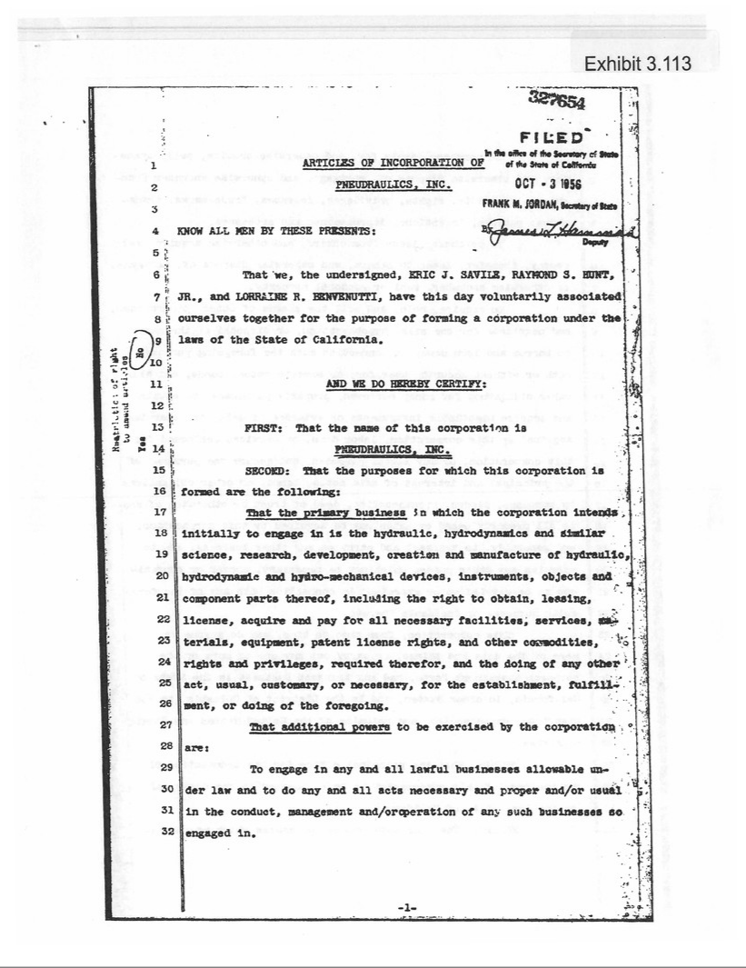

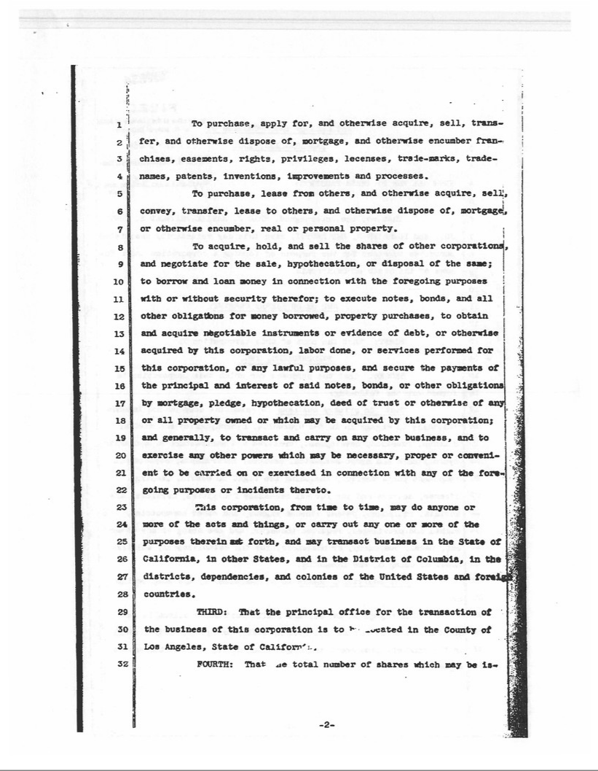

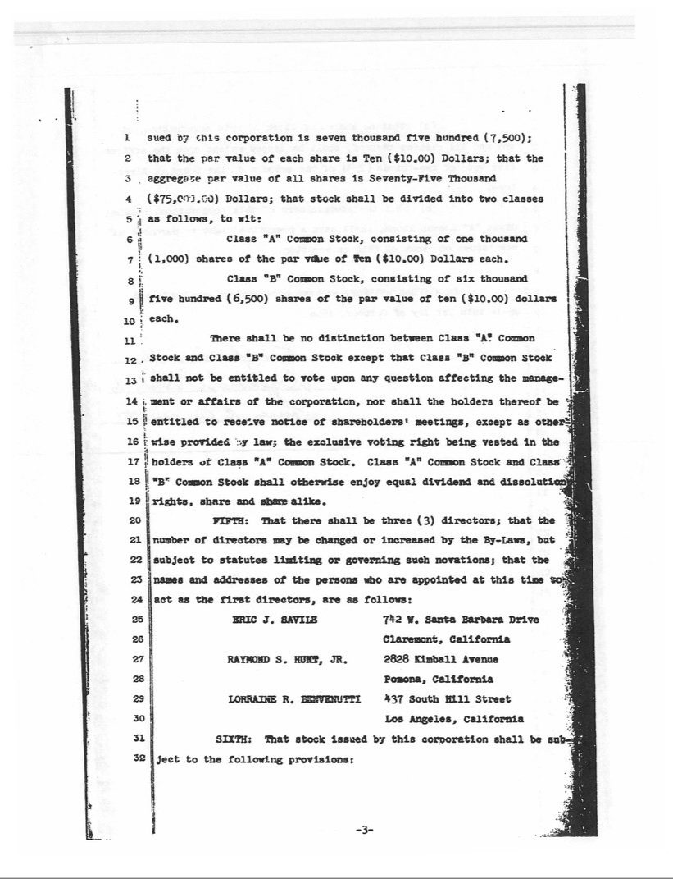

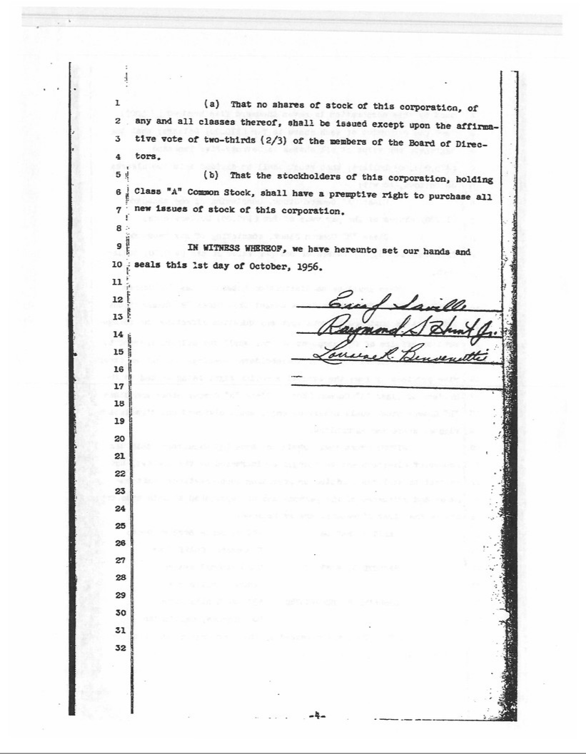

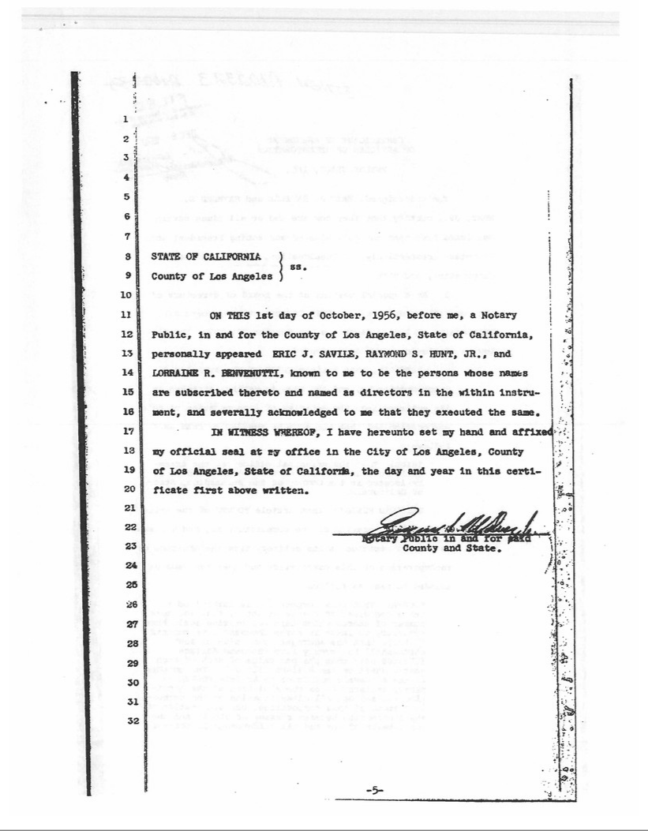

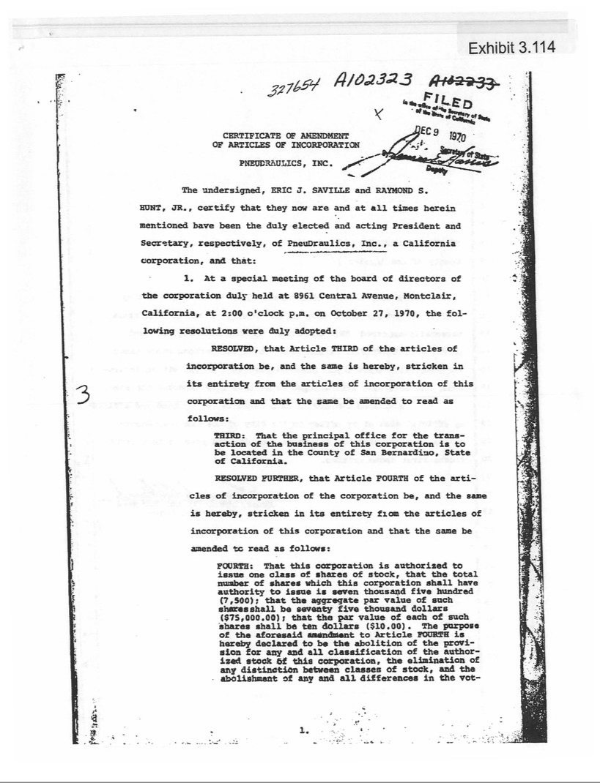

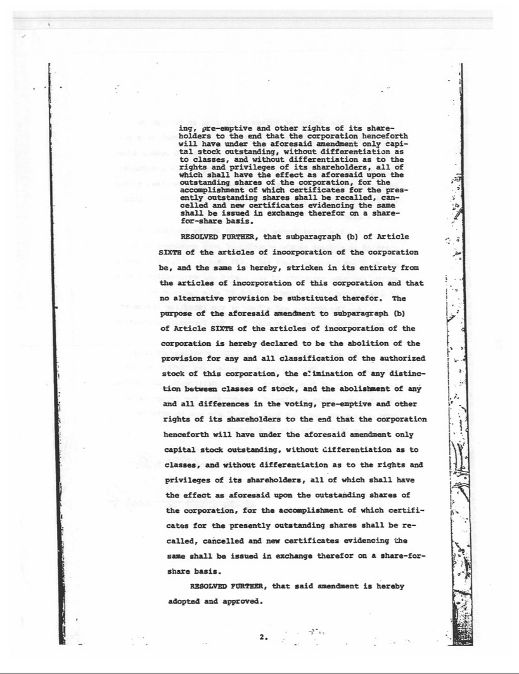

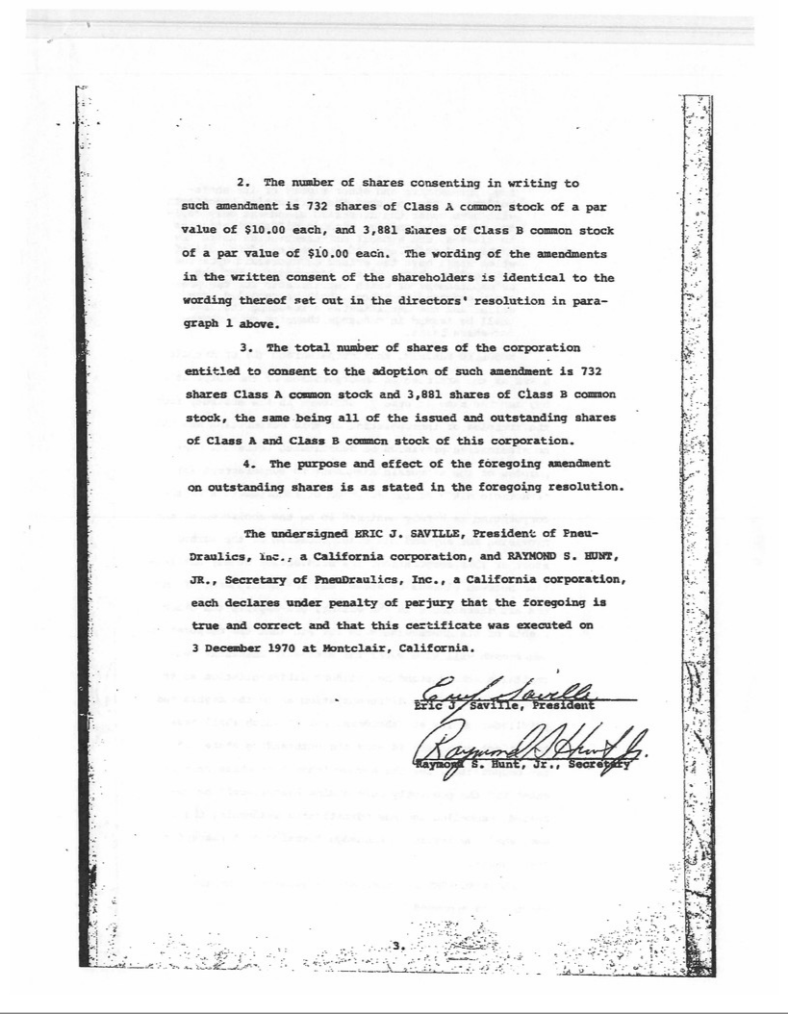

Exhibit 3.115

RESTATED BY-LAWS OF

PNEUDRAULICS, INC.

ARTICLE 1

SHAREHOLDERS’ MEETING

Section 1. PLACE OF MEETINGS.

All meetings of the shareholders shall be held at the office of the corporation in the State of California, as may be designated for that purpose from time to time by the Board of Directors.

Section 2. ANNUAL MEETINGS.

The annual meeting of the shareholders shall be held on the 31st day of December in each year, if not a legal holiday, and if a legal holiday, then on the next succeeding business day, at the hour of 10:00 o’clock A.M., at which time the shareholders shall elect by plurality vote a Board of Directors, consider reports of the affairs of the Corporation, and transact such other business as may properly be brought before the meeting.

Section 3. SPECIAL MEETINGS.

Special meetings of the shareholders, for any purpose or purposes whatsoever, may be called at any time by the President, or by the Board of Directors, or by any two or more members thereof, or by one or more shareholders holding not less than one-tenth (1/10) of the voting power of the corporation.

Section 4. NOTICE OF MEETINGS.

Notice of any shareholders’ meeting will be given either personally or by first-class mail or other written communication (including electronic transmission by the corporation) addressed to the shareholder at the physical or electronic address appearing on the corporation’s books or given by the shareholder to the corporation for purposes of notice. Such notice shall be provided no less than seven days before such meeting.

Section 5. CONSENT TO SHAREHOLDERS' MEETINGS.

The transactions of any meeting of shareholders, however called and noticed, shall be valid as though had at a meeting duly held after regular call and notice, if a quorum be present either in person or by proxy, and if, either before or after the meeting, each of the shareholders entitled to a vote, not present in person or by proxy, sign a written waiver of notice, or a consent to the holding of such meeting, or an approval of the minutes thereof. All such waivers, consents or approvals shall be filed with the corporate records or made a part of the minutes of the meeting.

Any action which may be taken at a meeting of the shareholders, may be taken without a meeting if authorized by a writing signed by all of the holders of shares who would be entitled to vote at a meeting for such purpose, and filed with the Secretary of the corporation.

Section 6. QUORUM.

The holders of a majority of the shares entitled to vote thereat, present in person, or represented by proxy, shall be requisite and shall constitute a quorum at all meetings of the shareholders for the transaction of business except as otherwise provided by law, by the Articles of Incorporation, or by these By-Laws. If, however, such majority shall not be present or represented at any meeting of the shareholders, the shareholders entitled to vote thereat, present in person, or by proxy, shall have power to adjourn the meeting from time to time, until the requisite amount of voting shares shall be present. At such adjourned meeting at which the requisite amount of voting shares shall be represented, any business may be transacted which might have been transacted at the meeting as originally notified.

Section 7. VOTING RIGHTS; CUMULATIVE VOTING.

Only persons in whose names shares entitled to vote stand on the stock records of the corporation on the day of any meeting of shareholders, unless some other day be fixed by the Board of Directors for the determination of shareholders of record, then on such other day, shall be entitled to vote at such meeting.

Every shareholder entitled to vote shall be entitled to one vote for each of said shares and shall have the right to accumulate his votes as provided in Section 2235, Corporations Code of California.

Section 8. PROXIES.

Every shareholder entitled to vote, or to execute consents, may do so, either in person or by written proxy, executed in accordance with the provisions of Section 2225 of the Corporations Code of California and filed with the Secretary of the corporation.

ARTICLE II

DIRECTORS; MANAGEMENT

Section 1. POWERS.

Subject to the limitation of the Articles of Incorporation, of the By-Laws and of the Laws of the State of California as to action to be authorized or approved by the shareholders, all corporate powers shall be exercised by or under authority of, and the business and affairs of this corporation shall be controlled by a Board of Directors.

Section 2. NUMBER AND QUALIFICATION.

The number of directors, which shall not be less than two or more than three, may be fixed or changed at a meeting of the shareholders called for the purpose of electing

-2-

directors at which a quorum is present, by the affirmative vote of the holders of a majority of the shares represented at the meeting and entitled to a vote on such proposal. The number of directors elected shall be deemed to be the number of directors fixed unless otherwise fixed by resolution adopted at the meeting at which such directors are elected.

Section 3. ELECTION AND TENURE OF OFFICE.

The directors shall be elected by ballot at the annual meeting of the shareholders, to serve for one year and until their successors are elected and have qualified. Their term of office shall begin immediately after election.

Section 4. VACANCIES.

Vacancies in the Board of Directors may be filled by a majority of the remaining directors, though less than a quorum, or by a sole remaining director, and each director so elected shall hold office until his successor is elected at an annual meeting of shareholders or at a special meeting called for that purpose.

The shareholders may at any time elect a director to fill any vacancy not filled by the directors, and may elect the additional directors at the meeting at which an amendment of the By-Laws is voted authorizing an increase in the number of directors.

A vacancy or vacancies shall be deemed to exist in case of the death, resignation or removal of any director, or if the shareholders shall increase the authorized number of directors but shall fail at the meeting at which such increase is authorized, or at an adjournment thereof, to elect the additional director so provided for, or in case the shareholders fail at any time to elect the full number of authorized directors.

If the Board of Directors accepts the resignation of a Director tendered to take effect at a future time, the Board, or the shareholders, shall have power to elect a successor to take office when the resignation shall become effective.

No reduction of the number of directors shall have the effect of removing any director prior to the expiration of his term of office.

Section 5. REMOVAL OF DIRECTORS.

The entire Board of Directors or any individual director may be removed from office as provided by Section 810 of the Corporations Code of the State of California.

Section 6. PLACE OF MEETINGS.

Meetings of the Board of Directors shall be held at the office of the corporation in the State of California, as designated for that purpose, from time to time, by resolution of the Board of Directors or written consent of all of the Members of the Board. Any meeting shall be valid, wherever held, if held by the written consent of all Members of the Board of Directors, given either before or after the meeting and filed with the Secretary of the corporation.

-3-

Section 7. ORGANIZATION MEETINGS.

The organization meetings of the Board of Directors shall be held immediately following the adjournment of the annual meetings of the shareholders.

Section 8. OTHER REGULAR MEETINGS.

Regular meetings of the Board of Directors shall be held quarterly on the first Tuesday of October, January, April, and July of each and every year. If said day shall fall upon a holiday, such meetings shall be held on the next succeeding business day thereafter. No notice need be given of such regular meetings.

Section 9. SPECIAL MEETINGS—NOTICES.

Special meetings of the Board of Directors for any purpose or purposes shall be called at any time by the President or if he is absent or unable or refuses to act, by any Vice-President or by any two directors.

Written notice of the time and place of special meetings shall be delivered personally to the directors or sent to each director by letter or by telegram, charges prepaid, addressed to him at his address as it is shown upon the records of the corporation, or if it is not so shown on such records or is not readily ascertainable, at the place in which the meetings of the directors are regularly held. In case such notice is mailed or telegraphed, it shall be deposited in the United States mail or delivered to the telegraph company in the place in which the principal office of the corporation is located at least forty-eight (48) hours prior to the time of the holding of the meeting. In case such notice is delivered as above provided; it shall be so delivered at least twenty-four (24) hours prior to the time of the holding of the meeting. Such mailing, telegraphing or delivery as above provided shall be due, legal and personal notice to such director.

Section 10. WAIVER OF NOTICE.

When all the directors are present at any directors’ meeting, however called or noticed, and sign a written consent thereto on the records of such meeting, or, if a majority of the directors are present, and if those not present sign in writing a waiver of notice of such meeting, whether prior to or after the holding of such meeting, which said waiver shall be filed with the Secretary of the corporation, the transactions thereof are as valid as if had at a meeting regularly called or noticed.

Section 11. NOTICE OF ADJOURNMENT.

Notice of the time and place of holding an adjourned meeting need not be given to absent directors if the time and place be fixed at the meeting adjourned.

Section 12. QUORUM.

A majority of the number of directors as fixed by the Articles or By-Laws shall be necessary to constitute a quorum for the transaction of business, and the action of a majority of the directors present at any meeting at which there is a quorum, when duly

-4-

assembled, is valid as a corporate act; provided that a minority of the directors, in the absence of a quorum, may adjourn from time to time, but may not transact any business.

ARTICLE III

OFFICERS

Section 1. OFFICERS.

The officers of the corporation shall be a president, a vice-president, a secretary, and a treasurer. The corporation may also have, at the discretion of the board of directors, a chairman of the board, one or more additional vice-presidents, one or more assistant secretaries, one or more assistant treasurers, and such other officers as may be appointed in accordance with the provisions of Section 3 of this article. One person may hold two or more offices, except those of president and secretary.

Section 2. ELECTION.

The officers of the corporation, except such officers as may be appointed in accordance with the provisions of Section 3 or Section 5 of this article shall be chosen annually by the board of directors, and each shall hold his office until he shall resign or shall be removed or otherwise disqualified to serve, or his successor shall be elected and qualified.

Section 3. SUBORDINATE OFFICERS, ETC.

The board of directors may appoint such other officers as the business of the corporation may require, each of whom shall hold office for such period, have such authority and perform such duties as are provided in the by-laws or as the board of directors may from time to time determine.

Section 4. REMOVAL AND RESIGNATION.

Any officer may be removed, either with or without cause, by a majority of the directors at the time in office, at any regular or special meeting of the board, or, except in case of an officer chosen by the board of directors, by any officer upon whom such power of removal may be conferred by the board of directors.

Any officer may resign at any time by giving written notice to the board of directors or to the president, or to the secretary of the corporation. Any such resignation shall take effect at the date of the receipt of such notice or at any later time specified therein; and, unless otherwise specified therein, the acceptance of such resignation shall not be necessary to make it effective.

Section 5. VACANCIES.

A vacancy in any office because of death, resignation, removal, disqualification or any other cause shall be filled in the manner prescribed in the by-laws for regular appointments to such office.

-5-

Section 6. CHAIRMAN OF THE BOARD.

The chairman of the board, if there shall be such an officer, shall, if present, preside at all meetings of the board of directors, and exercise and perform such other powers and duties as may be from time to time assigned to him by the board of directors or prescribed by the by-laws.

Section 7. PRESIDENT.

Subject to such supervisory powers, if any, as may be given by the board of directors to the chairman of the board, if there be such an officer, the president shall be the chief executive officer of the corporation and shall, subject to the control of the board of directors, have general supervision, direction and control of the business and officers of the corporation. He shall preside at all meetings of the shareholders and in the absence of the chairman of the board, or if there be none, at all meetings of the board of directors. He shall be ex officio a member of all the standing committees, including the executive committee, if any, and shall have the general powers and duties of management usually vested in the office of president of a corporation, and shall have such other powers and duties as may be prescribed by the board of directors or the by-laws.

Section 8. VICE PRESIDENT.

In the absence or disability of the president, the vice presidents in order of their rank as fixed by the board of directors, or if not ranked, the vice president designated by the board of directors shall perform all the duties of the president, and when so acting shall have all the powers of, and be subject to, all the restrictions upon, the president. The vice presidents shall have such other powers and perform such other duties as from time to time may be prescribed for them respectively by the board of directors or the by-laws.

Section 9. SECRETARY.

The secretary shall keep, or cause to be kept, a book of minutes at the principal office or such other place as the board of directors may order, of all meetings of directors and shareholders, with the time and place of holding, whether regular or special, and if special, how authorized, the notice thereof given, the names of those present at directors’ meetings, the number of shares present or represented at shareholders’ meetings and the proceeds thereof.

The secretary shall keep, or cause to be kept, at the principal office or at the office of the corporation’s transfer agent, a share register, or duplicate share register, showing the names of the shareholders and their addresses; the number and classes of shares held by each; the number and date of certificates issued for the same; and the number and date of cancellation of every certificate surrendered for cancellation.

The secretary shall give, or cause to be given, notice of all the meetings of the shareholders and of the board of directors required by the by-laws or by law to be given, and he shall keep the seal of the corporation in safe custody, and shall have such other

-6-

powers and perform such other duties as may be prescribed by the board of directors or the by-laws.

Section 10. TREASURER.

The treasurer shall keep and maintain, or cause to be kept and maintained, adequate and correct accounts of the properties and business transactions of the corporation, including accounts of its assets, liabilities, receipts, disbursements, gains, losses, capital, surplus and shares. Any surplus, including earned surplus, paid-in-surplus and surplus arising from a reduction of stated capital, shall be classified according to source and shown in a separate account. The books of account shall at all reasonable times be open to inspection by any director.

The treasurer shall deposit all moneys and other valuables in the name and to the credit of the corporation with such depositaries as may be designated by the board of directors. He shall disburse the funds of the corporation as may be ordered by the board of directors, shall render to the president and directors, whenever they request it, an account of all of his transactions as treasurer and of the financial condition of the corporation, and shall have such other powers and perform such other duties as may be prescribed by the board of directors or the by-laws.

Section 11. RESTRICTIONS ON OFFICERS.

That no officer of this corporation shall examine, peruse, read or have possession of or access to any prints, plans, specifications, documents or instruments requiring a security clearance pursuant to the Security Manual of the United States Department of Defense or any of the agencies or instrumentalities of said Department, unless said officer shall have prior thereto obtained a full and complete security clearance pursuant to such manual of the Department of Defense, and the same shall not be revoked, recalled or terminated at the time thereof.

ARTICLE IV

EXECUTIVE AND OTHER COMMITTEES

The Board of Directors may appoint an executive committee, and such other committees as may be necessary from time to time, consisting of such number of its members and with such powers as it may designate, consistent with the Articles of Incorporation and By-Laws and the General Corporation Laws of the State of California. Such committees shall hold office at the pleasure of the board.

ARTICLE V

CORPORATE RECORDS AND REPORTS—INSPECTION

Section 1. RECORDS.

The corporation shall maintain adequate and correct accounts, books and records of its business and properties. All of such books, records and accounts shall be kept at its

-7-

principal place of business in the State of California, as fixed by the Board of Directors from time to time.

Section 2. INSPECTION OF BOOKS AND RECORDS.

All books and records provided for in Section 3003 of the Corporations Code of California shall be open to inspection of the directors and shareholders from time to time and in the manner provided in said Section 3003.

Section 3. CERTIFICATION AND INPSECTION OF BY-LAWS.

The original or a copy of these By-Laws, as amended or otherwise altered to date, certified by the Secretary, shall be open to inspection by the shareholders of the company, as provided in Section 502 of the Corporations Code of California.

Section 4. CHECKS, DRAFTS, ETC.

All checks, drafts or other orders for payment of money, notes or other evidences of indebtedness, issued in the name of or payable to the corporation, shall be signed or endorsed by such person or persons and in such manner as shall be determined from time to time by resolution of the Board of Directors.

Section 5. CONTRACTS, ETC.—HOW EXECUTED.

The Board of Directors, except as in the By-Laws otherwise provided, may authorize any officer or officers, agent or agents, to enter into any contract or execute any instrument in the name of and on behalf of the corporation. Such authority may be general or confined to specific instances. Unless so authorized by the Board of Directors, no officer, agent or employee shall have any power or authority to bind the corporation by any contract or engagement, or to pledge its credit, or to render it liable for any purpose or to any amount.

Section 6. ANNUAL REPORT.

Upon the request of shareholders owning one-tenth (1/10) of the outstanding stock, the directors shall cause the be sent to the shareholders, not later than one hundred twenty (120) days after the close of the fiscal or calendar year, a balance sheet as of the closing date of such year, together with a statement of income and profit and loss for such year. These financial statements shall be certified to by the President, Secretary, Treasurer or a public accountant.

ARTICLE VI

CERTIFICATES AND TRANSFER OF SHARES

Section 1. CERTIFICATES FOR SHARES.

Certificates for shares shall be of such form and device as the Board of Directors may designate and shall state the name of the record holder of the shares represented thereby; its number; date of issuance; the number of shares for which it is issued; the par

-8-

value, if any, or a statement that such shares are without par value; a statement of the rights, privileges, preferences and restrictions, if any; a statement as to the redemption or conversion, if any; a statement of liens or restrictions upon transfer or voting, if any; if the shares be assessable or, if assessments are collectible by personal action, a plain statement of such facts.

Every certificate for shares must be signed by the President, Chief Executive Officer or a Vice-President and the Secretary or an Assistant Secretary or must be authenticated by facsimiles of the signatures of the President or Chief Executive Officer and Secretary or by a facsimile of the signature of its President or Chief Executive Officer and the written signature of its Secretary or an Assistant Secretary. Before it becomes effective every certificate for shares authenticated by a facsimile of a signature must be countersigned by a transfer agent or transfer clerk and must be registered by an incorporated bank or trust company, either domestic or foreign, as registrar of transfers.

Section 2. TRANSFER ON THE BOOKS.

Upon surrender to the Secretary or transfer agent of the corporation of a certificate for shares duly endorsed or accompanied by proper evidence of succession, assignment or authority to transfer, it shall be the duty of the corporation to issue a new certificate to the person entitled thereto, cancel the old certificate and record the transaction upon its books.

Section 3. LOST OR DESTROYED CERTIFICATES.

Any person claiming a certificate of stock to be lost or destroyed shall make an affidavit or affirmation of that fact and advertise the same in such manner as the Board of Directors may require, and shall if the directors so require give the corporation a bond of indemnity, in form and with one or more sureties satisfactory to the Board, in at least double the value of the stock represented by said certificate, whereupon a new certificate may be issued of the same tenor and for the same number of shares as the one alleged to be lost or destroyed.

Section 4. TRANSFER AGENTS AND REGISTRARS.

The Board of Directors may appoint one or more transfer agents or transfer clerks, and one or more registrars, which shall be an incorporated bank or trust company—either domestic or foreign, who shall be appointed at such times and places as the requirements of the corporation may necessitate and the Board of Directors may designate.

Section 5. CLOSING STOCK TRANSFER BOOKS.

The Board of Directors may close the transfer books in their discretion for a period not exceeding thirty days preceding any meeting, annual or special, of the shareholders, or the day appointed for the payment of a dividend.

-9-

ARTICLE VII

CORPORATE SEAL

The corporate seal shall be circular in form, and shall have inscribed thereon the name of the corporation, the date of its incorporation, and the word California.

ARTICLE VIII

AMENDMENTS TO BY-LAWS

Section 1. BY SHAREHOLDERS.

New By-Laws may be adopted or these By-Laws may be repealed or amended at their annual meeting, or at any other meeting of the shareholders called for that purpose, by a vote of shareholders entitled to exercise a majority of the voting power of the corporation, or by written assent of such shareholders.

Section 2. POWERS OF DIRECTORS.

Subject to the right of the shareholders to adopt, amend or repeal By-Laws, as provided in Section 1 of this Article VIII, the Board of Directors may adopt, amend or repeal any of these By-Laws other than a By-Law or amendment thereof changing the authorized number of directors.

Section 3. RECORD OF AMENDMENTS.

Whenever an amendment or new By-Law is adopted, it shall be copied in the Book of By-Laws with the original By-Laws, in the appropriate place. If any By-Law is repealed, the fact of repeal with the date of the meeting at which the repeal was enacted or written assent was filed shall be stated in said book.

-10-

Exhibit 4.8

TRANSDIGM INC.,

TRANSDIGM GROUP INCORPORATED,

THE GUARANTORS NAMED HEREIN,

AND

THE BANK OF NEW YORK MELLON TRUST COMPANY, N.A.,

as Trustee

SIXTH SUPPLEMENTAL INDENTURE

Dated as of August 28, 2015

to

Indenture

Dated as of October 15, 2012

by and among

TRANSDIGM INC.,

TRANSDIGM GROUP INCORPORATED,

THE GUARANTORS NAMED THEREIN,

AND

THE BANK OF NEW YORK MELLON TRUST COMPANY, N.A.,

as Trustee

5.50% Senior Subordinated Notes due 2020

of TransDigm Inc.

This SIXTH SUPPLEMENTAL INDENTURE (this “Supplemental Indenture”), dated as of August 28, 2015, by and among PneuDraulics, Inc.,

a California corporation (the “Guaranteeing Subsidiary”), TransDigm Inc., a Delaware corporation (the “Company”), TransDigm Group Incorporated, a

Delaware corporation (“TD Group”), Adams Rite Aerospace, Inc., a California corporation (“Adams Rite”), MarathonNorco Aerospace, Inc., a Delaware

corporation (“Marathon”), Champion Aerospace LLC, a Delaware limited liability company (“Champion”), Avionic Instruments LLC, a Delaware limited

liability company (“Avionic”), Skurka Aerospace Inc., a Delaware corporation (“Skurka”), CDA InterCorp LLC, a Florida limited liability company

(“CDA”), Aviation Technologies, Inc., a Delaware corporation (“ATI”), AvtechTyee, Inc., a Washington corporation (“Avtech”), Transicoil LLC, a Delaware

limited liability company (“Transicoil”), AeroControlex Group, Inc., a Delaware corporation (“AeroControlex”), Bruce Aerospace Inc., a Delaware

corporation (“Bruce Aerospace”), CEF Industries, LLC, a Delaware limited liability company (“CEF”), Acme Aerospace, Inc., a Delaware corporation

(“Acme”), Dukes Aerospace, Inc., a Delaware corporation (“Dukes”), Semco Instruments, Inc., a Delaware corporation, (“Semco”), Hartwell Corporation, a

California corporation (“Hartwell”), McKechnie Aerospace DE, Inc., a Delaware corporation (“McKechnie Aerospace DE”), McKechnie Aerospace

Holdings, Inc., a Delaware corporation (“McKechnie Aerospace Holdings”), McKechnie Aerospace Investments, Inc., a Delaware corporation (“McKechnie

Aerospace Investments”), McKechnie Aerospace US LLC, a Delaware limited liability company (“McKechnie Aerospace US”), Texas Rotronics, Inc., a

Texas corporation (“Rotronics”), Electromech Technologies LLC (formerly Western Sky Industries, LLC), a Delaware limited liability company

(“Electromech”), Schneller LLC, a Delaware limited liability company (“Schneller”), Schneller International Sales Corp., an Ohio corporation (“Schneller

International”), HARCO LLC (formerly Harco Laboratories, Incorporated), a Connecticut limited liability company (“HARCO”), AmSafe Global Holdings,

Inc., a Delaware corporation (“AmSafe Global”), Bridport Holdings, Inc., a Delaware corporation (“Bridport Holdings”), AmSafe, Inc., a Delaware

corporation (“AmSafe Inc.”), Shield Restraint Systems, Inc. (formerly AmSafe Commercial Products, Inc.), a Delaware corporation (“Shield”), Bridport-Air

Carrier, Inc., a Washington corporation (“Bridport-Air”), Bridport Erie Aviation, Inc., a Delaware corporation (“Bridport Erie”), Arkwin Industries, Inc., a

New York corporation (“Arkwin”), Whippany Actuation Systems, LLC, a Delaware limited liability company (“Whippany”), Aerosonic LLC, a Delaware

limited liability company (“Aerosonic”), Avionics Specialties, Inc., a Virginia corporation (“Avionics Specialties”), Airborne Global, Inc., a Delaware

corporation (“Airborne Global”), Airborne Holdings, Inc., a Delaware Corporation (“Airborne Holdings”), Airborne Acquisition, Inc., a Delaware

corporation (“Airborne Acquisitions”), Airborne Systems NA Inc., a Delaware corporation (“Airborne Systems NA”), Airborne Systems North America Inc.,

a Delaware corporation (“Airborne Systems North America”), Airborne Systems North America of CA Inc., a Delaware corporation (“Airborne Systems

North America CA”), Airborne Systems North America of NJ Inc., a New Jersey corporation (“Airborne Systems North America NJ”), Telair US LLC, a

Delaware limited liability company (“Telair US”), Telair International LLC, a Delaware limited liability company (“Telair International”), and Pexco

Aerospace, Inc., a Delaware corporation (collectively with TD Group, Adams Rite, Marathon, Champion, Avionic, Skurka, CDA, ATI, Avtech, Transicoil,

AeroControlex, Bruce Aerospace, CEF, Acme, Dukes, Semco, Hartwell, McKechnie Aerospace DE, McKechnie Aerospace Holdings, McKechnie Aerospace

Investments, McKechnie Aerospace US, Rotronics, Electromech, Schneller, Schneller International, HARCO, AmSafe Global, Bridport Holdings, AmSafe

Inc., Shield, Bridport-Air, Bridport Erie, Arkwin, Whippany, Aerosonic, Avionics Specialties, Airborne Global, Airborne Holdings, Airborne Acquisitions,

Airborne Systems NA, Airborne Systems North America, Airborne Systems North America CA, Airborne Systems North America NJ, Telair US and Telair

International, the “Existing Guarantors”), and The Bank of New York Mellon Trust Company, N.A., as trustee (the “Trustee”) under the Indenture referred

to below. Capitalized terms used herein and not otherwise defined shall have the meaning assigned to them in the Indenture.

WITNESSETH:

WHEREAS, the Company and the Existing Guarantors have heretofore executed and delivered to the Trustee an indenture, dated as of October 15, 2012 (as supplemented by the First Supplemental Indenture thereto, dated as of June 5, 2013, the Second Supplemental Indenture thereto, dated as of June 26, 2013, the Third Supplemental Indenture thereto, dated as of December 19, 2013, the Fourth Supplemental Indenture thereto, dated as of April 9, 215 and the Fifth Supplemental Indenture thereto, dated as of June 12, 2015, the “Indenture”), providing for the issuance by the Company of 5.50% Senior Subordinated Notes due 2020 (the “Notes”) and the guarantees thereof by each of the Existing Guarantors;

- 2 -

WHEREAS, the Indenture provides that under certain circumstances described therein, newly created or acquired Domestic Restricted Subsidiaries shall execute and deliver to the Trustee a supplemental indenture to the Indenture providing for a senior subordinated guarantee of payment of the Notes by such Domestic Restricted Subsidiary (the “Guarantee”);

WHEREAS, all things necessary to make this Supplemental Indenture the legal, valid and binding obligation of the Company, the Existing Guarantors and the Guaranteeing Subsidiary have been done; and

WHEREAS, pursuant to Section 9.01(g) of the Indenture, the Trustee is authorized to execute and deliver this Supplemental Indenture without the consent of the Holders of the Notes.

NOW, THEREFORE, in consideration of the foregoing and for other good and valuable consideration, the receipt of which is hereby acknowledged, each of the Guaranteeing Subsidiary covenants and agrees for the equal and ratable benefit of the Holders of the Notes as follows:

- CAPITALIZED TERMS. Capitalized terms used herein without definition shall have the meanings assigned to them in the Indenture.

- GUARANTEE, ETC. Each of the Guaranteeing Subsidiary hereby agrees that from and after the date hereof it shall be a Guarantor under the Indenture and be bound by the terms thereof applicable to Guarantors and shall be entitled to all of the rights and subject to all the obligations of a Guarantor thereunder.

- RATIFICATION OF INDENTURE; SUPPLEMENTAL INDENTURE PART OF INDENTURE. The Indenture is in all respects ratified and confirmed and all the terms, conditions and provisions thereof shall remain in full force and effect. This Supplemental Indenture shall form a part of the Indenture for all purposes, and every holder of Notes heretofore or hereafter authenticated and delivered shall be bound hereby.

- EXECUTION AND DELIVERY. Each of the Guaranteeing Subsidiary agrees that the Guarantee granted by it pursuant to the terms hereof shall remain in full force and effect notwithstanding any failure to endorse on each Note a notation of such Guarantee.

- NO RECOURSE AGAINST OTHERS. No past, present or future director, officer, employee, incorporator, stockholder or agent of any of the Guaranteeing Subsidiary (or any successor entity) (other than the Company or the Existing Guarantors), as such, shall have any liability for any obligations of the Company, TD Group, the Guaranteeing Subsidiary or any other Guarantor under the Notes, any Guarantee, the Indenture or this Supplemental Indenture or for any claim based on, in respect of, or by reason of, such obligations or their creation. Each Holder of the Notes by accepting a Note waives and releases all such liability. The waiver and release are part of the consideration for issuance of the Notes.

- NEW YORK LAW TO GOVERN. THE INTERNAL LAW OF THE STATE OF NEW YORK SHALL GOVERN AND BE USED TO CONSTRUE THIS SUPPLEMENTAL INDENTURE AND THE GUARANTEE GRANTED HEREUNDER WITHOUT GIVING EFFECT TO APPLICABLE PRINCIPLES OF CONFLICTS OF LAW TO THE EXTENT THAT THE APPLICATION OF THE LAWS OF ANOTHER JURISDICTION WOULD BE REQUIRED THEREBY.

- COUNTERPART ORIGINALS. The parties may sign any number of copies of this Supplemental Indenture. Each signed copy shall be an original, but all of them together represent the same agreement.

- EFFECT OF HEADINGS. The Section headings have been inserted for convenience of reference only, are not to be considered part of this Supplemental Indenture and shall in no way modify or restrict any of the terms or provisions hereof.

  - 3 -

- THE TRUSTEE. The Trustee shall not be responsible in any manner whatsoever for or in respect of the validity or sufficiency of this Supplemental Indenture or for or in respect of the recitals contained herein, all of which recitals are made solely by the Guaranteeing Subsidiary, the Existing Guarantors and the Company.

[Signature page follows.]

- 4 -

IN WITNESS WHEREOF, the parties hereto have caused this Supplemental Indenture to be duly executed as of the date hereof.

TRANSDIGM INC.

By: /s/ Terrance M. Paradie

Name: Terrance M. Paradie

Title: Chief Financial Officer

TRANSDIGM GROUP INCORPORATED

By: /s/ Terrance M. Paradie

Name: Terrance M. Paradie

Title Executive Vice President and Chief

Financial Officer

ACME AEROSPACE, INC.

ADAMS RITE AEROSPACE, INC.

AEROCONTROLEX GROUP, INC.

AIRBORNE ACQUISITION, INC.

AIRBORNE GLOBAL, INC.

AIRBORNE HOLDINGS, INC.

AIRBORNE SYSTEMS NORTH AMERICA OF CA INC.

AIRBORNE SYSTEMS NORTH AMERICA OF NJ INC.

AMSAFE GLOBAL HOLDINGS, INC.

AMSAFE, INC.

ARKWIN INDUSTRIES, INC.

AVIATION TECHNOLOGIES, INC.

AVTECHTYEE, INC.

BRIDPORT-AIR CARRIER, INC.

BRIDPORT HOLDINGS, INC.

BRUCE AEROSPACE INC.

HARTWELL CORPORATION

MARATHONNORCO AEROSPACE, INC.

MCKECHNIE AEROSPACE DE, INC.

MCKECHNIE AEROSPACE US LLC

By: McKechnie Aerospace DE, Inc., its sole member

SCHNELLER INTERNATIONAL SALES CORP.

SHIELD RESTRAINT SYSTEMS, INC.

SEMCO INSTRUMENTS, INC.

SKURKA AEROSPACE INC.

[Signature Page to the Sixth Supplemental Indenture – 2020 Notes]

TEXAS ROTRONICS, INC.

TRANSICOIL LLC

By: Aviation Technologies, Inc., its sole member

By: /s/ Gregory Rufus

Name: Gregory Rufus

Title: Chief Executive Officer

AEROSONIC LLC

AVIONIC INSTRUMENTS LLC

CDA INTERCORP LLC

CEF INDUSTRIES, LLC

CHAMPION AEROSPACE LLC

HARCO LLC

SCHNELLER LLC

TELAIR INTERNATIONAL LLC

TELAIR US LLC

WHIPPANY ACTUATION SYSTEMS, LLC

By: TransDigm Inc., its sole member

By: /s/ Terrance M. Paradie

Name: Terrance M. Paradie

Title: Chief Financial Officer

AIRBORNE SYSTEMS NA INC.

AIRBORNE SYSTEMS NORTH AMERICA INC.

AVIONICS SPECIALTIES, INC.

ELECTROMECH TECHNOLOGIES LLC

By: McKechnie Aerospace Investments, Inc., its sole member

MCKECHNIE AEROSPACE HOLDINGS, INC.

MCKECHNIE AEROSPACE INVESTMENTS, INC.

By: /s/ Gregory Rufus

Name: Gregory Rufus

Title: President

BRIDPORT ERIE AVIATION, INC.

By: /s/ Gregory Rufus

Name: Gregory Rufus

Title: Vice President and Treasurer

DUKES AEROSPACE, INC.

By: /s/ Gregory Rufus

Name: Gregory Rufus

Title: Chairman of the Board

PEXCO AEROSPACE, INC.

By: /s/ Terrance M. Paradie

Name: Terrance M. Paradie

[Signature Page to the Sixth Supplemental Indenture – 2020 Notes]

Title: President

PNEUDRAULICS, INC.

By: /s/ Terrance M. Paradie

Name: Terrance M. Paradie

Title: Chief Executive Officer

[Signature Page to the Sixth Supplemental Indenture – 2020 Notes]

THE BANK OF NEW YORK MELLON TRUST COMPANY, N.A., AS TRUSTEE

By: /s/ Lawrence M. Kusch

Name: Lawrence M. Kusch

Title: Vice President

[Signature Page to the Sixth Supplemental Indenture – 2020 Notes]

Exhibit 4.13

TRANSDIGM INC.,

TRANSDIGM GROUP INCORPORATED,

THE GUARANTORS NAMED HEREIN,

AND

THE BANK OF NEW YORK MELLON TRUST COMPANY, N.A.,

as Trustee

FOURTH SUPPLEMENTAL INDENTURE

Dated as of August 28, 2015

to

Indenture

Dated as of July 1, 2013

by and among

TRANSDIGM INC.,

TRANSDIGM GROUP INCORPORATED,

THE GUARANTORS NAMED THEREIN,

AND

THE BANK OF NEW YORK MELLON TRUST COMPANY, N.A.,

as Trustee

7.50% Senior Subordinated Notes due 2021

of TransDigm Inc.

- 1 -

This FOURTH SUPPLEMENTAL INDENTURE (this “Supplemental Indenture”), dated as of August 28, 2015, by and among PneuDraulics,

Inc., a California corporation (the “Guaranteeing Subsidiary”), TransDigm Inc., a Delaware corporation (the “Company”), TransDigm Group Incorporated, a

Delaware corporation (“TD Group”), Adams Rite Aerospace, Inc., a California corporation (“Adams Rite”), MarathonNorco Aerospace, Inc., a Delaware

corporation (“Marathon”), Champion Aerospace LLC, a Delaware limited liability company (“Champion”), Avionic Instruments LLC, a Delaware limited

liability company (“Avionic”), Skurka Aerospace Inc., a Delaware corporation (“Skurka”), CDA InterCorp LLC, a Florida limited liability company

(“CDA”), Aviation Technologies, Inc., a Delaware corporation (“ATI”), AvtechTyee, Inc., a Washington corporation (“Avtech”), Transicoil LLC, a Delaware

limited liability company (“Transicoil”), AeroControlex Group, Inc., a Delaware corporation (“AeroControlex”), Bruce Aerospace Inc., a Delaware

corporation (“Bruce Aerospace”), CEF Industries, LLC, a Delaware limited liability company (“CEF”), Acme Aerospace, Inc., a Delaware corporation

(“Acme”), Dukes Aerospace, Inc., a Delaware corporation (“Dukes”), Semco Instruments, Inc., a Delaware corporation, (“Semco”), Hartwell Corporation, a

California corporation (“Hartwell”), McKechnie Aerospace DE, Inc., a Delaware corporation (“McKechnie Aerospace DE”), McKechnie Aerospace

Holdings, Inc., a Delaware corporation (“McKechnie Aerospace Holdings”), McKechnie Aerospace Investments, Inc., a Delaware corporation (“McKechnie

Aerospace Investments”), McKechnie Aerospace US LLC, a Delaware limited liability company (“McKechnie Aerospace US”), Texas Rotronics, Inc., a

Texas corporation (“Rotronics”), Electromech Technologies LLC (formerly Western Sky Industries, LLC), a Delaware limited liability company

(“Electromech”), Schneller LLC, a Delaware limited liability company (“Schneller”), Schneller International Sales Corp., an Ohio corporation (“Schneller

International”), HARCO LLC (formerly Harco Laboratories, Incorporated), a Connecticut limited liability company (“HARCO”), AmSafe Global Holdings,

Inc., a Delaware corporation (“AmSafe Global”), Bridport Holdings, Inc., a Delaware corporation (“Bridport Holdings”), AmSafe, Inc., a Delaware

corporation (“AmSafe Inc.”), Shield Restraint Systems, Inc. (formerly AmSafe Commercial Products, Inc.), a Delaware corporation (“Shield”), Bridport-Air

Carrier, Inc., a Washington corporation (“Bridport-Air”), Bridport Erie Aviation, Inc., a Delaware corporation (“Bridport Erie”), Arkwin Industries, Inc., a

New York corporation (“Arkwin”), Whippany Actuation Systems, LLC, a Delaware limited liability company (“Whippany”), Aerosonic LLC, a Delaware

limited liability company (“Aerosonic”), Avionics Specialties, Inc., a Virginia corporation (“Avionics Specialties”), Airborne Global, Inc., a Delaware

corporation (“Airborne Global”), Airborne Holdings, Inc., a Delaware Corporation (“Airborne Holdings”), Airborne Acquisition, Inc., a Delaware

corporation (“Airborne Acquisitions”), Airborne Systems NA Inc., a Delaware corporation (“Airborne Systems NA”), Airborne Systems North America Inc.,

a Delaware corporation (“Airborne Systems North America”), Airborne Systems North America of CA Inc., a Delaware corporation (“Airborne Systems

North America CA”), Airborne Systems North America of NJ Inc., a New Jersey corporation (“Airborne Systems North America NJ”), Telair US LLC, a

Delaware limited liability company (“Telair US”), Telair International LLC, a Delaware limited liability company (“Telair International”), and Pexco

Aerospace, Inc., a Delaware corporation (collectively with TD Group, Adams Rite, Marathon, Champion, Avionic, Skurka, CDA, ATI, Avtech, Transicoil,

AeroControlex, Bruce Aerospace, CEF, Acme, Dukes, Semco, Hartwell, McKechnie Aerospace DE, McKechnie Aerospace Holdings, McKechnie Aerospace

Investments, McKechnie Aerospace US, Rotronics, Electromech, Schneller, Schneller International, HARCO, AmSafe Global, Bridport Holdings, AmSafe

Inc., Shield, Bridport-Air, Bridport Erie, Arkwin, Whippany, Aerosonic, Avionics Specialties, Airborne Global, Airborne Holdings, Airborne Acquisitions,

Airborne Systems NA, Airborne Systems North America, Airborne Systems North America CA, Airborne Systems North America NJ, Telair US and Telair

International, the “Existing Guarantors”), and The Bank of New York Mellon Trust Company, N.A., as trustee (the “Trustee”) under the Indenture referred

to below. Capitalized terms used herein and not otherwise defined shall have the meaning assigned to them in the Indenture.

WITNESSETH:

WHEREAS, the Company and the Existing Guarantors have heretofore executed and delivered to the Trustee an indenture, dated as of July 1, 2013 (as supplemented by the First Supplemental Indenture thereto, dated as of December 19, 2013, the Second Supplemental Indenture thereto, dated as of April 9, 2015 and the Third Supplemental Indenture thereto, dated as of May 29, 2015, the “Indenture”), providing for the issuance by the Company of 7.50% Senior Subordinated Notes due 2021 (the “Notes”) and the guarantees thereof by each of the Existing Guarantors;

WHEREAS, the Indenture provides that under certain circumstances described therein, newly created or acquired Domestic Restricted Subsidiaries shall execute and deliver to the Trustee a supplemental indenture to the

- 2 -

Indenture providing for a senior subordinated guarantee of payment of the Notes by such Domestic Restricted Subsidiary (the “Guarantee”);

WHEREAS, all things necessary to make this Supplemental Indenture the legal, valid and binding obligation of the Company, the Existing Guarantors and the Guaranteeing Subsidiary have been done; and

WHEREAS, pursuant to Section 9.01(g) of the Indenture, the Trustee is authorized to execute and deliver this Supplemental Indenture without the consent of the Holders of the Notes.

NOW, THEREFORE, in consideration of the foregoing and for other good and valuable consideration, the receipt of which is hereby acknowledged, the Guaranteeing Subsidiary covenants and agrees for the equal and ratable benefit of the Holders of the Notes as follows:

- CAPITALIZED TERMS. Capitalized terms used herein without definition shall have the meanings assigned to them in the Indenture.

- GUARANTEE, ETC. The Guaranteeing Subsidiary hereby agrees that from and after the date hereof it shall be a Guarantor under the Indenture and be bound by the terms thereof applicable to Guarantors and shall be entitled to all of the rights and subject to all the obligations of a Guarantor thereunder.

- RATIFICATION OF INDENTURE; SUPPLEMENTAL INDENTURE PART OF INDENTURE. The Indenture is in all respects ratified and confirmed and all the terms, conditions and provisions thereof shall remain in full force and effect. This Supplemental Indenture shall form a part of the Indenture for all purposes, and every holder of Notes heretofore or hereafter authenticated and delivered shall be bound hereby.

- EXECUTION AND DELIVERY. The Guaranteeing Subsidiary agrees that the Guarantee granted by it pursuant to the terms hereof shall remain in full force and effect notwithstanding any failure to endorse on each Note a notation of such Guarantee.

- NO RECOURSE AGAINST OTHERS. No past, present or future director, officer, employee, incorporator, stockholder or agent of the Guaranteeing Subsidiary (or any successor entity) (other than the Company or the Existing Guarantors), as such, shall have any liability for any obligations of the Company, TD Group, the Guaranteeing Subsidiary or any other Guarantor under the Notes, any Guarantee, the Indenture or this Supplemental Indenture or for any claim based on, in respect of, or by reason of, such obligations or their creation. Each Holder of the Notes by accepting a Note waives and releases all such liability. The waiver and release are part of the consideration for issuance of the Notes.

- NEW YORK LAW TO GOVERN. THE INTERNAL LAW OF THE STATE OF NEW YORK SHALL GOVERN AND BE USED TO CONSTRUE THIS SUPPLEMENTAL INDENTURE AND THE GUARANTEE GRANTED HEREUNDER WITHOUT GIVING EFFECT TO APPLICABLE PRINCIPLES OF CONFLICTS OF LAW TO THE EXTENT THAT THE APPLICATION OF THE LAWS OF ANOTHER JURISDICTION WOULD BE REQUIRED THEREBY.

- COUNTERPART ORIGINALS. The parties may sign any number of copies of this Supplemental Indenture. Each signed copy shall be an original, but all of them together represent the same agreement.

- EFFECT OF HEADINGS. The Section headings have been inserted for convenience of reference only, are not to be considered part of this Supplemental Indenture and shall in no way modify or restrict any of the terms or provisions hereof.

- THE TRUSTEE. The Trustee shall not be responsible in any manner whatsoever for or in respect of the validity or sufficiency of this Supplemental Indenture or for or in respect of the recitals contained herein, all of which recitals are made solely by the Guaranteeing Subsidiary, the Existing Guarantors and the Company.

  - 3 -

[Signature pages follow.]

- 4 -

IN WITNESS WHEREOF, the parties hereto have caused this Supplemental Indenture to be duly executed as of the date hereof.

TRANSDIGM INC.

By: /s/ Terrance M. Paradie

Name: Terrance M. Paradie

Title: Chief Financial Officer

TRANSDIGM GROUP INCORPORATED

By: /s/ Terrance M. Paradie

Name: Terrance M. Paradie

Title Executive Vice President and Chief

Financial Officer

ACME AEROSPACE, INC.

ADAMS RITE AEROSPACE, INC.

AEROCONTROLEX GROUP, INC.

AIRBORNE ACQUISITION, INC.

AIRBORNE GLOBAL, INC.

AIRBORNE HOLDINGS, INC.

AIRBORNE SYSTEMS NORTH AMERICA OF CA INC.

AIRBORNE SYSTEMS NORTH AMERICA OF NJ INC.

AMSAFE GLOBAL HOLDINGS, INC.

AMSAFE, INC.

ARKWIN INDUSTRIES, INC.

AVIATION TECHNOLOGIES, INC.

AVTECHTYEE, INC.

BRIDPORT-AIR CARRIER, INC.

BRIDPORT HOLDINGS, INC.

BRUCE AEROSPACE INC.

HARTWELL CORPORATION

MARATHONNORCO AEROSPACE, INC.

MCKECHNIE AEROSPACE DE, INC.

MCKECHNIE AEROSPACE US LLC

By: McKechnie Aerospace DE, Inc., its sole member

SCHNELLER INTERNATIONAL SALES CORP.

SHIELD RESTRAINT SYSTEMS, INC.

SEMCO INSTRUMENTS, INC.

SKURKA AEROSPACE INC.

[Signature Page to the Fourth Supplemental Indenture – 2021 Notes]

TEXAS ROTRONICS, INC.

TRANSICOIL LLC

By: Aviation Technologies, Inc., its sole member

By: /s/ Gregory Rufus

Name: Gregory Rufus

Title: Chief Executive Officer

AEROSONIC LLC

AVIONIC INSTRUMENTS LLC

CDA INTERCORP LLC

CEF INDUSTRIES, LLC

CHAMPION AEROSPACE LLC

HARCO LLC

SCHNELLER LLC

TELAIR INTERNATIONAL LLC

TELAIR US LLC

WHIPPANY ACTUATION SYSTEMS, LLC

By: TransDigm Inc., its sole member

By: /s/ Terrance M. Paradie

Name: Terrance M. Paradie

Title: Chief Financial Officer

AIRBORNE SYSTEMS NA INC.

AIRBORNE SYSTEMS NORTH AMERICA INC.

AVIONICS SPECIALTIES, INC.

ELECTROMECH TECHNOLOGIES LLC

By: McKechnie Aerospace Investments, Inc., its sole member

MCKECHNIE AEROSPACE HOLDINGS, INC.

MCKECHNIE AEROSPACE INVESTMENTS, INC.

By: /s/ Gregory Rufus

Name: Gregory Rufus

Title: President

BRIDPORT ERIE AVIATION, INC.

By: /s/ Gregory Rufus

Name: Gregory Rufus

Title: Vice President and Treasurer

DUKES AEROSPACE, INC.

By: /s/ Gregory Rufus

Name: Gregory Rufus

Title: Chairman of the Board

PEXCO AEROSPACE, INC.

By: /s/ Terrance M. Paradie

Name: Terrance M. Paradie

- 2 -

Title: President

PNEUDRAULICS, INC.

By: /s/ Terrance M. Paradie

Name: Terrance M. Paradie

Title: Chief Executive Officer

- 3 -

THE BANK OF NEW YORK MELLON TRUST COMPANY, N.A., AS TRUSTEE

By: /s/ Lawrence M. Kusch

Name: Lawrence M. Kusch

Title: Vice President

- 4 -

Exhibit 4.17

TRANSDIGM INC.,

TRANSDIGM GROUP INCORPORATED,

THE GUARANTORS NAMED HEREIN,

AND

THE BANK OF NEW YORK MELLON TRUST COMPANY, N.A.,

as Trustee

THIRD SUPPLEMENTAL INDENTURE

Dated as of August 28, 2015

to

Indenture

Dated as of June 4, 2014

by and among

TRANSDIGM INC.,

TRANSDIGM GROUP INCORPORATED,

THE GUARANTORS NAMED THEREIN,

AND

THE BANK OF NEW YORK MELLON TRUST COMPANY, N.A.,

as Trustee

6.000% Senior Subordinated Notes due 2022

of TransDigm Inc.

This THIRD SUPPLEMENTAL INDENTURE (this “Supplemental Indenture”), dated as of August 28, 2015, by and among PneuDraulics, Inc.,

a California corporation (the “Guaranteeing Subsidiary”), TransDigm Inc., a Delaware corporation (the “Company”), TransDigm Group Incorporated, a

Delaware corporation (“TD Group”), Adams Rite Aerospace, Inc., a California corporation (“Adams Rite”), MarathonNorco Aerospace, Inc., a Delaware

corporation (“Marathon”), Champion Aerospace LLC, a Delaware limited liability company (“Champion”), Avionic Instruments LLC, a Delaware limited

liability company (“Avionic”), Skurka Aerospace Inc., a Delaware corporation (“Skurka”), CDA InterCorp LLC, a Florida limited liability company

(“CDA”), Aviation Technologies, Inc., a Delaware corporation (“ATI”), AvtechTyee, Inc., a Washington corporation (“Avtech”), Transicoil LLC, a Delaware

limited liability company (“Transicoil”), AeroControlex Group, Inc., a Delaware corporation (“AeroControlex”), Bruce Aerospace Inc., a Delaware

corporation (“Bruce Aerospace”), CEF Industries, LLC, a Delaware limited liability company (“CEF”), Acme Aerospace, Inc., a Delaware corporation

(“Acme”), Dukes Aerospace, Inc., a Delaware corporation (“Dukes”), Semco Instruments, Inc., a Delaware corporation, (“Semco”), Hartwell Corporation, a

California corporation (“Hartwell”), McKechnie Aerospace DE, Inc., a Delaware corporation (“McKechnie Aerospace DE”), McKechnie Aerospace

Holdings, Inc., a Delaware corporation (“McKechnie Aerospace Holdings”), McKechnie Aerospace Investments, Inc., a Delaware corporation (“McKechnie

Aerospace Investments”), McKechnie Aerospace US LLC, a Delaware limited liability company (“McKechnie Aerospace US”), Texas Rotronics, Inc., a

Texas corporation (“Rotronics”), Electromech Technologies LLC (formerly Western Sky Industries, LLC), a Delaware limited liability company

(“Electromech”), Schneller LLC, a Delaware limited liability company (“Schneller”), Schneller International Sales Corp., an Ohio corporation (“Schneller

International”), HARCO LLC (formerly Harco Laboratories, Incorporated), a Connecticut limited liability company (“HARCO”), AmSafe Global Holdings,

Inc., a Delaware corporation (“AmSafe Global”), Bridport Holdings, Inc., a Delaware corporation (“Bridport Holdings”), AmSafe, Inc., a Delaware

corporation (“AmSafe Inc.”), Shield Restraint Systems, Inc. (formerly AmSafe Commercial Products, Inc.), a Delaware corporation (“Shield”), Bridport-Air

Carrier, Inc., a Washington corporation (“Bridport-Air”), Bridport Erie Aviation, Inc., a Delaware corporation (“Bridport Erie”), Arkwin Industries, Inc., a

New York corporation (“Arkwin”), Whippany Actuation Systems, LLC, a Delaware limited liability company (“Whippany”), Aerosonic LLC, a Delaware

limited liability company (“Aerosonic”), Avionics Specialties, Inc., a Virginia corporation (“Avionics Specialties”), Airborne Global, Inc., a Delaware

corporation (“Airborne Global”), Airborne Holdings, Inc., a Delaware Corporation (“Airborne Holdings”), Airborne Acquisition, Inc., a Delaware

corporation (“Airborne Acquisitions”), Airborne Systems NA Inc., a Delaware corporation (“Airborne Systems NA”), Airborne Systems North America Inc.,

a Delaware corporation (“Airborne Systems North America”), Airborne Systems North America of CA Inc., a Delaware corporation (“Airborne Systems

North America CA”), Airborne Systems North America of NJ Inc., a New Jersey corporation (“Airborne Systems North America NJ”), Telair US LLC, a

Delaware limited liability company (“Telair US”), Telair International LLC, a Delaware limited liability company (“Telair International”), and Pexco

Aerospace, Inc., a Delaware corporation (collectively with TD Group, Adams Rite, Marathon, Champion, Avionic, Skurka, CDA, ATI, Avtech, Transicoil,

AeroControlex, Bruce Aerospace, CEF, Acme, Dukes, Semco, Hartwell, McKechnie Aerospace DE, McKechnie Aerospace Holdings, McKechnie Aerospace

Investments, McKechnie Aerospace US, Rotronics, Electromech, Schneller, Schneller International, HARCO, AmSafe Global, Bridport Holdings, AmSafe

Inc., Shield, Bridport-Air, Bridport Erie, , Arkwin, Whippany, Aerosonic, Avionics Specialties, Airborne Global, Airborne Holdings, Airborne Acquisitions,

Airborne Systems NA, Airborne Systems North America, Airborne Systems North America CA, Airborne Systems North America NJ, Telair US and Telair

International, the “Existing Guarantors”), and The Bank of New York Mellon Trust Company, N.A., as trustee (the “Trustee”) under the Indenture referred

to below. Capitalized terms used herein and not otherwise defined shall have the meaning assigned to them in the Indenture.

- 2 -

WITNESSETH:

WHEREAS, the Company and the Existing Guarantors have heretofore executed and delivered to the Trustee an indenture, dated as of June 4, 2014 (as supplemented by the First Supplemental Indenture thereto, dated as of April 9, 2015 and the Second Supplemental Indenture thereto, dated as of June 12, 2015, the “Indenture”), providing for the issuance by the Company of 6.000% Senior Subordinated Notes due 2022 (the “Notes”) and the guarantees thereof by each of the Existing Guarantors;

WHEREAS, the Indenture provides that under certain circumstances described therein, newly created or acquired Domestic Restricted Subsidiaries shall execute and deliver to the Trustee a supplemental indenture to the Indenture providing for a senior subordinated guarantee of payment of the Notes by such Domestic Restricted Subsidiary (the “Guarantee”);

WHEREAS, all things necessary to make this Supplemental Indenture the legal, valid and binding obligation of the Company, the Existing Guarantors and the Guaranteeing Subsidiary have been done; and

WHEREAS, pursuant to Section 9.01(g) of the Indenture, the Trustee is authorized to execute and deliver this Supplemental Indenture without the consent of the Holders of the Notes.

NOW, THEREFORE, in consideration of the foregoing and for other good and valuable consideration, the receipt of which is hereby acknowledged, each of the Guaranteeing Subsidiary covenants and agrees for the equal and ratable benefit of the Holders of the Notes as follows:

- CAPITALIZED TERMS. Capitalized terms used herein without definition shall have the meanings assigned to them in the Indenture.

- GUARANTEE, ETC. Each of the Guaranteeing Subsidiary hereby agrees that from and after the date hereof it shall be a Guarantor under the Indenture and be bound by the terms thereof applicable to Guarantors and shall be entitled to all of the rights and subject to all the obligations of a Guarantor thereunder.

- RATIFICATION OF INDENTURE; SUPPLEMENTAL INDENTURE PART OF INDENTURE. The Indenture is in all respects ratified and confirmed and all the terms, conditions and provisions thereof shall remain in full force and effect. This Supplemental Indenture shall form a part of the Indenture for all purposes, and every holder of Notes heretofore or hereafter authenticated and delivered shall be bound hereby.

- EXECUTION AND DELIVERY. Each of the Guaranteeing Subsidiary agrees that the Guarantee granted by it pursuant to the terms hereof shall remain in full force and effect notwithstanding any failure to endorse on each Note a notation of such Guarantee.

- NO RECOURSE AGAINST OTHERS. No past, present or future director, officer, employee, incorporator, stockholder or agent of any of the Guaranteeing Subsidiary (or any successor entity) (other than the Company or the Existing Guarantors), as such, shall have any liability for any obligations of the Company, TD Group, the Guaranteeing Subsidiary or any other Guarantor under the Notes, any Guarantee, the Indenture or this Supplemental Indenture or for any claim based on, in respect of, or by reason of, such obligations or their creation. Each Holder of the Notes by accepting a Note waives and releases all such liability. The waiver and release are part of the consideration for issuance of the Notes.

- NEW YORK LAW TO GOVERN. THE INTERNAL LAW OF THE STATE OF NEW YORK SHALL GOVERN AND BE USED TO CONSTRUE THIS SUPPLEMENTAL INDENTURE AND THE GUARANTEE GRANTED HEREUNDER WITHOUT GIVING EFFECT TO APPLICABLE PRINCIPLES OF CONFLICTS OF LAW TO THE EXTENT THAT THE APPLICATION OF THE LAWS OF ANOTHER JURISDICTION WOULD BE REQUIRED THEREBY.

  - 3 -

- COUNTERPART ORIGINALS. The parties may sign any number of copies of this Supplemental Indenture. Each signed copy shall be an original, but all of them together represent the same agreement.

- EFFECT OF HEADINGS. The Section headings have been inserted for convenience of reference only, are not to be considered part of this Supplemental Indenture and shall in no way modify or restrict any of the terms or provisions hereof.

- THE TRUSTEE. The Trustee shall not be responsible in any manner whatsoever for or in respect of the validity or sufficiency of this Supplemental Indenture or for or in respect of the recitals contained herein, all of which recitals are made solely by the Guaranteeing Subsidiary, the Existing Guarantors and the Company.

[Signature page follows.]

- 4 -

IN WITNESS WHEREOF, the parties hereto have caused this Supplemental Indenture to be duly executed as of the date hereof.

TRANSDIGM INC.

By: /s/ Terrance M. Paradie

Name: Terrance M. Paradie

Title: Chief Financial Officer

TRANSDIGM GROUP INCORPORATED

By: /s/ Terrance M. Paradie

Name: Terrance M. Paradie

Title Executive Vice President and Chief

Financial Officer

ACME AEROSPACE, INC.

ADAMS RITE AEROSPACE, INC.

AEROCONTROLEX GROUP, INC.

AIRBORNE ACQUISITION, INC.

AIRBORNE GLOBAL, INC.

AIRBORNE HOLDINGS, INC.

AIRBORNE SYSTEMS NORTH AMERICA OF CA INC.

AIRBORNE SYSTEMS NORTH AMERICA OF NJ INC.

AMSAFE GLOBAL HOLDINGS, INC.

AMSAFE, INC.

ARKWIN INDUSTRIES, INC.

AVIATION TECHNOLOGIES, INC.

AVTECHTYEE, INC.

BRIDPORT-AIR CARRIER, INC.

BRIDPORT HOLDINGS, INC.

BRUCE AEROSPACE INC.

HARTWELL CORPORATION

MARATHONNORCO AEROSPACE, INC.

MCKECHNIE AEROSPACE DE, INC.

MCKECHNIE AEROSPACE US LLC

By: McKechnie Aerospace DE, Inc., its sole member

SCHNELLER INTERNATIONAL SALES CORP.

SHIELD RESTRAINT SYSTEMS, INC.

SEMCO INSTRUMENTS, INC.

SKURKA AEROSPACE INC.

[Signature page to the Third Supplemental Indenture – 2022 Notes]

TEXAS ROTRONICS, INC.

TRANSICOIL LLC

By: Aviation Technologies, Inc., its sole member

By: /s/ Gregory Rufus

Name: Gregory Rufus

Title: Chief Executive Officer

AEROSONIC LLC

AVIONIC INSTRUMENTS LLC

CDA INTERCORP LLC

CEF INDUSTRIES, LLC

CHAMPION AEROSPACE LLC

HARCO LLC

SCHNELLER LLC

TELAIR INTERNATIONAL LLC

TELAIR US LLC

WHIPPANY ACTUATION SYSTEMS, LLC

By: TransDigm Inc., its sole member

By: /s/ Terrance M. Paradie

Name: Terrance M. Paradie

Title: Chief Financial Officer

AIRBORNE SYSTEMS NA INC.

AIRBORNE SYSTEMS NORTH AMERICA INC.

AVIONICS SPECIALTIES, INC.

ELECTROMECH TECHNOLOGIES LLC

By: McKechnie Aerospace Investments, Inc., its sole member

MCKECHNIE AEROSPACE HOLDINGS, INC.

MCKECHNIE AEROSPACE INVESTMENTS, INC.

By: /s/ Gregory Rufus

Name: Gregory Rufus

Title: President

BRIDPORT ERIE AVIATION, INC.

By: /s/ Gregory Rufus

Name: Gregory Rufus

Title: Vice President and Treasurer

DUKES AEROSPACE, INC.

By: /s/ Gregory Rufus

Name: Gregory Rufus

Title: Chairman of the Board

PEXCO AEROSPACE, INC.

By: /s/ Terrance M. Paradie

Name: Terrance M. Paradie

[Signature page to the Third Supplemental Indenture – 2022 Notes]

Title: President

PNEUDRAULICS, INC.

By: /s/ Terrance M. Paradie

Name: Terrance M. Paradie

Title: Chief Executive Officer

[Signature page to the Third Supplemental Indenture – 2022 Notes]

THE BANK OF NEW YORK MELLON TRUST COMPANY, N.A., AS TRUSTEE

By: /s/ Lawrence M. Kusch

Name: Lawrence M. Kusch

Title: Vice President

[Signature page to the Third Supplemental Indenture – 2022 Notes]

Exhibit 4.21

TRANSDIGM INC.,

TRANSDIGM GROUP INCORPORATED,

THE GUARANTORS NAMED HEREIN,

AND

THE BANK OF NEW YORK MELLON TRUST COMPANY, N.A.,

as Trustee

THIRD SUPPLEMENTAL INDENTURE

Dated as of August 28, 2015

to

Indenture

Dated as of June 4, 2014

by and among

TRANSDIGM INC.,

TRANSDIGM GROUP INCORPORATED,

THE GUARANTORS NAMED THEREIN,

AND

THE BANK OF NEW YORK MELLON TRUST COMPANY, N.A.,

as Trustee

6.500% Senior Subordinated Notes due 2024

of TransDigm Inc.

- 1 -

This THIRD SUPPLEMENTAL INDENTURE (this “Supplemental Indenture”), dated as of August 28, 2015, by and among PneuDraulics, Inc.,

a California corporation, (the “Guaranteeing Subsidiary”), TransDigm Inc., a Delaware corporation (the “Company”), TransDigm Group Incorporated, a

Delaware corporation (“TD Group”), Adams Rite Aerospace, Inc., a California corporation (“Adams Rite”), MarathonNorco Aerospace, Inc., a Delaware

corporation (“Marathon”), Champion Aerospace LLC, a Delaware limited liability company (“Champion”), Avionic Instruments LLC, a Delaware limited

liability company (“Avionic”), Skurka Aerospace Inc., a Delaware corporation (“Skurka”), CDA InterCorp LLC, a Florida limited liability company

(“CDA”), Aviation Technologies, Inc., a Delaware corporation (“ATI”), AvtechTyee, Inc., a Washington corporation (“Avtech”), Transicoil LLC, a Delaware

limited liability company (“Transicoil”), AeroControlex Group, Inc., a Delaware corporation (“AeroControlex”), Bruce Aerospace Inc., a Delaware

corporation (“Bruce Aerospace”), CEF Industries, LLC, a Delaware limited liability company (“CEF”), Acme Aerospace, Inc., a Delaware corporation

(“Acme”), Dukes Aerospace, Inc., a Delaware corporation (“Dukes”), Semco Instruments, Inc., a Delaware corporation, (“Semco”), Hartwell Corporation, a

California corporation (“Hartwell”), McKechnie Aerospace DE, Inc., a Delaware corporation (“McKechnie Aerospace DE”), McKechnie Aerospace

Holdings, Inc., a Delaware corporation (“McKechnie Aerospace Holdings”), McKechnie Aerospace Investments, Inc., a Delaware corporation (“McKechnie

Aerospace Investments”), McKechnie Aerospace US LLC, a Delaware limited liability company (“McKechnie Aerospace US”), Texas Rotronics, Inc., a

Texas corporation (“Rotronics”), Electromech Technologies LLC (formerly Western Sky Industries, LLC), a Delaware limited liability company

(“Electromech”), Schneller LLC, a Delaware limited liability company (“Schneller”), Schneller International Sales Corp., an Ohio corporation (“Schneller

International”), HARCO LLC (formerly Harco Laboratories, Incorporated), a Connecticut limited liability company (“HARCO”), AmSafe Global Holdings,

Inc., a Delaware corporation (“AmSafe Global”), Bridport Holdings, Inc., a Delaware corporation (“Bridport Holdings”), AmSafe, Inc., a Delaware

corporation (“AmSafe Inc.”), Shield Restraint Systems, Inc. (formerly AmSafe Commercial Products, Inc.), a Delaware corporation (“Shield”), Bridport-Air

Carrier, Inc., a Washington corporation (“Bridport-Air”), Bridport Erie Aviation, Inc., a Delaware corporation (“Bridport Erie”), Arkwin Industries, Inc., a

New York corporation (“Arkwin”), Whippany Actuation Systems, LLC, a Delaware limited liability company (“Whippany”), Aerosonic LLC, a Delaware

limited liability company (“Aerosonic”), Avionics Specialties, Inc., a Virginia corporation (“Avionics Specialties”), Airborne Global, Inc., a Delaware

corporation (“Airborne Global”), Airborne Holdings, Inc., a Delaware Corporation (“Airborne Holdings”), Airborne Acquisition, Inc., a Delaware

corporation (“Airborne Acquisitions”), Airborne Systems NA Inc., a Delaware corporation (“Airborne Systems NA”), Airborne Systems North America Inc.,

a Delaware corporation (“Airborne Systems North America”), Airborne Systems North America of CA Inc., a Delaware corporation (“Airborne Systems

North America CA”), Airborne Systems North America of NJ Inc., a New Jersey corporation (“Airborne Systems North America NJ”), Telair US LLC, a

Delaware limited liability company (“Telair US”), Telair International LLC, a Delaware limited liability company (“Telair International”), and Pexco

Aerospace, Inc., a Delaware corporation (collectively with TD Group, Adams Rite, Marathon, Champion, Avionic, Skurka, CDA, ATI, Avtech, Transicoil,

AeroControlex, Bruce Aerospace, CEF, Acme, Dukes, Semco, Hartwell, McKechnie Aerospace DE, McKechnie Aerospace Holdings, McKechnie Aerospace

Investments, McKechnie Aerospace US, Rotronics, Electromech, Schneller, Schneller International, HARCO, AmSafe Global, Bridport Holdings, AmSafe

Inc., Shield, Bridport-Air, Bridport Erie, Arkwin, Whippany, Aerosonic, Avionics Specialties, Airborne Global, Airborne Holdings, Airborne Acquisitions,

Airborne Systems NA, Airborne Systems North America, Airborne Systems North America CA, Airborne Systems North America NJ, Telair US and Telair

International, the “Existing Guarantors”), and The Bank of New York Mellon Trust Company, N.A., as trustee (the “Trustee”) under the Indenture referred

to below. Capitalized terms used herein and not otherwise defined shall have the meaning assigned to them in the Indenture.

- 2 -

WITNESSETH:

WHEREAS, the Company and the Existing Guarantors have heretofore executed and delivered to the Trustee an indenture, dated as of June 4, 2014 (as supplemented by the First Supplemental Indenture thereto, dated as of April 9, 2015 and the Second Supplemental Indenture thereto, dated as of June 12, 2015, the “Indenture”), providing for the issuance by the Company of 6.500% Senior Subordinated Notes due 2024 (the “Notes”) and the guarantees thereof by each of the Existing Guarantors;

WHEREAS, the Indenture provides that under certain circumstances described therein, newly created or acquired Domestic Restricted Subsidiaries shall execute and deliver to the Trustee a supplemental indenture to the Indenture providing for a senior subordinated guarantee of payment of the Notes by such Domestic Restricted Subsidiary (the “Guarantee”);

WHEREAS, all things necessary to make this Supplemental Indenture the legal, valid and binding obligation of the Company, the Existing Guarantors and the Guaranteeing Subsidiary have been done; and

WHEREAS, pursuant to Section 9.01(g) of the Indenture, the Trustee is authorized to execute and deliver this Supplemental Indenture without the consent of the Holders of the Notes.

NOW, THEREFORE, in consideration of the foregoing and for other good and valuable consideration, the receipt of which is hereby acknowledged, each of the Guaranteeing Subsidiary covenants and agrees for the equal and ratable benefit of the Holders of the Notes as follows:

- CAPITALIZED TERMS. Capitalized terms used herein without definition shall have the meanings assigned to them in the Indenture.

- GUARANTEE, ETC. Each of the Guaranteeing Subsidiary hereby agrees that from and after the date hereof it shall be a Guarantor under the Indenture and be bound by the terms thereof applicable to Guarantors and shall be entitled to all of the rights and subject to all the obligations of a Guarantor thereunder.

- RATIFICATION OF INDENTURE; SUPPLEMENTAL INDENTURE PART OF INDENTURE. The Indenture is in all respects ratified and confirmed and all the terms, conditions and provisions thereof shall remain in full force and effect. This Supplemental Indenture shall form a part of the Indenture for all purposes, and every holder of Notes heretofore or hereafter authenticated and delivered shall be bound hereby.

- EXECUTION AND DELIVERY. Each of the Guaranteeing Subsidiary agrees that the Guarantee granted by it pursuant to the terms hereof shall remain in full force and effect notwithstanding any failure to endorse on each Note a notation of such Guarantee.

- NO RECOURSE AGAINST OTHERS. No past, present or future director, officer, employee, incorporator, stockholder or agent of any of the Guaranteeing Subsidiary (or any successor entity) (other than the Company or the Existing Guarantors), as such, shall have any liability for any obligations of the Company, TD Group, the Guaranteeing Subsidiary or any other Guarantor under the Notes, any Guarantee, the Indenture or this Supplemental Indenture or for any claim based on, in respect of, or by reason of, such obligations or their creation. Each Holder of the Notes by accepting a Note waives and releases all such liability. The waiver and release are part of the consideration for issuance of the Notes.

- NEW YORK LAW TO GOVERN. THE INTERNAL LAW OF THE STATE OF NEW YORK SHALL GOVERN AND BE USED TO CONSTRUE THIS SUPPLEMENTAL INDENTURE AND THE GUARANTEE GRANTED HEREUNDER WITHOUT GIVING EFFECT TO APPLICABLE PRINCIPLES OF CONFLICTS OF LAW TO THE EXTENT THAT THE APPLICATION OF THE LAWS OF ANOTHER JURISDICTION WOULD BE REQUIRED THEREBY.

  - 3 -

- COUNTERPART ORIGINALS. The parties may sign any number of copies of this Supplemental Indenture. Each signed copy shall be an original, but all of them together represent the same agreement.

- EFFECT OF HEADINGS. The Section headings have been inserted for convenience of reference only, are not to be considered part of this Supplemental Indenture and shall in no way modify or restrict any of the terms or provisions hereof.

- THE TRUSTEE. The Trustee shall not be responsible in any manner whatsoever for or in respect of the validity or sufficiency of this Supplemental Indenture or for or in respect of the recitals contained herein, all of which recitals are made solely by the Guaranteeing Subsidiary, the Existing Guarantors and the Company.

[Signature page follows.]

- 4 -

IN WITNESS WHEREOF, the parties hereto have caused this Supplemental Indenture to be duly executed as of the date hereof.

TRANSDIGM INC.

By: /s/ Terrance M. Paradie

Name: Terrance M. Paradie

Title: Chief Financial Officer

TRANSDIGM GROUP INCORPORATED

By: /s/ Terrance M. Paradie

Name: Terrance M. Paradie

Title Executive Vice President and Chief

Financial Officer

ACME AEROSPACE, INC.

ADAMS RITE AEROSPACE, INC.

AEROCONTROLEX GROUP, INC.

AIRBORNE ACQUISITION, INC.

AIRBORNE GLOBAL, INC.

AIRBORNE HOLDINGS, INC.

AIRBORNE SYSTEMS NORTH AMERICA OF CA INC.

AIRBORNE SYSTEMS NORTH AMERICA OF NJ INC.

AMSAFE GLOBAL HOLDINGS, INC.

AMSAFE, INC.

ARKWIN INDUSTRIES, INC.

AVIATION TECHNOLOGIES, INC.

AVTECHTYEE, INC.

BRIDPORT-AIR CARRIER, INC.

BRIDPORT HOLDINGS, INC.

BRUCE AEROSPACE INC.

HARTWELL CORPORATION

MARATHONNORCO AEROSPACE, INC.

MCKECHNIE AEROSPACE DE, INC.

MCKECHNIE AEROSPACE US LLC

By: McKechnie Aerospace DE, Inc., its sole member

SCHNELLER INTERNATIONAL SALES CORP.

SHIELD RESTRAINT SYSTEMS, INC.

SEMCO INSTRUMENTS, INC.

SKURKA AEROSPACE INC.

[Signature page to the Third Supplemental Indenture – 2024 Notes]

TEXAS ROTRONICS, INC.

TRANSICOIL LLC

By: Aviation Technologies, Inc., its sole member

By: /s/ Gregory Rufus

Name: Gregory Rufus

Title: Chief Executive Officer

AEROSONIC LLC

AVIONIC INSTRUMENTS LLC

CDA INTERCORP LLC

CEF INDUSTRIES, LLC

CHAMPION AEROSPACE LLC

HARCO LLC

SCHNELLER LLC

TELAIR INTERNATIONAL LLC

TELAIR US LLC

WHIPPANY ACTUATION SYSTEMS, LLC

By: TransDigm Inc., its sole member

By: /s/ Terrance M. Paradie

Name: Terrance M. Paradie

Title: Chief Financial Officer

AIRBORNE SYSTEMS NA INC.

AIRBORNE SYSTEMS NORTH AMERICA INC.

AVIONICS SPECIALTIES, INC.

ELECTROMECH TECHNOLOGIES LLC

By: McKechnie Aerospace Investments, Inc., its sole member

MCKECHNIE AEROSPACE HOLDINGS, INC.

MCKECHNIE AEROSPACE INVESTMENTS, INC.

By: /s/ Gregory Rufus

Name: Gregory Rufus

Title: President

BRIDPORT ERIE AVIATION, INC.

By: /s/ Gregory Rufus

Name: Gregory Rufus

Title: Vice President and Treasurer

DUKES AEROSPACE, INC.

By: /s/ Gregory Rufus

Name: Gregory Rufus

Title: Chairman of the Board

PEXCO AEROSPACE, INC.

By: /s/ Terrance M. Paradie

Name: Terrance M. Paradie

[Signature page to the Third Supplemental Indenture – 2024 Notes]

Title: President

PNEUDRAULICS, INC.

By: /s/ Terrance M. Paradie

Name: Terrance M. Paradie

Title: Chief Executive Officer

[Signature page to the Third Supplemental Indenture – 2024 Notes]

THE BANK OF NEW YORK MELLON TRUST COMPANY, N.A., AS TRUSTEE

By: /s/ Lawrence M. Kusch

Name: Lawrence M. Kusch

Title: Vice President

[Signature page to the Third Supplemental Indenture – 2024 Notes]

Exhibit 4.20

TRANSDIGM INC.,

TRANSDIGM GROUP INCORPORATED,

THE GUARANTORS NAMED HEREIN,

AND

THE BANK OF NEW YORK MELLON TRUST COMPANY, N.A.,

as Trustee

SECOND SUPPLEMENTAL INDENTURE

Dated as of August 28, 2015

to

Indenture

Dated as of May 14, 2015

by and among

TRANSDIGM INC.,

TRANSDIGM GROUP INCORPORATED,

THE GUARANTORS NAMED THEREIN,

AND

THE BANK OF NEW YORK MELLON TRUST COMPANY, N.A.,

as Trustee

6.500% Senior Subordinated Notes due 2025

of TransDigm Inc.

This SECOND SUPPLEMENTAL INDENTURE (this “Supplemental Indenture”), dated as of August 28, 2015, by and among PneuDraulics,

Inc., a California corporation, (the “Guaranteeing Subsidiary”), TransDigm Inc., a Delaware corporation (the “Company”), TransDigm Group Incorporated,

a Delaware corporation (“TD Group”), Adams Rite Aerospace, Inc., a California corporation (“Adams Rite”), MarathonNorco Aerospace, Inc., a Delaware

corporation (“Marathon”), Champion Aerospace LLC, a Delaware limited liability company (“Champion”), Avionic Instruments LLC, a Delaware limited

liability company (“Avionic”), Skurka Aerospace Inc., a Delaware corporation (“Skurka”), CDA InterCorp LLC, a Florida limited liability company

(“CDA”), Aviation Technologies, Inc., a Delaware corporation (“ATI”), AvtechTyee, Inc., a Washington corporation (“Avtech”), Transicoil LLC, a Delaware

limited liability company (“Transicoil”), AeroControlex Group, Inc., a Delaware corporation (“AeroControlex”), Bruce Aerospace Inc., a Delaware

corporation (“Bruce Aerospace”), CEF Industries, LLC, a Delaware limited liability company (“CEF”), Acme Aerospace, Inc., a Delaware corporation

(“Acme”), Dukes Aerospace, Inc., a Delaware corporation (“Dukes”), Semco Instruments, Inc., a Delaware corporation, (“Semco”), Hartwell Corporation, a

California corporation (“Hartwell”), McKechnie Aerospace DE, Inc., a Delaware corporation (“McKechnie Aerospace DE”), McKechnie Aerospace

Holdings, Inc., a Delaware corporation (“McKechnie Aerospace Holdings”), McKechnie Aerospace Investments, Inc., a Delaware corporation (“McKechnie

Aerospace Investments”), McKechnie Aerospace US LLC, a Delaware limited liability company (“McKechnie Aerospace US”), Texas Rotronics, Inc., a

Texas corporation (“Rotronics”), Electromech Technologies LLC (formerly Western Sky Industries, LLC), a Delaware limited liability company

(“Electromech”), Schneller LLC, a Delaware limited liability company (“Schneller”), Schneller International Sales Corp., an Ohio corporation (“Schneller

International”), HARCO LLC (formerly Harco Laboratories, Incorporated), a Connecticut limited liability company (“HARCO”), AmSafe Global Holdings,

Inc., a Delaware corporation (“AmSafe Global”), Bridport Holdings, Inc., a Delaware corporation (“Bridport Holdings”), AmSafe, Inc., a Delaware

corporation (“AmSafe Inc.”), Shield Restraint Systems, Inc. (formerly AmSafe Commercial Products, Inc.), a Delaware corporation (“Shield”), Bridport-Air

Carrier, Inc., a Washington corporation (“Bridport-Air”), Bridport Erie Aviation, Inc., a Delaware corporation (“Bridport Erie”), Arkwin Industries, Inc., a

New York corporation (“Arkwin”), Whippany Actuation Systems, LLC, a Delaware limited liability company (“Whippany”), Aerosonic LLC, a Delaware

limited liability company (“Aerosonic”), Avionics Specialties, Inc., a Virginia corporation (“Avionics Specialties”), Airborne Global, Inc., a Delaware

corporation (“Airborne Global”), Airborne Holdings, Inc., a Delaware Corporation (“Airborne Holdings”), Airborne Acquisition, Inc., a Delaware

corporation (“Airborne Acquisitions”), Airborne Systems NA Inc., a Delaware corporation (“Airborne Systems NA”), Airborne Systems North America Inc.,

a Delaware corporation (“Airborne Systems North America”), Airborne Systems North America of CA Inc., a Delaware corporation (“Airborne Systems

North America CA”), Airborne Systems North America of NJ Inc., a New Jersey corporation (“Airborne Systems North America NJ”), Telair US LLC, a

Delaware limited liability company (“Telair US”), Telair International LLC, a Delaware limited liability company (“Telair International”), and Pexco

Aerospace, Inc., a Delaware corporation (collectively with TD Group, Adams Rite, Marathon, Champion, Avionic, Skurka, CDA, ATI, Avtech, Transicoil,

AeroControlex, Bruce Aerospace, CEF, Acme, Dukes, Semco, Hartwell, McKechnie Aerospace DE, McKechnie Aerospace Holdings, McKechnie Aerospace

Investments, McKechnie Aerospace US, Rotronics, Electromech, Schneller, Schneller International, HARCO, AmSafe Global, Bridport Holdings, AmSafe

Inc., Shield, Bridport-Air, Bridport Erie, Arkwin, Whippany, Aerosonic, Avionics Specialties, Airborne Global, Airborne Holdings, Airborne Acquisitions,

Airborne Systems NA, Airborne Systems North America, Airborne Systems North America CA, Airborne Systems North America NJ, Telair US and Telair

International, the “Existing Guarantors”), and The Bank of New York Mellon Trust Company, N.A., as trustee (the “Trustee”) under the Indenture referred

to below. Capitalized terms used herein and not otherwise defined shall have the meaning assigned to them in the Indenture.

- 2 -

WITNESSETH:

WHEREAS, the Company and the Existing Guarantors have heretofore executed and delivered to the Trustee an indenture, dated as of May 14, 2015 (as supplemented by the First Supplemental Indenture thereto, dated as of June 12, 2015, the “Indenture”), providing for the issuance by the Company of 6.500% Senior Subordinated Notes due 2025 (the “Notes”) and the guarantees thereof by each of the Existing Guarantors;

WHEREAS, the Indenture provides that under certain circumstances described therein, newly created or acquired Domestic Restricted Subsidiaries shall execute and deliver to the Trustee a supplemental indenture to the Indenture providing for a senior subordinated guarantee of payment of the Notes by such Domestic Restricted Subsidiary (the “Guarantee”);

WHEREAS, all things necessary to make this Supplemental Indenture the legal, valid and binding obligation of the Company, the Existing Guarantors and the Guaranteeing Subsidiary have been done; and

WHEREAS, pursuant to Section 9.01(g) of the Indenture, the Trustee is authorized to execute and deliver this Supplemental Indenture without the consent of the Holders of the Notes.

NOW, THEREFORE, in consideration of the foregoing and for other good and valuable consideration, the receipt of which is hereby acknowledged, each of the Guaranteeing Subsidiary covenants and agrees for the equal and ratable benefit of the Holders of the Notes as follows:

- CAPITALIZED TERMS. Capitalized terms used herein without definition shall have the meanings assigned to them in the Indenture.

- GUARANTEE, ETC. Each of the Guaranteeing Subsidiary hereby agrees that from and after the date hereof it shall be a Guarantor under the Indenture and be bound by the terms thereof applicable to Guarantors and shall be entitled to all of the rights and subject to all the obligations of a Guarantor thereunder.

- RATIFICATION OF INDENTURE; SUPPLEMENTAL INDENTURE PART OF INDENTURE. The Indenture is in all respects ratified and confirmed and all the terms, conditions and provisions thereof shall remain in full force and effect. This Supplemental Indenture shall form a part of the Indenture for all purposes, and every holder of Notes heretofore or hereafter authenticated and delivered shall be bound hereby.

- EXECUTION AND DELIVERY. Each of the Guaranteeing Subsidiary agrees that the Guarantee granted by it pursuant to the terms hereof shall remain in full force and effect notwithstanding any failure to endorse on each Note a notation of such Guarantee.

- NO RECOURSE AGAINST OTHERS. No past, present or future director, officer, employee, incorporator, stockholder or agent of any of the Guaranteeing Subsidiary (or any successor entity) (other than the Company or the Existing Guarantors), as such, shall have any liability for any obligations of the Company, TD Group, the Guaranteeing Subsidiary or any other Guarantor under the Notes, any Guarantee, the Indenture or this Supplemental Indenture or for any claim based on, in respect of, or by reason of, such obligations or their creation. Each Holder of the Notes by accepting a Note waives and releases all such liability. The waiver and release are part of the consideration for issuance of the Notes.

- NEW YORK LAW TO GOVERN. THE INTERNAL LAW OF THE STATE OF NEW YORK SHALL GOVERN AND BE USED TO CONSTRUE THIS SUPPLEMENTAL INDENTURE AND THE GUARANTEE GRANTED HEREUNDER WITHOUT GIVING EFFECT TO APPLICABLE PRINCIPLES OF CONFLICTS OF LAW TO THE EXTENT THAT THE APPLICATION OF THE LAWS OF ANOTHER JURISDICTION WOULD BE REQUIRED THEREBY.

  - 3 -

- COUNTERPART ORIGINALS. The parties may sign any number of copies of this Supplemental Indenture. Each signed copy shall be an original, but all of them together represent the same agreement.

- EFFECT OF HEADINGS. The Section headings have been inserted for convenience of reference only, are not to be considered part of this Supplemental Indenture and shall in no way modify or restrict any of the terms or provisions hereof.

- THE TRUSTEE. The Trustee shall not be responsible in any manner whatsoever for or in respect of the validity or sufficiency of this Supplemental Indenture or for or in respect of the recitals contained herein, all of which recitals are made solely by the Guaranteeing Subsidiary, the Existing Guarantors and the Company.

[Signature page follows.]

- 4 -

IN WITNESS WHEREOF, the parties hereto have caused this Supplemental Indenture to be duly executed as of the date hereof.

TRANSDIGM INC.

By: /s/ Terrance M. Paradie

Name: Terrance M. Paradie

Title: Chief Financial Officer

TRANSDIGM GROUP INCORPORATED

By: /s/ Terrance M. Paradie

Name: Terrance M. Paradie

Title Executive Vice President and Chief

Financial Officer

ACME AEROSPACE, INC.

ADAMS RITE AEROSPACE, INC.

AEROCONTROLEX GROUP, INC.

AIRBORNE ACQUISITION, INC.

AIRBORNE GLOBAL, INC.

AIRBORNE HOLDINGS, INC.

AIRBORNE SYSTEMS NORTH AMERICA OF CA INC.

AIRBORNE SYSTEMS NORTH AMERICA OF NJ INC.

AMSAFE GLOBAL HOLDINGS, INC.

AMSAFE, INC.

ARKWIN INDUSTRIES, INC.

AVIATION TECHNOLOGIES, INC.

AVTECHTYEE, INC.

BRIDPORT-AIR CARRIER, INC.

BRIDPORT HOLDINGS, INC.

BRUCE AEROSPACE INC.

HARTWELL CORPORATION

MARATHONNORCO AEROSPACE, INC.

MCKECHNIE AEROSPACE DE, INC.

MCKECHNIE AEROSPACE US LLC

By: McKechnie Aerospace DE, Inc., its sole member

SCHNELLER INTERNATIONAL SALES CORP.

SHIELD RESTRAINT SYSTEMS, INC.

SEMCO INSTRUMENTS, INC.

SKURKA AEROSPACE INC.

[Signature page to the Second Supplemental Indenture – 2025 Notes]

TEXAS ROTRONICS, INC.

TRANSICOIL LLC

By: Aviation Technologies, Inc., its sole member

By: /s/ Gregory Rufus

Name: Gregory Rufus

Title: Chief Executive Officer

AEROSONIC LLC

AVIONIC INSTRUMENTS LLC

CDA INTERCORP LLC

CEF INDUSTRIES, LLC

CHAMPION AEROSPACE LLC

HARCO LLC

SCHNELLER LLC

TELAIR INTERNATIONAL LLC

TELAIR US LLC

WHIPPANY ACTUATION SYSTEMS, LLC

By: TransDigm Inc., its sole member

By: /s/ Terrance M. Paradie

Name: Terrance M. Paradie

Title: Chief Financial Officer

AIRBORNE SYSTEMS NA INC.

AIRBORNE SYSTEMS NORTH AMERICA INC.

AVIONICS SPECIALTIES, INC.

ELECTROMECH TECHNOLOGIES LLC

By: McKechnie Aerospace Investments, Inc., its sole member

MCKECHNIE AEROSPACE HOLDINGS, INC.

MCKECHNIE AEROSPACE INVESTMENTS, INC.

By: /s/ Gregory Rufus

Name: Gregory Rufus

Title: President

BRIDPORT ERIE AVIATION, INC.

By: /s/ Gregory Rufus

Name: Gregory Rufus

Title: Vice President and Treasurer

DUKES AEROSPACE, INC.

By: /s/ Gregory Rufus

Name: Gregory Rufus

Title: Chairman of the Board

PEXCO AEROSPACE, INC.

By: /s/ Terrance M. Paradie

Name: Terrance M. Paradie

[Signature page to the Second Supplemental Indenture – 2025 Notes]

Title: President

PNEUDRAULICS, INC.

By: /s/ Terrance M. Paradie

Name: Terrance M. Paradie

Title: Chief Executive Officer

[Signature page to the Second Supplemental Indenture – 2025 Notes]

THE BANK OF NEW YORK MELLON TRUST COMPANY, N.A., AS TRUSTEE

By: /s/ Lawrence M. Kusch

Name: Lawrence M. Kusch

Title: Vice President

[Signature page to the Second Supplemental Indenture – 2025 Notes]

Exhibit 10.49 Schedule III

to Supplement No. 7

to the Guarantee and

Collateral Agreement

SUPPLEMENT NO. 7 dated as of September 2, 2015 (this “Supplement”), to the Guarantee and Collateral Agreement dated as of June 23, 2006, as amended and restated as of December 6, 2010, February 14, 2011, and February 28, 2013 (as further amended, restated, supplemented or otherwise modified from time to time, the “Guarantee and Collateral Agreement”), among TRANSDIGM INC., a Delaware corporation (the “Borrower”), TRANSDIGM GROUP INCORPORATED, a Delaware corporation (“Holdings”), each subsidiary of the Borrower listed on Schedule I thereto (each such subsidiary individually a “Subsidiary Guarantor” and collectively, the “Subsidiary Guarantors”; the Subsidiary Guarantors, Holdings and the Borrower are referred to collectively herein as the “Grantors”) and CREDIT SUISSE AG, as collateral agent for the Secured Parties and as administrative agent (in such capacities, the “Agent”).

- Reference is made to the Second Amended and Restated Credit Agreement dated as of June 4, 2014 (as further amended, supplemented, or otherwise modified from time to time, the “Credit Agreement”), among the Borrower, Holdings, each subsidiary of the Borrower from time to time party thereto, the lenders from time to time party thereto (the “Lenders”) and the Agent.

- Capitalized terms used herein and not otherwise defined herein shall have the meanings assigned to such terms in the Credit Agreement or the Guarantee and Collateral Agreement, as the context may require.

- The Grantors have entered into the Guarantee and Collateral Agreement in order to induce the Lenders to make Loans and the Issuing Banks to issue Letters of Credit. Section 7.16 of the Guarantee and Collateral Agreement provides that additional Domestic Subsidiaries of the Loan Parties may become Subsidiary Guarantors and Grantors under the Guarantee and Collateral Agreement by execution and delivery of an instrument in the form of this Supplement. The undersigned Subsidiary (the “New Subsidiary”) is executing this Supplement in accordance with the requirements of the Credit Agreement to become a Subsidiary Guarantor and a Grantor under the Guarantee and Collateral Agreement in order to induce the Lenders to make additional Loans and the Issuing Banks to issue additional Letters of Credit, and as consideration for Loans previously made and Letters of Credit previously issued.

Accordingly, the Agent and the New Subsidiary agree as follows:

SECTION 1. In accordance with Section 7.16 of the Guarantee and Collateral Agreement, the New Subsidiary by its signature below becomes a Grantor and Subsidiary Guarantor under the Guarantee and Collateral Agreement with the same force and effect as if originally named therein as a Grantor and Subsidiary Guarantor, and the New Subsidiary hereby (a) agrees to all the terms and provisions of the Guarantee and Collateral Agreement applicable to it as a Grantor and Subsidiary Guarantor thereunder and (b) represents and warrants that the representations and warranties made by it as a Grantor and Subsidiary Guarantor thereunder are true and correct in all material respects on and as of the date hereof (except for any representation or warranty that is limited by its terms to an earlier specified date). In furtherance of the foregoing, the New Subsidiary, as security for the payment and performance in full of the

Secured Obligations (as defined in the Guarantee and Collateral Agreement), does hereby create and grant to the Agent, its successors and assigns, for the ratable benefit of the Secured Parties, their successors and assigns, a security interest in and lien on all of the New Subsidiary’s right, title and interest in and to the Collateral (as defined in the Guarantee and Collateral Agreement) of the New Subsidiary. Each reference to a “Grantor” or a “Subsidiary Guarantor” in the Guarantee and Collateral Agreement shall be deemed to include the New Subsidiary. The Guarantee and Collateral Agreement is hereby incorporated herein by reference.

SECTION 2. The New Subsidiary represents and warrants to the Agent and the other Secured Parties that this Supplement has been duly authorized, executed and delivered by it and constitutes its legal, valid and binding obligation, enforceable against it in accordance with its terms subject to applicable bankruptcy, insolvency or similar laws affecting creditors’ rights generally and to general principles of equity.

SECTION 3. This Supplement may be executed in counterparts (and by different parties hereto on different counterparts), each of which shall constitute an original, but all of which when taken together shall constitute a single contract. This Supplement shall become effective when the Agent shall have received counterparts of this Supplement that, when taken together, bear the signatures of the New Subsidiary and the Agent. Delivery of an executed signature page to this Supplement by facsimile or other electronic transmission shall be as effective as delivery of a manually signed counterpart of this Supplement.

SECTION 4. The New Subsidiary hereby represents and warrants that (a) set forth on Schedule I attached hereto is a true and correct schedule of all leased and owned real property of the New Subsidiary and each other location where any Collateral of the New Subsidiary is stored or otherwise located with a value in excess of $300,000 for each such location, set forth on Schedule II is a true and correct schedule of the Pledged Collateral of the New Subsidiary and set forth on Schedule III is a true and correct schedule of the Intellectual Property of the New Subsidiary, and (b) set forth under its signature hereto, is the true and correct legal name of the New Subsidiary, its jurisdiction of formation and the location of its chief executive office.

SECTION 5. Except as expressly supplemented hereby, the Guarantee and Collateral Agreement shall remain in full force and effect.

SECTION 6. THIS SUPPLEMENT SHALL BE GOVERNED BY, AND CONSTRUED IN ACCORDANCE WITH, THE LAWS OF THE STATE OF NEW YORK.

SECTION 7. In case any one or more of the provisions contained in this Supplement should be held invalid, illegal or unenforceable in any respect, the validity, legality and enforceability of the remaining provisions contained herein and in the Guarantee and Collateral Agreement shall not in any way be affected or impaired thereby (it being understood that the invalidity of a particular provision in a particular jurisdiction shall not in and of itself affect the validity of such provision in any other jurisdiction). The parties hereto shall endeavor in good-faith negotiations to replace the invalid, illegal or unenforceable provisions with valid

provisions the economic effect of which comes as close as possible to that of the invalid, illegal or unenforceable provisions.

SECTION 8. All communications and notices hereunder shall be in writing and given as provided in Section 7.01 of the Guarantee and Collateral Agreement. All communications and notices hereunder to the New Subsidiary shall be given to it at the address set forth under its signature below.

SECTION 9. The New Subsidiary agrees to reimburse the Agent for its reasonable out-of-pocket expenses in connection with this Supplement, including the reasonable fees, other charges and disbursements of counsel for the Agent.

[Signature pages to follow]

IN WITNESS WHEREOF, the New Subsidiary and the Agent have duly executed this Supplement to the Guarantee and Collateral Agreement as of the day and year first above written.

PNEUDRAULICS, INC.

by /s/ Sean P. Maroney

Name: Sean P. Maroney

Title: Treasurer

Address: 8575 Helms Ave.

Rancho Cucamonga, CA

Legal Name: PNEUDRAULICS, INC.

Jurisdiction of Formation: California

Location of Chief Executive Office:
8575 Helms Avenue.
Rancho Cucamonga, CA

CREDIT SUISSE AG, CAYMAN ISLANDS BRANCH, as Agent

by | /s/s Doreen Barr
 | Name: Doreen Barr
 | Title: Authorized Signatory
by | /s/ Warren Van Heyst
 | Name: Warren Van Heyst
 | Title: Authorized Signatory

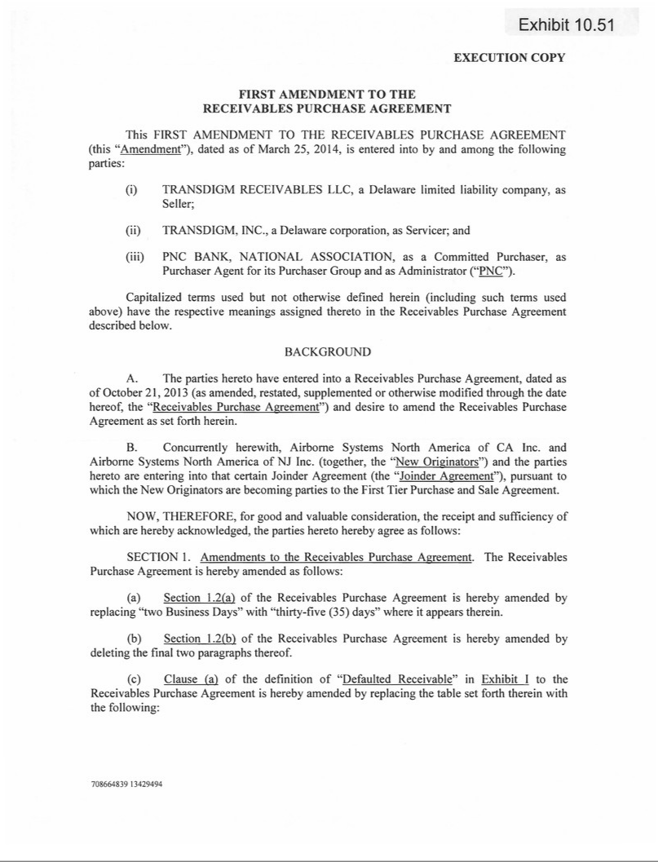

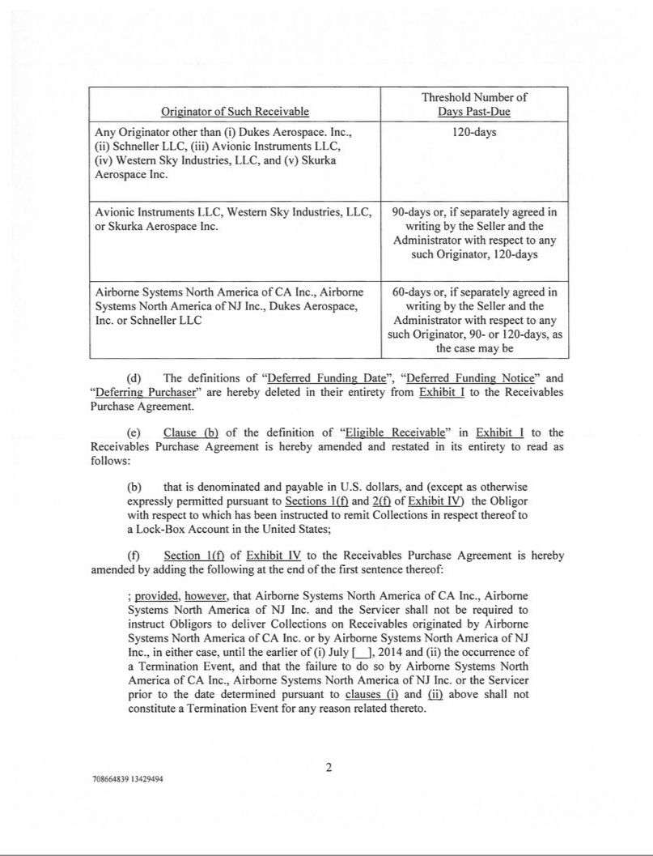

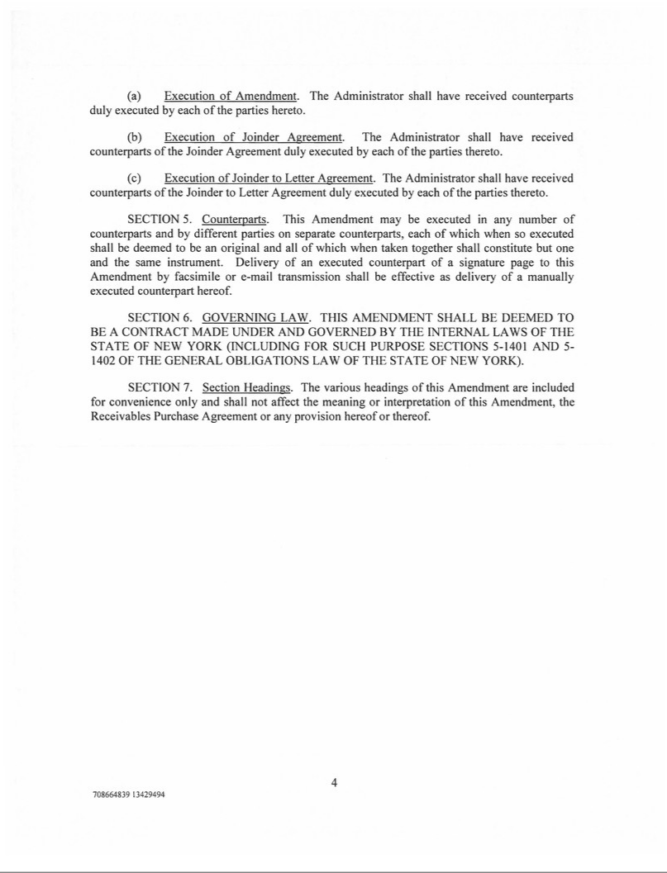

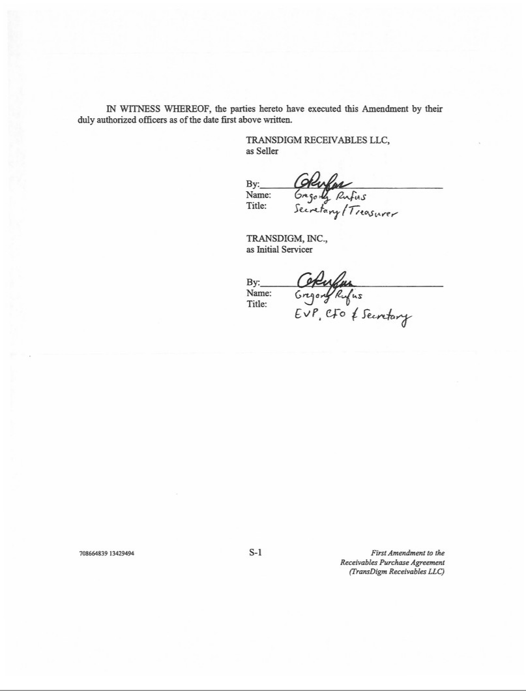



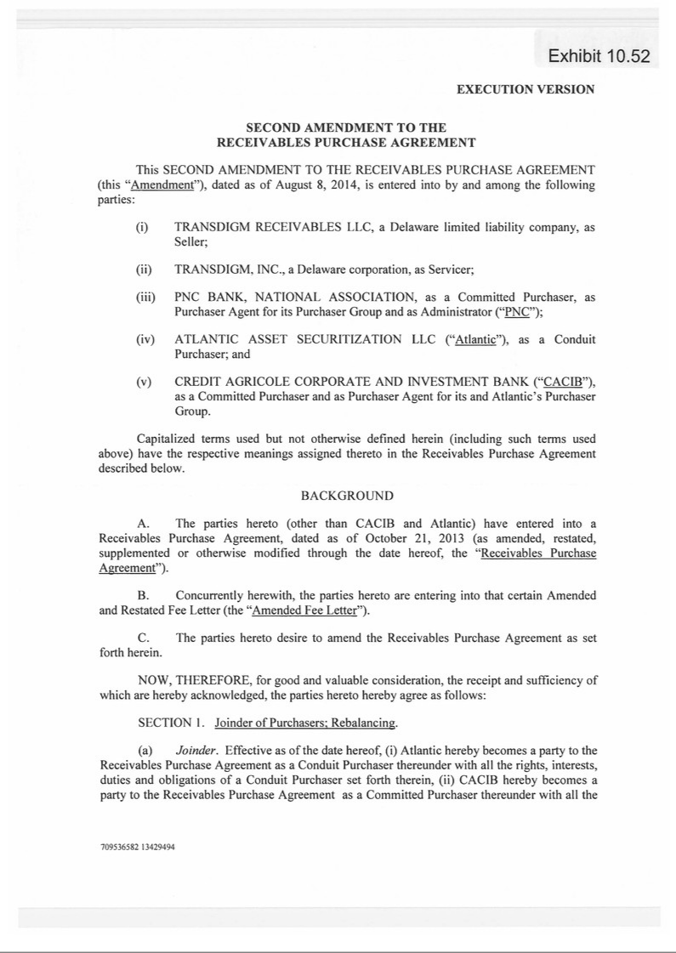

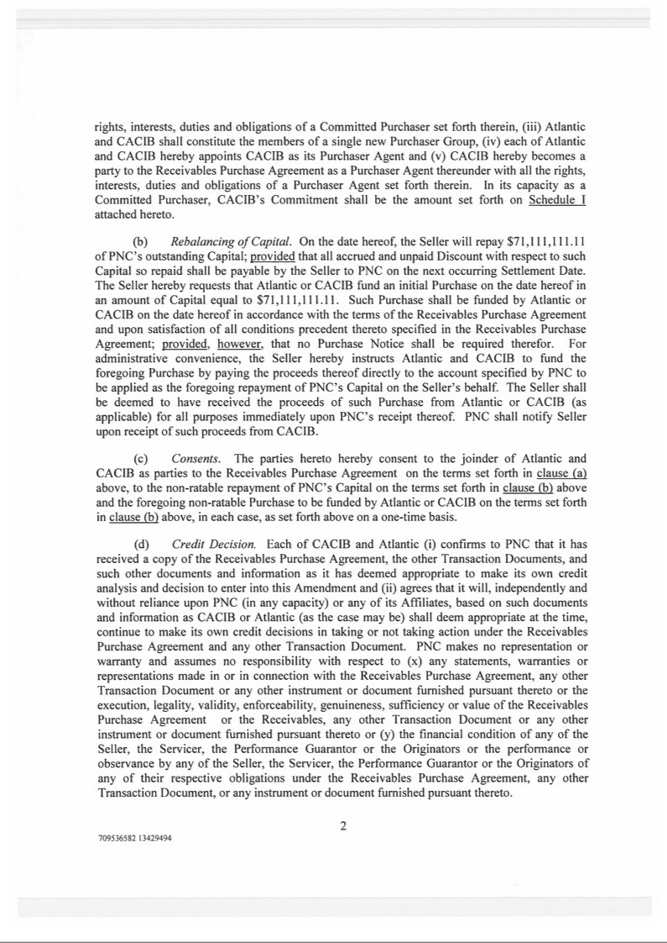

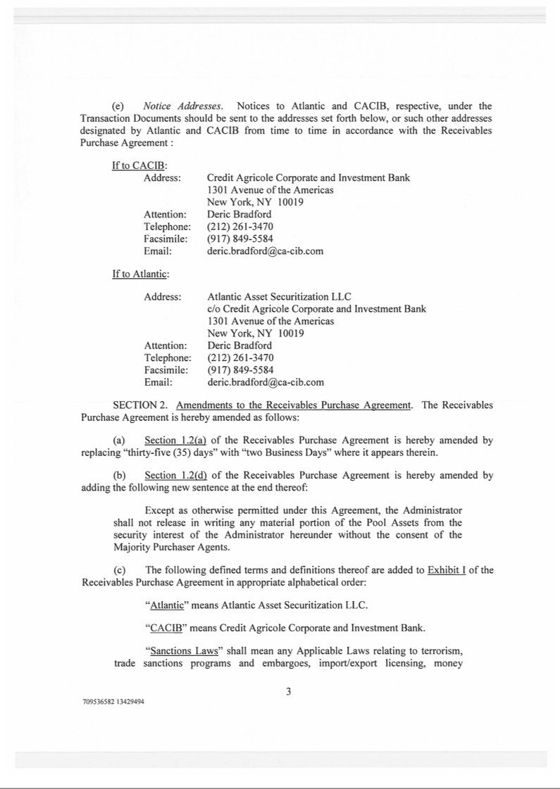

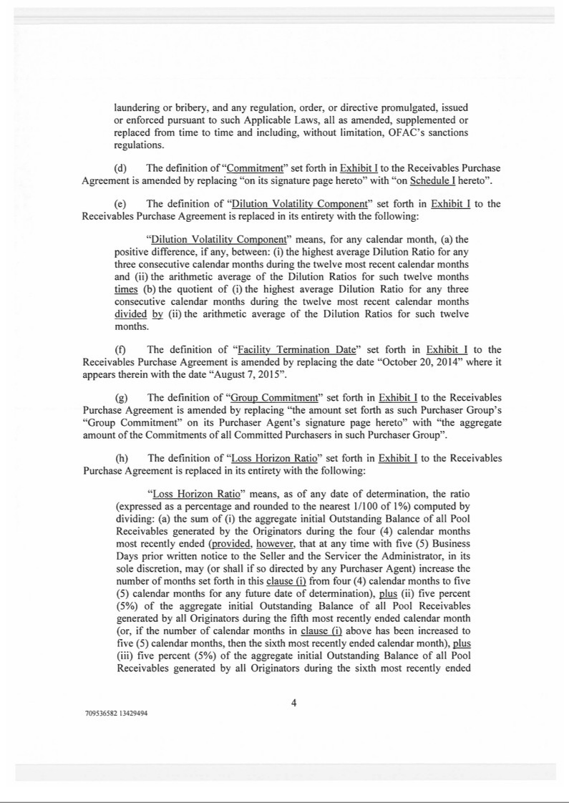

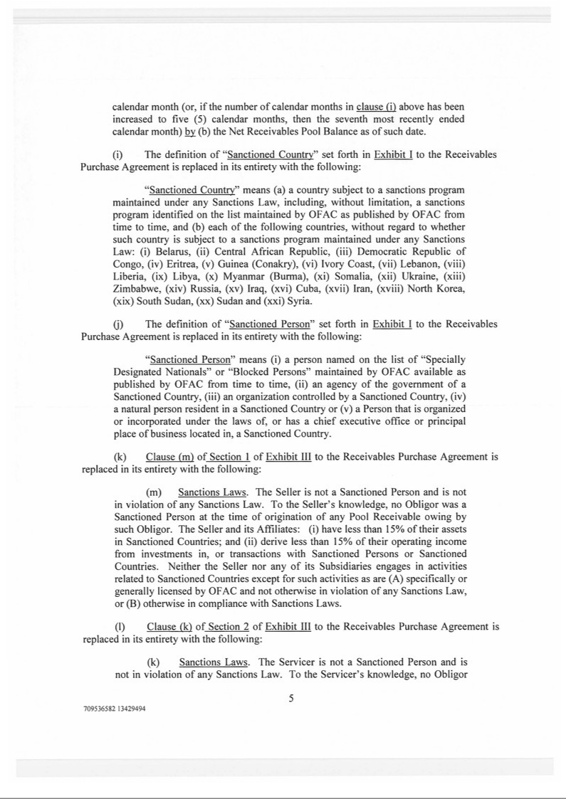

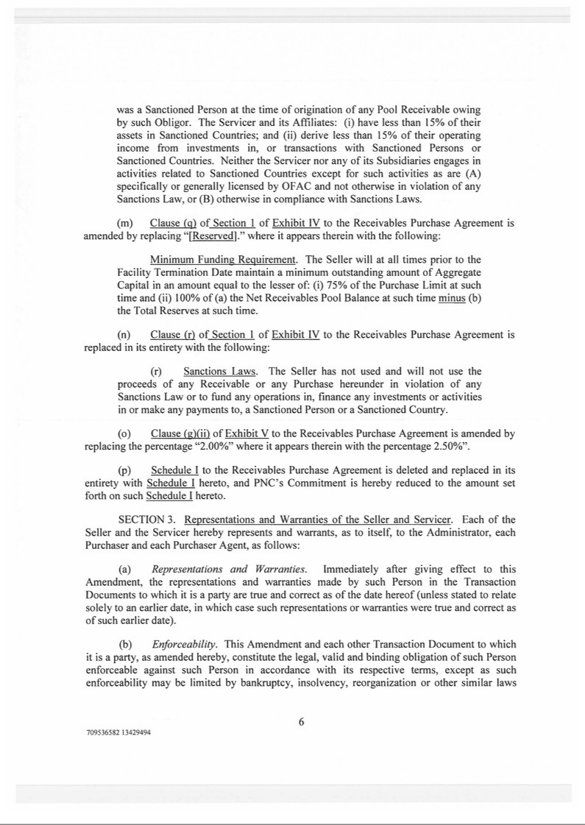

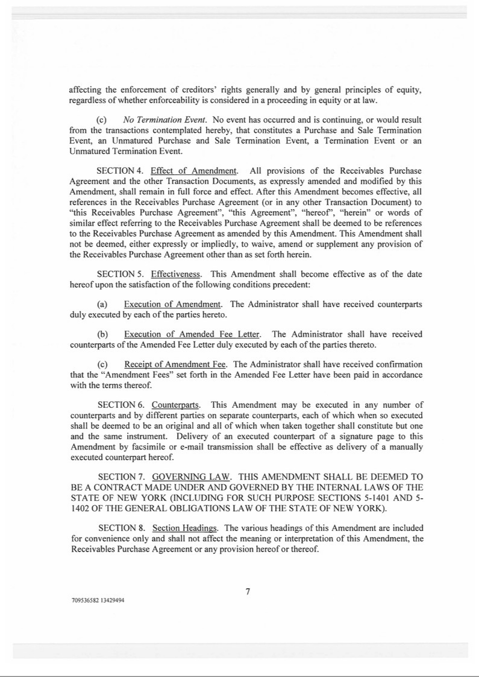

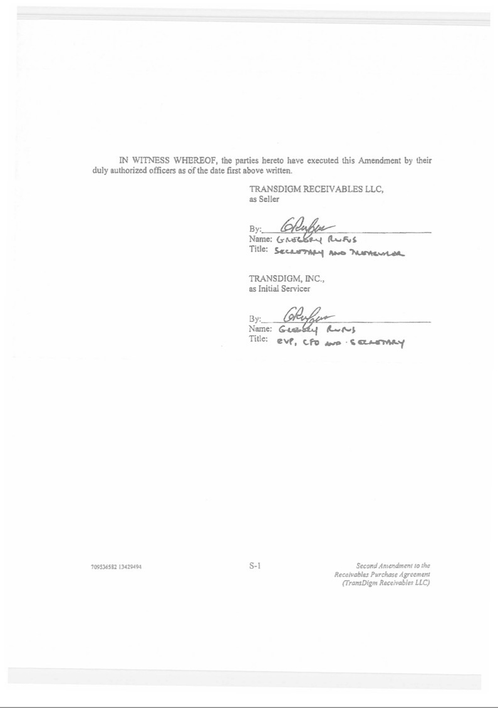



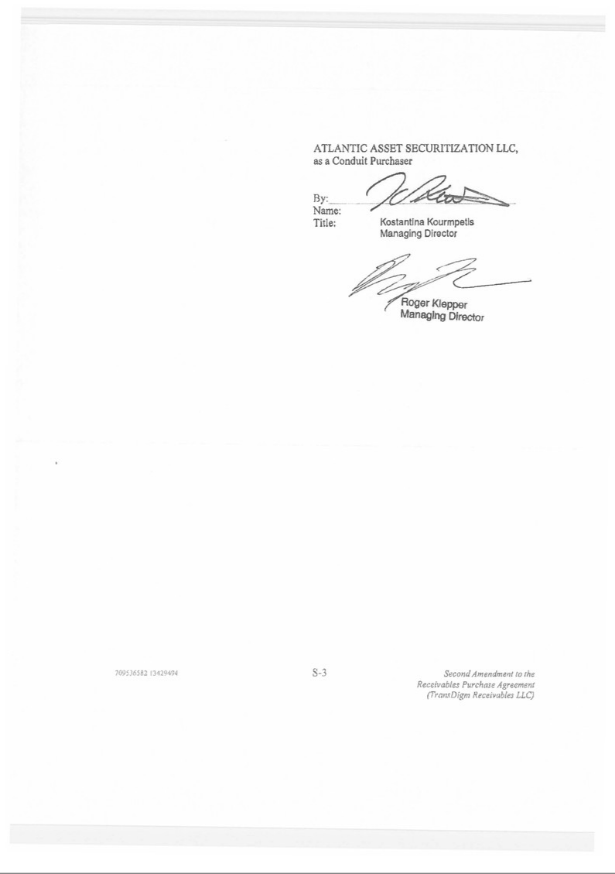

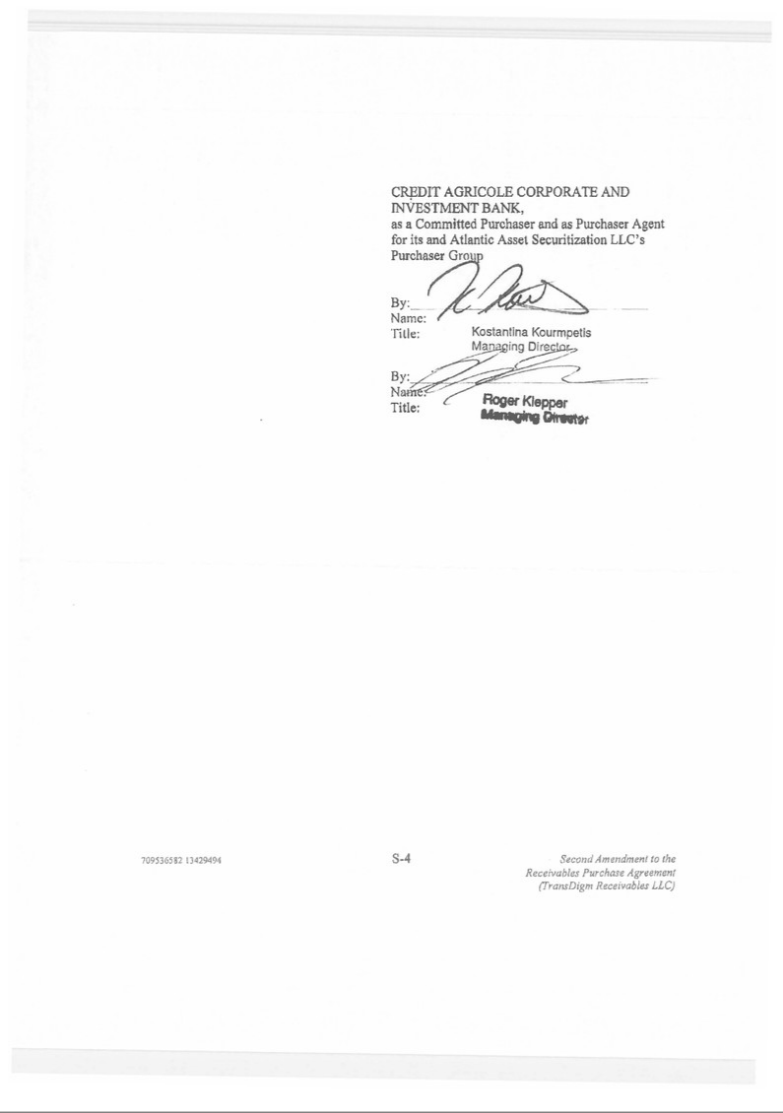



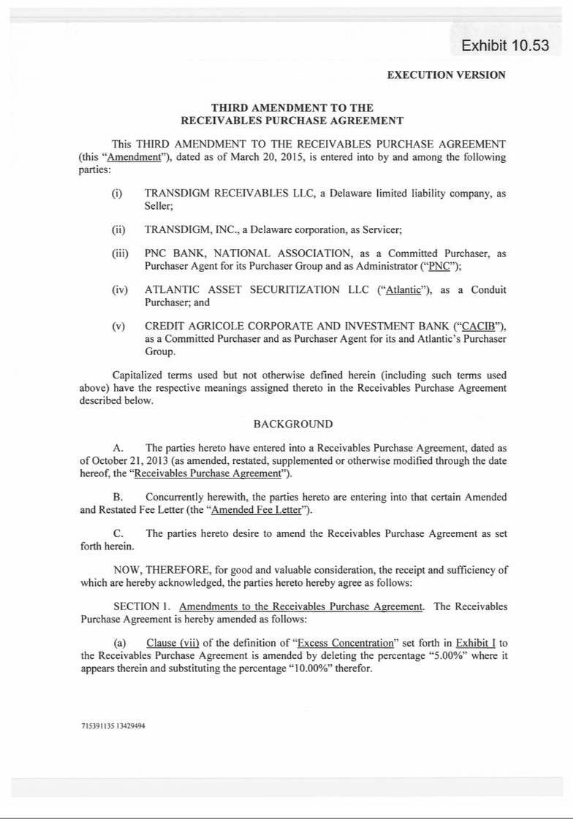

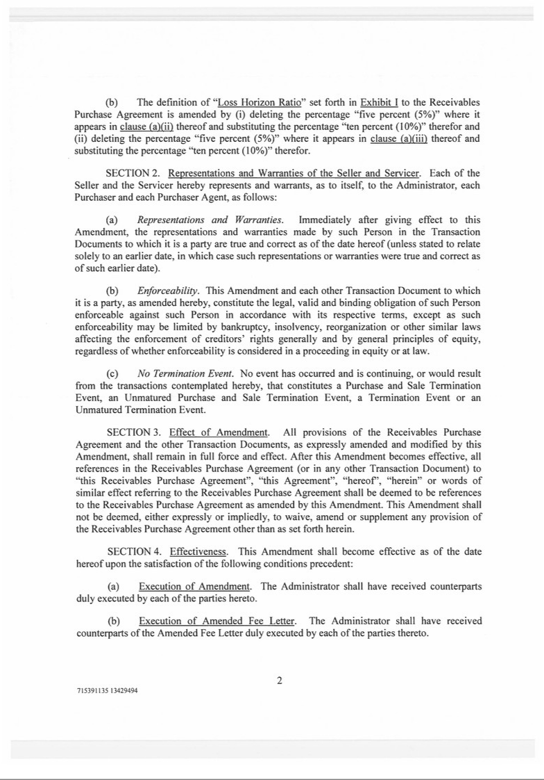

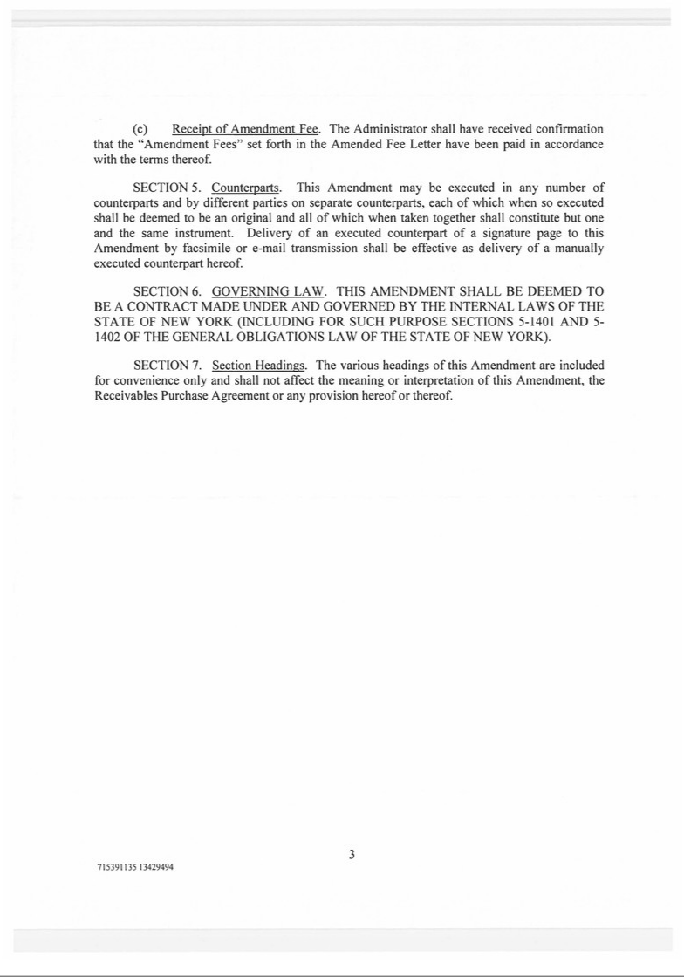

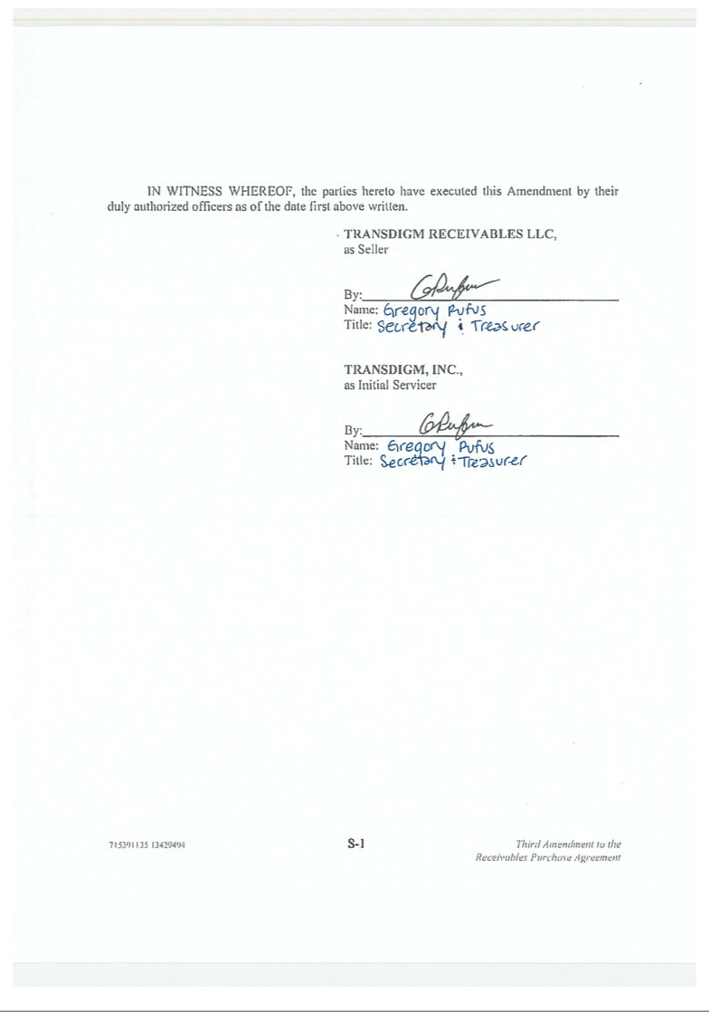



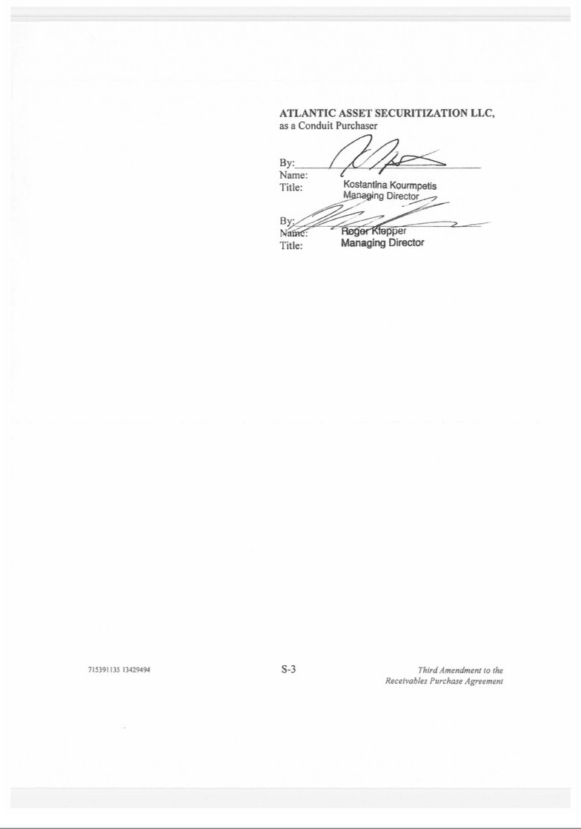

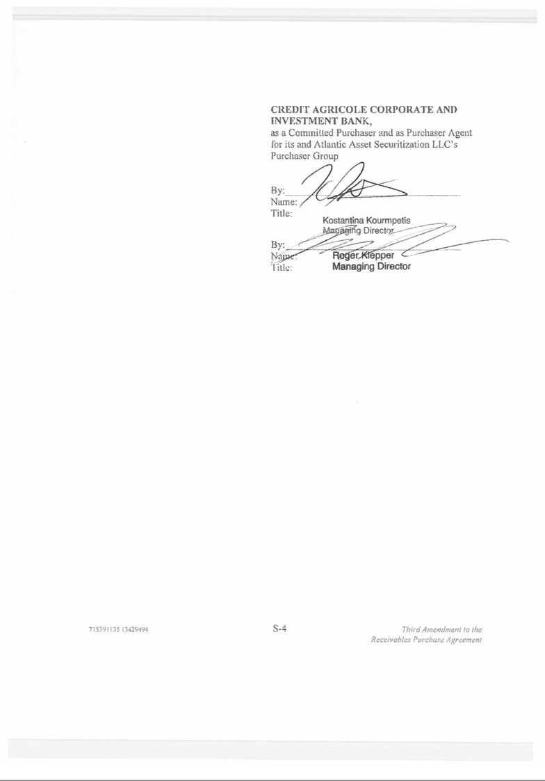

Exhibit 12.1

TRANSDIGM GROUP INCORPORATED

COMPUTATION OF RATIO OF EARNINGS TO FIXED CHARGES

(Amounts in Thousands)

 |  |  |  | Fiscal Year Ended September 30,
 |  | 2015 |  | 2014 |  | 2013 |  | 2012 |  | 2011
Earnings:
Total earnings $ |  | 447,200 |  | $306,910 |  | $302,789 |  | $324,969 |  | $152,225
from
continuing
operations
Income tax |  | 189,600 |  | 141,600 |  | 145,700 |  | 162,900 |  | 77,200
provision
Pre Tax |  | 636,800 |  | 448,510 |  | 448,489 |  | 487,869 |  | 229,425
Earnings
Fixed charges:
Interest |  | 418,785 |  | 347,688 |  | 270,685 |  | 211,906 |  | 185,256
charges
Interest factor |  | 4,631 |  | 3,979 |  | 3,026 |  | 2,602 |  | 1,959
of operating
rents
Total |  | 423,416 |  | 351,667 |  | 273,711 |  | 214,508 |  | 187,215
fixed
charges
Earnings as | $ | 1,060,216 |  | $800,177 |  | $722,200 |  | $702,377 |  | $416,640
adjusted
Ratio of earnings to |  | 2.5 |  | 2.3 |  | 2.6 |  | 3.3 |  | 2.2
fixed charges⁽¹⁾

- For purposes of computing the ratio of earnings to fixed charges, earnings consist of earnings before income taxes plus fixed charges. Fixed charges consist of interest expense, amortization of debt issuance costs and the portion (approximately 33%) of rental expense that management believes is representative of the interest component of rental expense.

Exhibit 21.1

SUBSIDIARIES OF TRANSDIGM GROUP INCORPORATED

TransDigm Inc. is a wholly owned subsidiary of TransDigm Group Incorporated TransDigm Inc. owns directly or indirectly the following subsidiaries:

 |  | State of Jurisdiction of
Name of Subsidiary |  | Incorporation or Organization
Acme Aerospace, Inc. |  | Delaware
Adams Rite Aerospace, Inc. |  | California
Adams Rite Aerospace GmbH |  | Germany
Advanced Inflatable Products Limited |  | England
AeroControlex Group, Inc. |  | Delaware
Aerosonic LLC |  | Delaware
Air-Sea Survival Equipment Trustee Limited |  | England
Airborne Acquisition, Inc. |  | Delaware
Airborne Global, Inc. |  | Delaware
Airborne Holdings, Inc. |  | Delaware
Airborne Systems Canada Ltd. |  | Ontario, Canada
Airborne Systems France |  | France
Airborne Systems Group Limited |  | England
Airborne Systems Holdings Limited |  | England
Airborne Systems Limited |  | England
Airborne Systems NA, Inc. |  | Delaware
Airborne Systems North America Inc. |  | Delaware
Airborne Systems North America of CA Inc. |  | Delaware
Airborne Systems North America of NJ Inc. |  | New Jersey
Airborne Systems Pension Trustee Limited |  | England
Airborne UK Acquisition Limited |  | England
Airborne UK Parent Limited |  | England
Aircraft Materials Limited |  | England
AmSafe, Inc. |  | Delaware
AmSafe Aviation (Chongqing), Ltd. |  | China
AmSafe Bridport Ltd. |  | England
AmSafe Bridport (Kunshan) Co., Ltd. |  | China
AmSafe Bridport (Private) Ltd. |  | Sri Lanka
AmSafe Global Holdings, Inc. |  | Delaware
AmSafe Global Services (Private) Limited |  | Sri Lanka
ARA Holding GmbH |  | Germany
Arkwin Industries, Inc. |  | New York
Aviation Technologies, Inc. |  | Delaware
Avionic Instruments LLC |  | Delaware
Avionics Specialties, Inc. |  | Virginia
AvtechTyee, Inc. |  | Washington

 |  | State of Jurisdiction of
Name of Subsidiary |  | Incorporation or Organization
Bridport—Air Carrier, Inc. |  | Washington
Bridport Erie Aviation, Inc. |  | Delaware
Bridport Holdings, Inc. |  | Delaware
Bridport Ltd. |  | England
Bruce Aerospace, Inc. |  | Delaware
CDA InterCorp LLC |  | Florida
CEF Industries, LLC |  | Delaware
Champion Aerospace LLC |  | Delaware
Dukes Aerospace, Inc. |  | Delaware
Edlaw Limited |  | England
Electromech Technologies LLC |  | Delaware
Elektro-Metall Export GmbH |  | Germany
Elektro-Metall Paks KFT |  | Hungary
GC Parachutes Limited |  | England
HARCO LLC |  | Connecticut
Hartwell Corporation |  | California
Irwin Aerospace Limited |  | England
Irwin-GQ Limited |  | England
Kunshan Shield Restraint Systems, Ltd. |  | China
Marathon Power Technologies Limited |  | England
MarathonNorco Aerospace, Inc. |  | Delaware
McKechnie Aerospace DE, Inc. |  | Delaware
McKechnie Aerospace (Europe) Ltd. |  | England
McKechnie Aerospace Holdings, Inc. |  | Delaware
McKechnie Aerospace Investments, Inc. |  | Delaware
McKechnie Aerospace US LLC |  | Delaware
Mecanismos de Matamoros S.A. de C.V. |  | Mexico
Militair Aviation, Ltd. |  | England
Nordisk Asia Pacific Limited |  | Hong Kong
Nordisk Asia Pacific Pte Ltd |  | Singapore
Nordisk Aviation Products AS |  | Norway
Nordisk Aviation Products (Kunshan) Ltd. |  | China
Pexco Aerospace, Inc. |  | Delaware
PneuDraulics, Inc. |  | California
Schneller Asia Pte. Ltd. |  | Singapore
Schneller LLC |  | Delaware
Schneller S.A.R.L. |  | France
Semco Instruments, Inc. |  | Delaware
Shield Restraint Systems, Inc. |  | Delaware
Shield Restraint Systems Ltd. |  | England
Skurka Aerospace, Inc. |  | Delaware

 |  | State of Jurisdiction of
Name of Subsidiary |  | Incorporation or Organization
TDG Cayman Limited |  | Cayman Islands
TDG Germany GmbH |  | Germany
TDG Netherlands BV |  | Netherlands
Technical Airborne Components Limited |  | England
Technical Airborne Components Industries SPRL |  | Belgium
Telair US LLC |  | Delaware
Telair International AB |  | Sweden
Telair International GmbH |  | Germany
Telair International LLC |  | Delaware
Telair International Services PTE Ltd (JV 70.5%) |  | Singapore
Texas Rotronics, Inc. |  | Texas
TransDigm Holdings UK Limited |  | UK
TransDigm Ireland Ltd. |  | Ireland
TransDigm Receivables LLC |  | Delaware
Transicoil (Malaysia) Sendirian Berhad |  | Malaysia
Transicoil LLC |  | Delaware
Whippany Actuation Systems, LLC |  | Delaware

Exhibit 23.1

Consent of Independent Registered Public Accounting Firm We consent to the incorporation by reference in the following Registration Statements:

- Registration Statements (Form S-8 No. 333-174122 and Form S-8 No. 333-152847) pertaining to the TransDigm Group Incorporated 2006 Stock Incentive Plan,

- Registration Statement (Form S-8 No. 333-132808) pertaining to the TransDigm Group Incorporated 2006 Stock Incentive Plan and the TransDigm Group Fourth Amended and Restated 2003 Stock Option Plan, as amended, and

- Registration Statement (Form S-8 No. 333-200204) pertaining to the TransDigm Group 2014 Stock Option Plan;

of our reports dated November 13, 2015, with respect to the consolidated financial statements and schedule of TransDigm Group Incorporated and the effectiveness of internal control over financial reporting of TransDigm Group Incorporated included in this Annual Report (Form 10-K) of TransDigm Group Incorporated for the year ended September 30, 2015.

/s/ Ernst & Young LLP

Cleveland, Ohio

November 13, 2015

Exhibit 31.1

CERTIFICATION

I, W. Nicholas Howley, certify that:

- I have reviewed this annual report on Form 10-K of TransDigm Group Incorporated;

- Based on my knowledge, this report does not contain any untrue statement of a material fact or omit to state a material fact necessary to make the statements made, in light of the circumstances under which such statements were made, not misleading with respect to the period covered by this report;

- Based on my knowledge, the financial statements, and other financial information included in this report, fairly present in all material respects the financial condition, results of operations and cash flows of the registrant as of, and for, the periods presented in this report;

- The registrant’s other certifying officer and I are responsible for establishing and maintaining disclosure controls and procedures (as defined in Exchange Act Rules 13a-15(e) and 15d-15(e)) and internal control over financial reporting (as defined in Exchange Act Rules 13a-15(f) and 15d-15(f)) for the registrant and have:

  - designed such disclosure controls and procedures, or caused such disclosure controls and procedures to be designed under our supervision, to ensure that material information relating to the registrant, including its consolidated subsidiaries, is made known to us by others within those entities, particularly during the period in which this report is being prepared;
  - designed such internal control over financial reporting, or caused such internal control over financial reporting to be designed under our supervision, to provide reasonable assurance regarding the reliability of financial reporting and the preparation of financial statements for external purposes in accordance with generally accepted accounting principles;

  - evaluated the effectiveness of the registrant’s disclosure controls and procedures and presented in this report our conclusions about the effectiveness of the disclosure controls and procedures, as of the end of the period covered by this report based on such evaluation; and

  - disclosed in this report any change in the registrant’s internal control over financial reporting that occurred during the registrant’s fourth fiscal quarter that has materially affected, or is reasonably likely to materially affect, the registrant’s internal control over financial reporting; and

- The registrant’s other certifying officer and I have disclosed, based on our most recent evaluation of internal control over financial reporting, to the registrant’s auditors and the audit committee of the registrant’s Board of Directors:

  - all significant deficiencies and material weaknesses in the design or operation of internal control over financial reporting which are reasonably likely to adversely affect the registrant’s ability to record, process, summarize and report financial information; and
  - any fraud, whether or not material, that involves management or other employees who have a significant role in the registrant’s internal control over financial reporting.

Date: November 13, 2015

/s/ W. Nicholas Howley

Name: W. Nicholas Howley

Title: Chairman of the Board of Directors, President and Chief

Executive Officer (Principal Executive Officer)

Exhibit 31.2

CERTIFICATION

I, Terrance M. Paradie, certify that:

  - I have reviewed this annual report on Form 10-K of TransDigm Group Incorporated;

  - Based on my knowledge, this report does not contain any untrue statement of a material fact or omit to state a material fact necessary to make the statements made, in light of the circumstances under which such statements were made, not misleading with respect to the period covered by this report;

  - Based on my knowledge, the financial statements, and other financial information included in this report, fairly present in all material respects the financial condition, results of operations and cash flows of the registrant as of, and for, the periods presented in this report;

  - The registrant’s other certifying officer and I are responsible for establishing and maintaining disclosure controls and procedures (as defined in Exchange Act Rules 13a-15(e) and 15d-15(e)) and internal control over financial reporting (as defined in Exchange Act Rules 13a-15(f) and 15d-15(f)) for the registrant and have:

    - designed such disclosure controls and procedures, or caused such disclosure controls and procedures to be designed under our supervision, to ensure that material information relating to the registrant, including its consolidated subsidiaries, is made known to us by others within those entities, particularly during the period in which this report is being prepared;
    - designed such internal control over financial reporting, or caused such internal control over financial reporting to be designed under our supervision, to provide reasonable assurance regarding the reliability of financial reporting and the preparation of financial statements for external purposes in accordance with generally accepted accounting principles;

    - evaluated the effectiveness of the registrant’s disclosure controls and procedures and presented in this report our conclusions about the effectiveness of the disclosure controls and procedures, as of the end of the period covered by this report based on such evaluation; and

    - disclosed in this report any change in the registrant’s internal control over financial reporting that occurred during the registrant’s fourth fiscal quarter that has materially affected, or is reasonably likely to materially affect, the registrant’s internal control over financial reporting; and

- The registrant’s other certifying officer and I have disclosed, based on our most recent evaluation of internal control over financial reporting, to the registrant’s auditors and the audit committee of the registrant’s Board of Directors:

    - all significant deficiencies and material weaknesses in the design or operation of internal control over financial reporting which are reasonably likely to adversely affect the registrant’s ability to record, process, summarize and report financial information; and
    - any fraud, whether or not material, that involves management or other employees who have a significant role in the registrant’s internal control over financial reporting.

Date: November 13, 2015

/s/ Terrance M. Paradie

Name: Terrance M. Paradie

Title: Executive Vice President and Chief

Financial Officer (Principal Financial and Accounting Officer)

Exhibit 32.1

CERTIFICATION PURSUANT TO

18 U.S.C. SECTION 1350,

AS ADOPTED PURSUANT TO SECTION 906 OF THE SARBANES-OXLEY ACT OF 2002

In connection with the Annual Report on Form 10-K of TransDigm Group Incorporated (the “Company”) for the fiscal year ended September 30, 2015 as filed with the Securities and Exchange Commission on the date hereof (the “Report”), I, W. Nicholas Howley, Chief Executive Officer and Director (Principal Executive Officer), certify, pursuant to 18 U.S.C. Section 1350, as adopted pursuant to Section 906 of the Sarbanes-Oxley Act of 2002, that, to my knowledge:

- The Report fully complies with the requirements of Section 13(a) or 15(d) of the Securities and Exchange Act of 1934; and

- The information contained in the Report fairly presents in all material respects, the financial condition of the Company as of the dates indicated and results of operations of the Company for the periods indicated.

Date: November 13, 2015

/s/ W. Nicholas Howley

Name: W. Nicholas Howley

Title: Chairman of the Board of Directors, President and Chief

Executive Officer (Principal Executive Officer)

Exhibit 32.2

CERTIFICATION PURSUANT TO

18 U.S.C. SECTION 1350,

AS ADOPTED PURSUANT TO SECTION 906 OF THE SARBANES-OXLEY ACT OF 2002

In connection with the Annual Report on Form 10-K of TransDigm Group Incorporated (the “Company”) for the fiscal year ended September 30, 2015 as filed with the Securities and Exchange Commission on the date hereof (the “Report”), I, Gregory Rufus, Executive Vice President, Chief Financial Officer and Secretary (Principal Financial and Accounting Officer) certify, pursuant to 18 U.S.C. Section 1350, as adopted pursuant to Section 906 of the Sarbanes-Oxley Act of 2002, that, to my knowledge:

- The Report fully complies with the requirements of Section 13(a) or 15(d) of the Securities and Exchange Act of 1934; and

- The information contained in the Report fairly presents in all material respects, the financial condition of the Company as of the dates indicated and results of operations of the Company for the periods indicated.

Date: November 13, 2015

/s/ Terrance M. Paradie

Name: Terrance M. Paradie

Title: Executive Vice President and Chief

Financial Officer (Principal Financial and Accounting Officer)

