UNITED STATES

SECURITIES AND EXCHANGE COMMISSION

Washington, D.C. 20549

Schedule 14A

Proxy Statement Pursuant to Section 14(a) of the

Securities Exchange Act of 1934

(Amendment No. )

Filed by the Registrant x Filed by a party other than the Registrant ☐

Check the appropriate box:

- Preliminary Proxy Statement

- Confidential, for Use of the Commission Only (as permitted by Rule 14a-6(e)(2))

- Definitive Proxy Statement

- Definitive Additional Materials

- Soliciting Materials Pursuant to §240.14a-12

TransDigm Group Incorporated

(Name of registrant as specified in its charter)

(Name of Person(s) Filing Proxy Statement, if other than the Registrant)

Payment of Filing Fee (Check the appropriate box):

- No fee required.

- Fee computed on table below per Exchange Act Rules 14a-6(i)(1) and 0-11.

- Title of each class of securities to which transaction applies:

- Aggregate number of securities to which transaction applies:

- Per unit price or other underlying value of transaction computed pursuant to Exchange Act Rule 0-11 (set forth the amount on which the filing fee is calculated and state how it was determined):

- Proposed maximum aggregate value of transaction:

- Total fee paid:

- Fee paid previously with preliminary materials.

- Check box if any part of the fee is offset as provided by Exchange Act Rule 0-11(a)(2) and identify the filing for which the offsetting fee was paid previously. Identify the previous filing by registration statement number, or the Form or Schedule and the date of its filing.

- Amount previously paid:

- Form, Schedule or Registration Statement No.:

- Filing party:

- Date Filed:

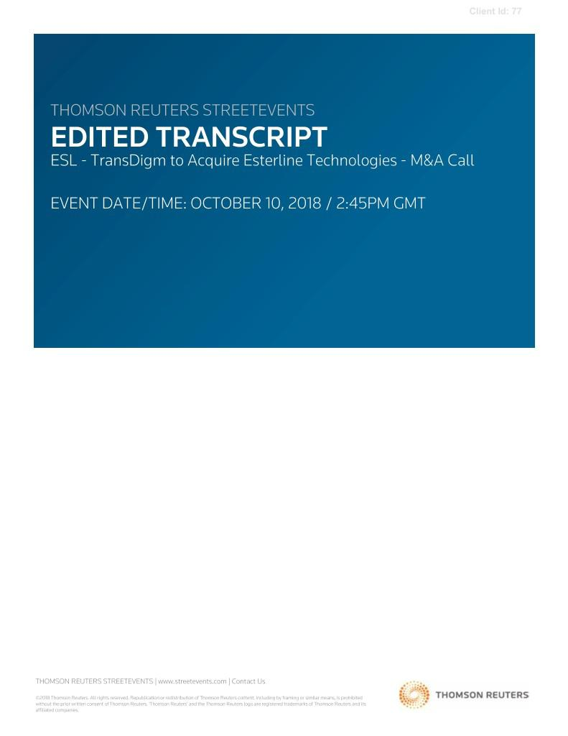

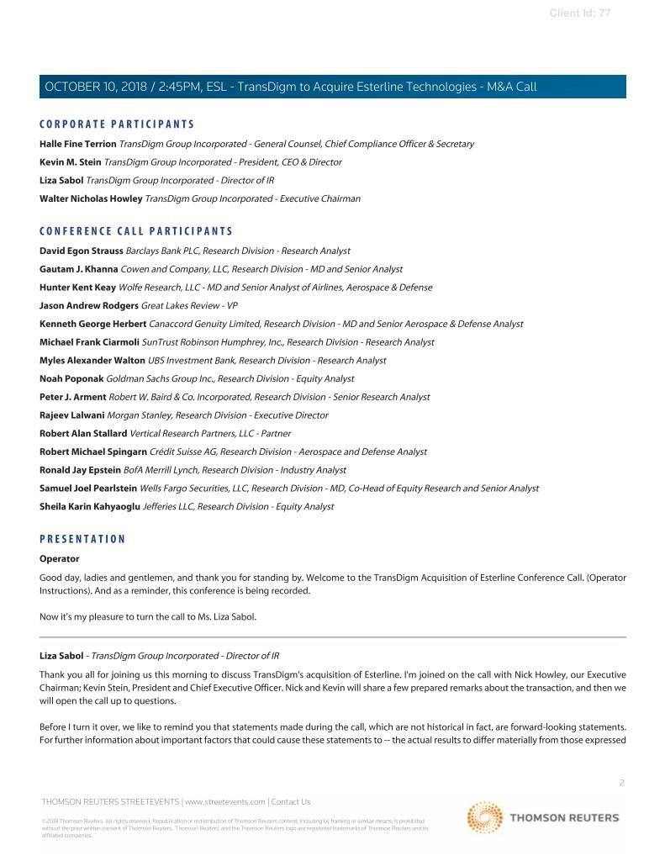

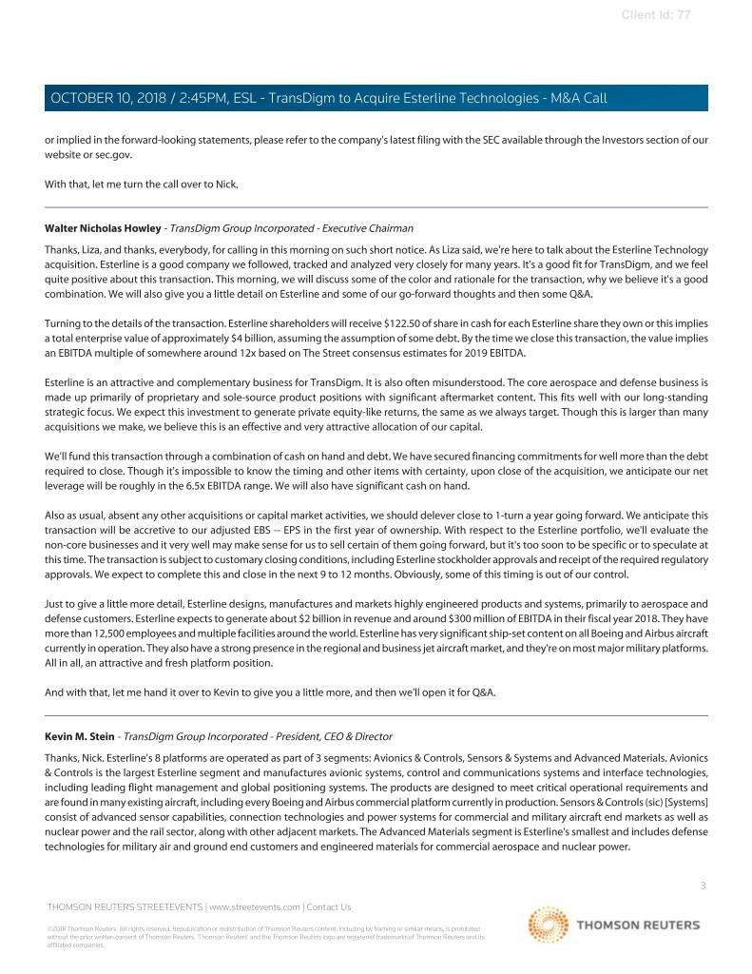

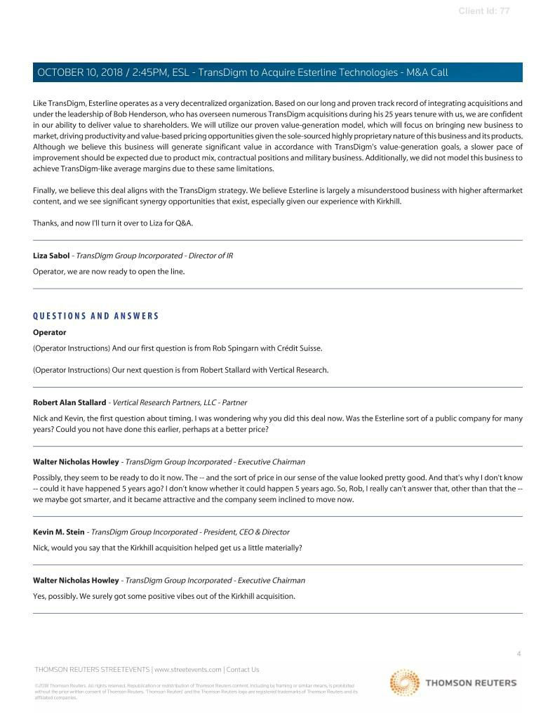

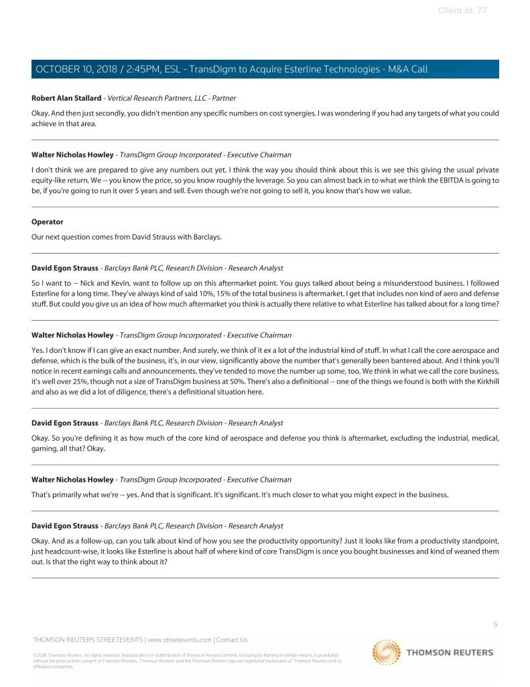

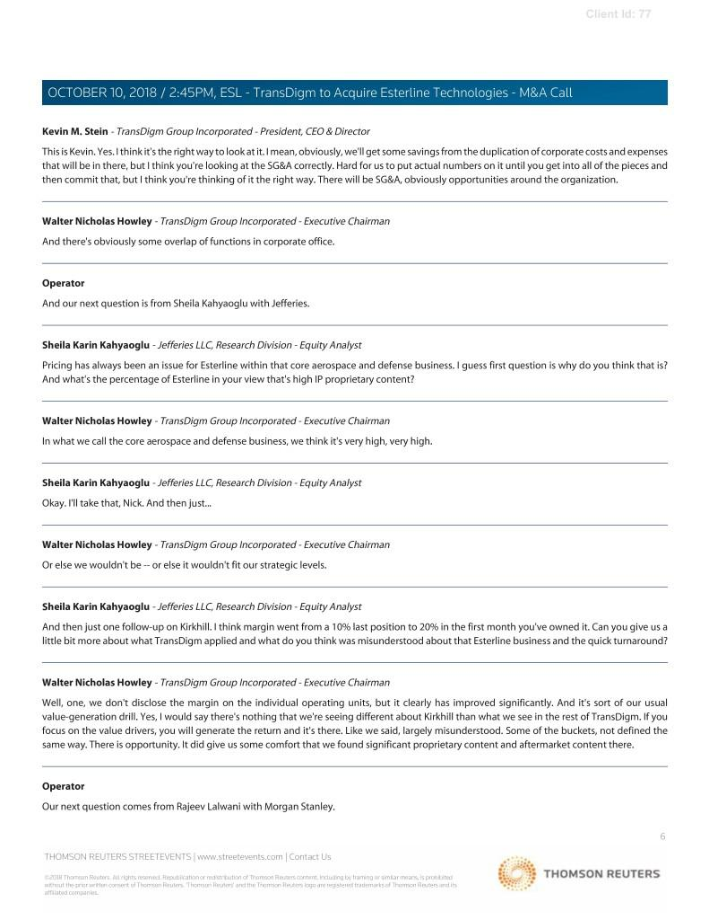

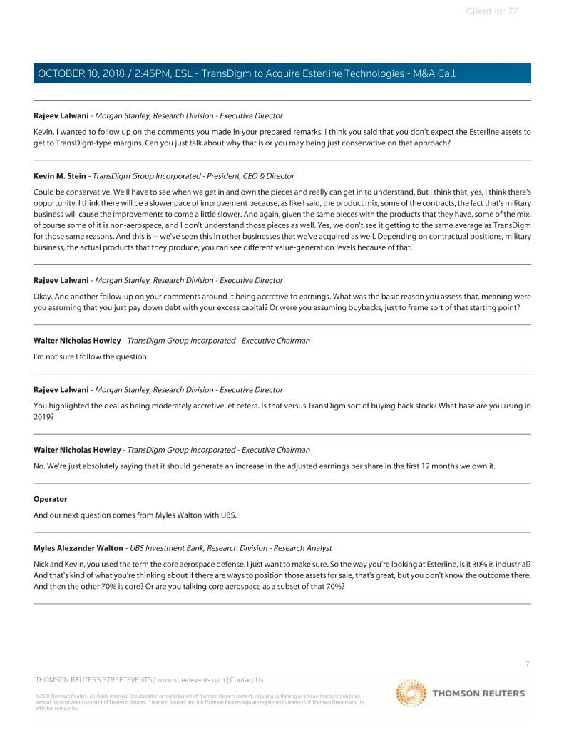

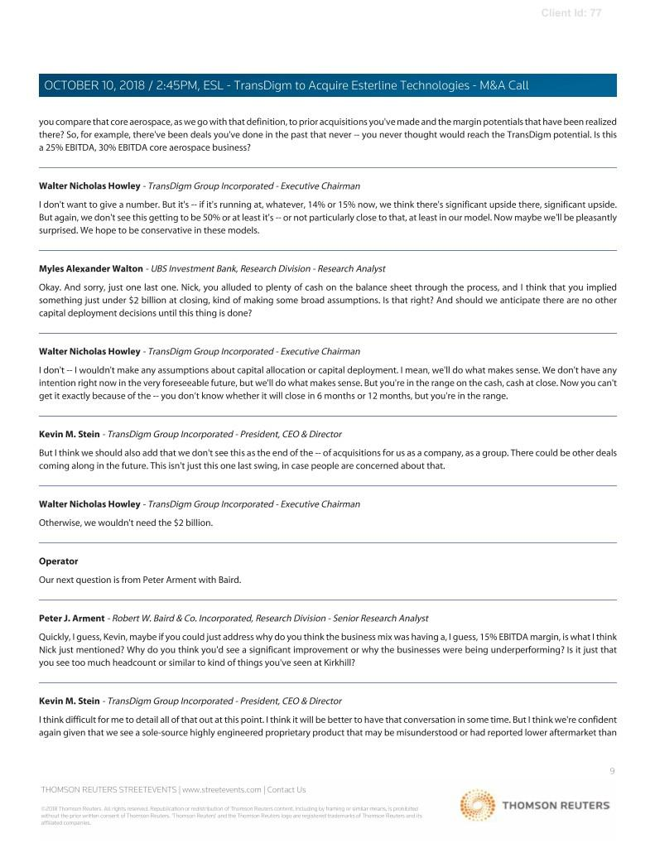

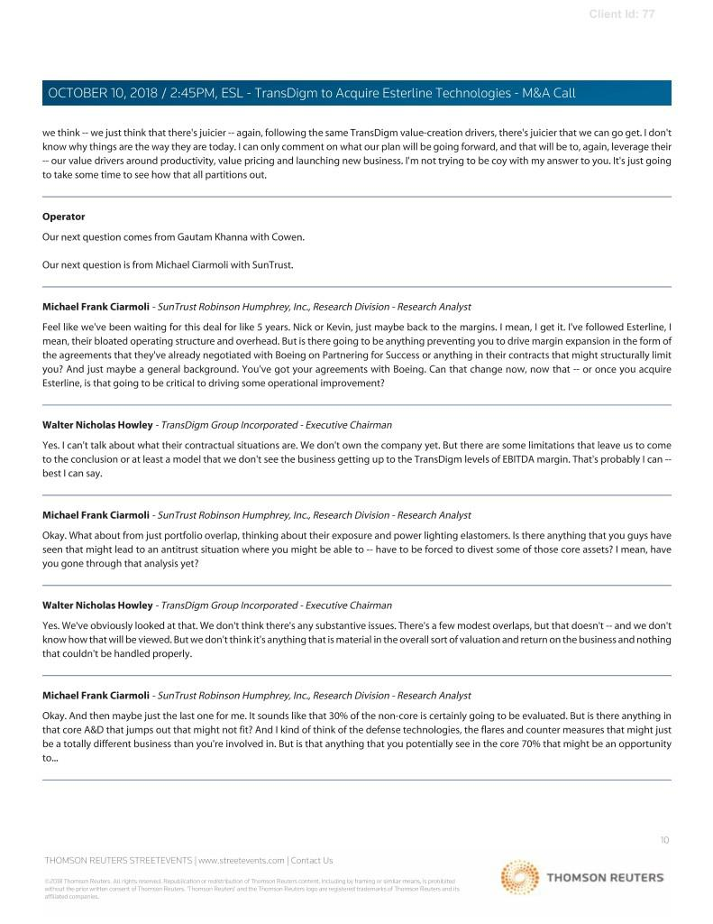

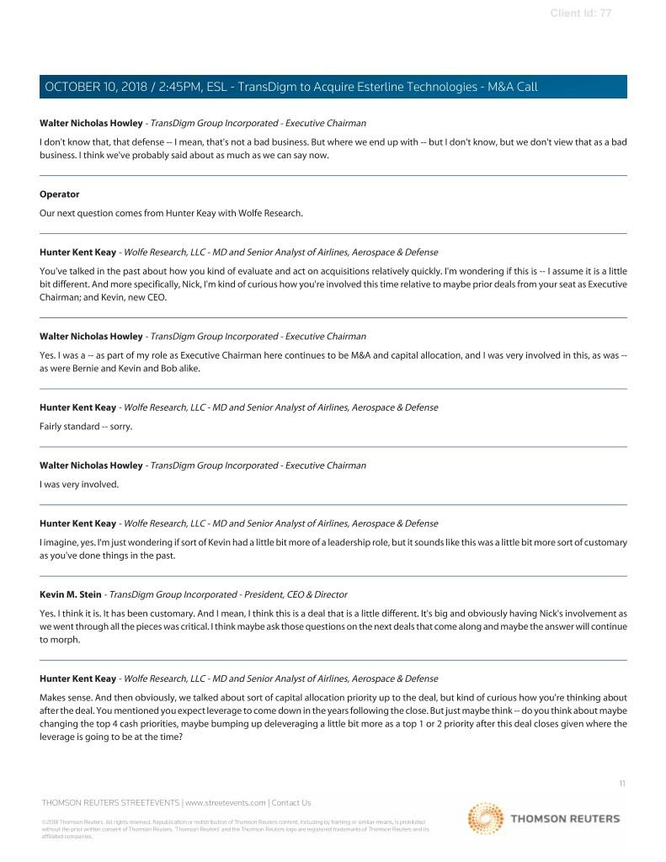

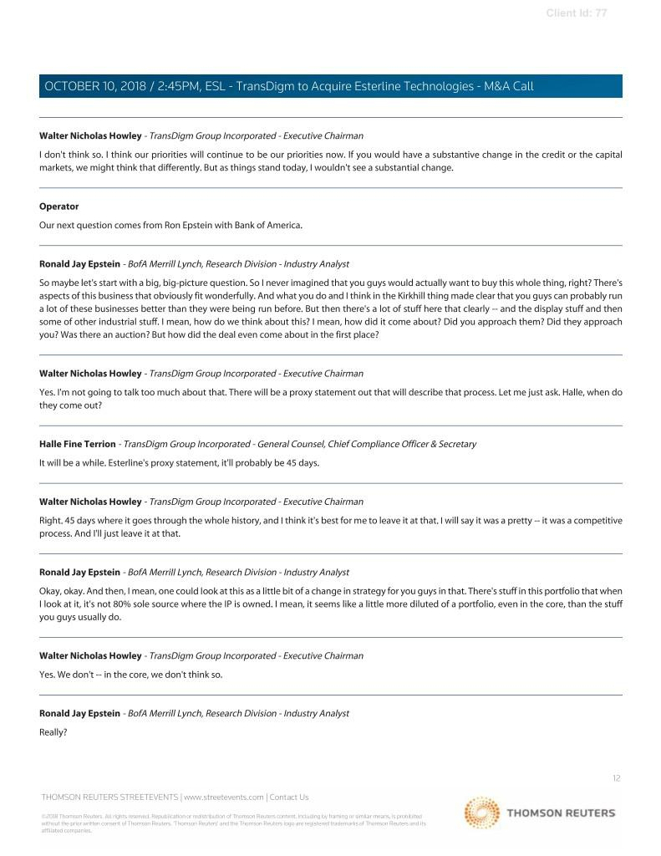

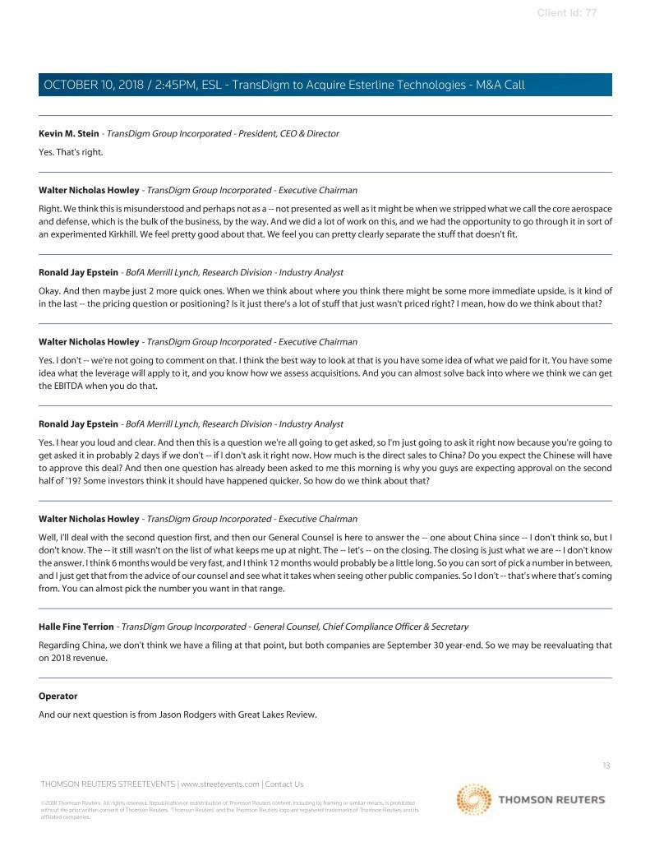

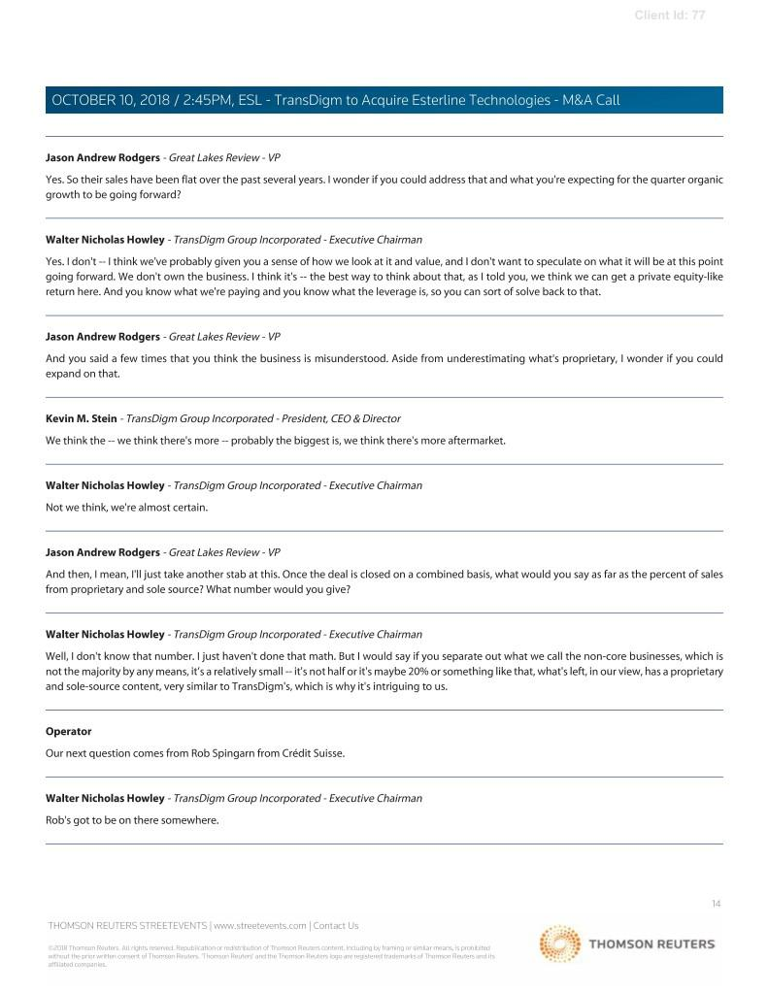

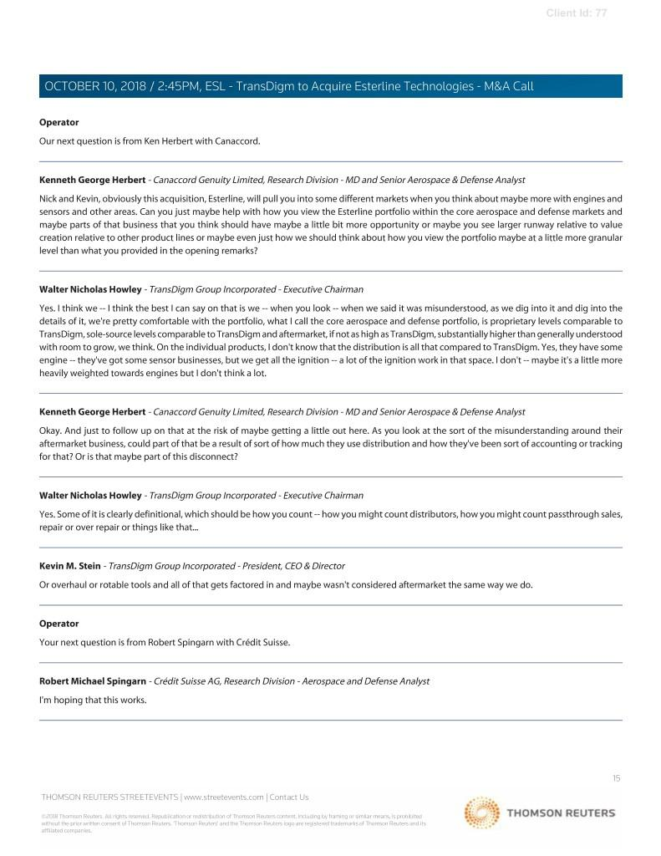

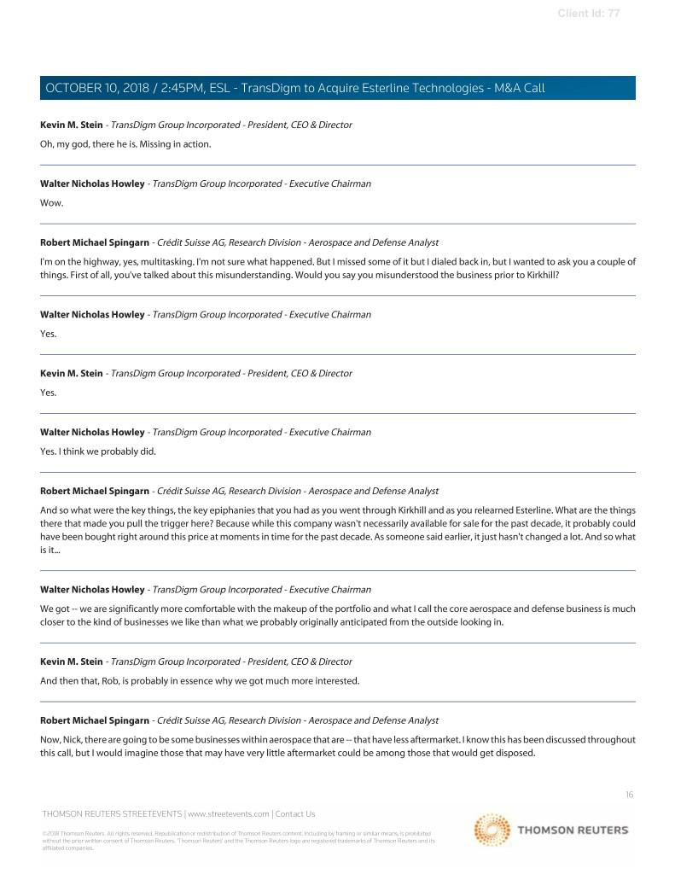

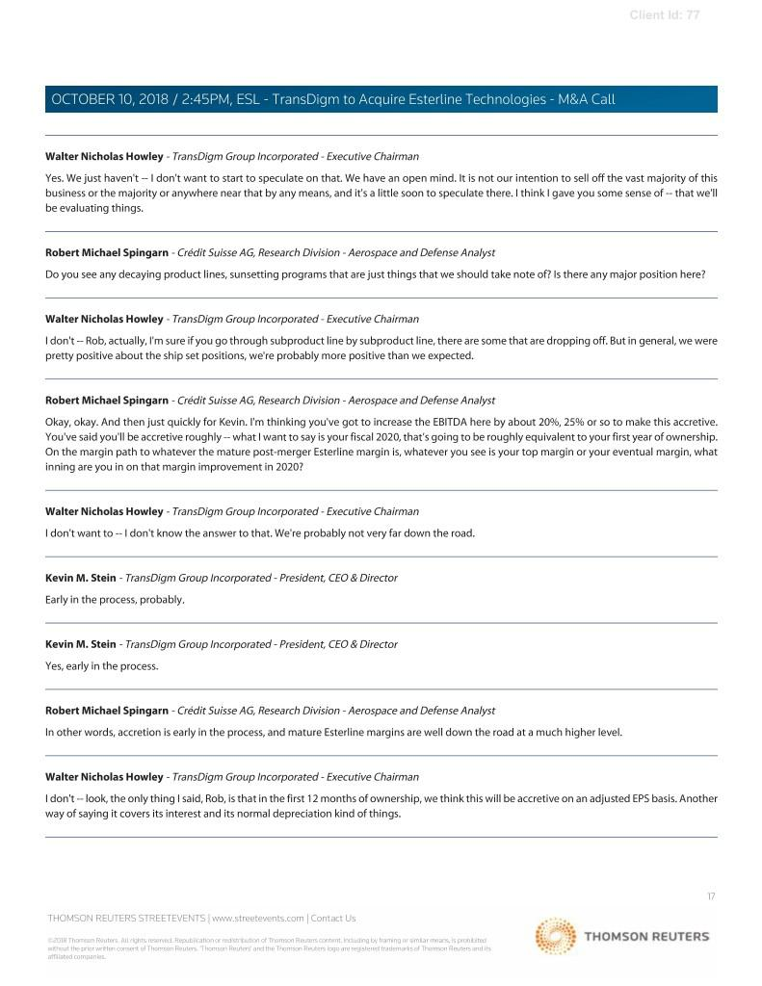

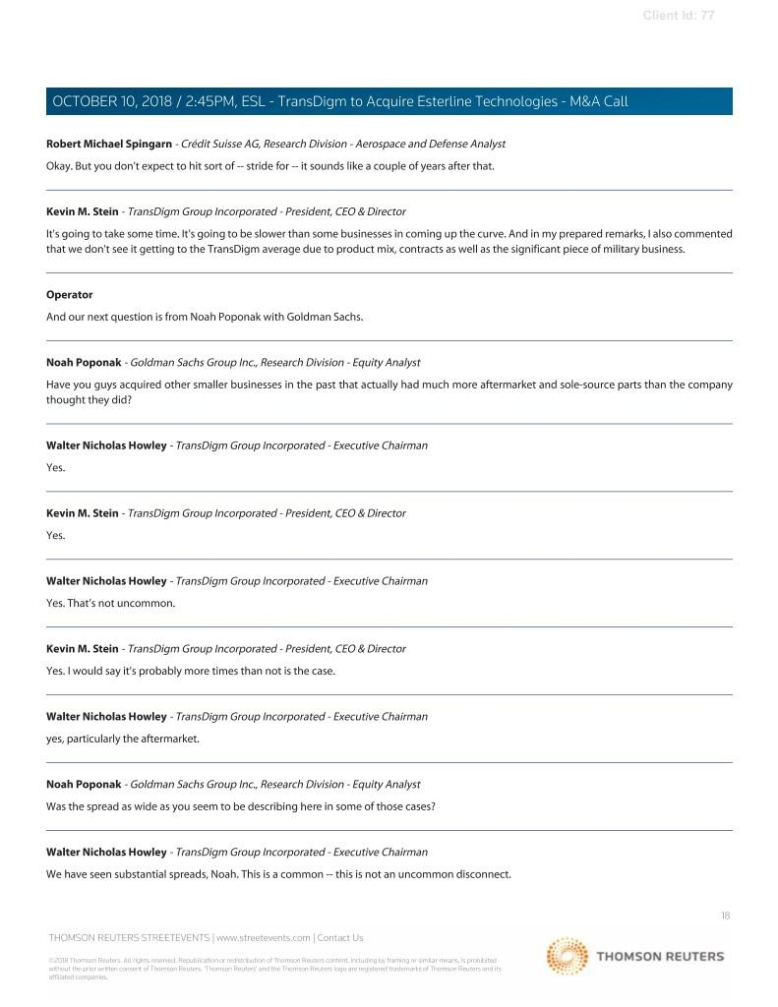

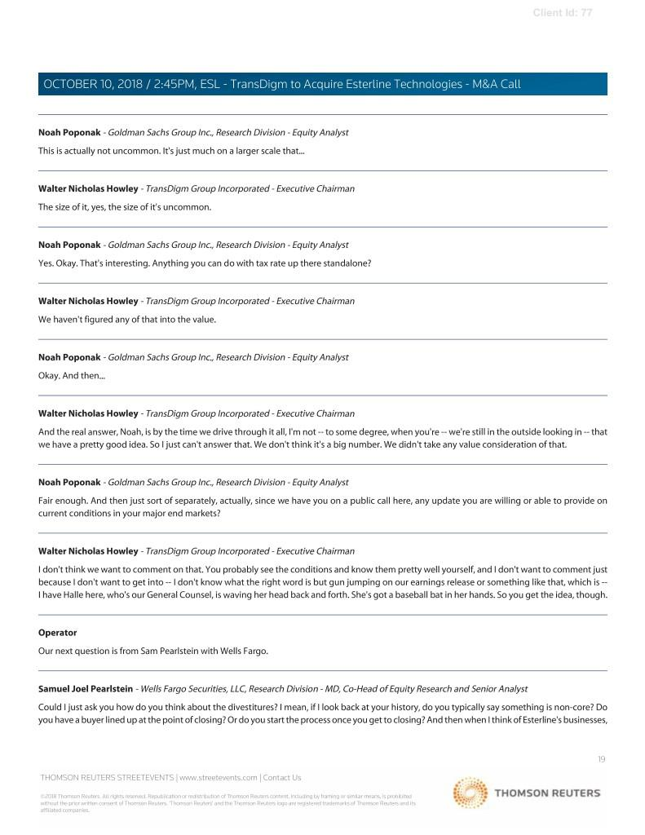

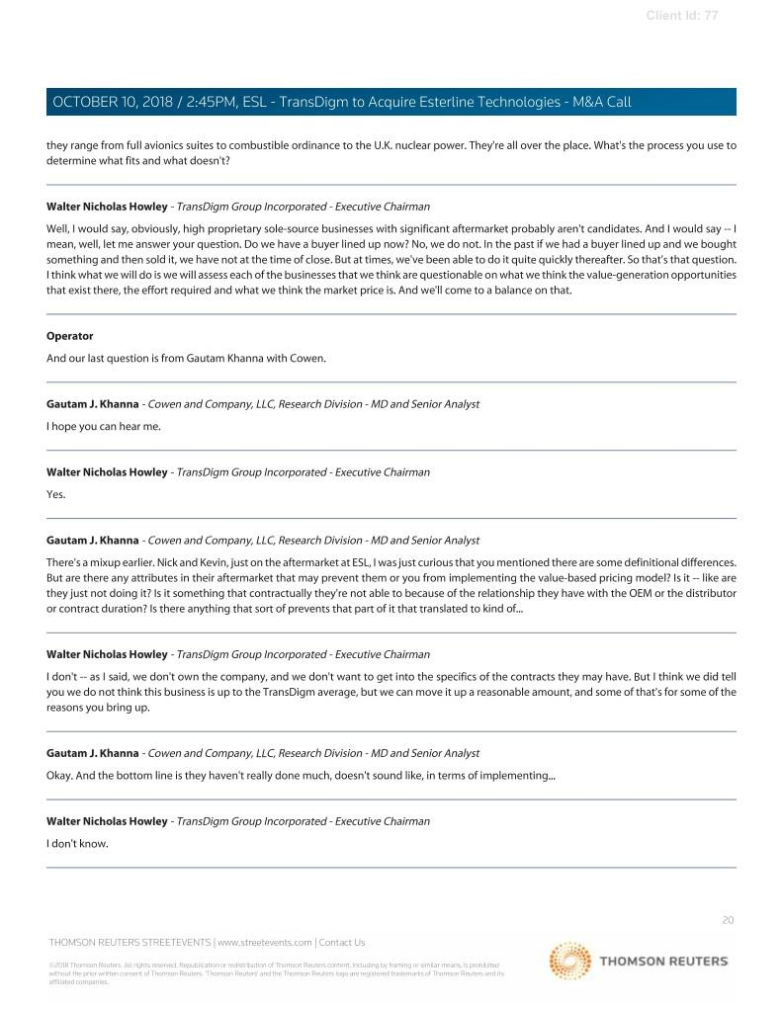

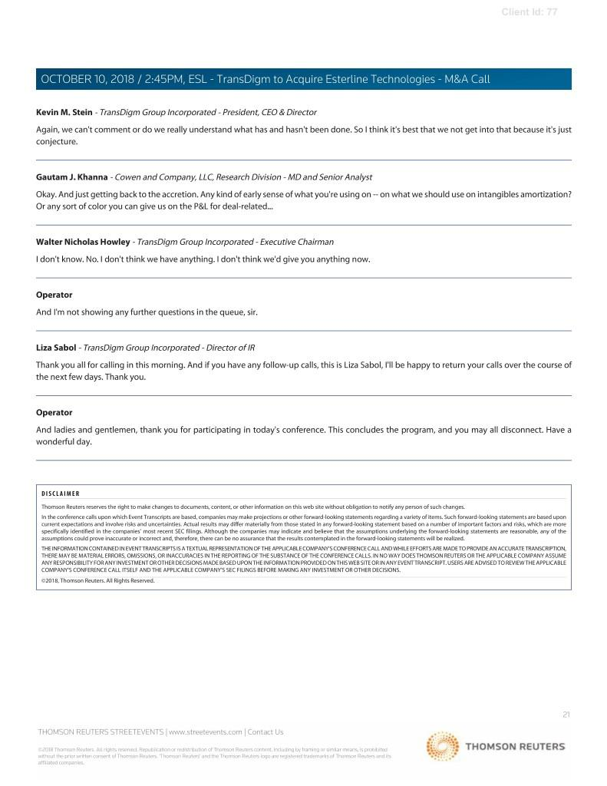

Important Additional Information and Where to Find It

Esterline intends to file with the Securities and Exchange Commission (the “SEC”) a proxy statement in connection with the contemplated transactions. The definitive proxy statement will be sent or given to Esterline stockholders and will contain important information about the contemplated transactions.
INVESTORS AND SECURITY HOLDERS ARE URGED TO READ CAREFULLY AND IN THEIR ENTIRETY THE PROXY STATEMENT AND ANY OTHER RELEVANT DOCUMENTS FILED WITH THE SEC WHEN THEY BECOME AVAILABLE. Investors and security holders may obtain a free copy of the proxy statement (when it is available) and other documents filed with the SEC at the SEC’s website at www.sec.gov.

Participants in the Merger Solicitation

The Company and Esterline and their respective directors and executive officers may be deemed participants in the solicitation of proxies from Esterline investors and security holders in connection with the contemplated transactions. Information about the Company’s directors and executive officers is set forth in its proxy statement for its 2018 Annual Meeting of Stockholders and its most recent annual report on Form 10-K. Information about Esterline’s directors and executive officers is set forth in its proxy statement for its 2018 Annual Meeting of Stockholders and its most recent annual report on Form 10-K. These documents may be obtained for free at the SEC’s website at www.sec.gov. Additional information regarding the interests of participants in the solicitation of proxies in connection with the contemplated transactions will be included in the proxy statement that Esterline intends to file with the SEC.

Cautionary Statement Regarding Forward-Looking Statements

Statements in this communication which are not historic facts are forward-looking statements under the provisions of the Private Securities Litigation Reform Act of 1995, including but not limited to expectations of Esterline’s future performance, profitability, growth and earnings; expectations of TransDigm’s earnings per share and the financial impact of the proposed transaction; the financing of the proposed transaction; and the timing of the proposed transaction. All statements other than statements of historical fact that address activities, events or developments that we expect, believe or anticipate will or may occur in the future are forward-looking statements, including, in particular, statements about our plans, objectives, strategies and prospects regarding, among other things, the acquired business. We have identified some of these forward-looking statements with words like “believe,” “may,” “will,” “should,” “expect,” “intend,” “plan,” “predict,” “anticipate,” “estimate” or “continue” and other words and terms of similar meaning. All forward-looking statements involve risks and uncertainties which could affect TransDigm’s actual results and could cause its actual results or the benefits of the proposed transaction to differ materially from those expressed in any forward-looking statements made by, or on behalf of TransDigm. These risks and uncertainties include, but are not limited to, closing conditions to the proposed transaction may not be achieved, the occurrence of any event, change or other circumstance that could give rise to the termination of the Merger Agreement, the effect of the announcement or pendency of the proposed transaction on the TransDigm’s and Esterline’s business relationships, operating results and business generally, risks related to diverting management’s attention from ongoing business operations, the outcome of any legal proceedings that may be instituted related to the Merger Agreement or the proposed transaction, unexpected costs, charges or expenses resulting from the proposed transaction, Esterline’s actual financial results for the year ended September 28, 2018 may differ from expected results, TransDigm may have difficulty obtaining required approvals, TransDigm may have difficulty implementing its strategic value drivers, and TransDigm may be impacted by the effects of general economic and industry conditions. Except as required by law, TransDigm undertakes no obligation to revise or update the forward-looking information contained in this communication.

