UNITED STATES

SECURITIES AND EXCHANGE COMMISSION

Washington, D.C. 20549

FORM 8-K

CURRENT REPORT

Pursuant to Section 13 or 15(d) of The Securities Exchange Act of 1934

Date of Report (Date of earliest event reported): June 6, 2008

TransDigm Group Incorporated

(Exact name of registrant as specified in its charter)

Delaware

(State or other jurisdiction of incorporation)

333-130483

(Commission File Number)

51-0484716

(IRS Employer Identification No.)

1301 East 9th Street, Suite 3710, Cleveland, Ohio

44114

(Address of principal executive offices)

(Zip Code)

(216) 706-2939

(Registrant’s telephone number, including area code)

(Former name or former address, if changed since last report.)

Check the appropriate box below if the Form 8-K filing is intended to simultaneously satisfy the filing obligation of the registrant under any of the following provisions (see General Instruction A.2. below):

- Written communications pursuant to Rule 425 under the Securities Act (17 CFR 230.425)

üSoliciting material pursuant to Rule 14a-12 under the Exchange Act (17 CFR 240.14a-12)

- Pre-commencement communications pursuant to Rule 14d-2(b) under the Exchange Act (17 CFR 240.14d-2(b))

- Pre-commencement communications pursuant to Rule 13e-4(c) under the Exchange Act (17 CFR 240.13e-4(c))

Item 8.01. Other Events

Attached hereto as Exhibit 99.1 are materials to be used by members of management of TransDigm Group Incorporated in investor presentations regarding the proposed amendment to TransDigm Group’s 2006 Stock Incentive Plan.

Safe Harbor Statement Under the Private Securities Litigation Reform Act of 1995

This document contains certain forward-looking statements within the meaning of Section 27A of the Securities Act of 1933, as amended, and Section 21E of the Securities Act of 1934 as amended. These include statements as to future financial and operating results, and projected earnings per share impact of the proposed amendment as well as any other statements regarding future results or expectations. All statements other than statements of historical fact that address activities, events or developments that we expect, believe or anticipate will or may occur in the future are forward-looking statements, including, in particular, statements about our plans, objectives, strategies and prospects regarding, among other things, our financial condition, results of operations, and business. We have identified some of these forward-looking statements with words like “believe,” “may,” “will,” “should,” “expect,” “intend,” “plan,” “predict,” “anticipate,” “estimate,” “forecast” or “continue” and other words and terms of similar meaning. All forward-looking statements involve risks and uncertainties which could affect TransDigm Group’s actual results and could cause its actual results to differ materially from those expressed in any forward-looking statements made by, or on behalf of, TransDigm Group. These risks and uncertainties include but are not limited to: future terrorist attacks; a decrease in flight hours and our customers’ profitability, both of which are impacted by general economic conditions; our substantial indebtedness; our reliance on certain customers; our fixed price contracts; the U.S. defense budget and risks associated with being a government supplier; failure to maintain government or industry approvals; the pricing review to which certain of our divisions and subsidiaries have been subject; failure to complete or successfully integrate acquisitions; future sales of common stock in the market caused by the substantial amount of stock held by affiliates; and other factors. Further information regarding the important factors that could cause actual results to differ materially from projected results can be found in TransDigm Group’s Annual Report on Form 10-K and any other reports that TransDigm Group or its subsidiaries have filed with the Securities and Exchange Commission. Except as required by law, TransDigm Group undertakes no obligation to revise or update the forward-looking statements contained in this investor presentation.

Item 9.01. Financial Statements and Exhibits.

(d) Exhibits

The following exhibits are being filed with this Current Report on Form 8-K:

Exhibit No. 99.1 Investor Presentation

2

SIGNATURES

Pursuant to the requirements of the Securities Exchange Act of 1934, the Registrant has duly caused this report to be signed on its behalf by the undersigned hereunto duly authorized.

TRANSDIGM GROUP INCORPORATED

By /s/ Gregory Rufus

Gregory Rufus

Executive Vice President and Chief

Financial Officer

Date: June 6, 2008

3

Exhibit Index

Exhibit No. 99.1 Investor Presentation

4

Exhibit 99.1


Pay for Valuel Creationi

Proposing g unique public company option plan

Goal

- Generate superior returns by . . . .

- Maintain the value focus & culture of private equity in a public environment

Simple concept

- Management / shareholders are partners

- If management creates significant value for shareholders, management is rewarded

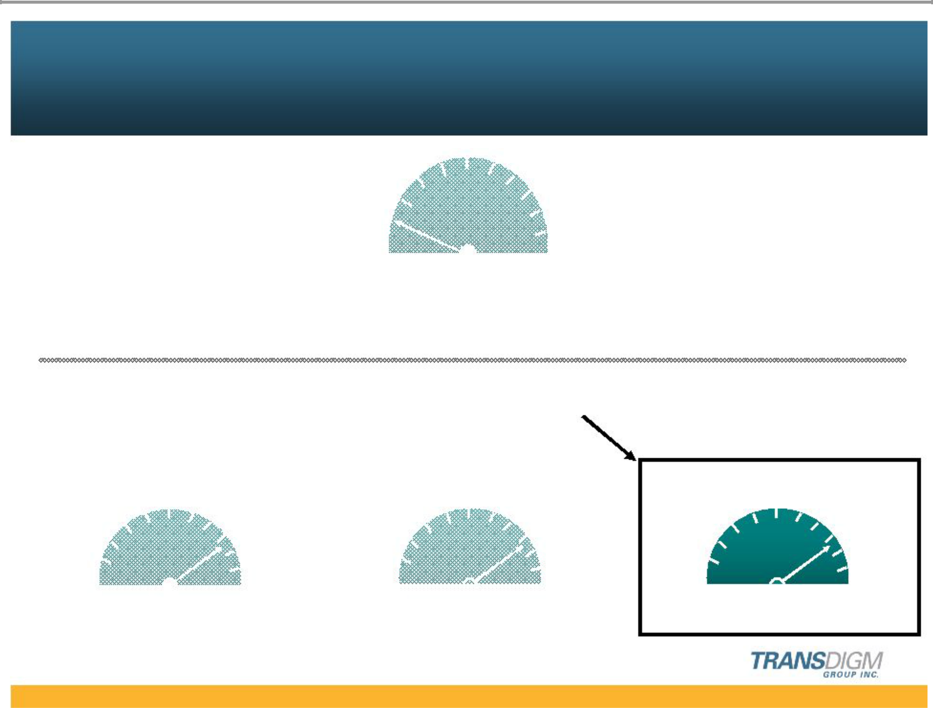
Successful Culture and Organization

CORPORATE

Corporate | Local
Corporate | Autonomy
Control | Autonomy

Value Generation Strategy

Key Element

OPERATING UNIT

Economy | Mgmt | Central | Local | Emp- | Owners
of Scale | Resources | Control | Autonomy | loyees | Owners
 | Structure |  | Execution |  | Motivation

1

- Significant part of our ability to create value is our organizational concept & culture

  - Execution g

    - Significant local autonomy

    - Minimize corporate interference g minimize corporate staff g erodes ownership

  - Motivation g think like an owner g create value

    - Stock options & ownership for key people g significant

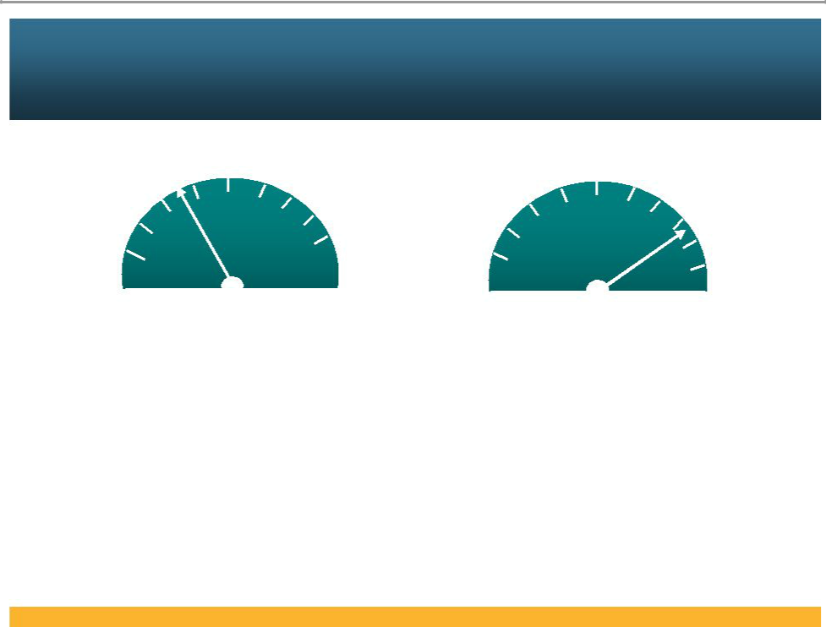
Compensation Concept – “Think / act like an owner”

Low | High | Low | High
 | Cash Compensation ⁽¹⁾ |  | Equity Based
 |  |  | Compensation ⁽²⁾

- Salary and Bonus

- Options

2

- We want managers who can think & act like owners

- We have historically paid executives & key managers cash compensation below the average

- We pay well above average in equity based compensation

- Goal = create real value for shareholders, net of management’s share

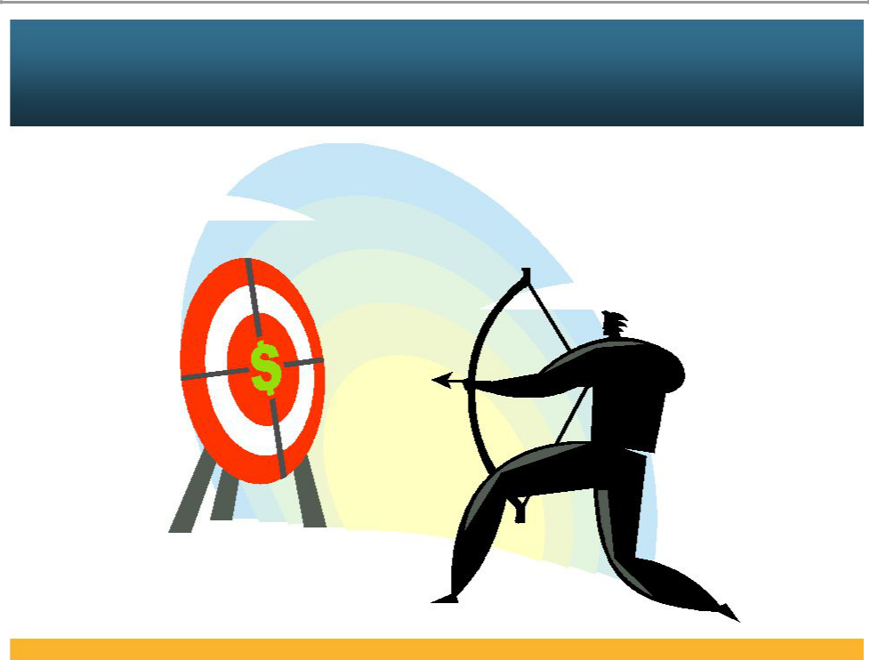
Key Managers Aligned with Shareholders

Value

Generating

Activities

3

We want to maintain our clear management alignment with shareholders

A. 3 Value Drivers

- Price

- Productivity

- New Business

- Very difficult to get this day to day focus on “details of value creation” without real ownership

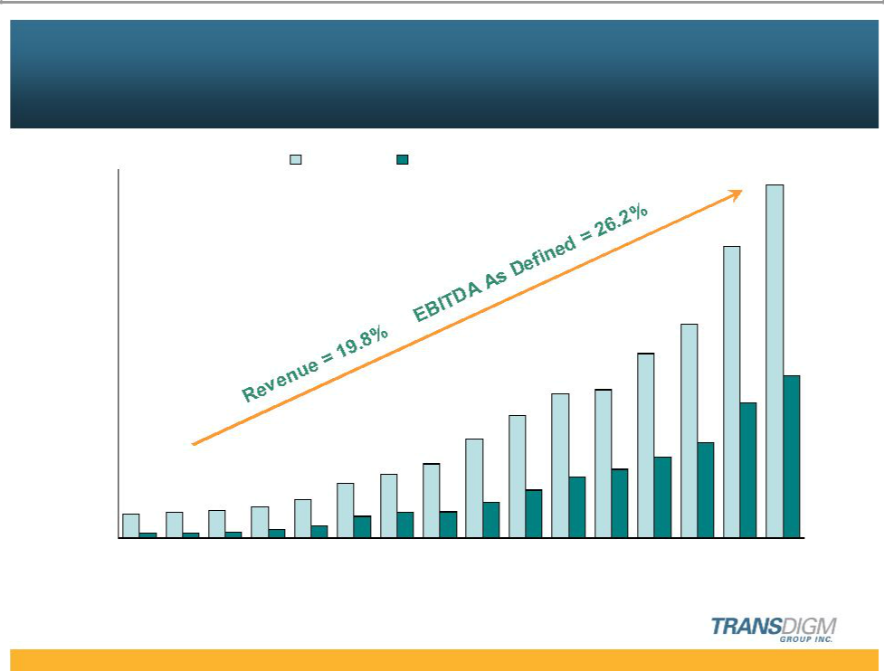
Proven Record of Growth and Margin Expansion

($ in millions)

$750

$600

$450

$300

$150
$48 | $52 | $57 | $63
$10 | $10 | $13 | $17
$0 | '94 | '95 | '96
'93 | '94 | '95 | '96
% of Sales 20% | 19% | 23% | 27%

Revenue EBITDA As Defined⁽¹⁾

$717

$593

 |  |  |  |  |  |  |  |  | $435
 |  |  |  |  |  |  |  | $374
 |  |  |  |  |  |  |  |  |  | $329
 |  |  |  |  |  | $293 | $301
 |  |  |  |  |  | $293 |  |  |  | $275
 |  |  |  |  | $249 |  |  |  |  | $275
 |  |  |  | $201 |  |  |  |  | $194
 |  |  | $151 |  |  |  | $139 | $164
 |  | $131 | $151 |  |  |  | $139
 | $111 | $131 |  |  |  | $124
 | $111 |  |  |  | $98
$78 |  |  |  | $72 | $98
$78 |  | $51 | $54 | $72
$25 | $44 | $51 | $54
'97 | '98 | '99 | '00 | '01 | '02 | '03 | '04 | '05 | '06 | '07 '08 (F)⁽²⁾
31% | 39% | 39% | 36% | 36% | 39% | 42% | 46% | 44% | 45% | 46%

- EBITDA As Defined is a non-GAAP financial measure presented here as supplemental disclosures to net income. For a presentation of the most directly comparable GAAP measure and a reconciliation of EBITDA As Defined, please see appendix.

- Midpoint of May 6, 2008 guidance (including CEF Industries).

4

- This has worked for us – look at history of company

- Thru good and bad markets the company has been able to consistently improve

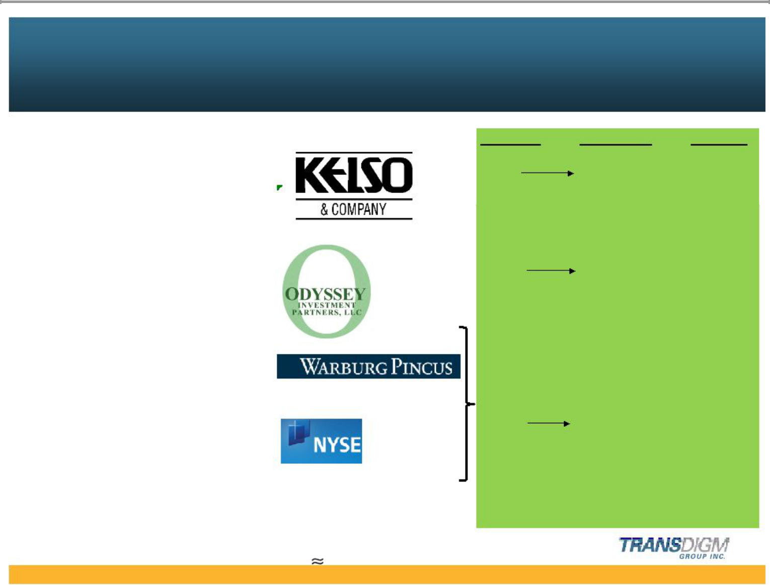
Consistent Growth in Equity Value

 |  | Equity In | Equity Out | Multiple
Formation | 1993 | $25M | $347M | 13.9x
 | to 1998 ⁽¹⁾

Equity Recap | 1998 | $100M | $503M | 5.0x
 | to 2003

Equity Recap | 2003
Leveraged Dividend | 2005
 | $471M | $2,138M ⁽²⁾ | 4.5x
IPO | 2006
Secondary Offering | 2007

- Approximately 90% of Kelso ownership sold in 1998, balance cashed out in 2003.

- Assumes Warburg Pincus maintained 100% ownership of 43.6 million shares valued at a stock price of $43 plus

repayment of shareholder notes including interest of $263 million.

5

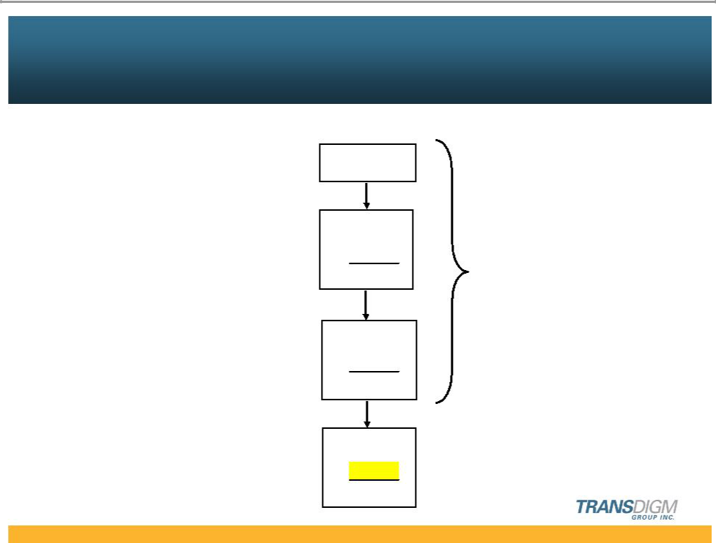
Management Ownership / Options

(% of total shares) ⁽¹⁾

1993 New Awards 15%

1998 | Rollover | 10%
Recap | New Awards | 12%
 | Total | 22%

2003 | Rollover | 7%
Recap | New Awards | 10%
 | Total | 17%

2008 | Rollover | 8%
New Plan | New Awards | 7%
 | Total | 15%

- Calculated on a fully diluted basis.

Historical

Pattern

6

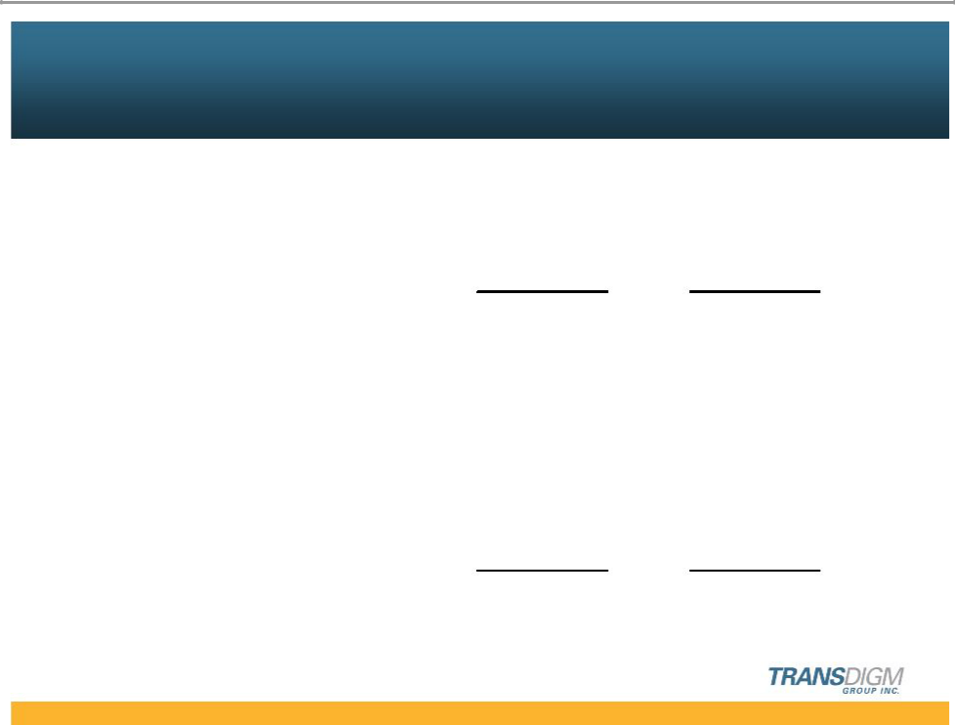
Unique Performance Based Option Plan

Public

Private Equity

Equity Current

Historical Proposal

Time Based | 20% | 20%

Operating Performance ⁽¹⁾ | 80% | 40%

Market Performance --- 40%

100% 100%

- Includes annual and 5 year targets.

7

- Performance based plans are common in private equity but unusual in public equity

- We are trying to make this look like a private equity plan

- Minimal time vesting » 20% only / 5 years

- Highly performance driven

40% — based on operating performance to support 20% IRR 40% — based on stock market growth of 20% IRR

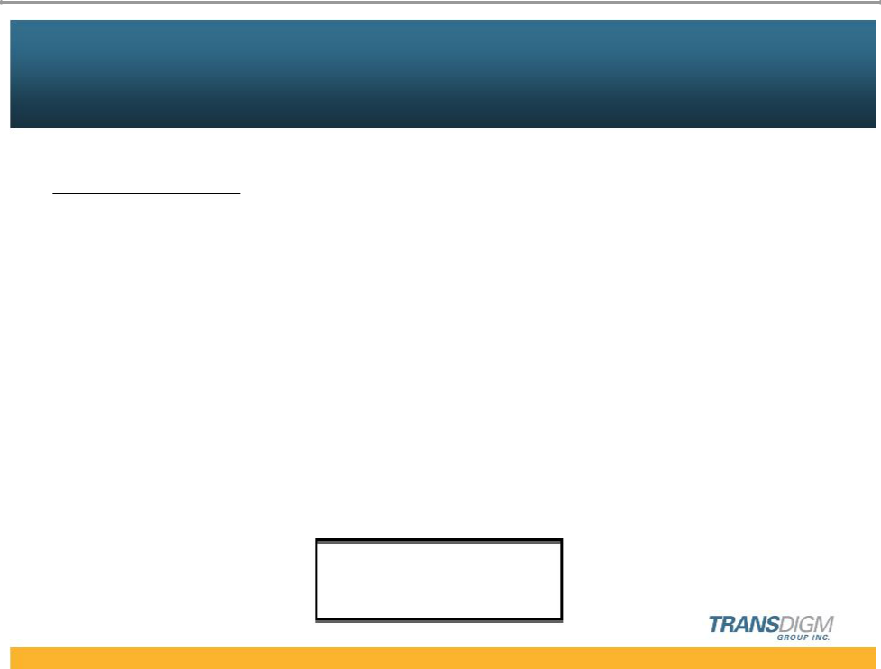
Vest Criteria –
Meet Targets After Dilution for Options to Vest

Definitions
Operating | (EBITDA As Defined x multiple) - net debt) / diluted shares
Performance
Market Performance | Share price gain & Dividend
Required Growth | Less than 12.5% per year | = No performance vesting
 | Greater than 12.5% per year = Partial performance vesting
 | 20% per year & greater | = Full vesting

After Dilution

8

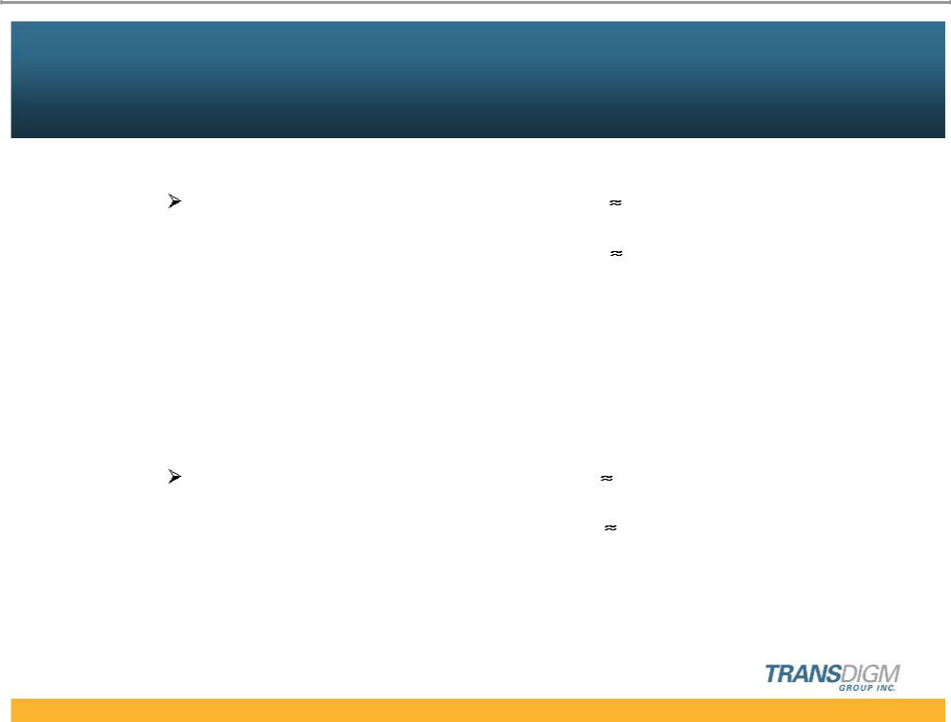
“Skin in The Game”

Minimum Rollover Investment Required

Top 5 Officers

Years of base compensation

$35 Million *

$25 Million

14 years

Minimum hold for 30% of new awards

Top 5 Officers

$35 Million

$18 Million

* @ $40/share

9

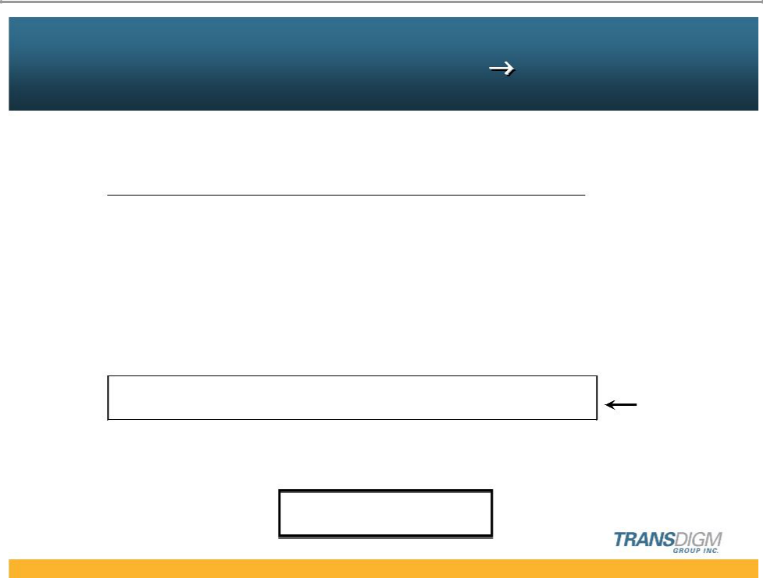
Net Result –
Shareholders Make Superior Return

Management Share Increases

Example based on 2008 estimate

 |  | (Dollars in Millions)
IRR ⁽¹⁾ | Gain In |  |  |  | Mgmt. %
IRR ⁽¹⁾ | Mkt.Cap. |  | Mgmt. $ |  | of Gain
10.0% | $ | 1,465 | $ | 16 | 1.1%
12.5% | $ | 1,865 | $ | 42 | 2.3%
15.0% | $ | 2,300 | $ | 80 | 3.5%
20.0% | $ | 3,300 | $ | 197 | 6.0%
25.0% | $ | 4,500 | $ | 275 | 6.1%

IRR = After Dilution

- After management share

10

- Net result g graduated sharing

- IRR is after management take

- Highly incentivized to increase equity value

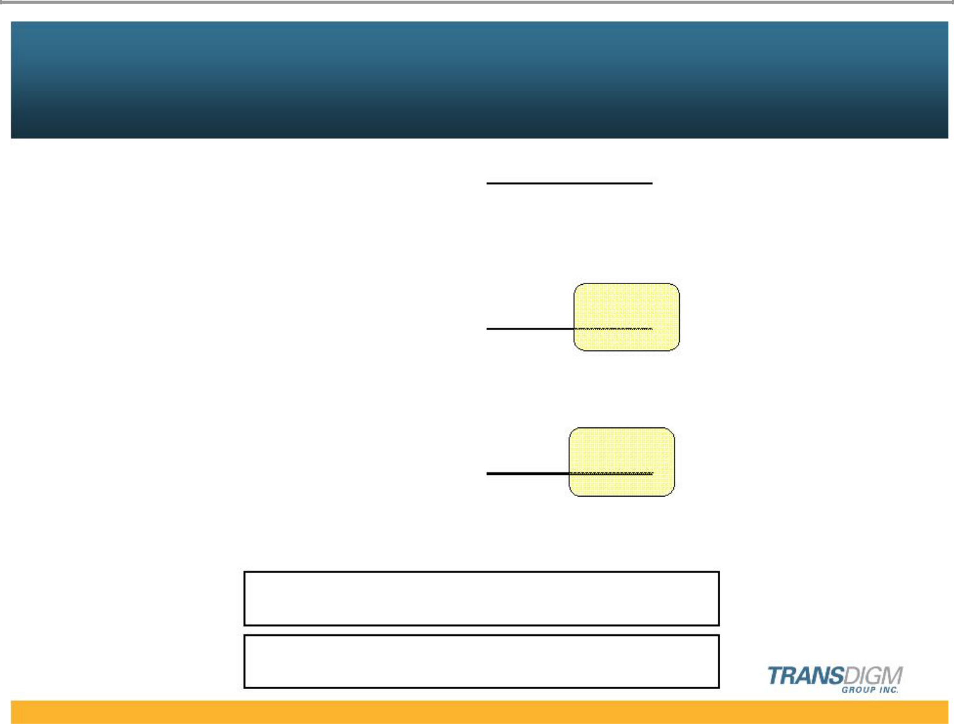
New Authorization 1.5 Million Options

 | # of Options
Previously Authorized | 2.6 | Million
Newly Authorized | + 1.2
Total Per Program | 3.8
Miscellaneous | + 0.3
 | 4.1 | Million

New Authorization of 1.5 Million Shares

ISS Will Not Recommend

11

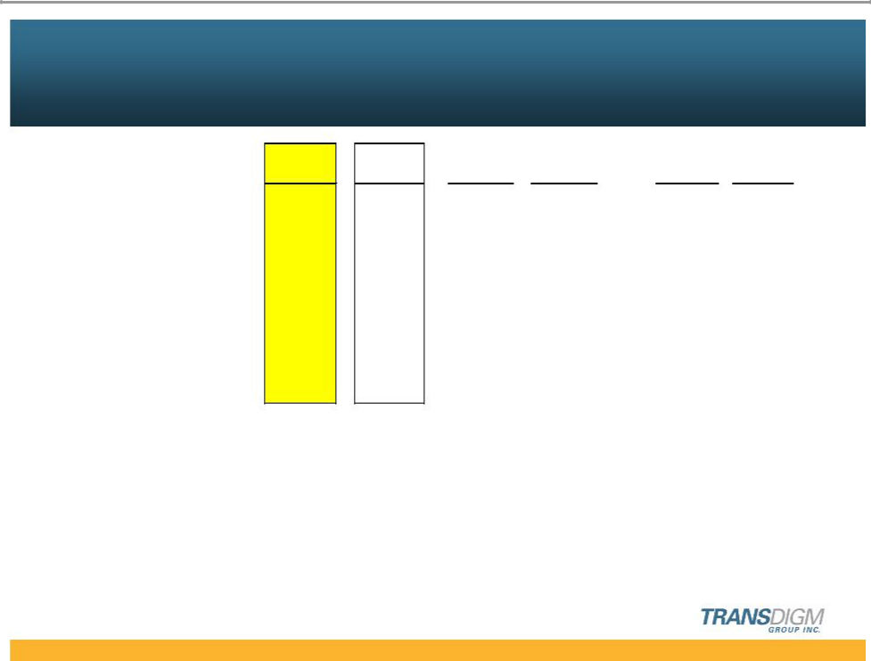
New Plan EPS Impact

 | Peer ⁽¹⁾ | 2008 | 2009 | 2013 | 2009 | 2013
 | Average | Est. | 12.5% IRR | 12.5% IRR | 20% IRR | 20% IRR
EPS Diluted | $ 2.31 | $ 2.72 | $ 3.06 | $ 4.90 | $ 3.26 | $ 6.77

Option Expense (Per Share) | $ 0.10 | $ 0.06 | $ 0.05 | $ 0.08 | $ 0.08 | $ 0.12

% of EPS Diluted | 4.4% | 2.2% | 1.6% | 1.6% | 2.5% | 1.8%

- Peer group includes Goodrich, Rockwell Collins, BE Aerospace, Hexcel, Triumph, Woodward-Governor, Curtis Wright, Esterline & Precision Cast Parts

12

- Impact on eps is less than peers & roughly in line with current TDG level



Pay for Value Creation

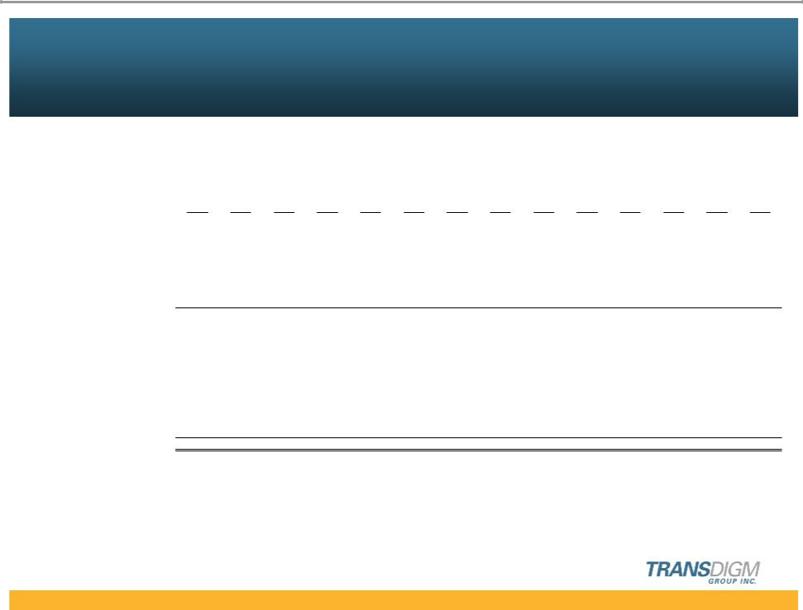
Appendix

Reconciliation of Net Income to EBITDA As Defined

(in millions)
 | 1994 | 1995 | 1996 | 1997 | 1998 | 1999 | 2000 | 2001 | 2002 | 2003 | 2004 | 2005 | 2006 | 2007
Net Income | ($5) | $0 | $1 | $3 | $14 | ($17) | $11 | $14 | $31 | ($76) | $14 | $35 | $25 | $89
Depreciation and amortization | 7 | 7 | 7 | 6 | 7 | 6 | 7 | 9 | 13 | 10 | 18 | 17 | 16 | 24
Interest expense, net | 5 | 5 | 5 | 3 | 3 | 23 | 28 | 32 | 37 | 43 | 75 | 80 | 77 | 92
Income tax provision | (2) | - | 2 | 5 | 13 | (2) | 8 | 9 | 17 | (45) | 6 | 23 | 16 | 53
Warrant put value adjustment | 1 | 1 | 2 | 5 | 7 | - | - | - | - | - | - | - | - | -
Extraordinary item | - | - | - | 2 | - | - | - | - | - | - | - | - | - | -
EBITDA | 6 | 13 | 17 | 24 | 44 | 10 | 54 | 64 | 98 | (68) | 113 | 155 | 134 | 258
Merger expense | - | - | - | - | - | 40 | - | - | - | 176 | - | - | - | -
Acquisition-related costs | 4 | - | - | 1 | - | 1 | - | 8 | - | 15 | 20 | 2 | 1 | 9
Non-cash compensation and
deferred compensation costs | - | - | - | - | - | - | - | - | - | 1 | 6 | 7 | 1 | 6
One-time special bonus | - | - | - | - | - | - | - | - | - | - | - | - | 6 | -
Public offering costs | - | - | - | - | - | - | - | - | - | - | - | - | 3 | 2
Refinancing costs | - | - | - | - | - | - | - | - | - | - | - | - | 49 | -
EBITDA As Defined | $10 | $13 | $17 | $25 | $44 | $51 | $54 | $72 | $98 | $124 | $139 | $164 | $194 | $275

14

