UNITED STATES
SECURITIES AND EXCHANGE COMMISSION
WASHINGTON, D.C. 20549
FORM 8-K
CURRENT REPORT
Pursuant to Section 13 or 15(d)
of The Securities Exchange Act of 1934
Date of Report (Date of earliest event reported): September 28, 2026
TransDigm Group Incorporated
(Exact name of registrant as specified in its charter)
 |  |  | Delaware |  |  |  |  |  | 001-32833 |  |  |  |  |  | 41-2101738
 |  |  | (State or other jurisdiction  of incorporation) |  |  |  |  |  | (Commission  File Number) |  |  |  |  |  | (IRS Employer  Identification No.)
1350 Euclid Avenue, |  |  | Suite 1600, |  |  | Cleveland, |  |  | Ohio |  |  |  |  |  | 44115
(Address of principal executive offices) |  |  |  |  |  |  |  |  |  |  |  |  |  |  | (Zip Code)
(216) 706-2960
(Registrant’s telephone number, including area code)

Not Applicable
(Former name or former address, if changed since last report.)
Check the appropriate box below if the Form 8-K filing is intended to simultaneously satisfy the filing obligation of the registrant under any of the following provisions:
☐ |  |  | Written communications pursuant to Rule 425 under the Securities Act (17 CFR 230.425)
☐ |  |  | Soliciting material pursuant to Rule 14a-12 under the Exchange Act (17 CFR 240.14a-12)
☐ |  |  | Pre-commencement communications pursuant to Rule 14d-2(b) under the Exchange Act (17 CFR 240.14d-2(b))
☐ |  |  | Pre-commencement communications pursuant to Rule 13e-4(c) under the Exchange Act (17 CFR 240.13e-4(c))
Securities registered pursuant to Section 12(b) of the Act:
Title of each class: |  |  |  |  |  | Trading Symbol: |  |  |  |  |  | Name of each exchange on which registered:
Common Stock, $0.01 par value |  |  |  |  |  | TDG |  |  |  |  |  | New York Stock Exchange
Indicate by check mark whether the registrant is an emerging growth company as defined in Rule 405 of the Securities Act of 1933 (§230.405 of this chapter) or Rule 12b-2 of the Securities Exchange Act of 1934 (§240.12b-2 of this chapter).
Emerging Growth Company ☐
If an emerging growth company, indicate by check mark if the registrant has elected not to use the extended transition period for complying with any new or revised financial accounting standards provided pursuant to Section 13(a) of the Exchange Act. ☐

Item 8.01. |  |  | Other Events.
On September 28, 2026, TransDigm Group Incorporated (“TransDigm Group”) issued a press release (the “Press Release”) announcing the completion of the acquisition of Prince & Izant (“P&I” or “the Company”), formerly a portfolio company of Industrial Growth Partners, for approximately $1.066 billion in cash, including certain tax benefits. TransDigm Group financed the acquisition of the Company through cash on hand. The entry into the definitive agreement to acquire P&I was previously reported in a Current Report on Form 8-K filed on July 27, 2026. A copy of this Press Release is attached to this Current Report on Form 8-K as Exhibit 99.1 and is incorporated herein by reference.
Item 9.01. |  |  | Financial Statements and Exhibits.
(d) Exhibits
Exhibit No. |  |  |  |  |  | Description
99.1 |  |  |  |  |  | Press Release
104 |  |  |  |  |  | Cover Page Interactive Data File (embedded within the Inline XBRL document)

SIGNATURE
Pursuant to the requirements of the Securities Exchange Act of 1934, the Registrant has duly caused this report to be signed on its behalf by the undersigned hereunto duly authorized.
TRANSDIGM GROUP INCORPORATED
By: |  |  |  |  |  |  |  |  | /s/ Armani Vadiee
 |  |  | Name: |  |  |  |  |  | Armani Vadiee
 |  |  | Title: |  |  |  |  |  | General Counsel, Chief Compliance Officer and Secretary

Dated: September 28, 2026

Exhibit 99.1

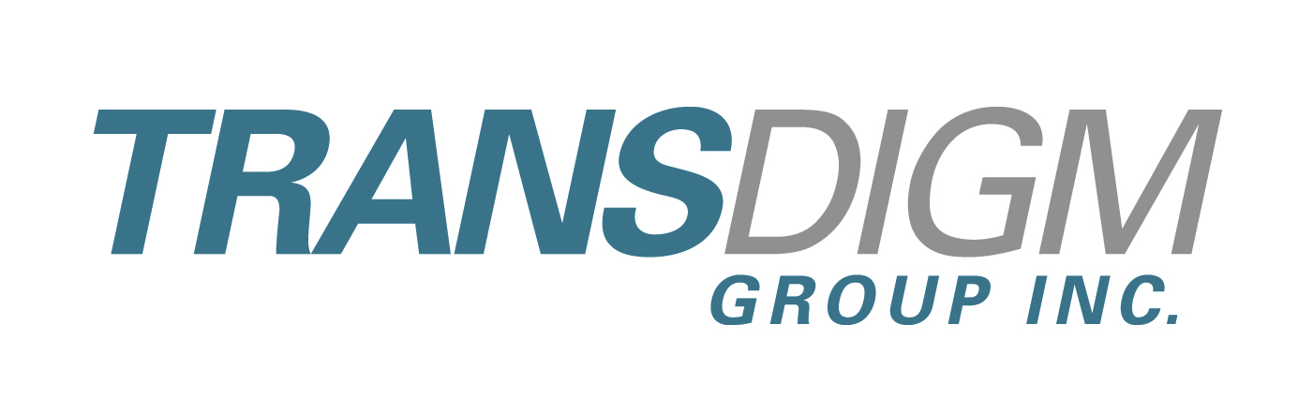

TransDigm Completes Acquisition of Prince & Izant
Cleveland, Ohio, September 28, 2026 /PRNewswire/ -- TransDigm Group Incorporated (NYSE: TDG) today announced that it has successfully completed its acquisition of Prince & Izant (“P&I” or “the Company”), formerly a portfolio company of Industrial Growth Partners, for approximately $1.066 billion in cash, including certain tax benefits. TransDigm financed the acquisition of the Company through cash on hand. The acquisition was previously announced on July 27, 2026.
Headquartered in Cleveland, Ohio, Prince & Izant is a leading global designer and manufacturer of highly engineered brazing alloys and specialty metal components used across a range of advanced performance and high cost-of-failure applications. The Company primarily supports the aerospace and defense, aeroderivative turbine, and transportation end markets. Within aerospace and defense, select applications include aircraft engine fuel nozzles and rocket engines. Additionally, but to a lesser degree, the Company also serves the medical and general industrial end markets.
The Company derives the majority of its revenue from the aftermarket and supports a large installed base globally. Prince & Izant’s products are highly proprietary in nature and support end customers through the Company’s advanced metallurgy, precise chemistry requirements, and deep formulation expertise which are critical to supporting the evolving performance requirements in the markets which it serves.
The Company’s products span nearly 10,000 active SKUs, and the majority of P&I’s revenue is derived from specialty metals including gold, silver, and platinum alloys.
P&I is now expected to generate approximately $390 million in revenue for the calendar year ending December 31, 2026. The Company has manufacturing locations in Cleveland, Ohio; Tinley Park, Illinois; Franksville, Wisconsin; and Bay Shore, New York. Prince & Izant employs approximately 220 people.
About TransDigm Group
TransDigm Group, through its wholly-owned subsidiaries, is a leading global designer, producer and supplier of highly engineered aircraft components for use on nearly all commercial and military aircraft in service today. Major product offerings, substantially all of which are ultimately provided to end-users in the aerospace industry, include mechanical/electro-mechanical actuators and controls, ignition systems and engine technology, specialized pumps and valves, power conditioning devices, specialized AC/DC electric motors and generators, batteries and chargers, engineered latching and locking devices, engineered rods, engineered connectors and elastomer sealing solutions, databus and power controls, cockpit security components and systems, specialized and advanced cockpit displays, engineered audio, radio and antenna systems, specialized lavatory components, seat belts and safety restraints, engineered and customized interior surfaces and related components, advanced sensor products, switches and relay panels, thermal protection and insulation, lighting and control technology, parachutes, high performance hoists, winches and lifting devices, and cargo loading, handling and delivery systems, specialized flight, wind tunnel and jet engine testing services and equipment, electronic components used in the generation, amplification, transmission and reception of microwave signals, and complex testing and instrumentation solutions.
1
Forward-Looking Statements
All forward-looking statements involve risks and uncertainties that could cause TransDigm Group’s actual results to differ materially from those expressed or implied in any forward-looking statements made by, or on behalf of, TransDigm Group. These risks and uncertainties include but are not limited to: the sensitivity of our business to the number of flight hours that our customers’ planes spend aloft and our customers’ profitability, both of which are affected by general economic conditions; supply chain constraints; increases in raw material costs, taxes and labor costs that cannot be recovered in product pricing; failure to complete or successfully integrate acquisitions; our indebtedness; current and future geopolitical or other worldwide events, including, without limitation, wars or conflicts and public health crises; cybersecurity threats; risks related to the transition or physical impacts of climate change and other natural disasters or meeting regulatory requirements; our reliance on certain customers; the United States (“U.S.”) defense budget and risks associated with being a government supplier including government audits and investigations; failure to maintain government or industry approvals; risks related to changes in laws and regulations, including increases in compliance costs and potential changes in trade policies and tariffs; potential environmental liabilities; liabilities arising in connection with litigation; risks and costs associated with our international sales and operations; and other factors. Further information regarding the important factors that could cause actual results to differ materially from projected results can be found in TransDigm Group’s most recent Annual Report on Form 10-K and other reports that TransDigm Group or its subsidiaries have filed with the Securities and Exchange Commission. Except as required by law, TransDigm Group undertakes no obligation to revise or update the forward-looking statements contained in this press release.

Contact: |  |  |  |  |  | Investor Relations
 |  |  |  |  |  | 216-706-2945
 |  |  |  |  |  | ir@transdigm.com

2

